|  |  |
| --- | --- |
| **How to create a report of successful and unsuccessful logins to Alma for a specific time period** |  |
|  | |

Yoel Kortick

Senior Librarian

**Question:**

I want to see how many logins to Alma there have been for a specific time period, for example how many successful logins and unsuccessful logins to Alma were there in the past month or year?

**Short Answer:**

In order to make a report with number of successful and unsuccessful logins to Alma you can use the “events” subject area and filter the Event Metadata Description by “Successful login” and “The user has failed to login to the system”

**Full Detailed Answer:**

**ONE**

Create a new analysis

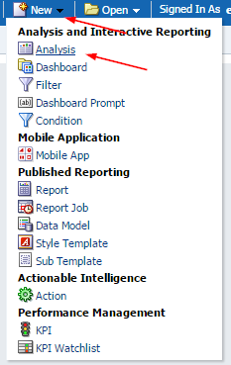

**TWO**

Choose subject area “events”

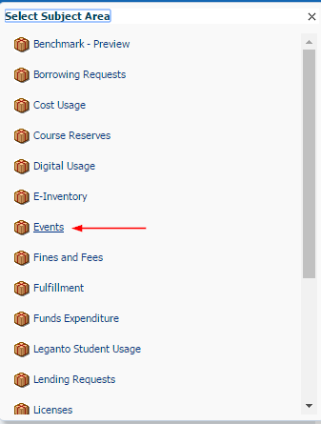

**THREE**

In the criteria tab left pane choose fields

1. “Description” from the “Events Metadata” folder
2. “Num of Events” from the “Event Keys” folder

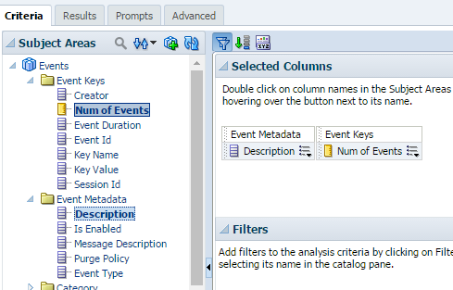

**FOUR**

On the filter section of the right pane click the “create a filter” icon

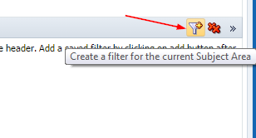

**FIVE**

Select “More Columns” and choose the field “”Date Key” from the “Event Date” folder

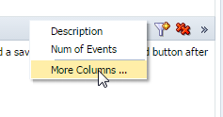

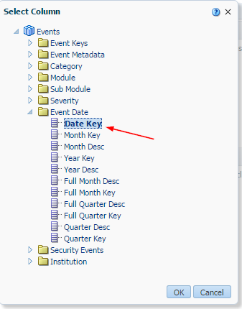

**SIX**

Filter by the last month (or whatever you want).

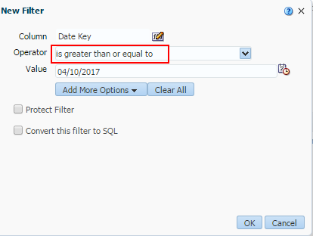

**SEVEN**

Instead of hard coding it by a specific date you can also have it always take the last month my converting to SQL and changing

**"Event Date"."Date Key" >= date '2017-04-10'**

To

**"Event Date"."Date Key" >= TIMESTAMPADD(SQL_TSI_MONTH,-1,CURRENT_DATE)**

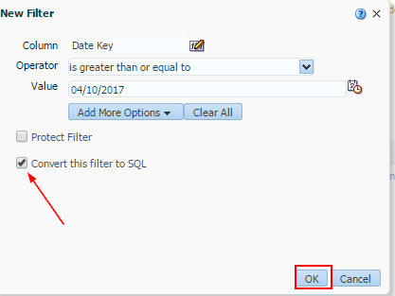

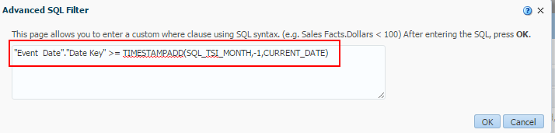

**EIGHT**

Filter the Event Metadata Description by “Successful login” and “The user has failed to login to the system”

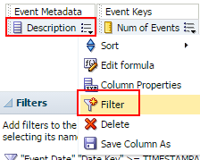 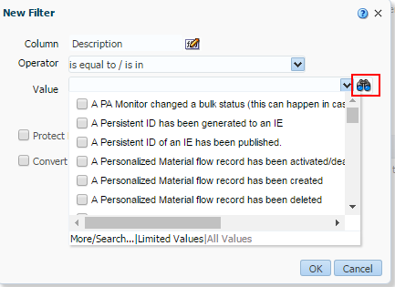

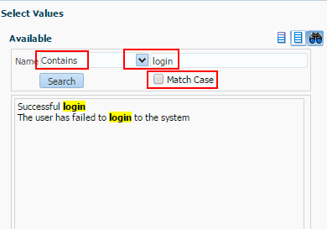 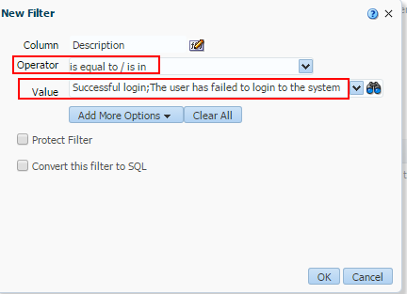

**NINE**

See results. For example:

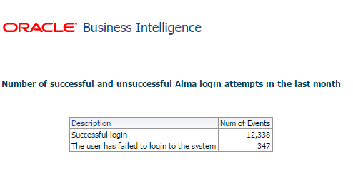

**TEN**

If you want to see who the user name of the staff user who logged in you can include the field “Creator” from the “Event Keys” folder. Note that in the case of “The user has failed to login to the system” the “Creator” will be registered as “System” (because no one really logged in).

