**Common Broker Configuration Errors**

For the broker integration to properly function, some resource sharing and fulfillment configurations need to be set up. Below is a list of some common setup issues.

### “Barcode sent to Alma in the AcceptItem message is not being used when the brief bib & item record is created”

The AcceptItem message is used to assign the communicated barcode to the temporary item, to activate the hold request workflow and to create the resource sharing borrowing request in status of ‘received by library’. In order for this to take place, the ‘Automatic Receive’ option must be turned on in the partner configuration.

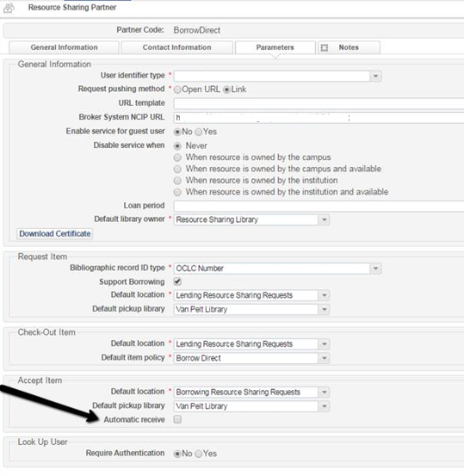

Without having this on, the AcceptItem creates the request but does not use the communicated barcode. It also will not activate the request workflow. This will result in the item being blocked from fulfillment actions with a ‘“Item not received by resource sharing operator” error.

**Required Action**: The “Automatic Receive’ switch should be turned on.

### “Pickup location sent to Alma in the AcceptItem message appears to be ignored by Alma”

The AcceptItem message is used to assign a hold request to the temporary item, with the pickup location that has been communicated in the AcceptItem message, and to activate the hold request workflow.

The pickup location is expected to be communicated in the AcceptItem message’s PickupLocation element, for example:  *<PickupLocation>MAIN</PickupLocation>*

For the communicated code to be used by Alma, the following needs to be true:

* 1. The code used in this message must be aligned with one of the valid library codes in Alma. In the example above, ‘MAIN’ must be the code of a library in Alma
  2. The pickup location must be allowed by the resource sharing library. This means that there must be a ‘Deliver To’ relation from the resource sharing library to the pickup location. In the above example –

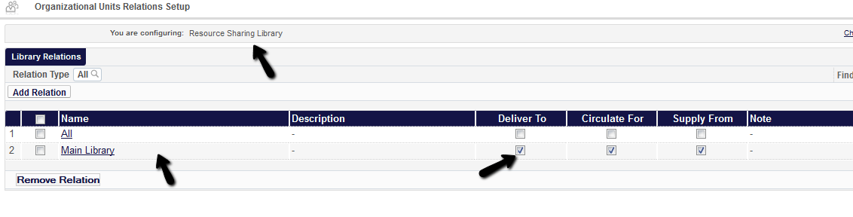

If either of the above conditions is not met, Alma ignores the communicated pickup location and uses the default pickup location that is configured on the partner record –

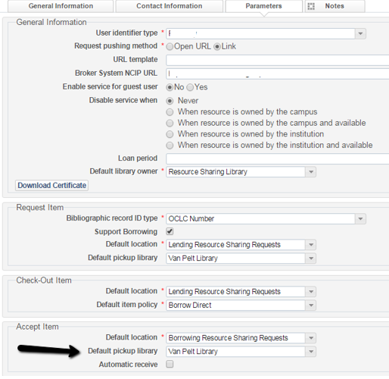

**Required Action**:

1. Verify that correct codes are used by the broker. For example, the below request was created with a “Pickup at” value of “Van Pelt Library” because the NCIP message communicated a pickup location of “vpcirc”, which is not a valid library code.

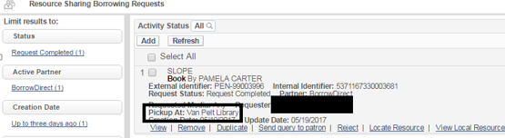

1. Configure the Resource Sharing library with a ‘Deliver To’ relation other libraries. It should have this relation with any library that is expected to be a valid pickup location.

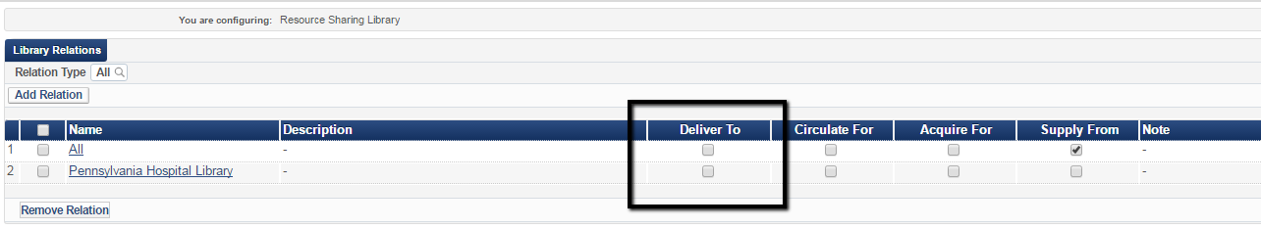

### “Records are being assigned to the Resource Sharing Library in Alma, which restricts circulation from library circulation desks”

The temporary item is created as owned by the resource sharing library. As a standard fulfillment process, for items of library A to circulate at library B, library B must have a ‘Circulate For’ relation with library A. For example:

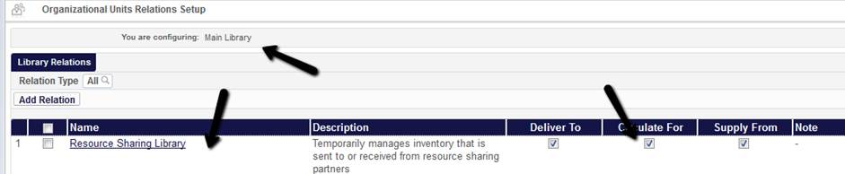

In addition, when checking out an item from another library, the circulation desk must be configured as a Primary desk –

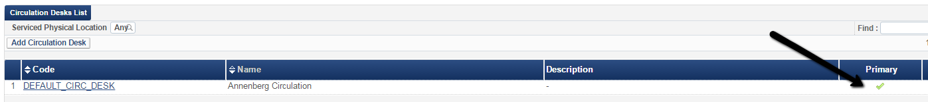

**Required Action**: Make sure relevant libraries are allowed to check out resource sharing library items.