Deposits for Producer Agents

1. Deposits for Producer Agents

1.1 Welcome
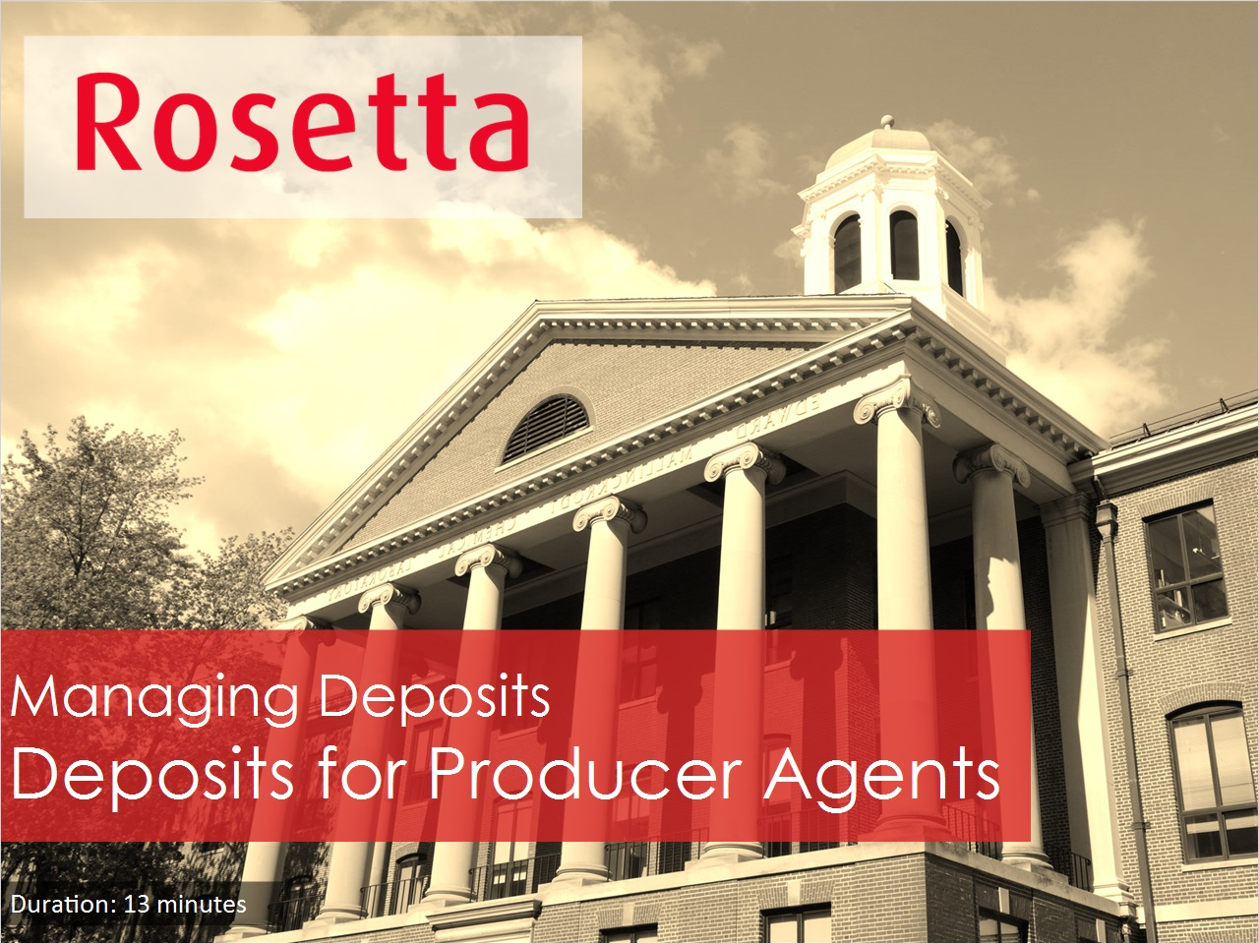
Notes:
Welcome to Deposits for Producer Agents session.

1.2 Agenda
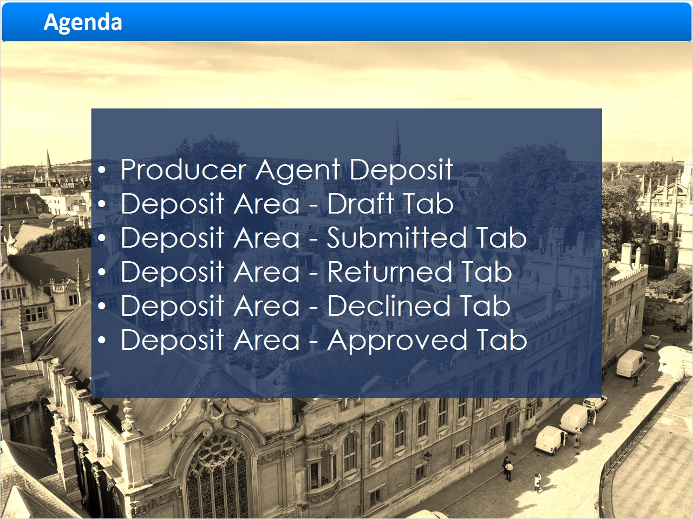
Notes:
We'll begin with a demonstration of Producer Agent deposit, then review the functional tabs in the Deposit Area.
Note that Staff deposit will not be covered in this session as it was addressed in the Deposits for Staff Users session.

1.3 Producer Agent Deposit
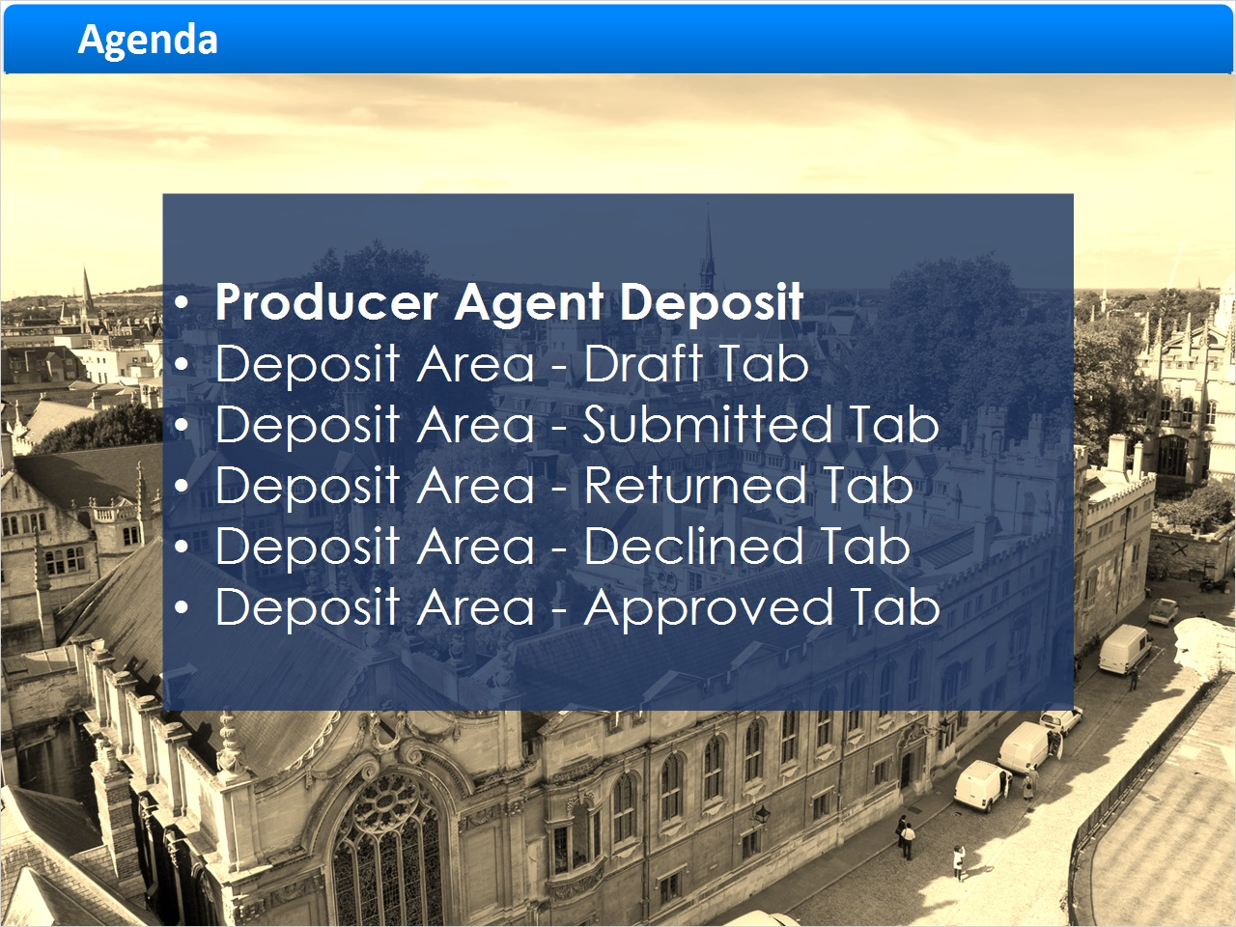
Notes:
Producer Agent Deposit.

1.4 Logging In
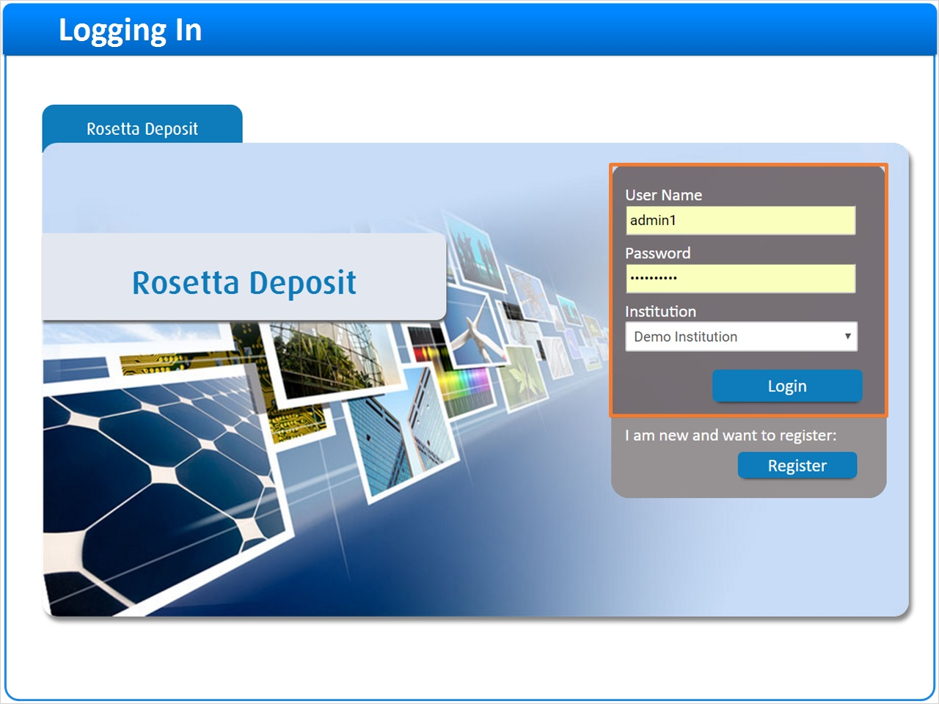
Notes:
In the Producers and Producer Agents session we learned that Producer Agents are individuals who deposit the Producer's content into Rosetta.

Producer Agents might work for one or more Producers and may be an external entity, like a researcher.

Let's see how the Producer Agent deposits content.

Producer Agents can manually deposit content from the Rosetta Deposit Module. To start the deposit, registered Producer Agents must enter their User Name and Password before clicking Login to access the Rosetta Deposit Module.

1.5 My Producers
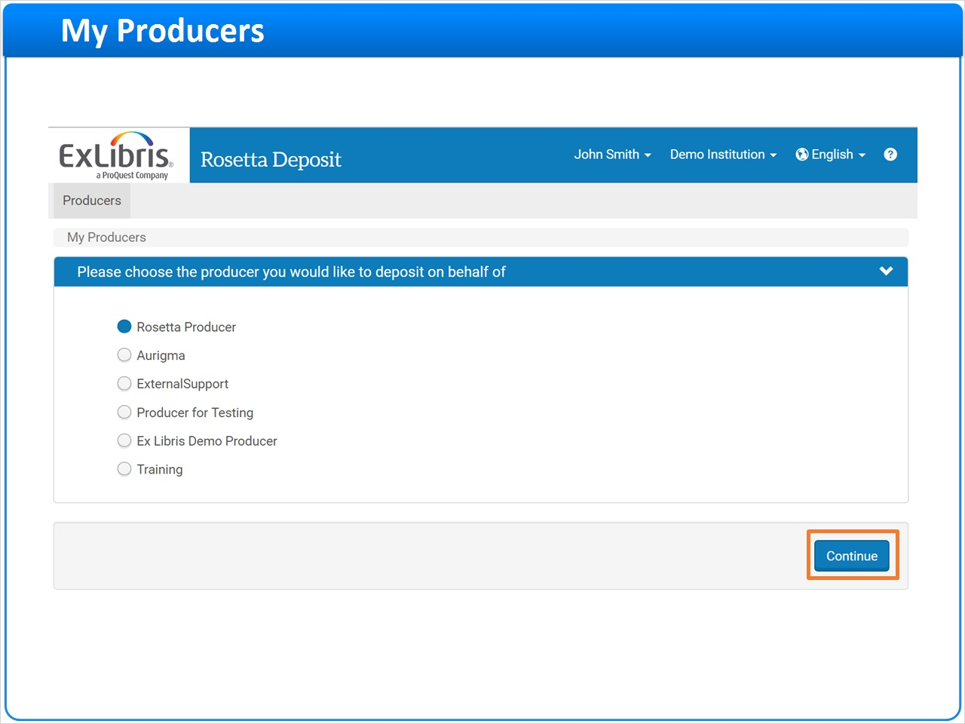
Notes:
After login, Producer Agents go directly to the My Producers list to select the Producer on whose behalf they are depositing content.

Once the Producer is selected, click on the Continue button to advance to the next step in the Deposit wizard.

1.6 Add Deposit Activity
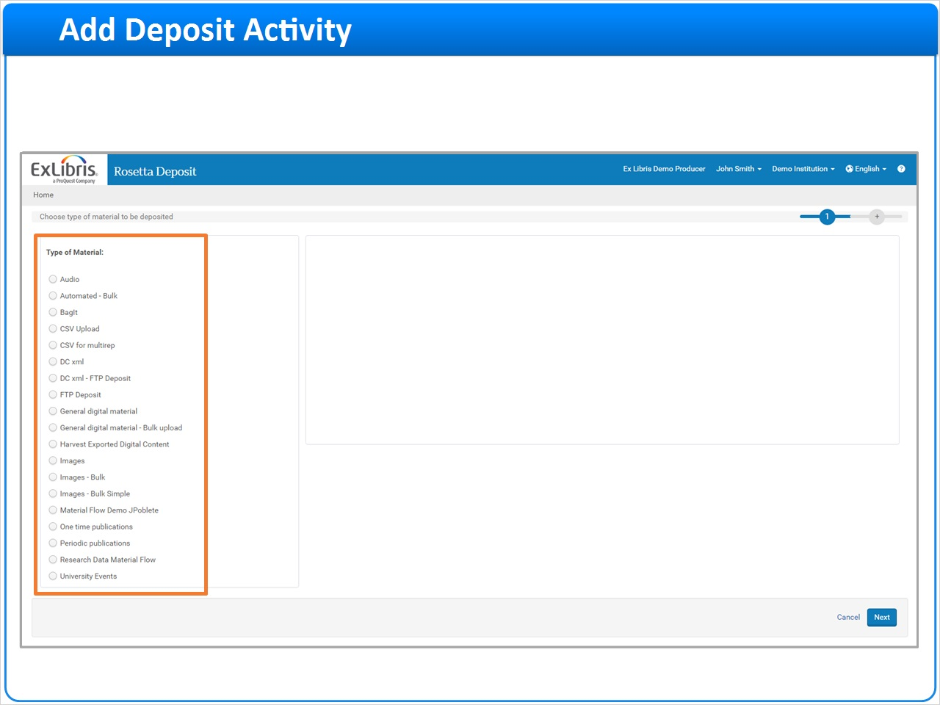
Notes:
This opens the Deposit Activities dashboard displaying the Draft, Submitted, Returned, Declined, and Approved deposit tabs. We will review the tabs later in this session.

To create a new deposit, click the Add Deposit Activity button.
This opens the Deposit wizard to the first step.
Note that the Type of Material templates that display in the wizard refer to Material Flows created in the Rosetta Management Module and covered in depth in the Material Flows training sessions.
The Description/Instructions field describes how and when to use the material flow, insuring that the correct material flows are used to deposit the appropriate content.
Choose the type of material to be deposited in the left pane.

1.7 Deposity Activity Information
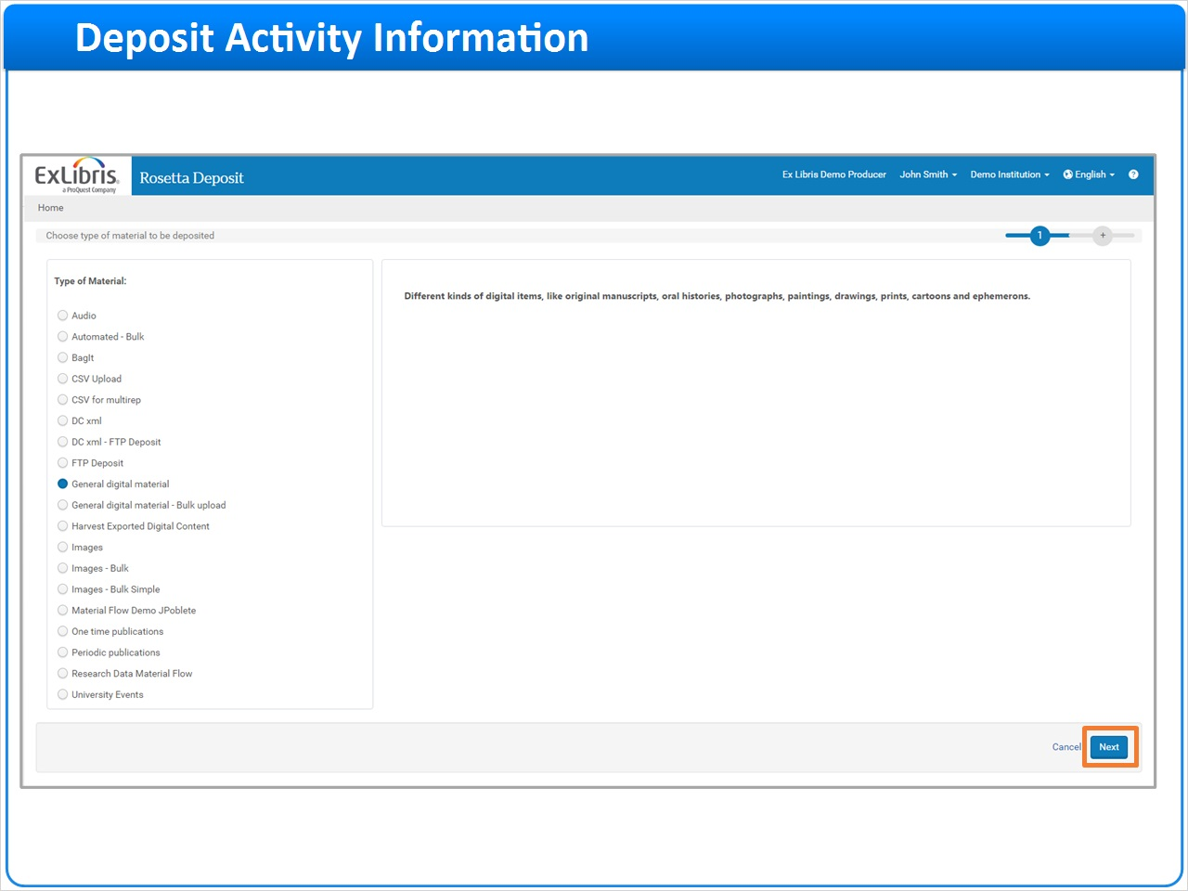
Notes:
The information about the selected material flow is displayed. Click the Next button to advance to the next step in the wizard.

1.8 Descriptive Information
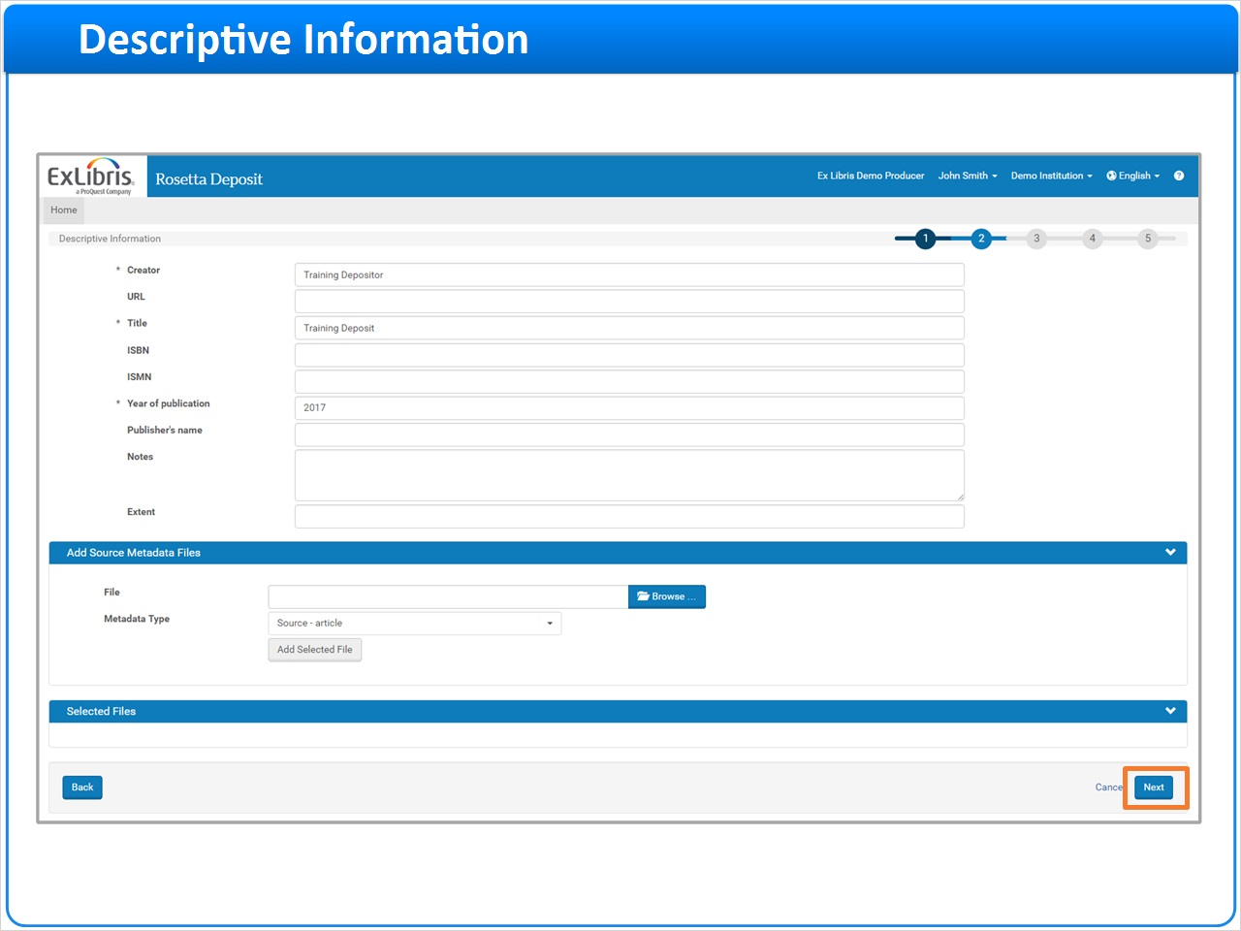
Notes:
Note that the submission format linked to the Material Flow influences the number of steps in the wizard.

For example, if a Manual Material Flow includes a manual submission job, the associated Deposit Wizard will likely be 5 steps.

If a Manual Material Flow includes an automated submission format, the associated Deposit Wizard may only include 2 or 3 steps because the files, and in some cases the descriptive metadata, have already been placed on the server.

In this example we are using a manual submission job, so there will be 5 steps in this Deposit Wizard.

We are on step 2 which refers to the Metadata Form.

In this example, the One Time Publications material flow uses the Metadata Form displayed.

Complete the mandatory fields and click the Next button to continue to step 3.

1.9 Rights and Policies
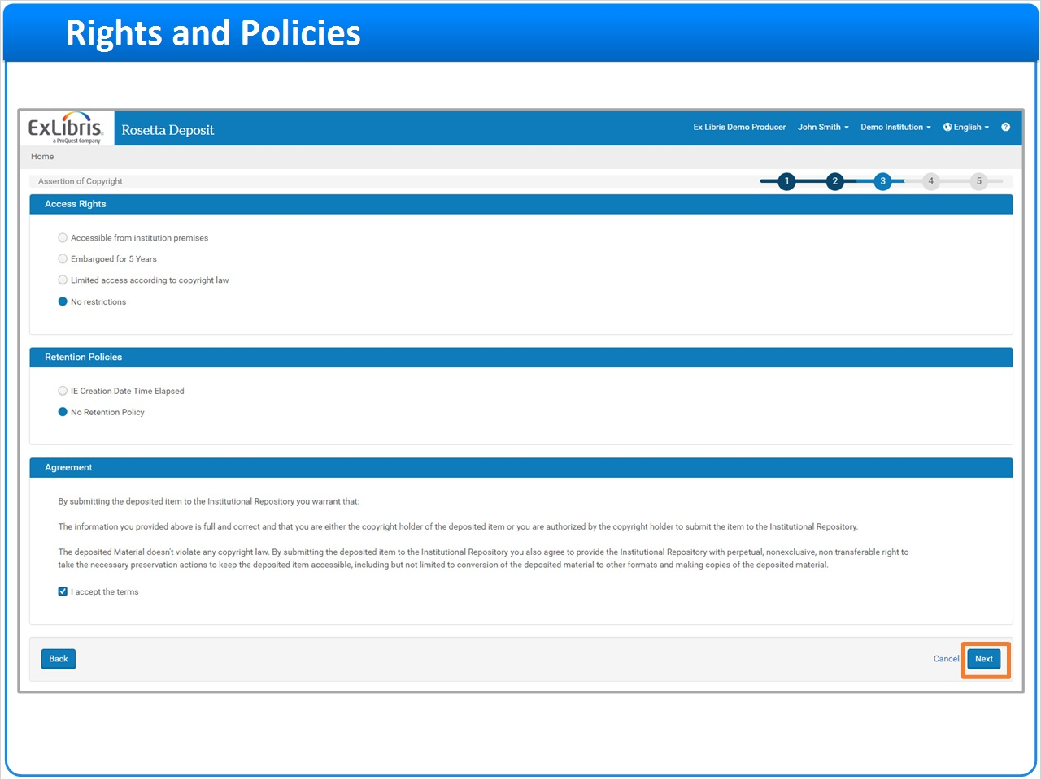
Notes:
Step 3 in the wizard refers to the Access Rights and Retention Periods that are associated with this Material Flow.

In this example, the Producer agent can choose an Access Rights policy, whereas a default Retention Policy has already been assigned.

The Copyright Agreement displays in the bottom portion of the screen. The user must check the checkbox indicating acceptance of the copyright terms. Neglecting to check this box will prompt the message Please accept the Terms of Use to appear at the top of the screen.

Finally, the user must also click the Next button to continue to step 4.

1.10 Upload Files
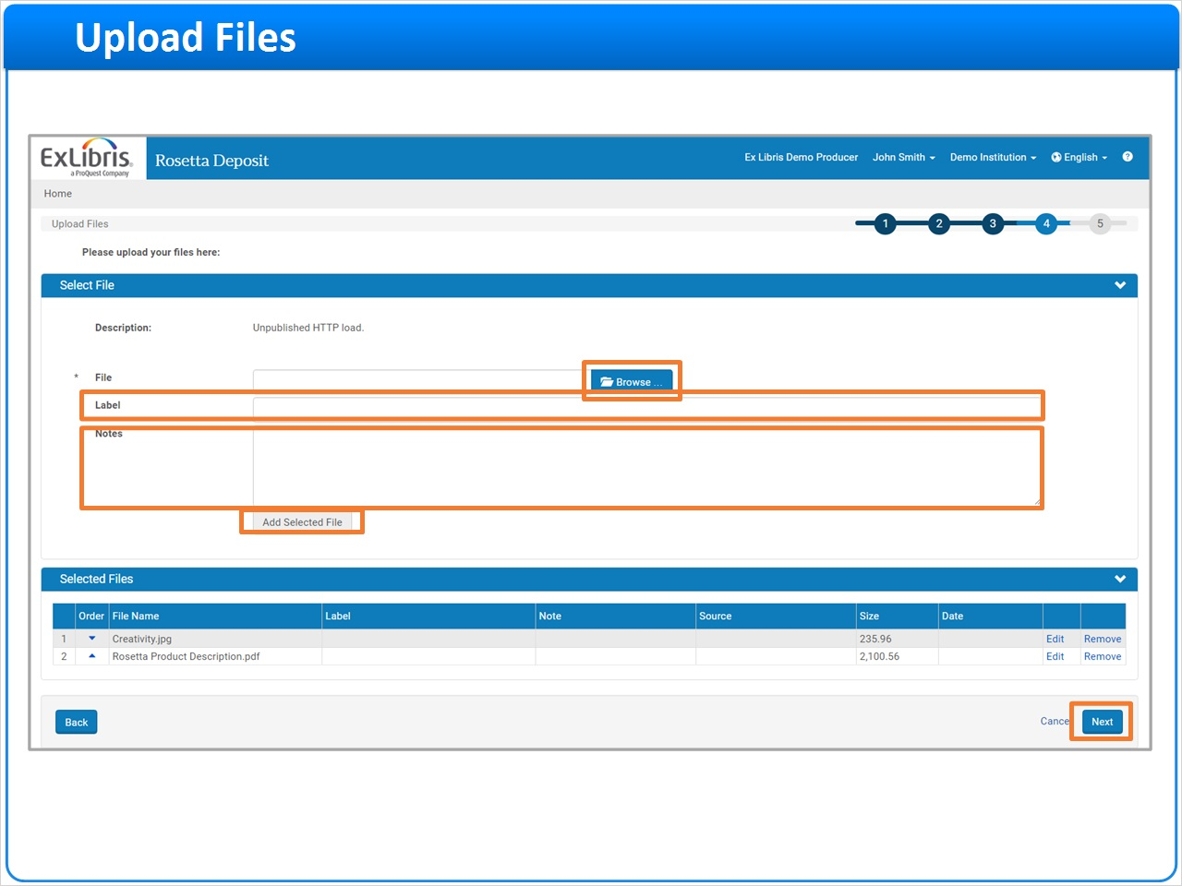
Notes:
Step 4 in the wizard refers to the Submission Formats associated with this Material Flow.
Click the Browse button in the mandatory File field to locate the file to upload for the deposit.
Once the file is selected, click the Add Selected File to link it to the deposit.
You can include an optional Label that will display in the viewer when this content is eventually discovered by content consumers.
Any text you add to the optional Notes field will only display to the Rosetta Staff Assessors and Arrangers.
Once you're made all of your selections click the Next button to continue to step 5.

1.11 Review and Submit
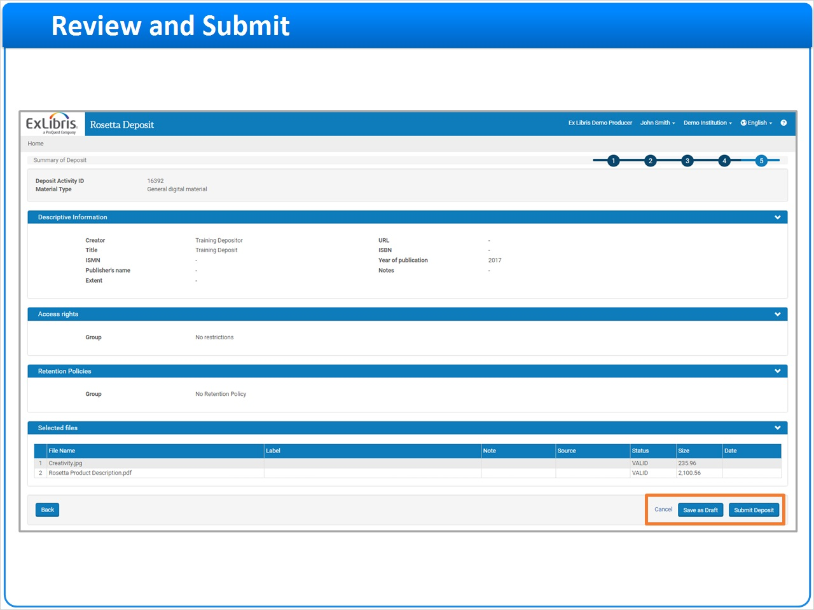
Notes:
Step 5 is the last step in the deposit wizard that displays a summary screen of all selections from steps 1 through 4.
At this point you can review the data before submission and if you need to change anything, click the Back button to return to a specific step for revisions.
Clicking Cancel will cancel and close the deposit wizard.
Click the Save as Draft button to save this submission in your Drafts tab; it will not be submitted for ingest.
You can also click the Submit Deposit button to submit it to Rosetta Assessors and Arrangers for review and ingest.

1.12 Submitted
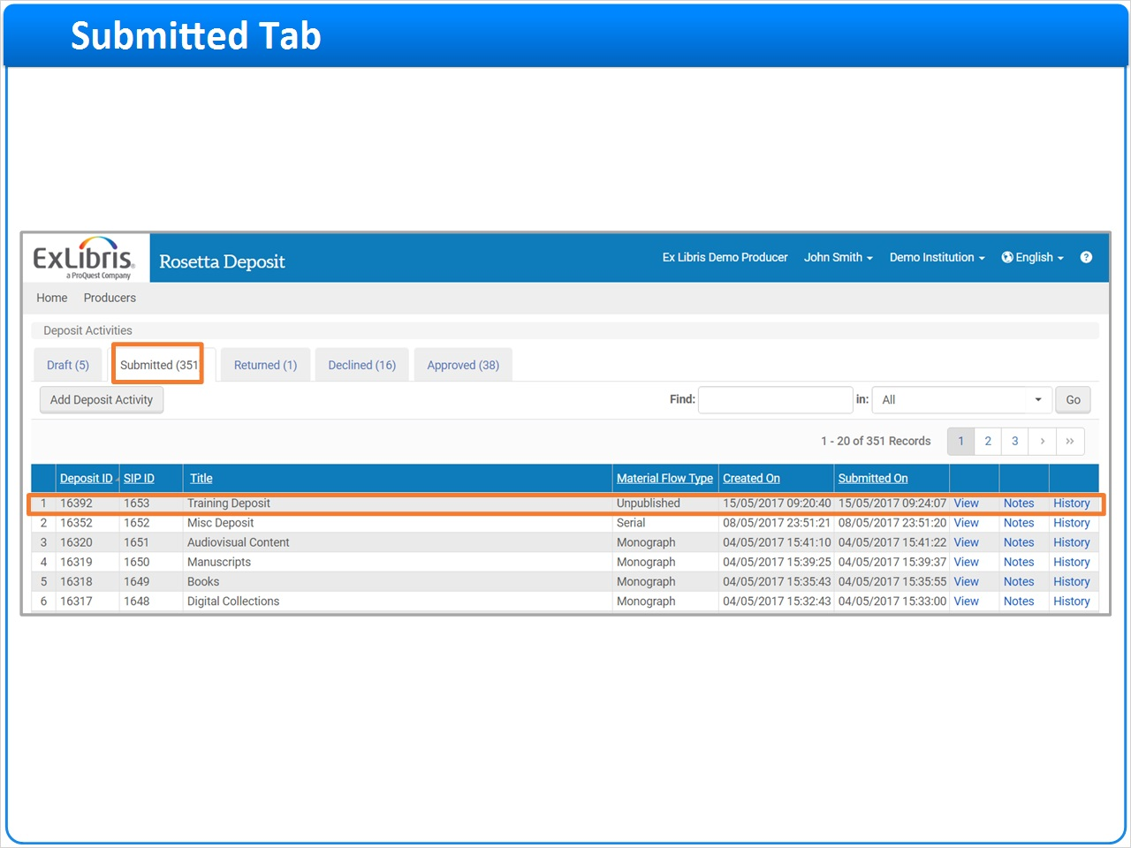
Notes:
Clicking the Submit Deposit button moves your deposit submission to the Submitted tab.
Note that this submission has both a Deposit ID and a SIP ID which are unique numeric identifiers for this submission. These IDs can be used to locate the record in the Rosetta Management Module.

For more information on searching for Submission Information Packages, or SIPs, and other types of Rosetta searches, refer to the Searching in Rosetta session.

1.13 Draft Tab
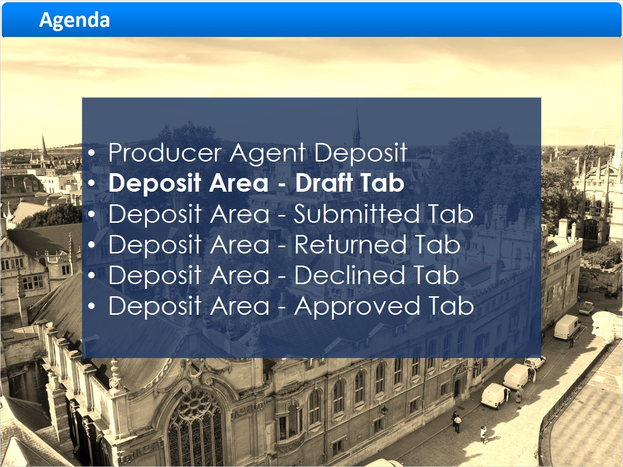
Notes:
Deposit Area - Draft Tab

1.14 Draft Tab
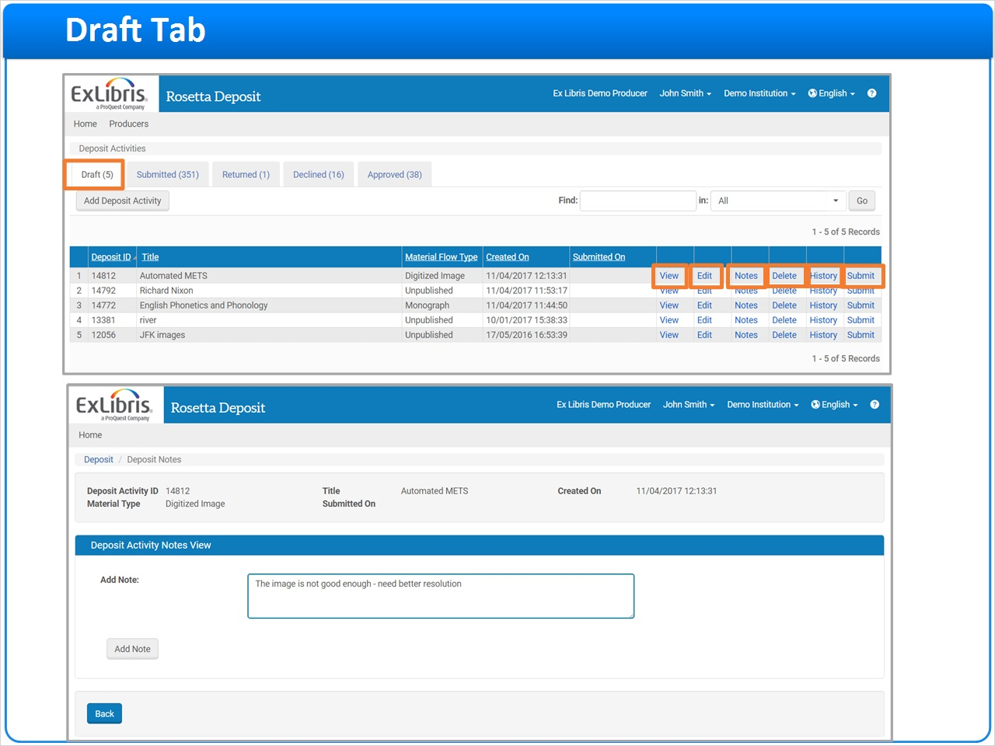
Notes:
Now that the deposit has been submitted and placed in the Submitted tab, let's turn our attention to the functional tabs in the Deposit area, starting with the Draft tab.

The Draft tab contains draft deposits that have not yet been submitted to the Approvers and Arrangers.
From here we can review our draft deposit by clicking the View link.
To make changes to it, click the Edit link.
To delete the draft SIP without submitting it, click Delete. You will be prompted to confirm your deletion and will have the option to cancel if needed.
To see a History of all activities with this Deposit, click the History link.
Since we've just created this deposit and have not yet submitted it, there is no ‘history' for this deposit.
To send the Deposit submission off for review and possible inclusion in the Repository, click Submit.
Clicking Submit moves the Deposit out of the Draft tab and into the Submitted tab.
Finally, to convey any additional information to the Rosetta Approvers and Arrangers who will review this content, you can assign a note to the deposit by clicking the Notes link.
The Deposit Notes screen displays for you to add your note; click the Add Note link the note to the Deposit.
Producer Agents can view notes that are stored in all folders and can add and edit notes that are stored in the Drafts, Submitted, and Returned folders.

1.15 Submitted Tab
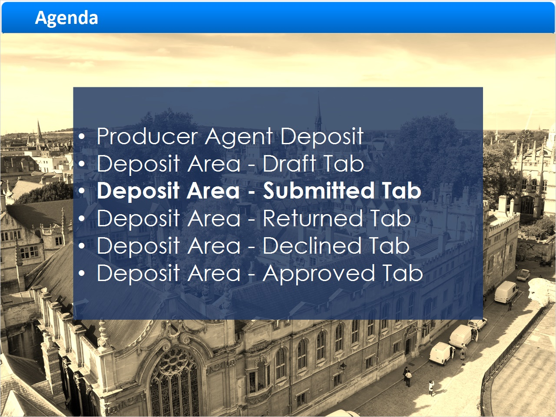
Notes:
Deposit Area - Submitted Tab

1.16 Submitted Tab
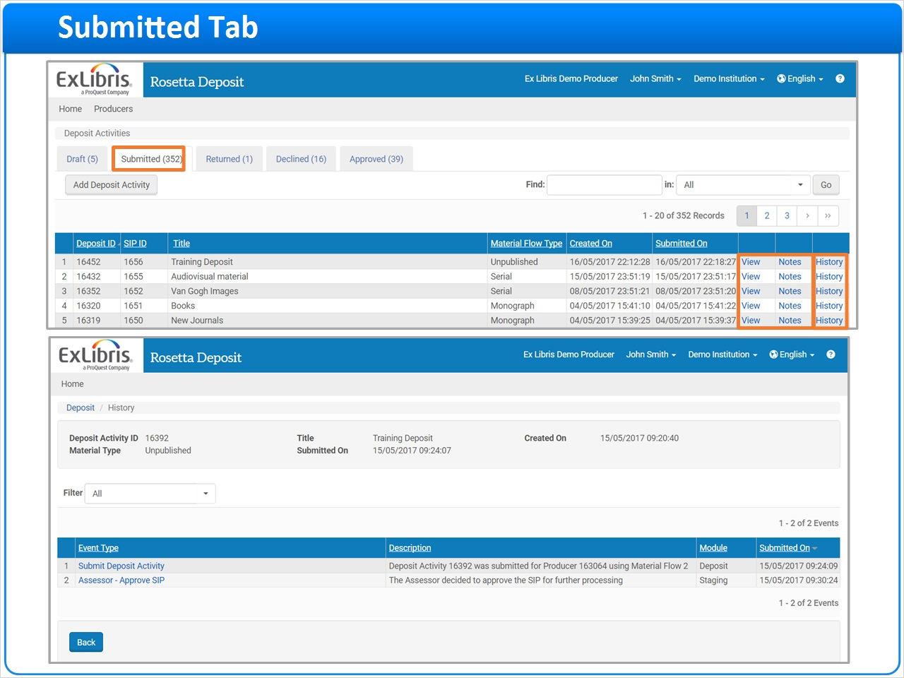
Notes:
Let's review the Submitted tab next.

The Submitted tab contains deposits that have been submitted for ingest into Rosetta.
Unlike the Draft tab, we no longer have the options to delete, edit, or submit the deposit, as it is now in the hands of the Assessors and Approvers.
Like the Draft tab, we still have the View and Notes functions.
To see a History of all activities with this Deposit, click the History link.
Now that the deposit has been submitted, we can see some ‘history' activities.

1.17 Returned Tab
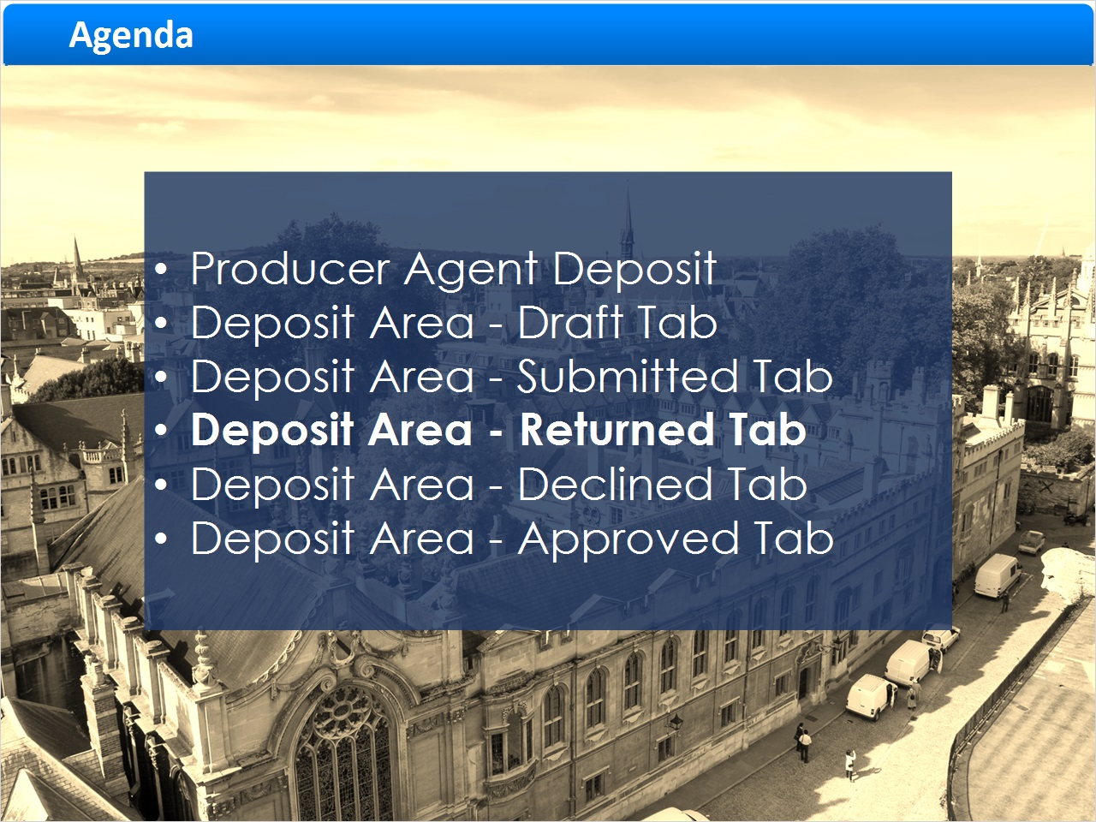
Notes:
Deposit Area - Returned Tab

1.18 Returned Tab
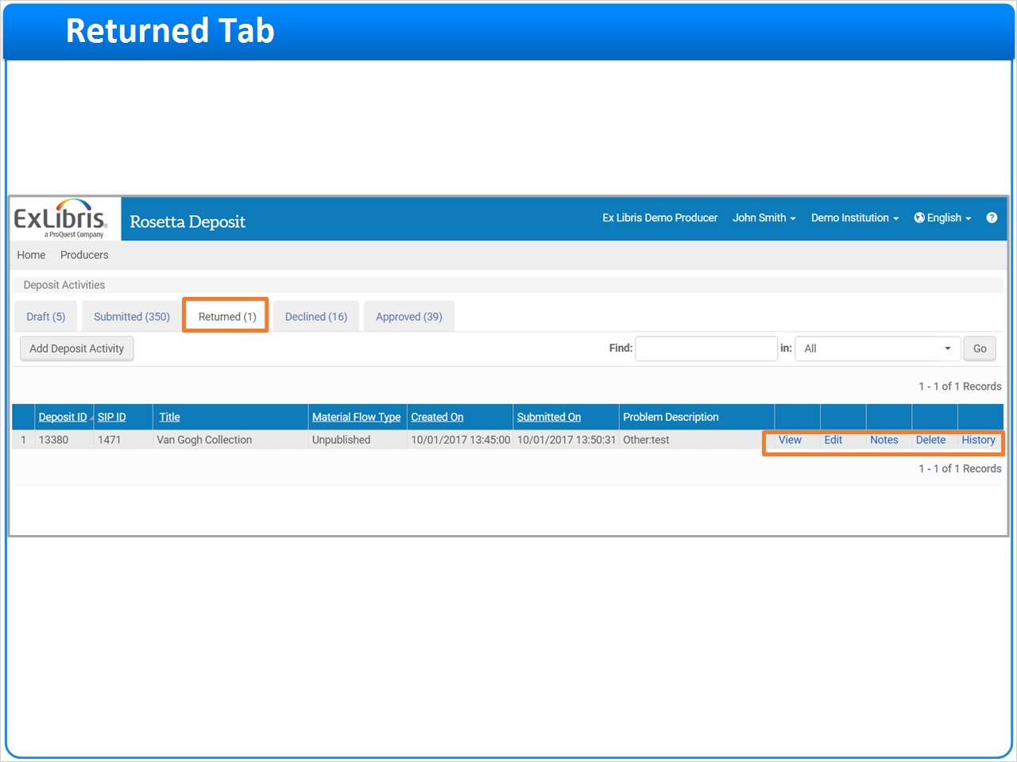
Notes:
When the deposit resided in the Submit tab, the Assessors and Approvers in the Rosetta Management Module could also see and review them.

In this example the Assessors and Approvers reviewed the deposit submission and found a problem with the associated files. They have ‘returned' the deposit to the Producer Agent for correction, and now it appears here in the Returned tab.

The "Returned" tab has the view, edit, notes, delete, and history functions.
In this scenario, . the Producer Agent would click on the Notes link to identify the issues that the Assessors and Approvers had with the content.

1.19 Returned Tab
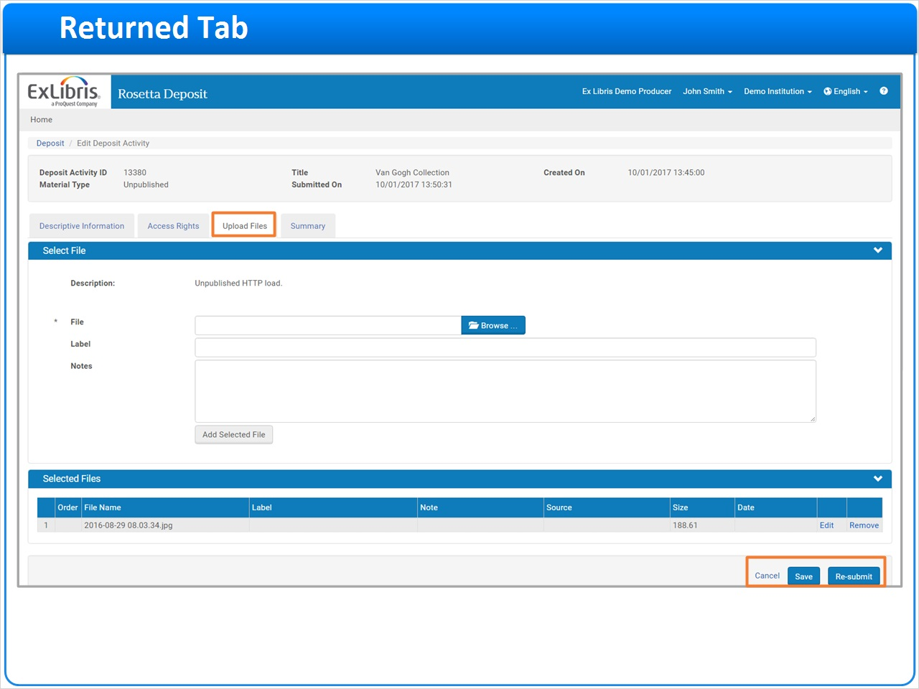
Notes:
Once the Producer Agent has reviewed the Assessors and Approvers comments, they can click on the Edit link to edit the returned submission.
In this example, there was a problem concerning the original files attached to the submission. Once the submission is in edit mode, the Producer Agent can click on the Uploaded files tab to upload a higher resolution file to correct the issue.
When they are done editing they can either click Save to save changes without re-submitting or they can click Re-submit to send the revised submission back to the Assessors and Approvers for further review.

1.20 Declined Tab
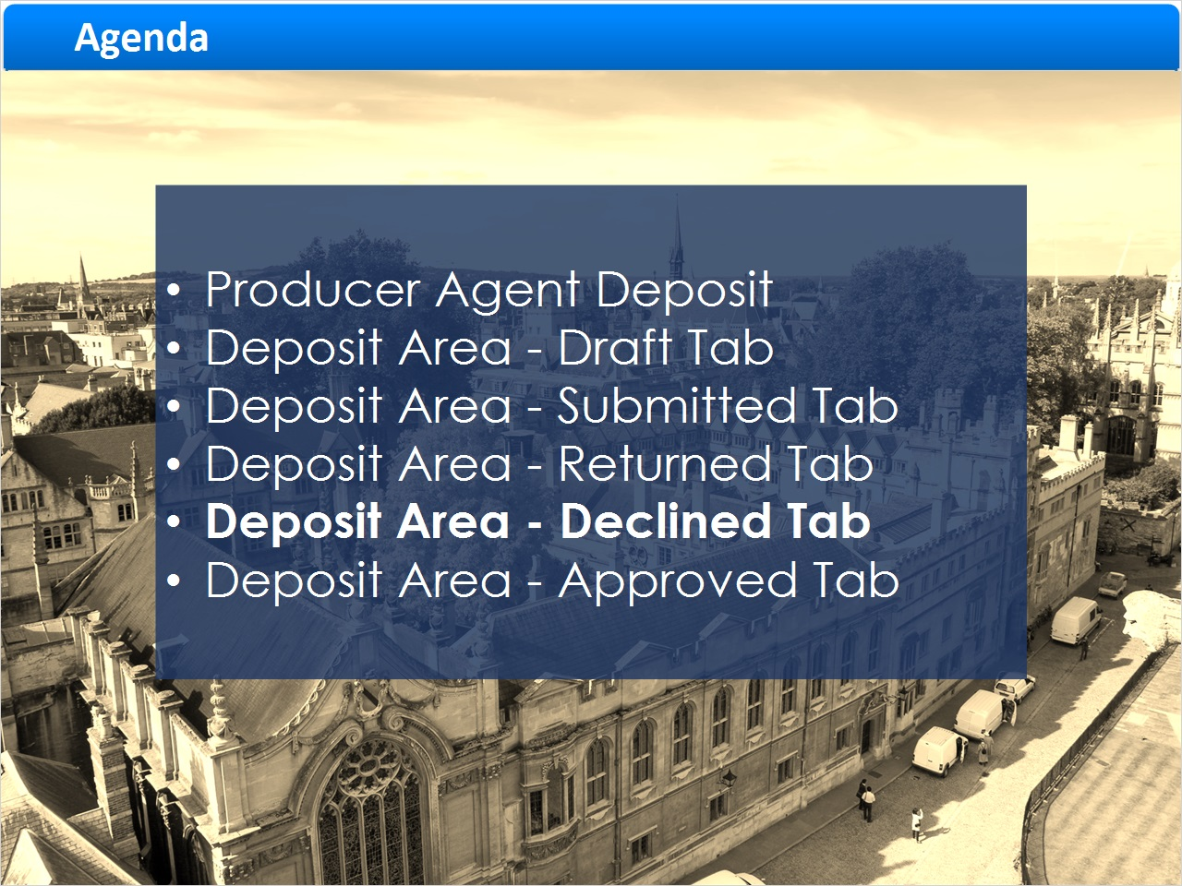
Notes:
Deposit Area - Declined Tab

1.21 Declined Tab
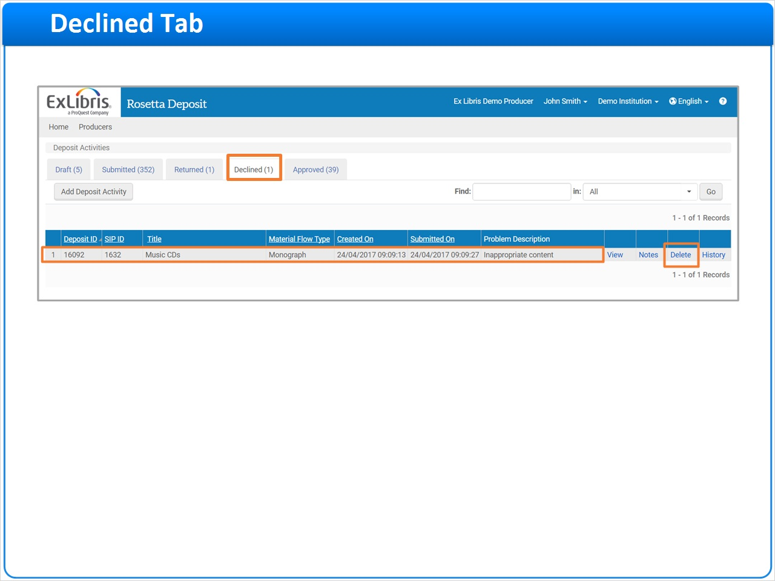
Notes:
Rosetta staff Assessors and Approvers can also Decline submissions.

Declining a Producer Agent's submission means that they cannot resubmit it for any reason.

Declining is often used when the submitted content is not appropriate for the repository or falls outside of the institution's collection policies.
Producer Agents can view declined deposit activities along with the Staff user's notes that explain why the deposit was declined. At this point the only action the Producer Agent can perform is to Delete it.

In this example we see one declined deposit.

1.22 Approved Tab
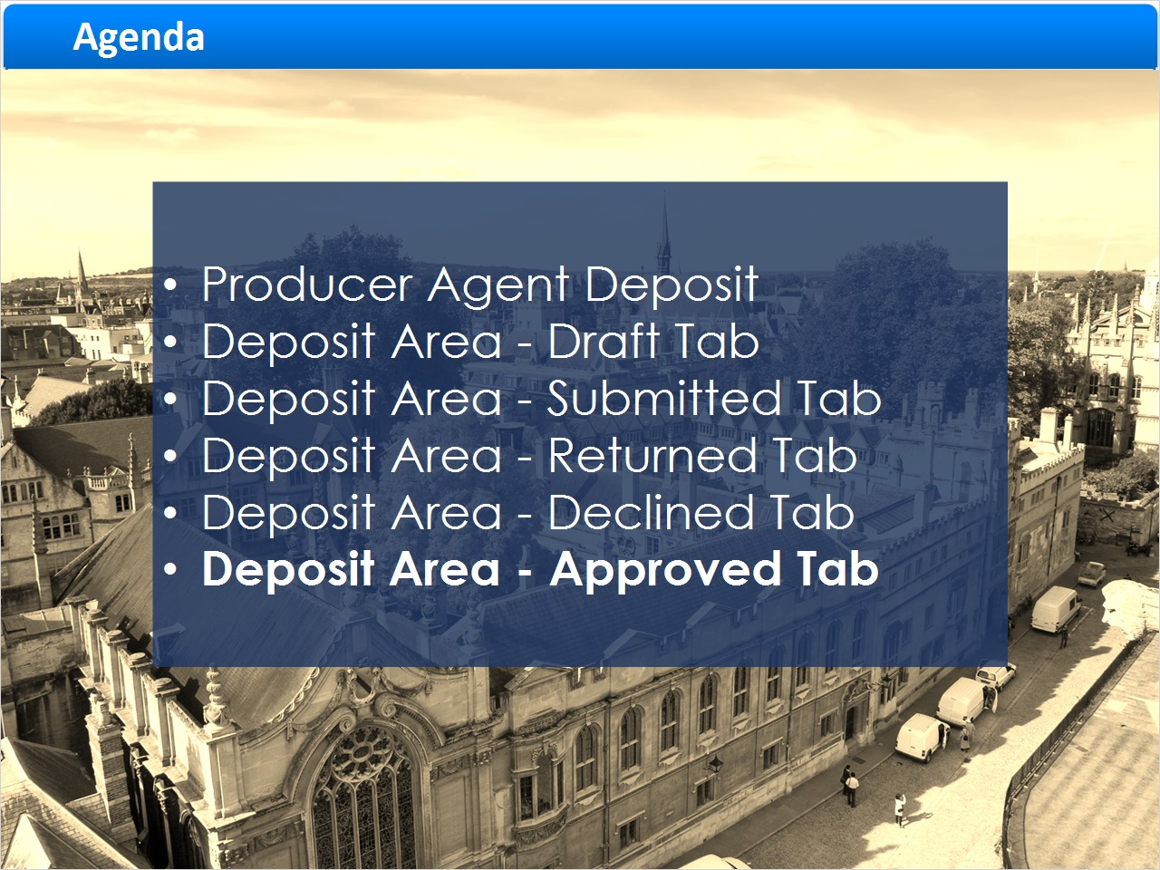
Notes:
Deposit Area - Approved Tab

1.23 Approved Tab
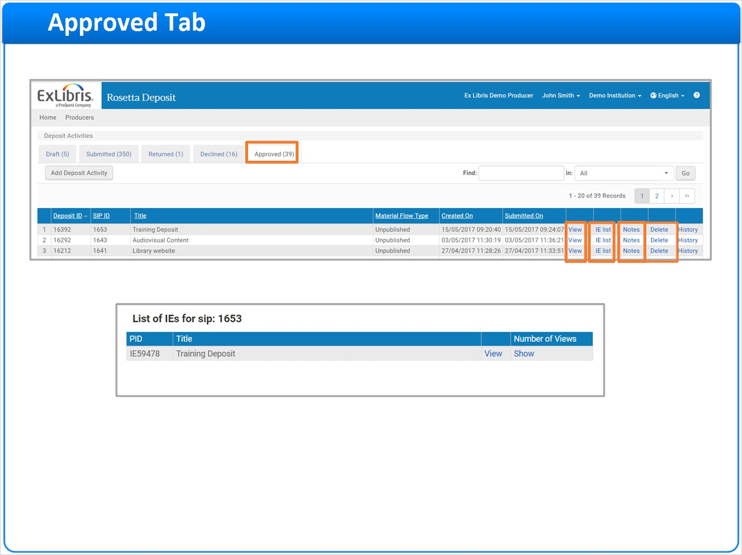
Notes:
The Approved Tab contains deposit activities that have been approved by a Staff user and therefore cannot be edited by the Producer Agent.

Producer Agents can click "View" to see the approved submission.

They can also click on the "IE list" link to view the IEs that were created from the SIP that now reside in Rosetta's permanent repository.

As with many of the other tabs, Producer Agents can also view the associated Notes and the SIPs processing History.
Now that the SIP content is ingested, the Producer Agent can delete the SIP from the Approved Tab.

Note that this action does not affect the newly-created object in Rosetta, it merely removes it from this list in the Approved Tab.

1.24 Session Summary
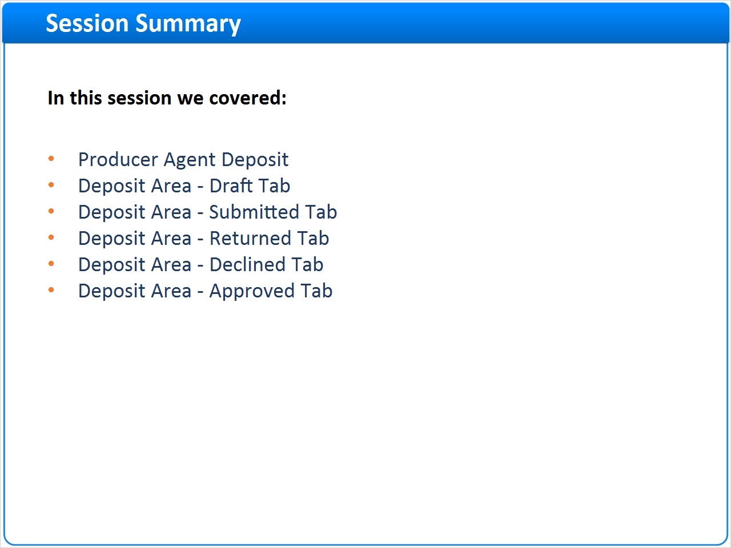
Notes:
In this session we reviewed Producer Agent's manual deposits and the Deposit Activities tabs in the deposit area.
Please take this opportunity to review this information in your new Rosetta environment.
We hope that you've found this information helpful in your understanding of Rosetta.

1.25 Additional Resources

Notes:
Thank you for joining this session!

1.26 About this Training
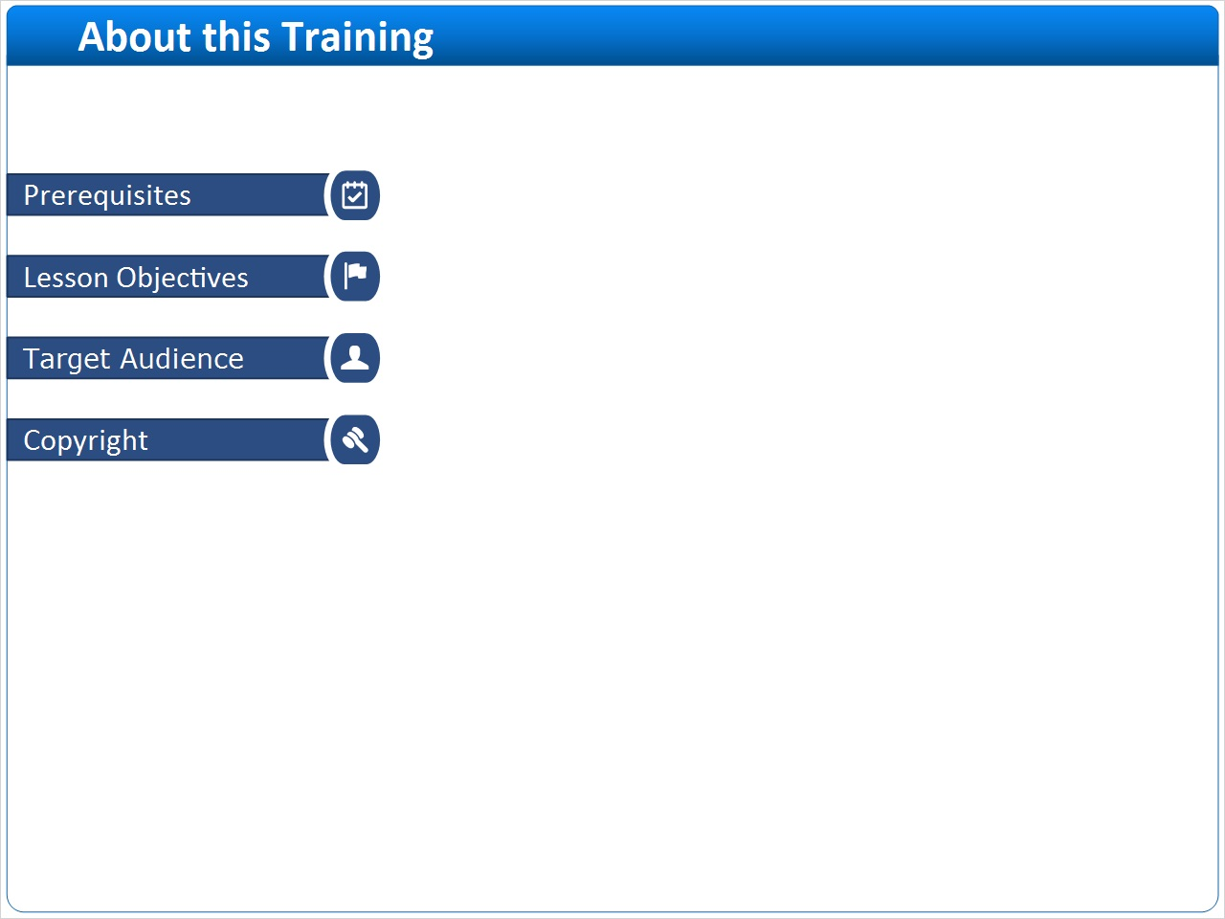
Notes:

1 (Slide Layer)
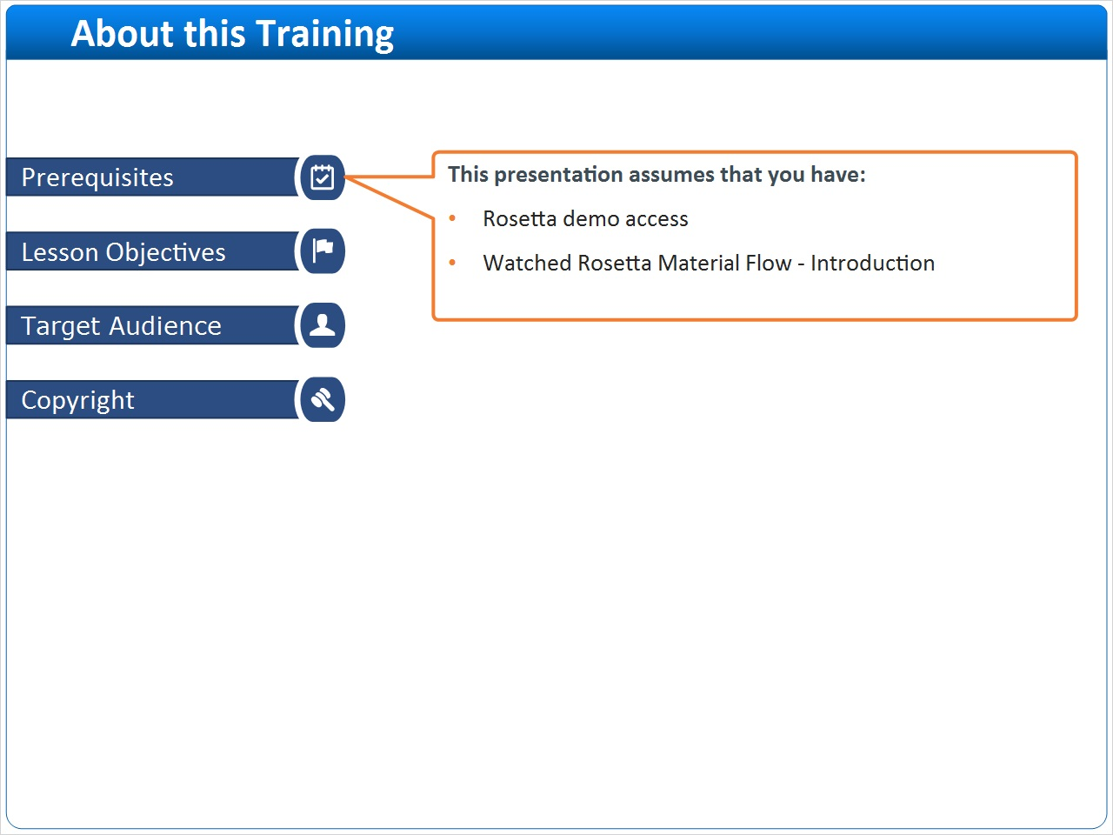

2 (Slide Layer)
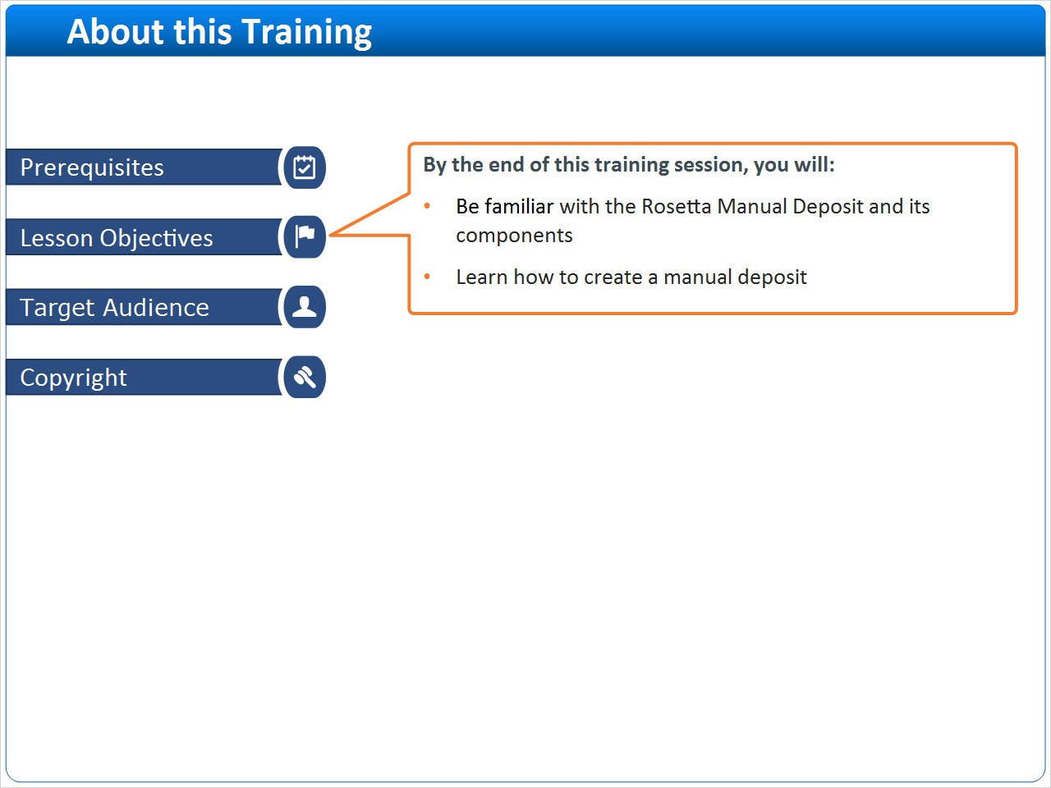

3 (Slide Layer)
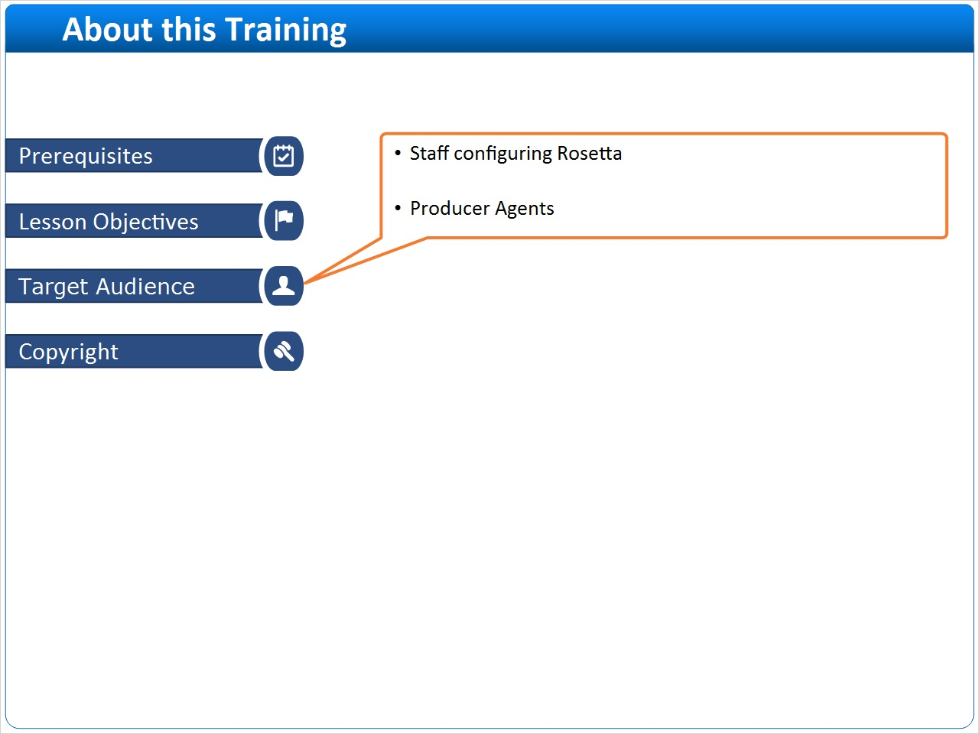

4 (Slide Layer)


