SIP Processing Configuration

1. SIP Processing Configuration

1.1 SIP Processing
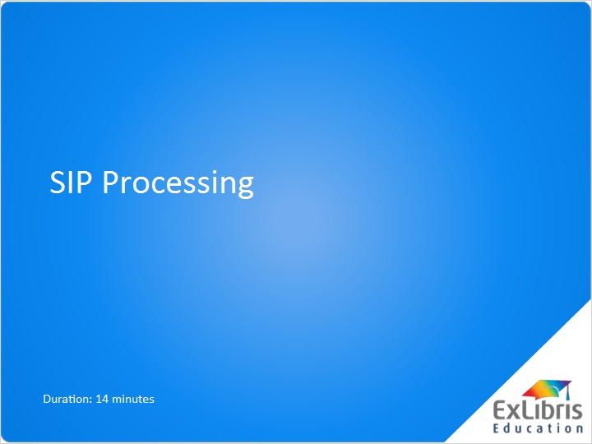
Notes:
Welcome to the Rosetta SIP Processing session.

1.2 Agenda
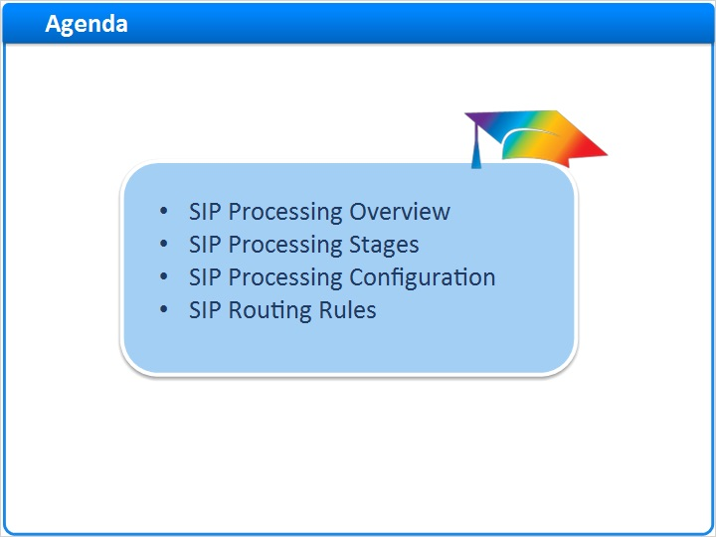
Notes:
In this session, we will address the following topics:
SIP Processing Overview
SIP Processing Stages
SIP Processing Configuration
SIP Routing Rules

1.3 SIP Processing Overview
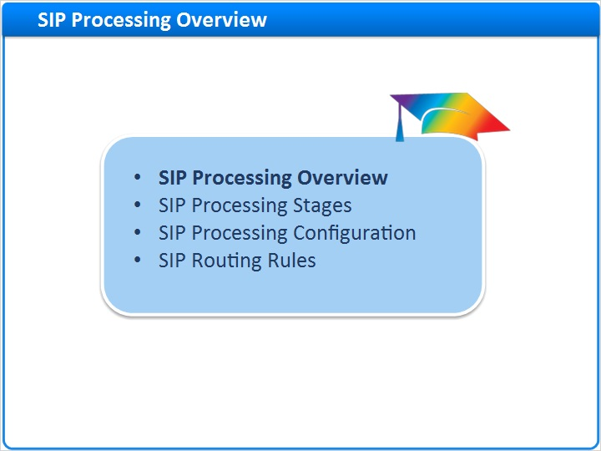
Notes:
SIP Processing Overview

1.4 OAIS Model
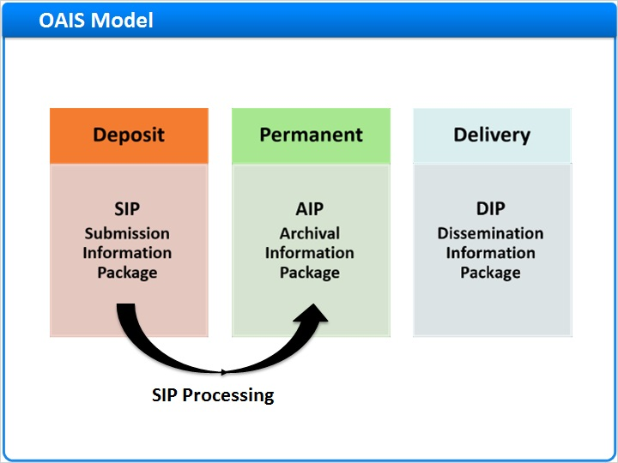
Notes:
Let’s review the OAIS model and see how the SIP Processing is integrated into the Rosetta ingest process.
The OAIS reference model defines three types of information packages that need to be managed by a preservation system.
The SIP, or “Submission information package” refers to the digital object and metadata that was ingested into Rosetta.
The AIP which refers to “Archival information package” represents a set of files and metadata stored in Rosetta’s permanent repository.

The DIP, or “Dissemination Information Package” is the package that Rosetta uses for content delivery.
Rosetta transforms the SIP into an AIP during the SIP processing stage.
SIP processing configurations define how the SIP is processed at each stage.
The SIP processing workflow begins when a SIP is moved from the Deposit Server to the Staging Server, and ends when a SIP is moved from the Staging Server to the Permanent Repository.
At each stage, the Rosetta system performs a series of tasks that we will review in this session.

1.5 Components
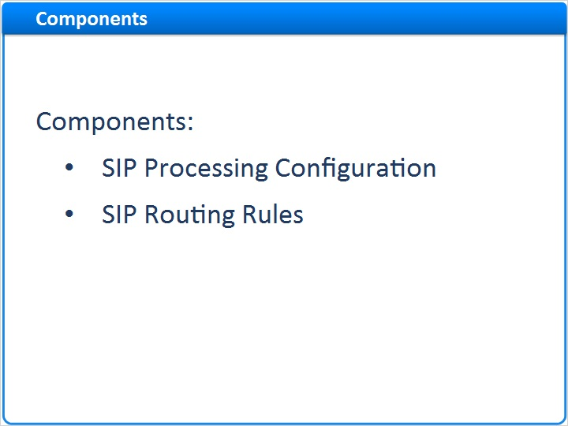
Notes:
Rosetta SIP Processing has two components: SIP Processing Configuration, and SIP Routing Rules.

1.6 SIP Processing Stages
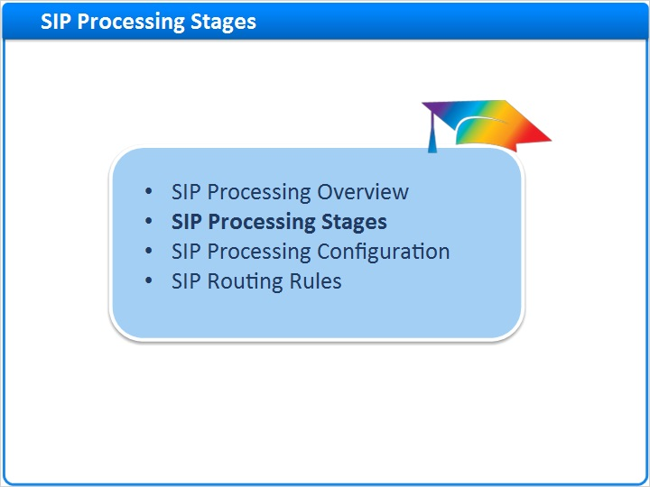
Notes:
SIP Processing Stages

1.7 Overview
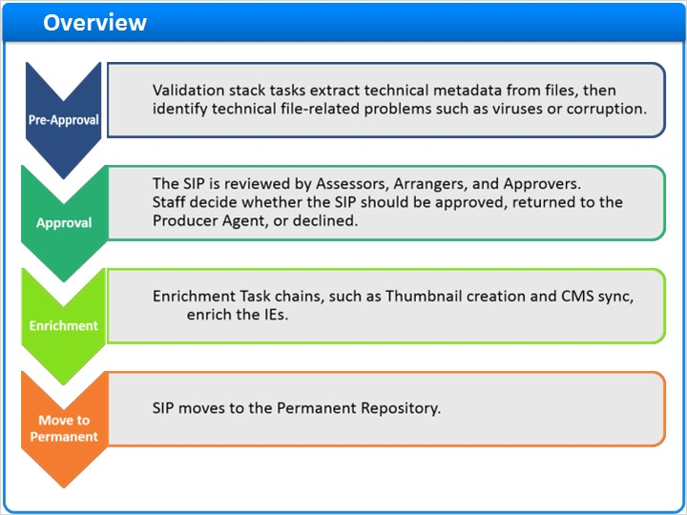
Notes:
Let’s take a closer look at the 4 SIP Processing stages.
SIP processing begins with the Pre-Approval stage.
During this stage, the validation stack tasks run to extract technical metadata, then identify technical file-related problems such as viruses or corruption.
In the Approval stage the SIP is reviewed by Assessors, Arrangers, and Approvers.
Staff decide whether the SIP should be approved, returned to the Producer Agent, or declined.
In the Enrichment stage the Enrichment Task chains, such as Thumbnail creation and Content Management System, or “CMS” sync, are run to enrich the IEs.
During the Move-to-Permanent stage Rosetta moves the IEs to the Permanent Repository.

1.8 Pre-Approval Stage
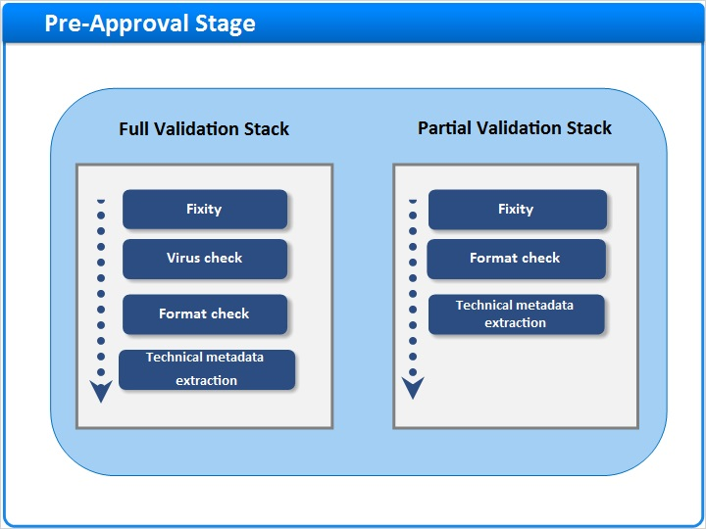
Notes:
As we learned in the “Validation Stack” session, in the Pre-Approval stage, the Validation stack task chains are run on all files.
Validation stack task chains can be fully customized to include or exclude certain tasks.
In this example, we can run a full or partial validation stack task chain.
The difference between these two task chains is that the virus check was eliminated from the Partial Validation Stack.

1.9 Approval Stage
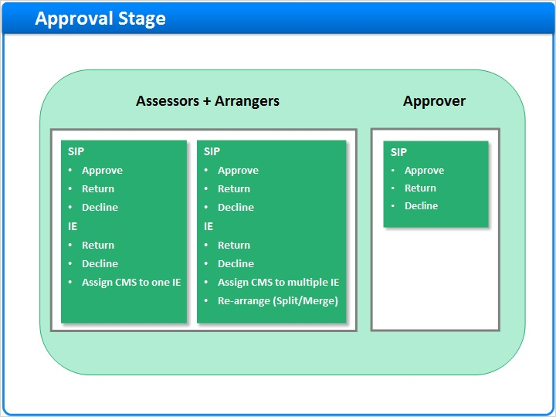
Notes:
During the approval stage you can determine whether the SIP will be reviewed by the Assessor and the Arranger or by the Approver.

Each has different permissions and can perform different actions on the SIP and the IEs.
If you indicate that the SIP will be reviewed by the “Approver” the IE will bypass the Assessor and Arranger. If the “Sampling Rate” in the Material Flow is less than 100%, the SIP can go directly into the Permanent repository with no further action.
This option helps to automate bulk ingests and streamline the processing of several SIPs at once.

1.10 Enrichment Stage
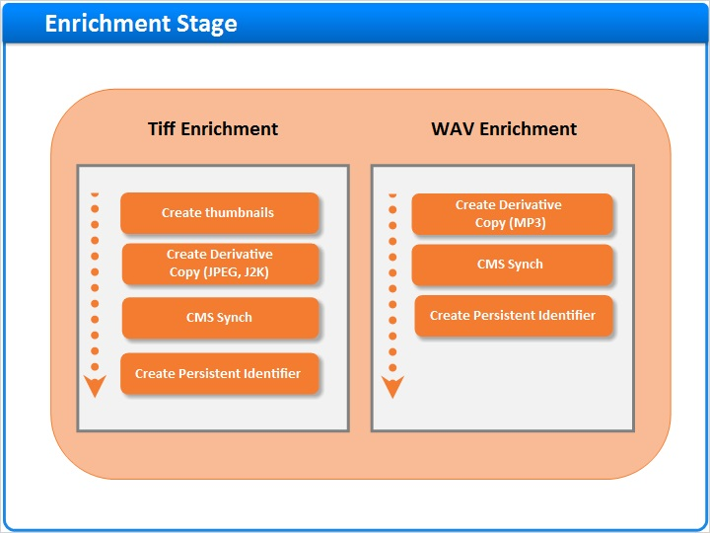
Notes:
Here are two examples of Enrichment stage task chains which are configured according to the files they process.

Both task chains will “Create a Persistent ID” and synchronize with a Content Management System.

The Tiff Enrichment version of this task chain will also create thumbnails and a lower resolution derivative copy, such as a JPEG2000 file. This derivative copy can be delivered over http more easily than the original Tiff.
The WAV file will also get a derivative, but this will be an MP3, which will be easier to deliver as well.

After this stage the IEs are moved to the Permanent Repository.

1.11 SIP Processing Configuration
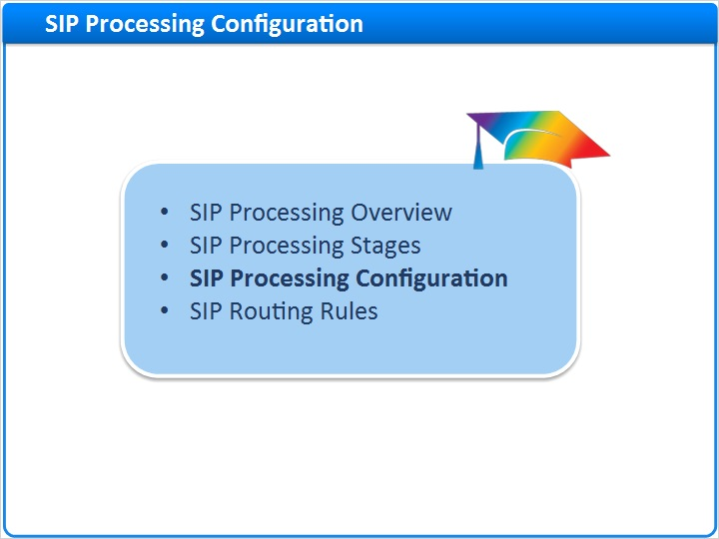
Notes:
SIP Processing Configuration

1.12 SIP Processing Configuration List
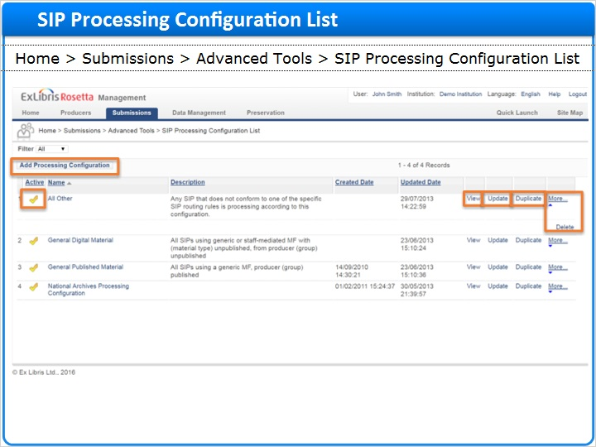
Notes:
The SIP processing configuration determines how the SIP is processed at each stage.
Deposit Managers define and customize these settings from the SIP Processing Configuration List page.
To access the SIP Processing Configuration page, go to HOME > Submissions > Advanced Tools > SIP Processing Configuration List.
To Add a new configuration click on “Add Processing Configuration”
To enable or disable a configuration click on the gold checkmark icon in the “Active” column.
To view an existing configuration without making updates click “View”.
To update an existing configuration click “Update”.
To duplicate an existing configuration as a template for creating a new one, click “Duplicate”.
Duplicating can reduce redundancy as well as preserve consistency across SIP Processing Configurations.
It is often easier to duplicate and modify an existing configuration than to create a new one.
To delete a configuration click “More” to expand the menu and then “Delete”.

1.13 SIP Processing Configuration
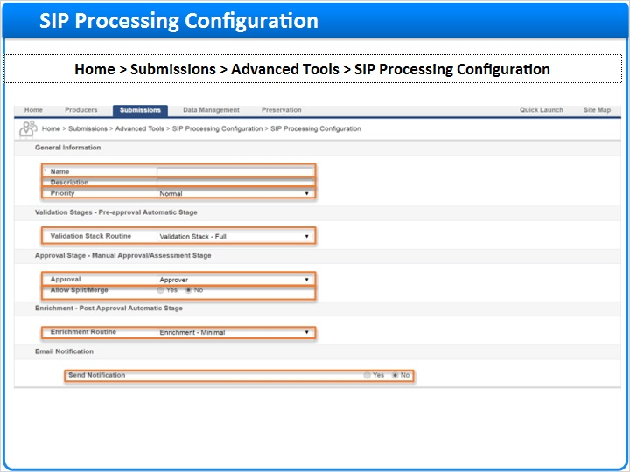
Notes:
After clicking on “Add Processing Configuration” the editor page opens.
The field names preceded with an asterisk (*) are mandatory.
Enter the “Name” of the SIP processing configuration.
Then enter a “Description”; this might be an explanation of when and where this configuration should be used.
As of version 5.1 there is an option to add a “Priority” to the SIP.
The default priority and best practice is “Normal”.
If you would prefer that the SIP be processed ahead of the queue you can set the priority to “High”.
If the SIP is a lower priority, selecting “Low” places it at the end of the processing queue.
Select the appropriate “Validation Stack Routine” from the pull-down list. This is applied when the SIP enters the validation stage.
Select the appropriate “Approval” method from the pull-down list.
Remember - if “Approver” is selected the IE will bypass the Assessor and Arranger and if the “Sampling Rate” in the Material Flow is less than 100%, the SIP can go directly into the Permanent repository with no further action.
If “Assessor + Arranger” is selected the SIP will be flagged for manual assessment under Home > Submissions > Approval > Assessor SIPs List.
Selecting “Yes” for “Allow Split/Merge” allows the Arranger to either divide a single IE into two separate ones or to merge two separate IEs into a single one.
Selecting “No” for “Allow Split/Merge” will NOT allow the Arranger to split or merge the IEs.
Select the appropriate “Enrichment Routine”. This is the routine that gets executed when the SIP enters the enrichment stage.
Selecting “Yes” for the “Email Notification” will send an email to the Producer Agent, notifying them of the deposit.

1.14 SIP Processing Configuration
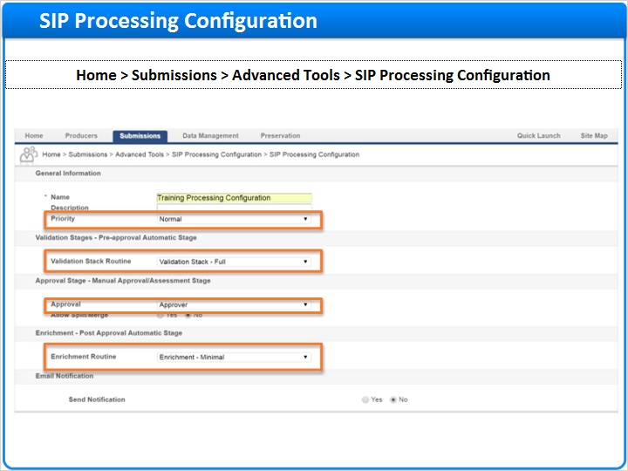
Notes:
In this example of a SIP Processing Configuration the ‘Priority’ is set to “Normal”.
The “Validation Stack - Full” is selected , which means that it will include Thumbnail and Derivative Copy creation, CMS Sync, and Persistent ID creation tasks.
The “Approver” Approval stage is selected , which means that the IE will bypass the Assessors and Arrangers if the Material Flow’s “Sampling Rate” is below 100%.
Finally the “Enrichment - Minimal” Enrichment Routine will be applied to this SIP.

1.15 SIP Routing Rules
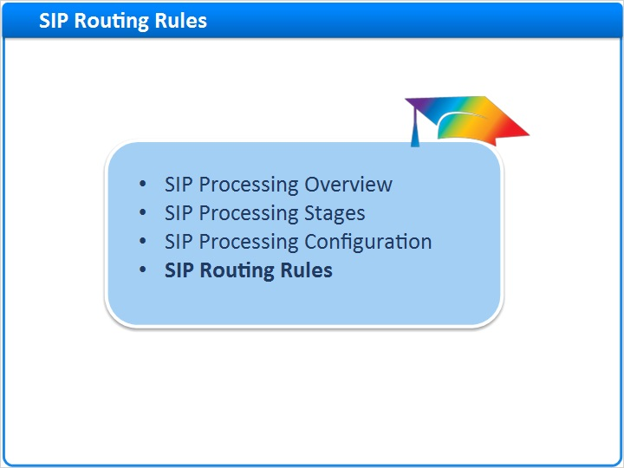
Notes:
SIP Routing Rules

1.16 Rules List
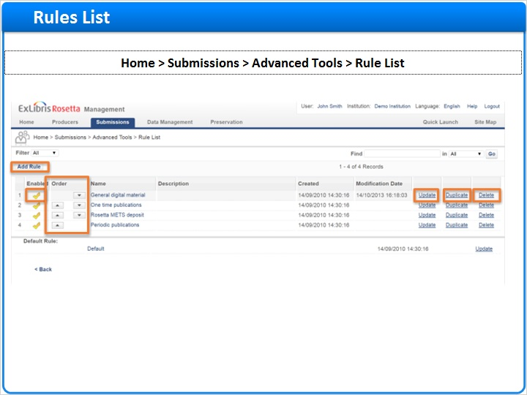
Notes:
SIP Routing Rules determine which Processing Configurations get used when SIPs are loaded into Rosetta.
Deposit Managers can define SIP Routing Rules by going to Home > Submissions > Advanced Tools > SIP Routing Rules.
To Add a new SIP Routing rule click “Add Rule”.
To enable or disable a SIP Routing Rule click on the gold checkmark icon in the ‘Enabled’ column.
To update an existing SIP Routing Rule click “Update”.
To duplicate an existing SIP Routing Rule to use it as a template for a new rule, click “Duplicate”.
Duplicating can reduce redundancy as well as to preserve consistency across SIP Routing Rules.
It is sometimes faster to duplicate and modify an existing SIP Routing Rule than it is to create a new one.
To delete a SIP Routing rule click “Delete”.
Note that the “Order” column allows you to order the list of SIP Routing Rules.
Rosetta reads this list from top to the bottom, so we recommend that you place the rules with the most specific criteria at the top of the list and the rules that are more general at the bottom.
The rule’s criteria are defined in the SIP Routing Rule’s ‘input’ and output’ parameters. We’ll see that next.

1.17 Adding a new rule – Rules Details
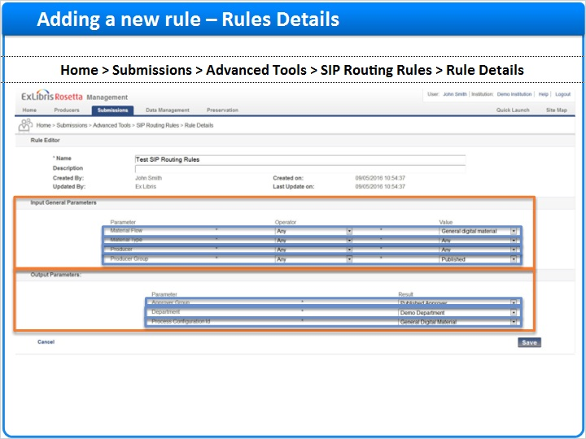
Notes:
The SIP Routing Rules define the circumstances under which the SIP Processing Configuration will be applied.
After the Deposit Manager clicks “Add Rule” the Rule Details page opens.
There are 2 main sections of this page:
- The “Input Parameters” section defines the parameters that the SIP needs to have before the configuration is applied.
- The “Output Parameters” section defines the Output, or result parameters.
Note that all Input and Output options are pre-defined and the logical relationship between them is ’AND’; meaning, “these input parameters AND these output parameters will be applied to the SIP”.
In the “Input Parameters” section you can assign the SIP to the set of Routing Rules based on:
The Material flow used to ingest the SIP
The SIP’s Material type
A specific Producer group that this SIP is assigned to
and a specific Producer that this SIP is assigned to
In the “Output Parameters” section you can assign this SIP to display statistical and reporting information based on:
Which Approval group the SIP belongs to
Which Department the SIP belongs to
The “Processing Configuration ID” which is a pull-down menu listing all available SIP Processing Configurations.
Choose the appropriate configuration in order to link the SIP Routing Rule to the appropriate SIP Processing Configuration.
Let’s take a look at an example configuration to see how all the pieces fit together.

1.18 Adding a new rule – Input General Parameters
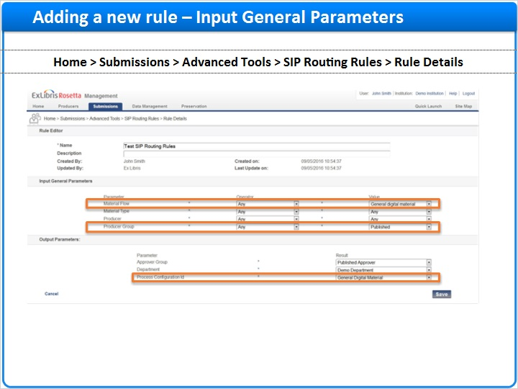
Notes:
In this SIP Routing Rule example, if you choose the “General digital material” Material flow AND the “Published” Producer Group as input parameters, ONLY SIPs that have those parameters will get processed according to the linked “Processing Configuration”, in this case “General Digital Material”.

1.19 Adding a new rule – SIP Processing Configuration
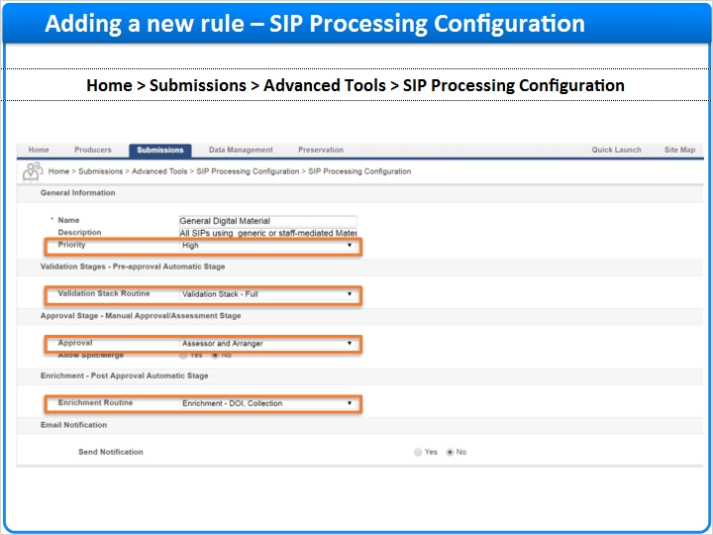
Notes:
Let’s go back to Home > Submissions > Advanced Tools > SIP Processing Configuration
We can see that the “General Digital Material” SIP Processing Configuration includes the following parameters:
The Priority is “High”
It will use the “Validation Stack - FULL” routine
and since the “Assessor and Arranger” is selected in the “Approval” field, the SIP will be flagged for manual assessment under Home > Submissions > Approval > Assessor SIPs List .
And the “Enrichment - DOI, Collection” routine will be applied to the SIP .

1.20 Adding a new rule – Output Parameters
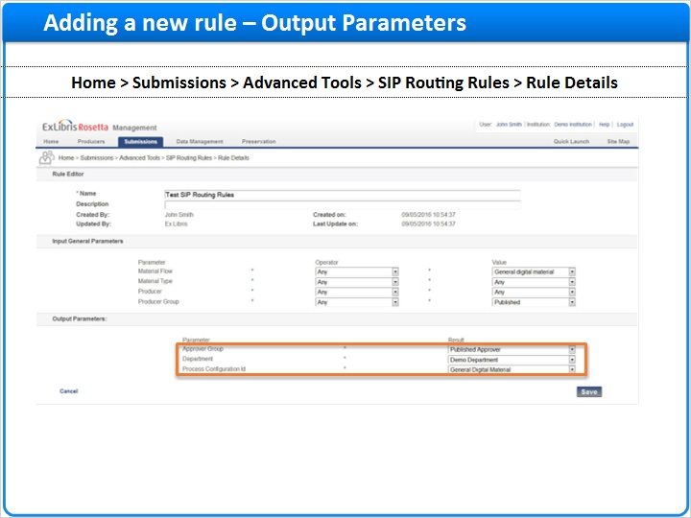
Notes:
If the SIP meets these input parameters, the following “Output Parameters” will be applied.

First, the SIP will be assigned to the “Published Approver” Approval Group AND the “Demo” Department, and then the SIP will be assigned a “General Digital Material” Process Configuration ID

1.21 Session Review
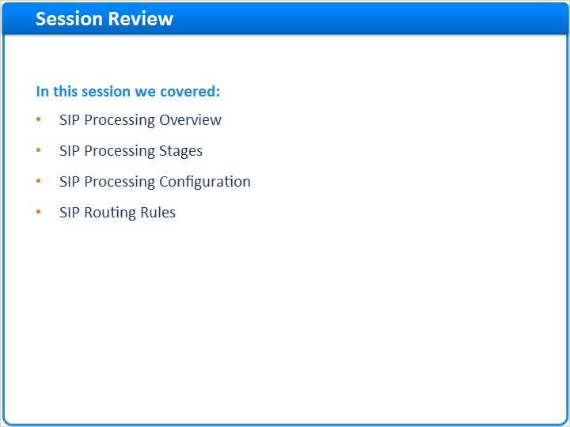
Notes:
In this session we learned about SIP processing, and the stages involved in the process. We also learned how to define the SIP Processing Configuration and how to link it with the appropriate SIP Routing Rules.

Please take this opportunity to review this information in your new Rosetta environment.
We hope that you’ve found this information helpful to your understanding of Rosetta.

1.22 Additional Resources

Notes:
Thank you for joining this session!

1.23 About this Training
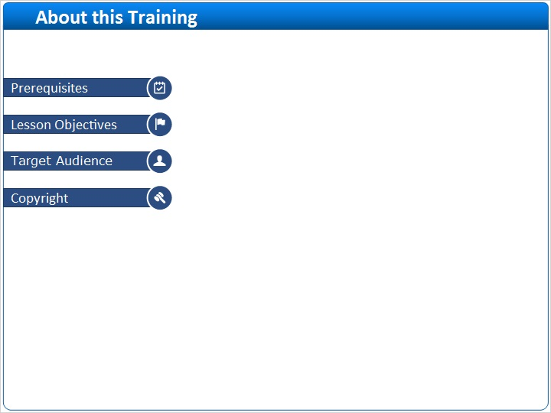
Notes:

1 (Slide Layer)
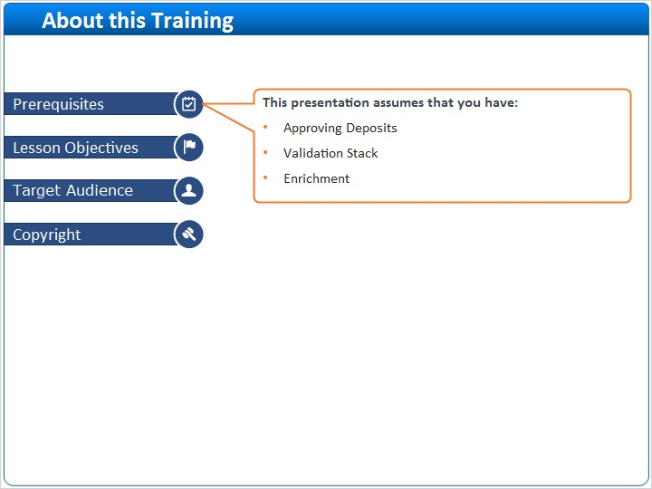

2 (Slide Layer)
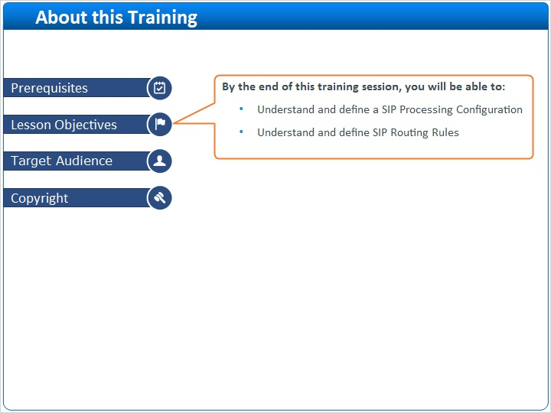

3 (Slide Layer)
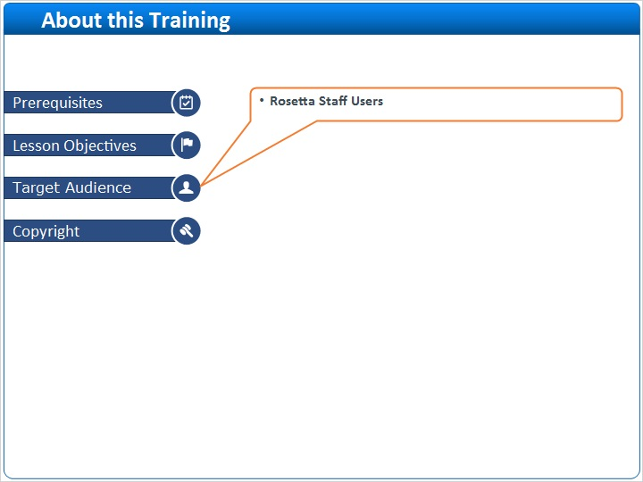

4 (Slide Layer)


