Managing Producers and Producer Agents

1. Managing Producers and Producer Agents

1.1 Welcome

Notes:
Welcome to the Producers and Producer Agents session.

1.2 Agenda
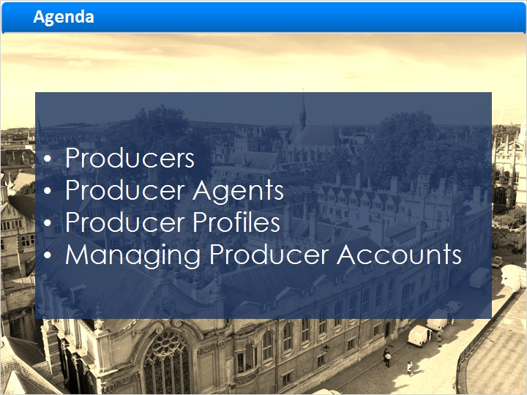
Notes:
In this session we will discuss the Producer and Producer Agent roles, how the Producer Profiles enable personalization, and how to manage Producer accounts.

1.3 Producers
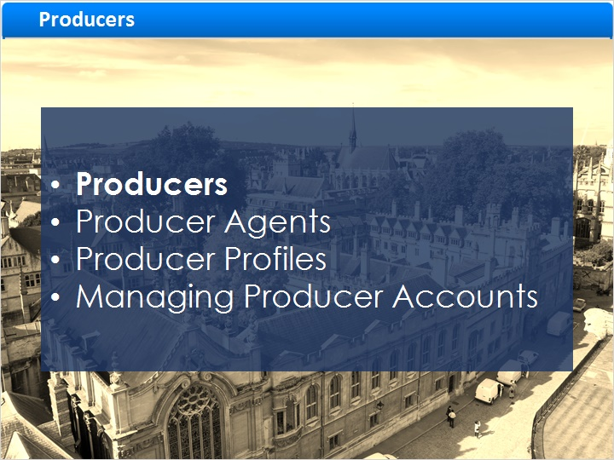
Notes:
Producers

1.4 Producers
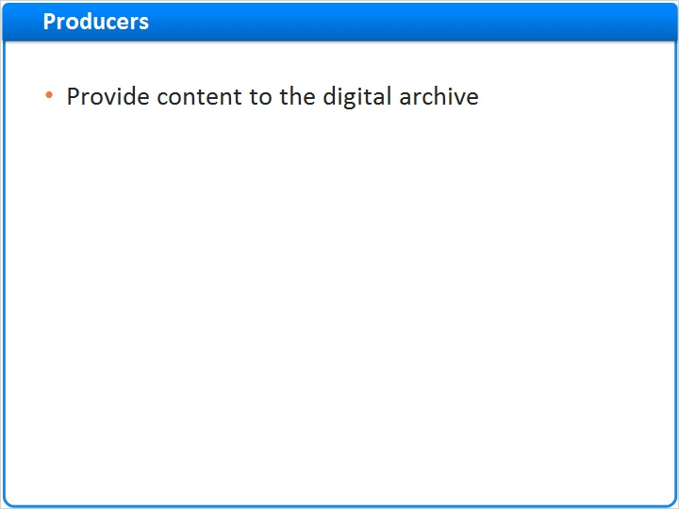
Notes:
In Rosetta, a producer is a person or organization who provides content to the digital archive. Producers can represent organizations (Group Producers) or individuals (Individual Producers). They can provide content for ingest but do not interact directly with Rosetta. Producers authorize Producer Agents to deposit content on their behalf. The Negotiator staff role can assign one or multiple Producer Agents to submit content for Producers.

bullet 2 (Slide Layer)
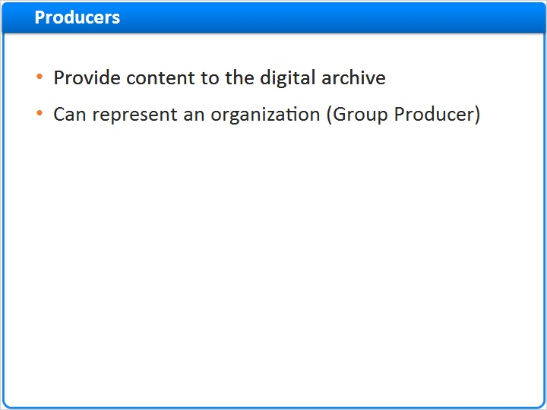

bullet 3 (Slide Layer)
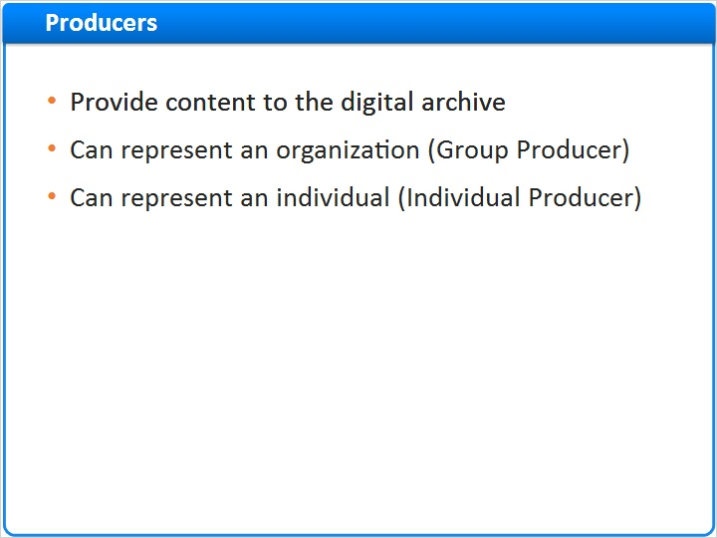

bullet 4 (Slide Layer)
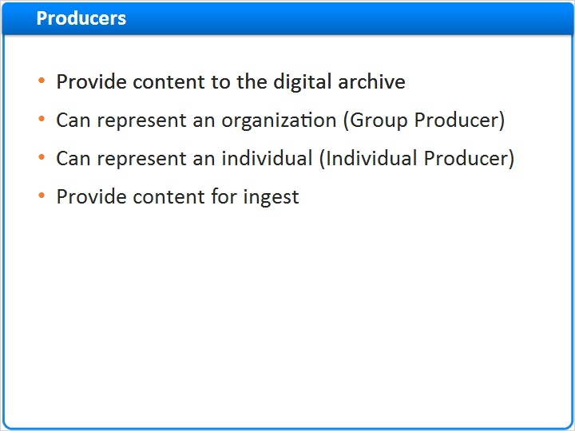

bullet 5 (Slide Layer)
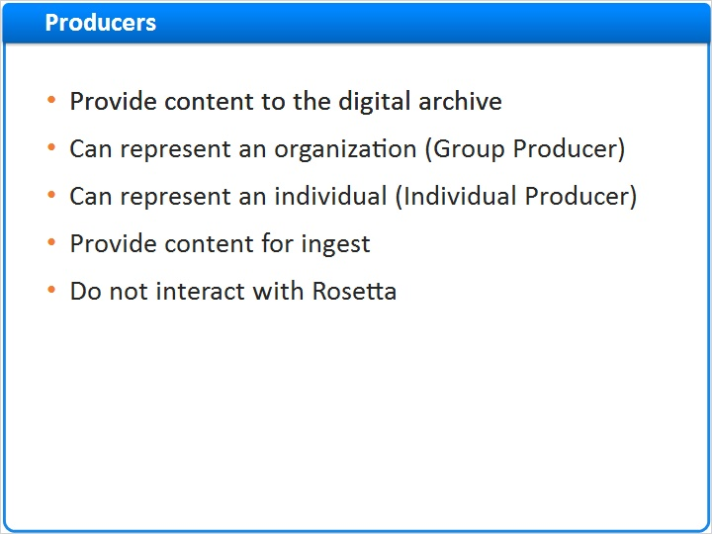

bullet 6 (Slide Layer)
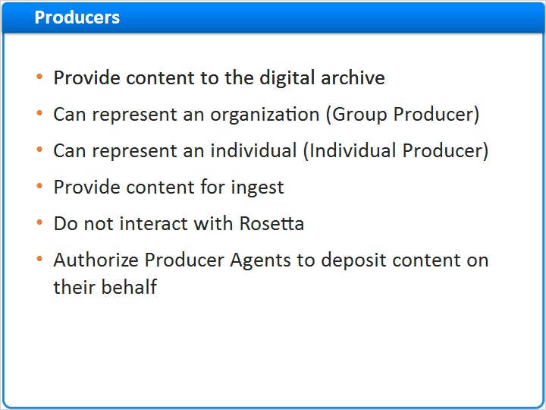

bullet 7 (Slide Layer)
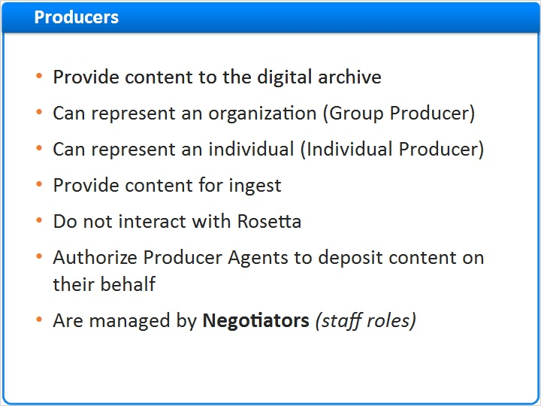

1.5 Producer Agents
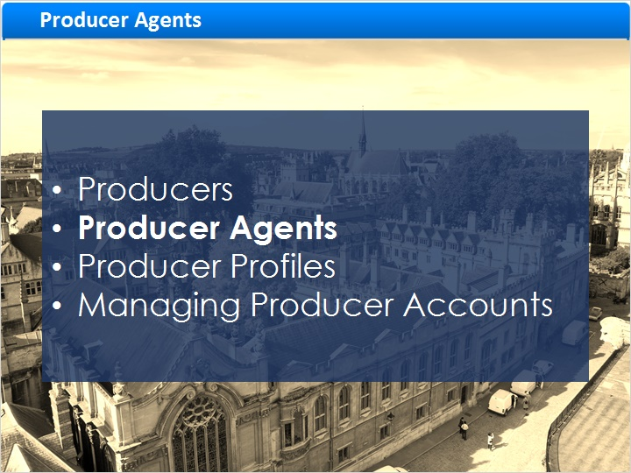
Notes:
Producer Agents

1.6 Producer Agents
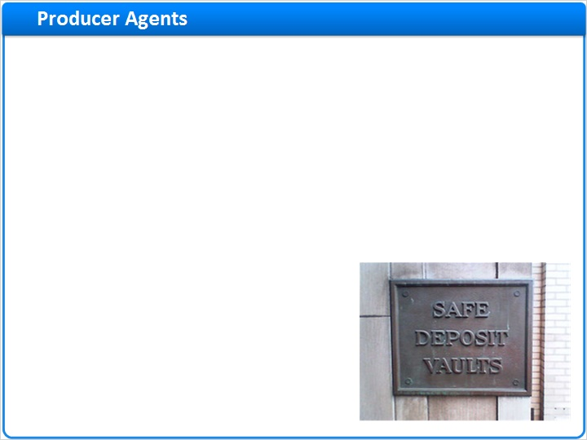
Notes:
Now let’s take a look at the Producer Agent’s duties.

Producer Agents are individuals who deposit the Producer's content into Rosetta. They can also deposit content for themselves. Producer Agents might work for one or more Producers and may be a Rosetta Staff Member or an external entity, like a researcher.

Depending on how you configure your Producer Agents to interact with Rosetta, they will be able to deposit content using one of three methods: the Rosetta Deposit Interface, the
Submission Applications or Submission Jobs.

bullet 1 (Slide Layer)
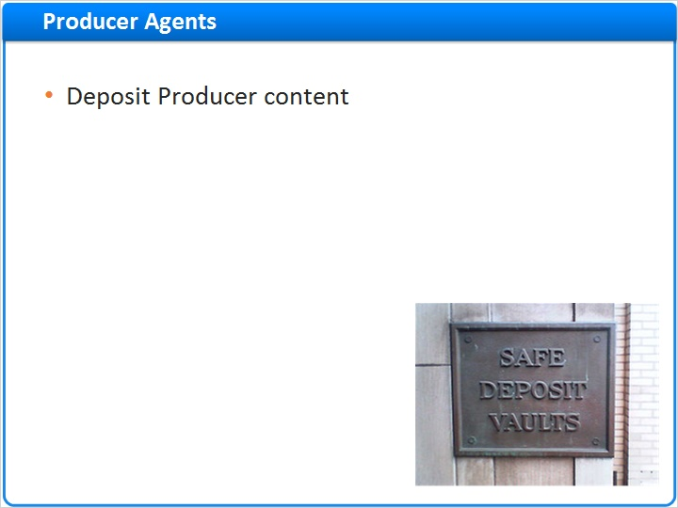

bullet 2 (Slide Layer)
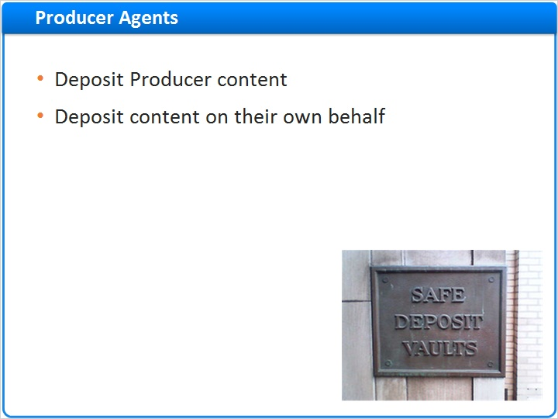

bullet 3 (Slide Layer)
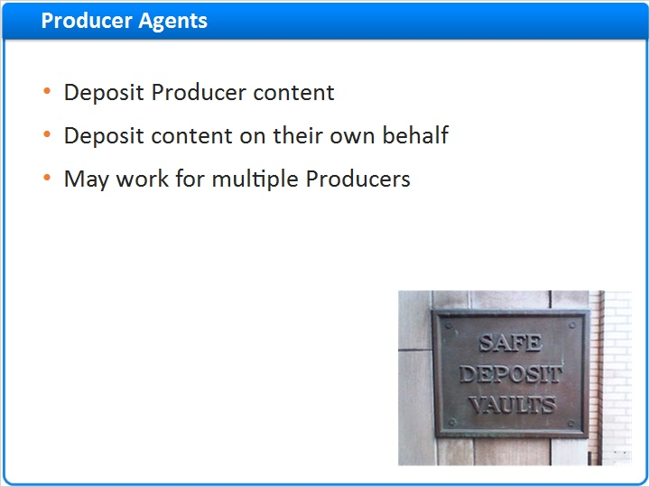

bullet 4 (Slide Layer)
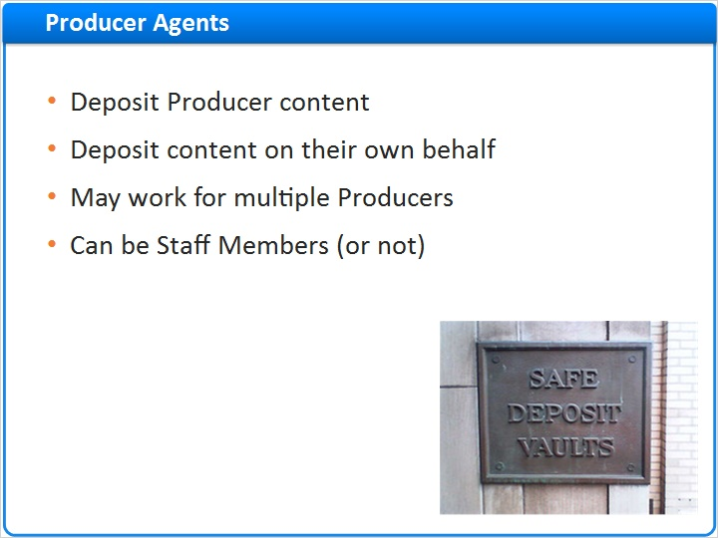

bullet 5 (Slide Layer)
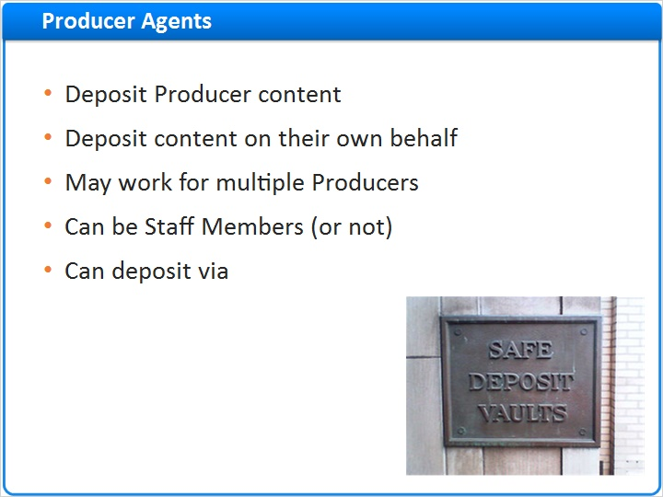

bullet 5a (Slide Layer)
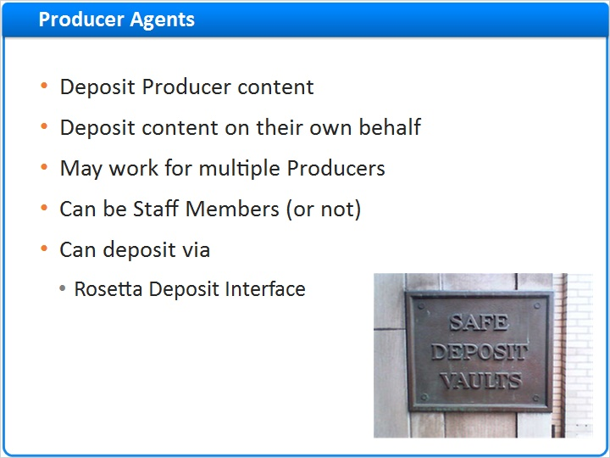

bullet 5b (Slide Layer)
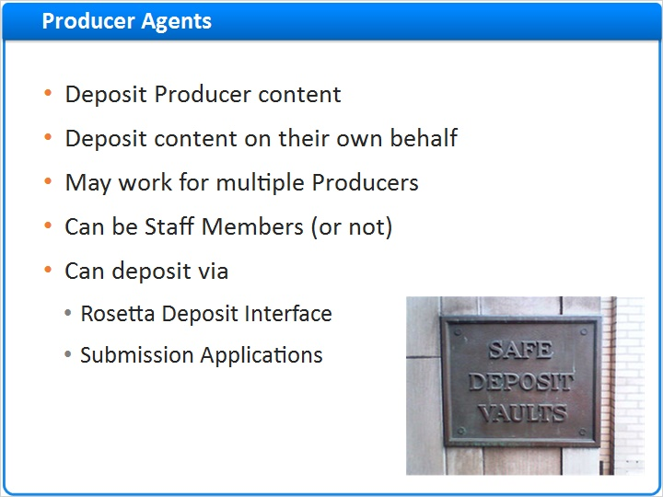

bullet 5c (Slide Layer)
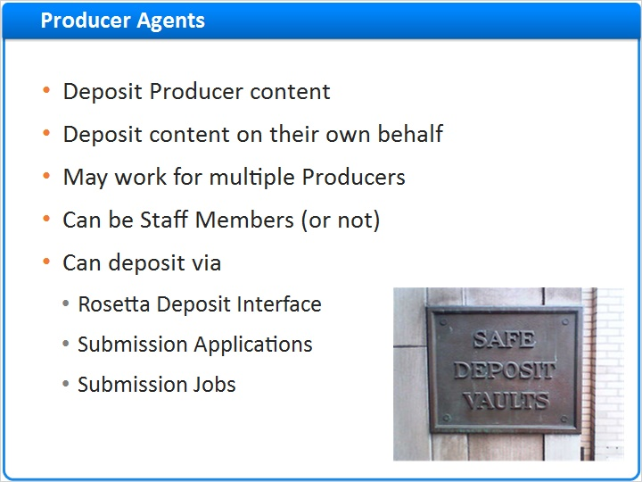

1.7 Producers and Producer Agents
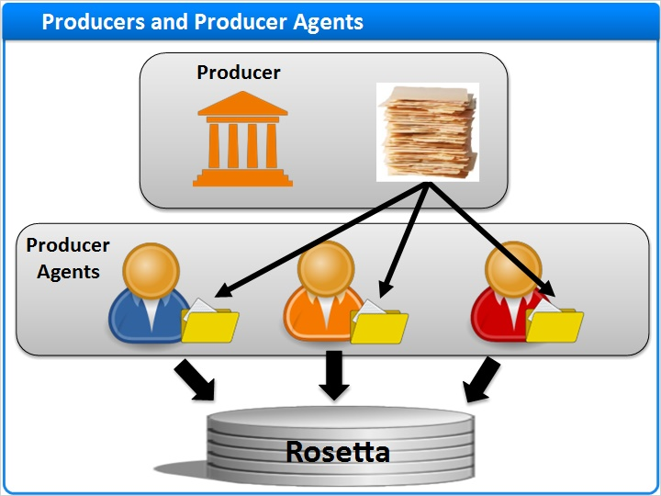
Notes:
Let’s see an example of how Producers and Producer Agents interact.

The Producer represents the University, and is working with three Producer Agents. The Producer provides content to the Producer Agents, and then the Producer Agents deposit this content into Rosetta.

You can create any number of Producers for your institution. The more Producers you create, the more you can customize submission information package processing - also called SIP processing, and delivery rules. For example, Rosetta’s delivery rules can be controlled at the producer level so that different delivery rules apply to different producers. Since delivery rules control how the object is viewed by your users, having multiple producers will give you more options on how to present your objects.

Also, with more producers, you can get more granular reporting and statistics. For example, if you create a Producer for each collection you load, this granularity will be reflected in the Rosetta reporting output.

1.8 Producer Profiles
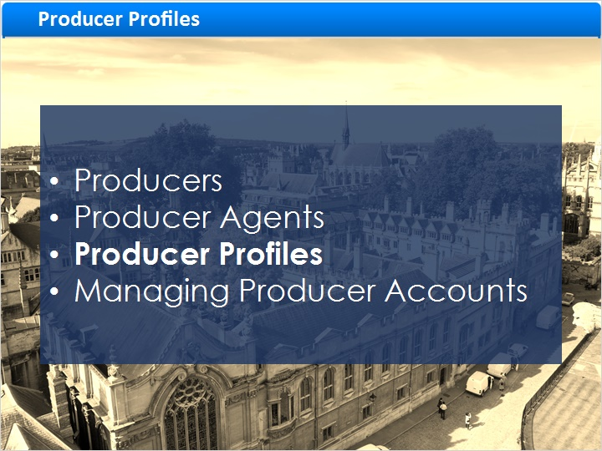
Notes:
Producer Profiles

1.9 Producer Profiles
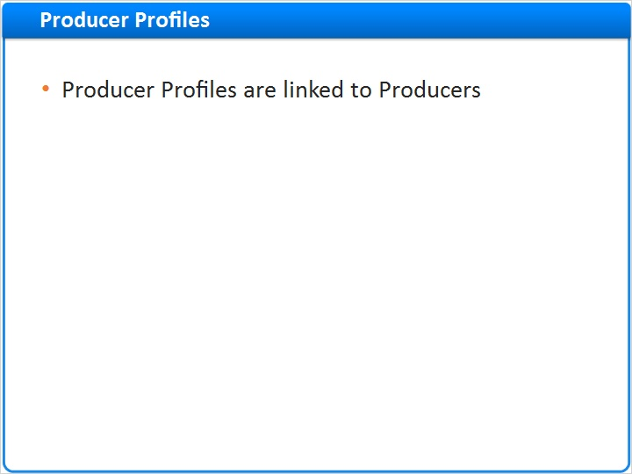
Notes:
Producers, and their Producer Agents in turn will have a Producer Profile.

This producer profile will define how producer agents deposit content as well as the amount that they can deposit. Producer Profiles also define how Rosetta will process the content being deposited. Producer Profiles are configured and managed by Rosetta Staff users. One Producer Profile can be shared by multiple Producers.

bullet 2 (Slide Layer)
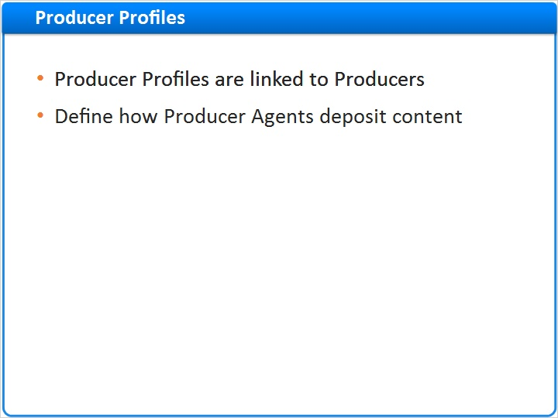

bullet 3 (Slide Layer)
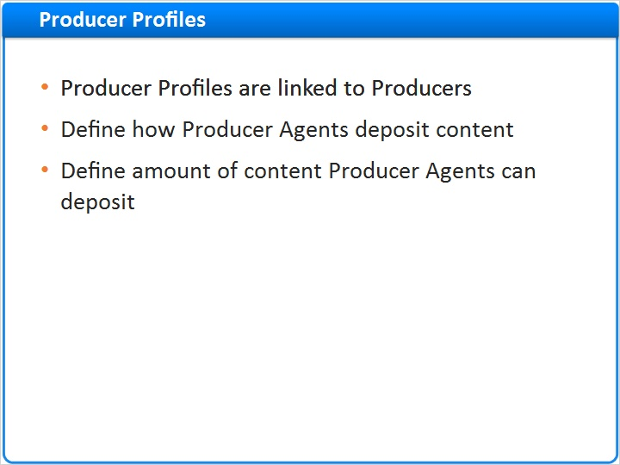

bullet 4 (Slide Layer)
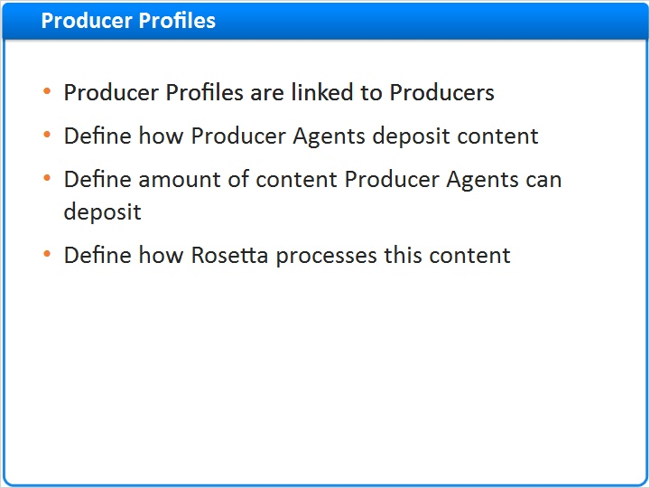

bullet 5 (Slide Layer)
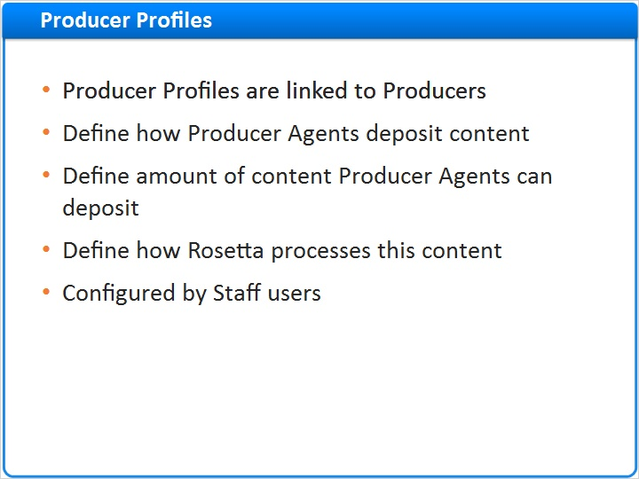

bullet 6 (Slide Layer)
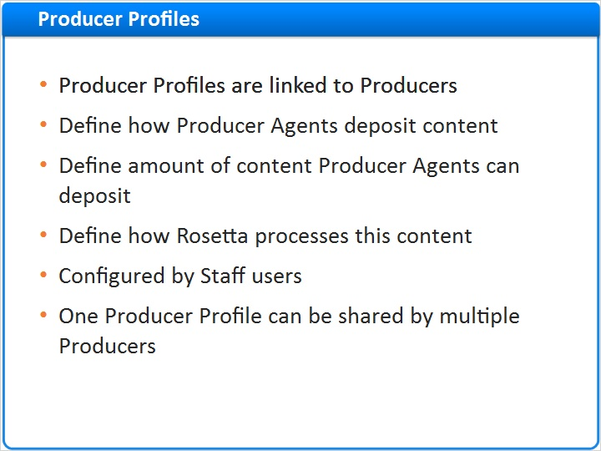

1.10 Building Blocks
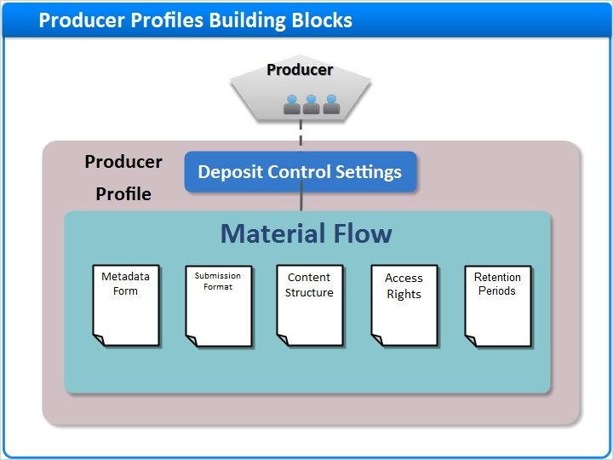
Notes:
The Producer Profile has two components: the Deposit control settings and the Material flows.

Let's look at the Deposit control settings first.

1.11 Deposit Control Settings
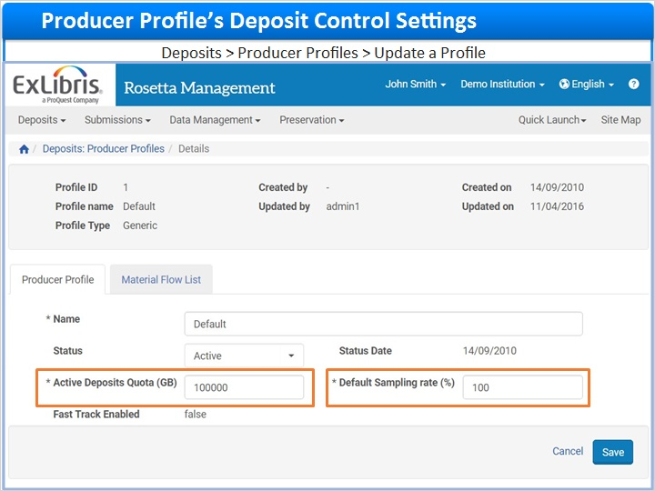
Notes:
The Active Deposits Quota refers to the total number of gigabytes the Producer Agent can deposit across all active deposits. If this number is set at 1,000,000 and the latest deposit exceeds that number, the deposit will be blocked until this number is increased in the Producer Profile. You can set the Active Deposits Quota to 0 for no limit.
The Default Sampling Rate records the percentage of the Producer Agent’s content that needs to be reviewed by Staff before being saved to the permanent repository. If you enter a value of “100%”, ALL deposited content must be reviewed by Assessors and Arrangers. If you enter a value less than 100% the specified percentage of content must be reviewed by an Approver. For example, a sampling of 25% of the total submitted content will be flagged for review. The remaining 75% will go directly to the permanent repository without manual review.

1.12 Building Blocks
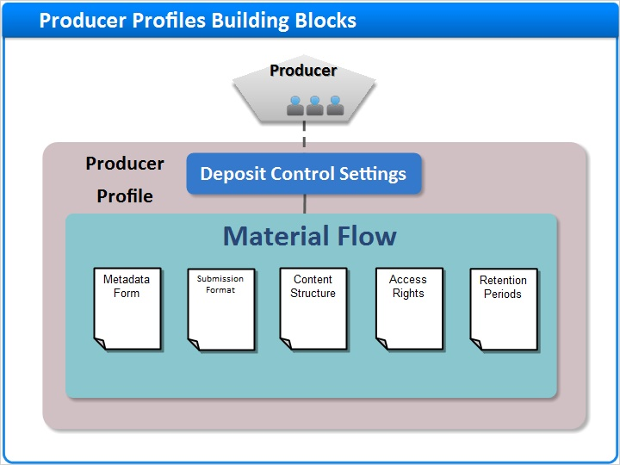
Notes:
Now let’s look at the Material Flows.

1.13 Material Flow List
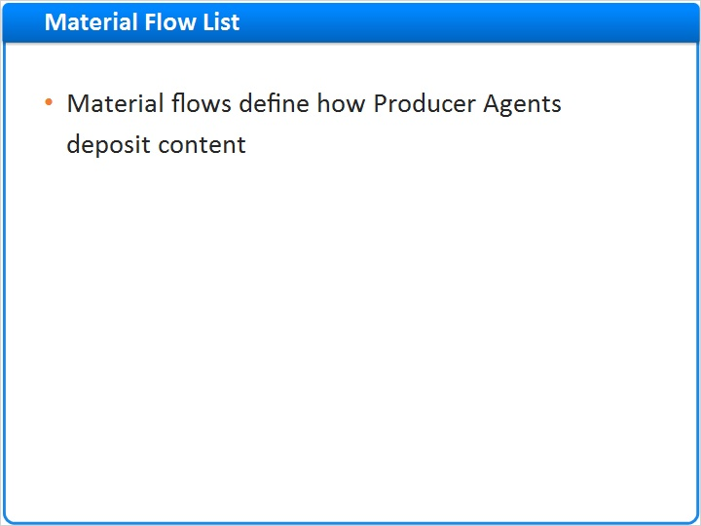
Notes:
Material flows define how Producer Agents deposit content.

The configurations in the Material Flow consist of a sequence of forms that are used during the deposit process. These include a set of instructions on how to process the submitted data for loading into Rosetta’s Staging environment. You can define as many Material Flows as needed. A Material Flow is associated with one or many Producers and Producer Profiles.

This topic will be covered in more depth during the “Managing Material Flows” session.

bullet 2 (Slide Layer)
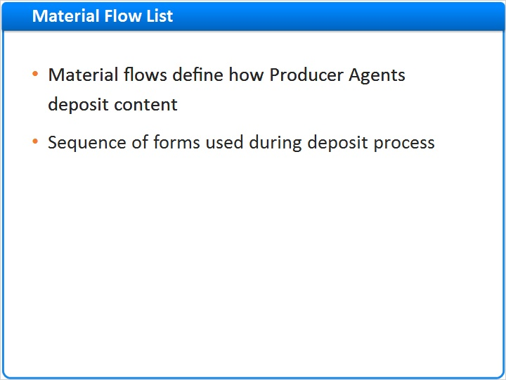

bullet 3 (Slide Layer)
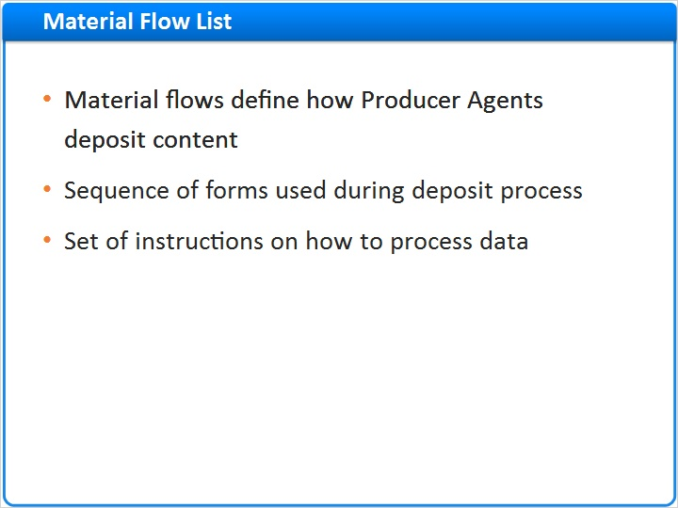

bullet 4 (Slide Layer)
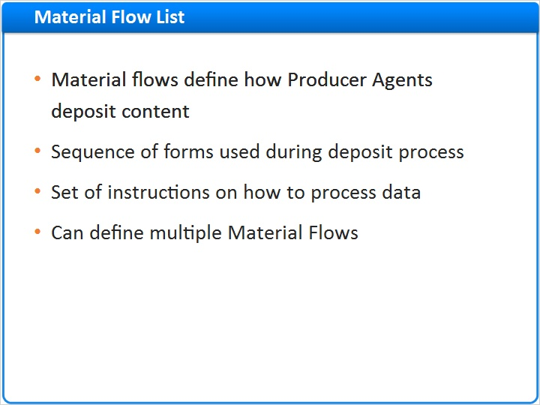

bullet 5 (Slide Layer)
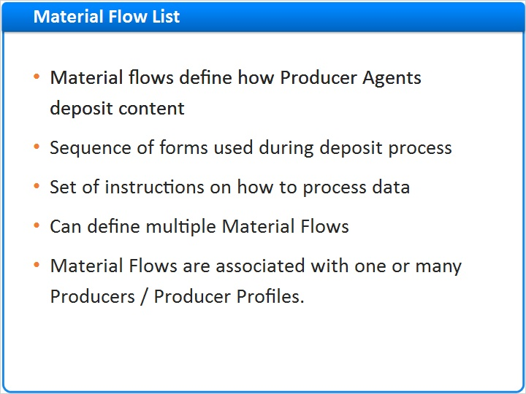

1.14 Selecting Material Flow Lists
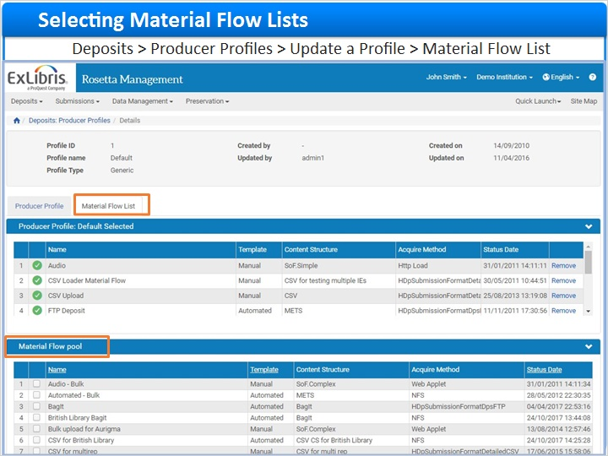
Notes:
If we go to the Producer Profile Material Flow list we will see a set of Material Flows that have been assigned to a Producer.
In the lower pane you can see the “Material Flow Pool”. From here, you can select the appropriate Material Flow that was created in the Producer Profile.

1.15 Managing Producer Accounts
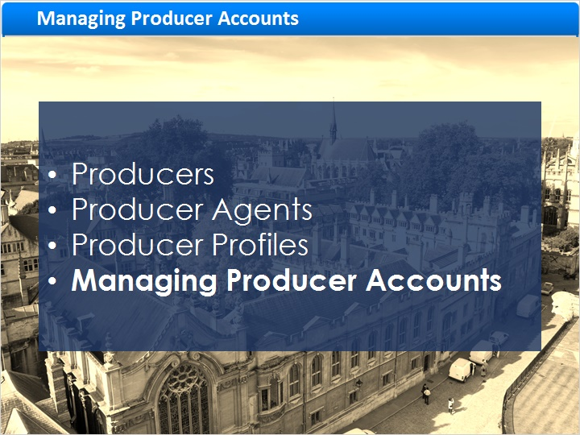
Notes:
Managing Producer Accounts

1.16 Creating a Producer
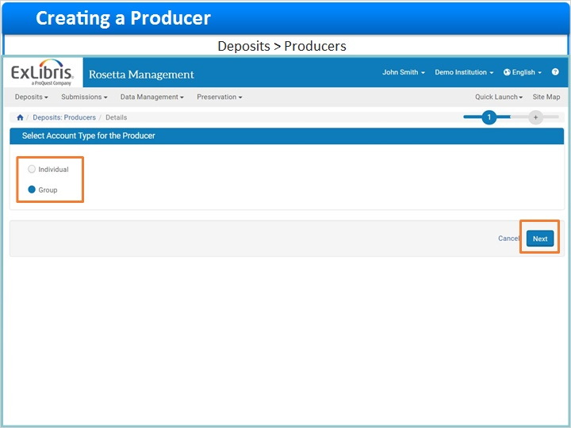
Notes:
Here is a list of Producers in Rosetta. Keep in mind that Producers are either organizations or individuals who create content for ingest into Rosetta.

To create a new Producer, click the Add Producer button. Next, select the Producer type.

When creating a new Producer account, you will need to indicate whether this Producer will be represented by an individual or a group or institution.

In this case there will be a number of Producer Agents depositing content for the group. Now click Next to advance to the Producer Details form.

1.17 Creating a Producer
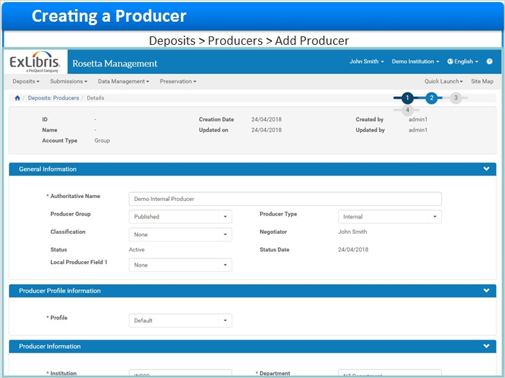
Notes:
With the Producer Details form displaying, complete all of the mandatory fields before clicking the “Save” button. Note that you will be able to determine what fields are mandatory in the Rosetta configuration. For now we are working with the default settings.

1.18 Producer Group and Type
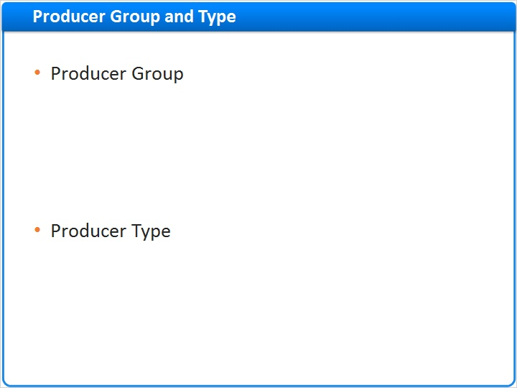
Notes:
When creating a Producer you will need to determine what Producer Group and Type this Producer will belong to.
Producer Groups represent groups of Producers and their Producer Agents. They are used as a reporting metric in Rosetta’s reports, and they are used for SIP Routing Rule Assignment, which will be covered in a later session.
The Producer Type describes the kinds of producers you might work with in your institution. There are a few out-of-the-box options - casual, internal, trusted, and registered, but it is also possible to configure your own types at the consortium level.
In fact, both the Producer Groups and Producer Types are customizable.

1a (Slide Layer)
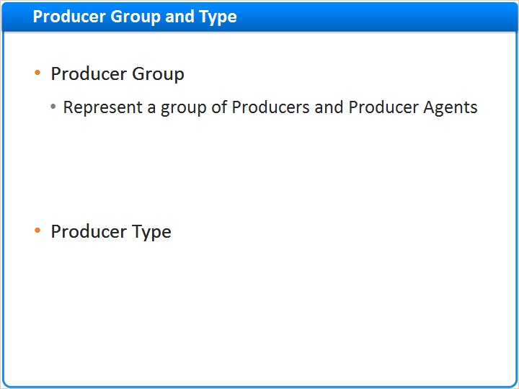

1b (Slide Layer)
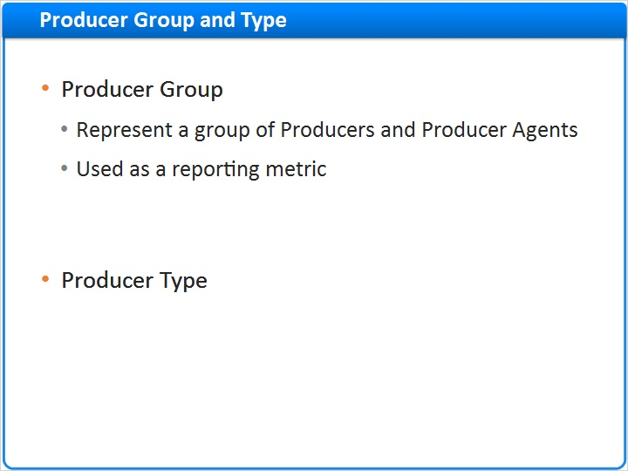

1c (Slide Layer)
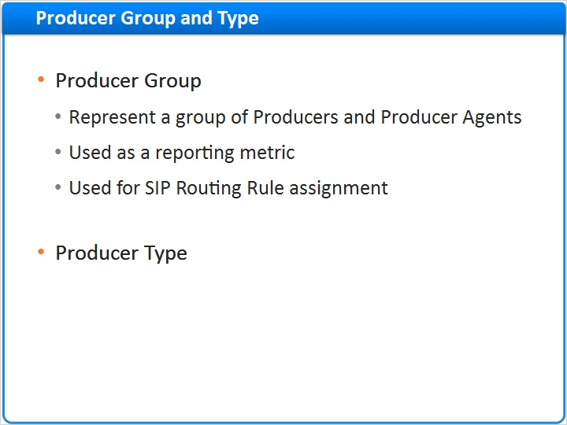

2a (Slide Layer)
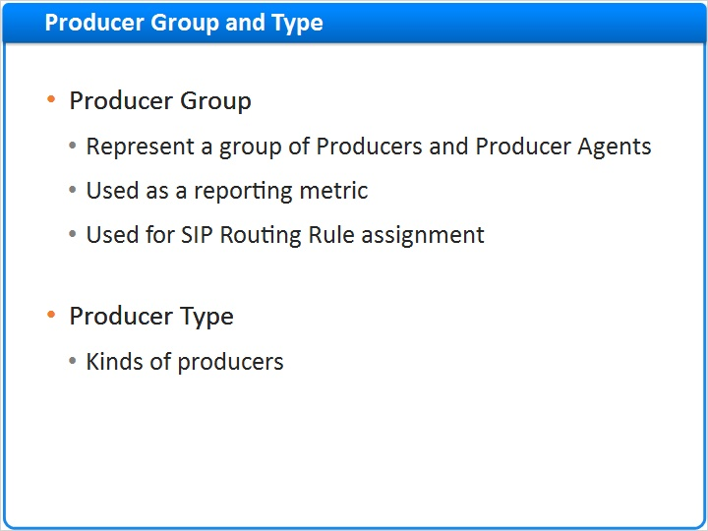

2b (Slide Layer)
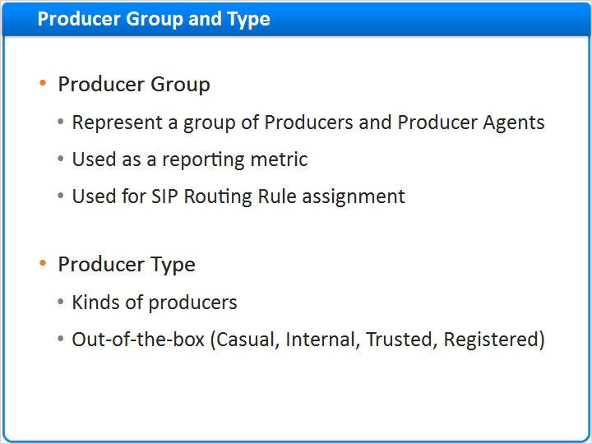

2c (Slide Layer)
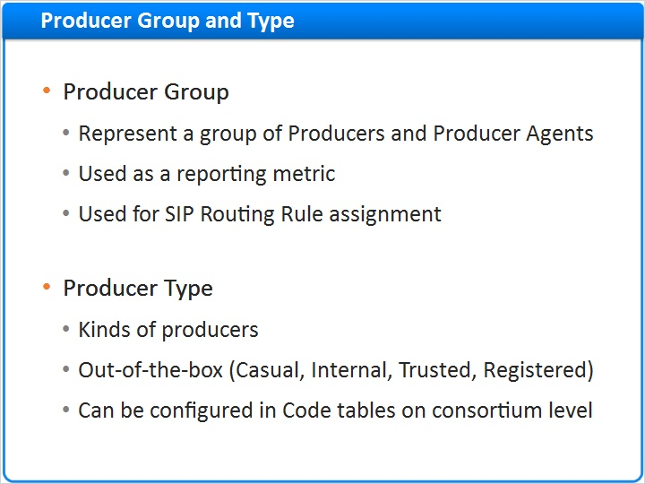

1.19 Creating a Producer Profile
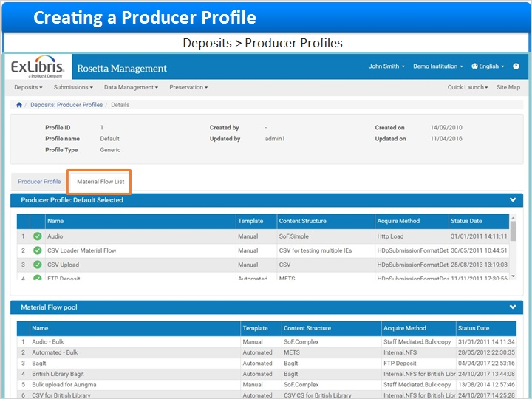
Notes:
Next we need to create a producer profile to link the producer to a material flow.

From the Producer Profile List, click the Add Producer Profile button. This opens the Producer Profile creation form, with the Producer Profile tab active.

Complete the mandatory fields before clicking over to the Material Flow List tab. There you can add the Material Flows that the Producer Agent will work with.
Once you’ve added the Material flows you can go back to the Producer Profile tab and click Save to save the record.

1.20 Assigning a Producer Agent
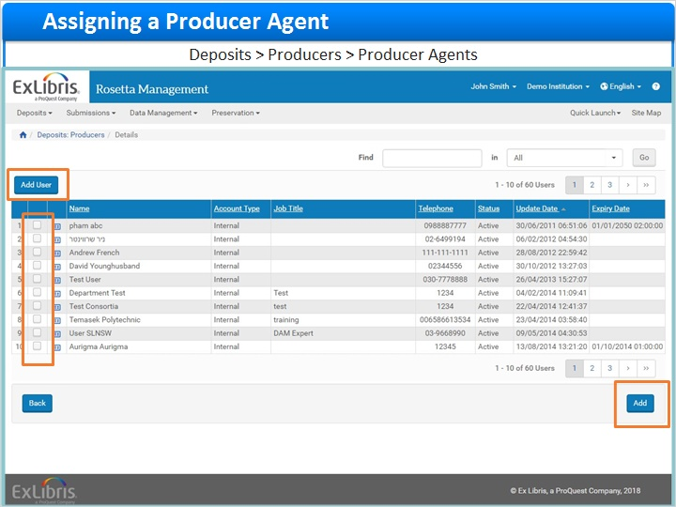
Notes:
Finally, we need to create a Producer Agent and link it to the Producer.

Clicking on the More link displays the Producer Agents list in the Producer List window. Clicking on the Add Producer Agent button will display a list of users to choose from.

Select the appropriate user from the list by ticking the checkbox next to their name and clicking Add. If the user is not listed, you can add them by clicking on Add User. You can also add a Staff User first so that it displays here for selection.

Now we have both a Producer and a linked Producer Agent who can ingest content.

1.21 Summary
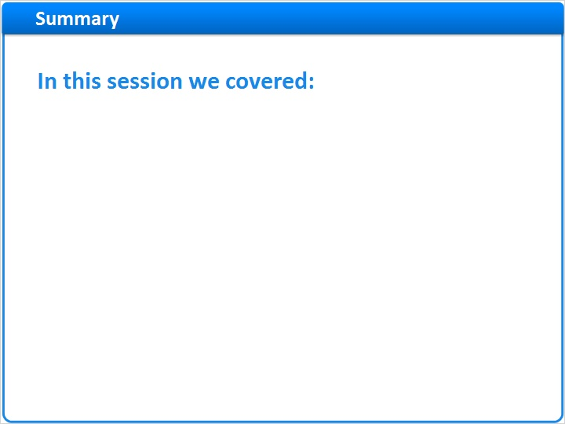
Notes:
This concludes the Producers and Producer Agents session.
In this session we discussed the Producers and Producer Agents roles, how the Producer Profiles enable personalization, and how to manage Producer accounts
Please take this opportunity to review this information in your new Rosetta environment.
We hope that you’ve found this information helpful. We recommend that you now watch the other Managing Material Flows sessions to get a more in-depth understanding of the other related material flow components.

1 (Slide Layer)
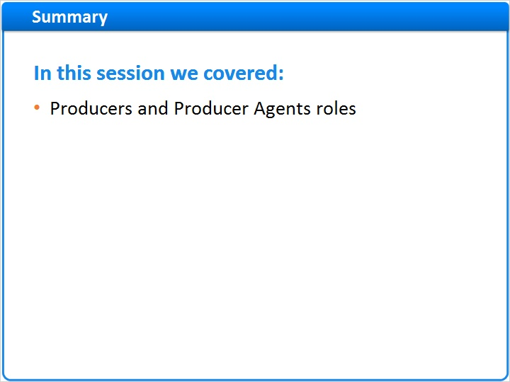

2 (Slide Layer)
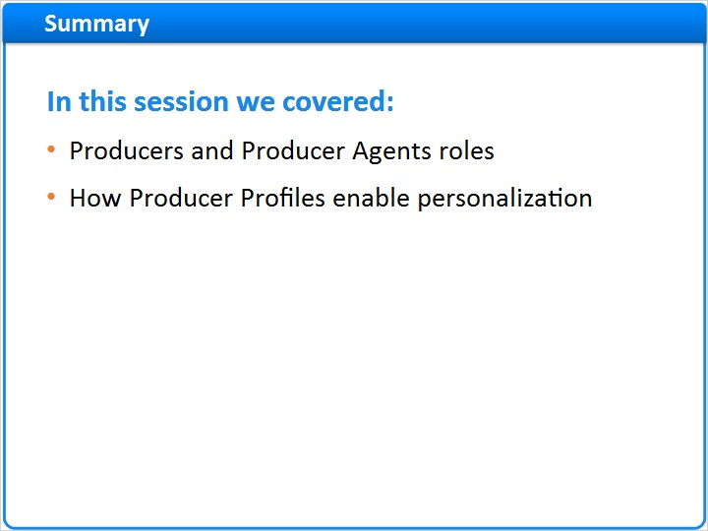

3 (Slide Layer)
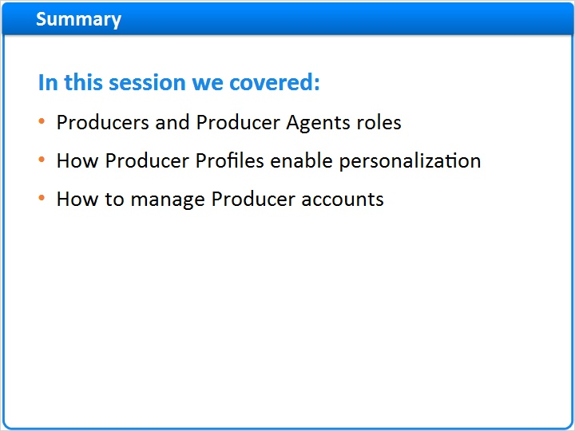

note (Slide Layer)
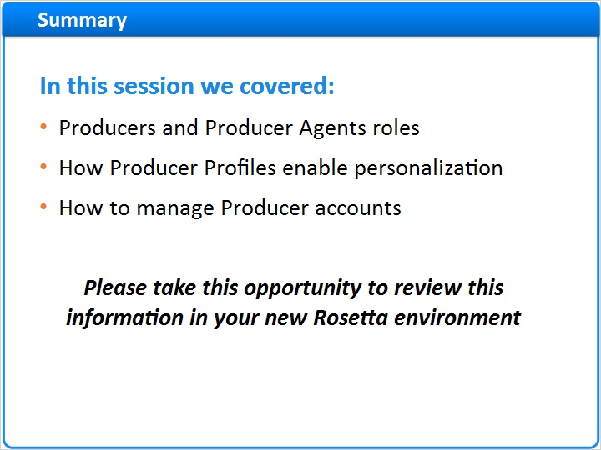

1.22 Additional Resources

Notes:
Thank you for joining this session!

1.23 About this Training
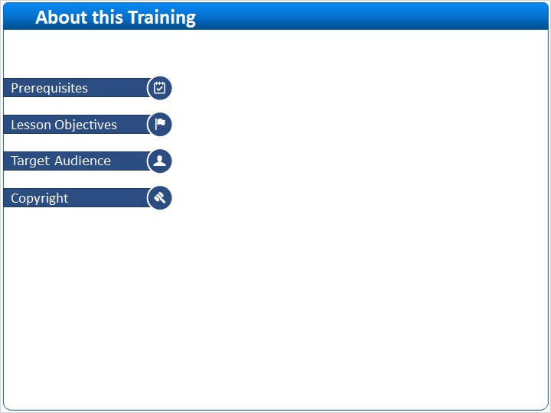
Notes:

1 (Slide Layer)
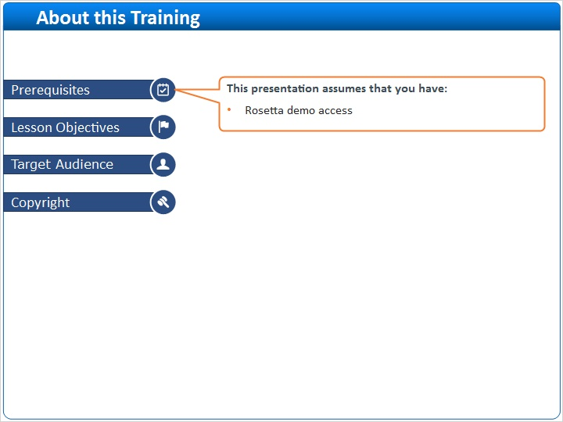

2 (Slide Layer)
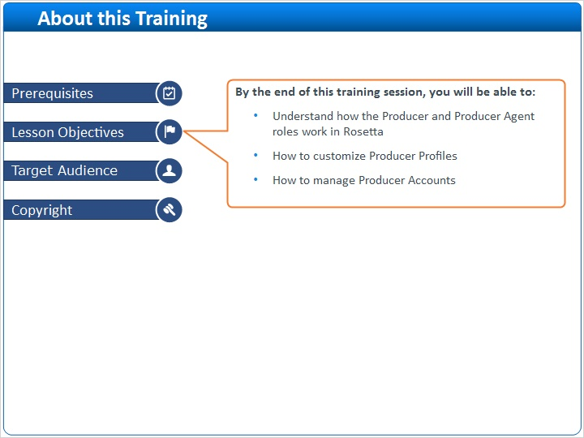

3 (Slide Layer)
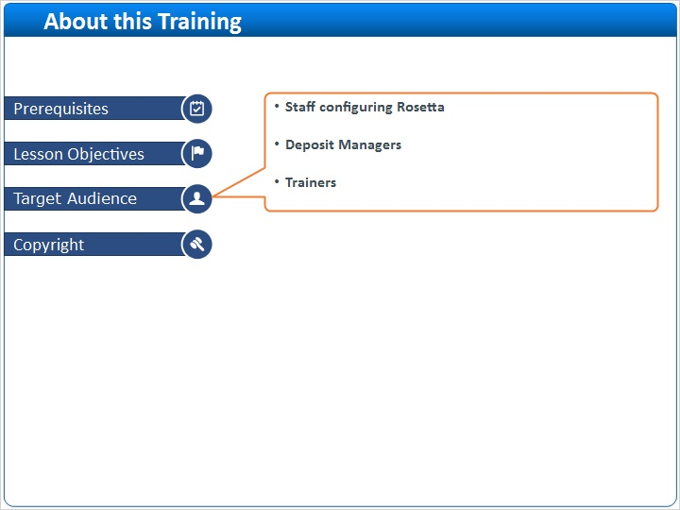

4 (Slide Layer)


