Material Flow Introduction

1. Managing Rosetta Material Flows

1.1 Welcome
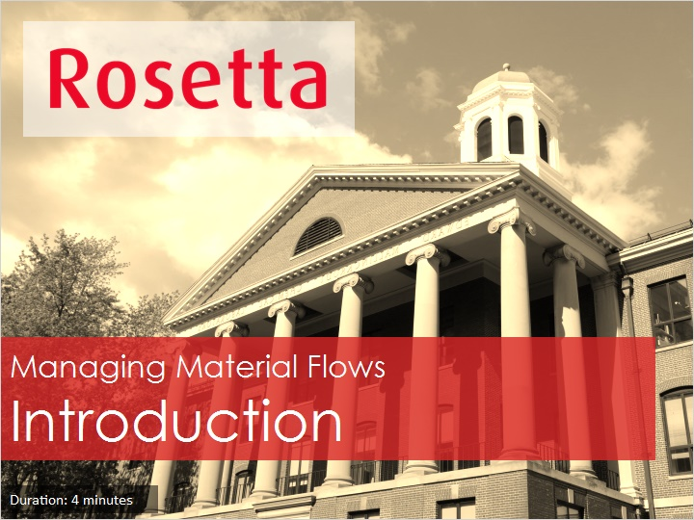
Notes:
Hello, and welcome to this introduction to Managing Rosetta Material Flows.

1.2 Agenda
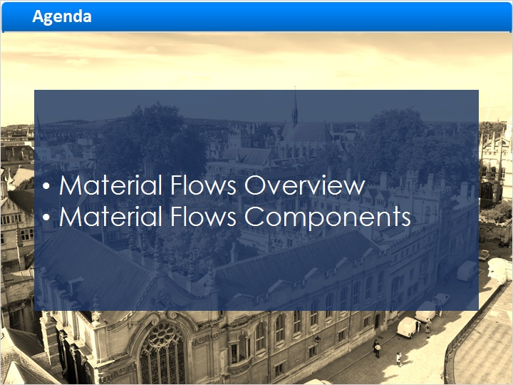
Notes:
In this session we will discuss the Rosetta Material flow and it’s components.

1.3 Material Flows Overview
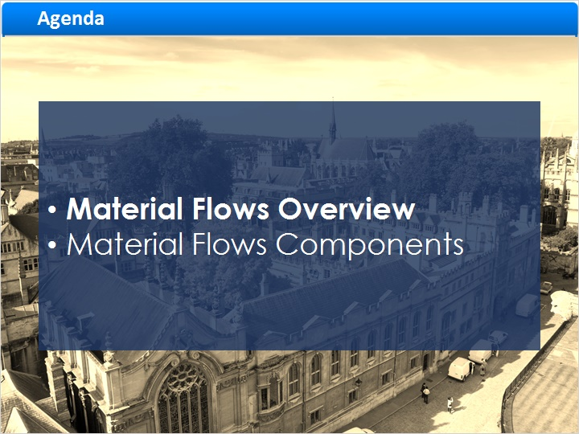
Notes:
So what is a Material flow in Rosetta?

1.4 What are Material Flows?
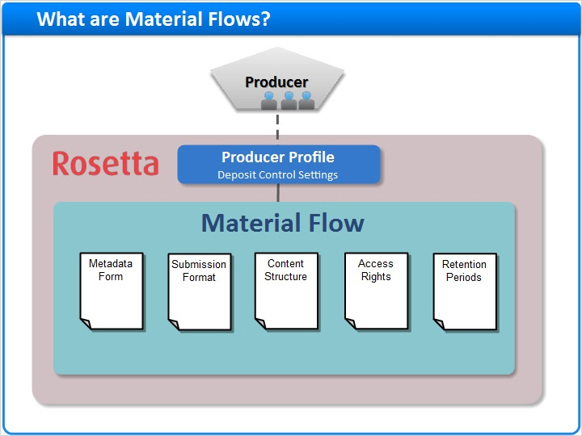
Notes:
Let’s first look at the entities involved in depositing digital materials in Rosetta:

We have our Producer, which is the entity that provides the digital materials, for example, the Near-Eastern studies department.
Each producer has Producer Agents, who are the Rosetta-users who deposit materials on behalf of the producer, such as Suzy Smith from Near Eastern studies.
You can learn more about Producers and Producer Agents, in the "Managing Producers and Producer Agents" session.

Now each Producer is represented in Rosetta by their Producer Profile, which contains various settings regarding to deposit control.

Furthermore, each producer profile is associated with one or more Material Flows.
The Material Flow defines what types of content Producer Agents can deposit and how.

The same material flow may be associated with several Producer Profiles, and vice versa.

However, Material flows are institution specific so each institution in your Rosetta system will have different material flows defined for it.
The Rosetta Material Flow comprises of five configurable components which we shall describe presently.
Each of these components can be associated with one or more material flows.

1.5 Material Flow List
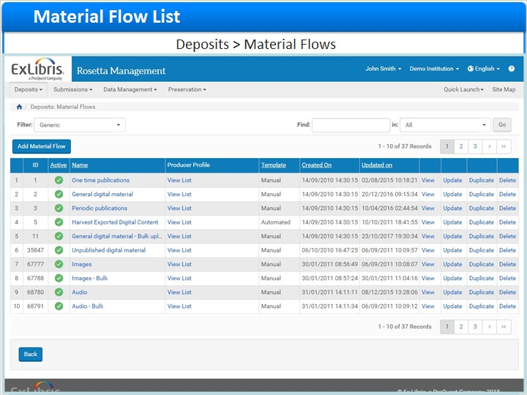
Notes:
To access the List of Material Flows go to Deposits > Material Flow in the Rosetta Management Module.

We’ll learn more about creating material flows and putting together their components in the session Managing Material Flows - Combining Material Flow components.

1.6 Untitled Slide
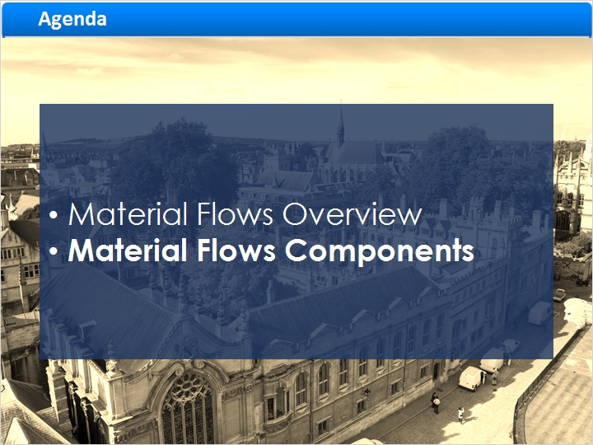
Notes:
Now let’s briefly go over the five Components that make a Material Flow.

1.7 Metadata Form
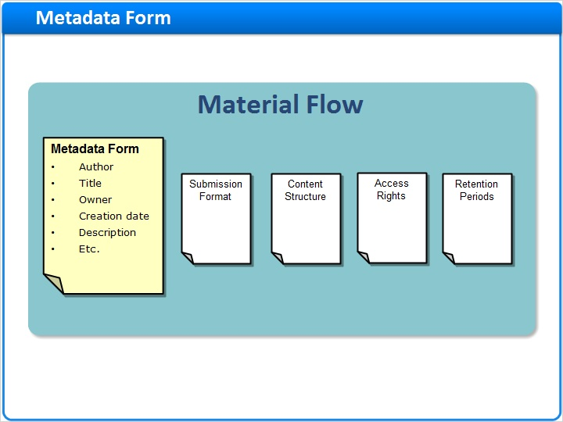
Notes:
The first component, Metadata Form, defines which descriptive metadata the Producer Agents need to provide for the material, such as:
Author, Title, Owner, Creation date, Description, Etc.

1.8 Submission Format
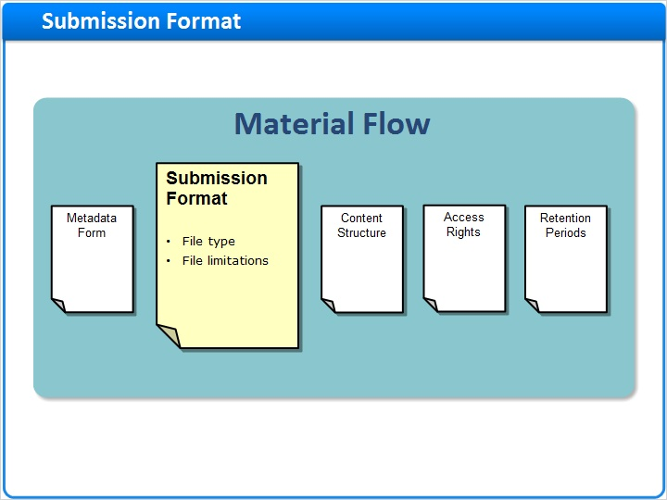
Notes:
The second component, Submission Format, defines the conditions for uploading files for deposit, including the file type and various limitations.

1.9 Content Structure
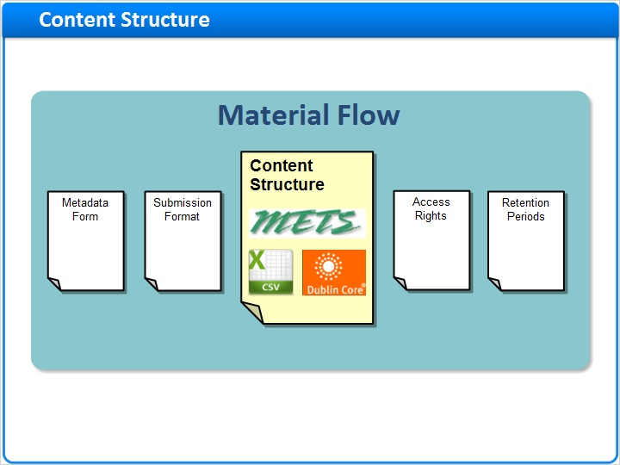
Notes:
Content Structure is the structure of the submission package ingested into Rosetta, which is in turn converted to Rosetta-compatible METS
The following formats are supported: Dublin Core, METS, and CSV.

1.10 Material Flow Components
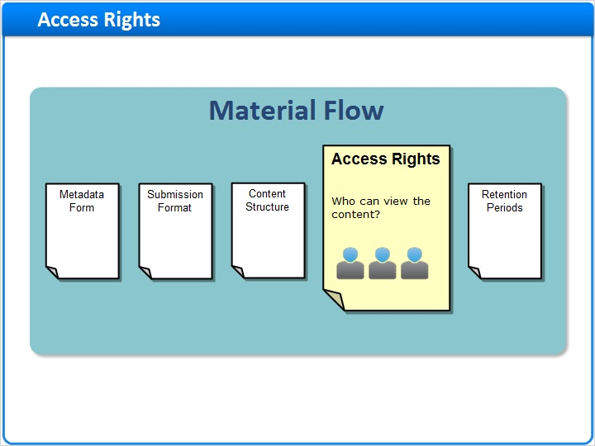
Notes:
Access Rights allow Producer Agents to control who may view the content ingested using this Material Flow.

1.11 Retention Period
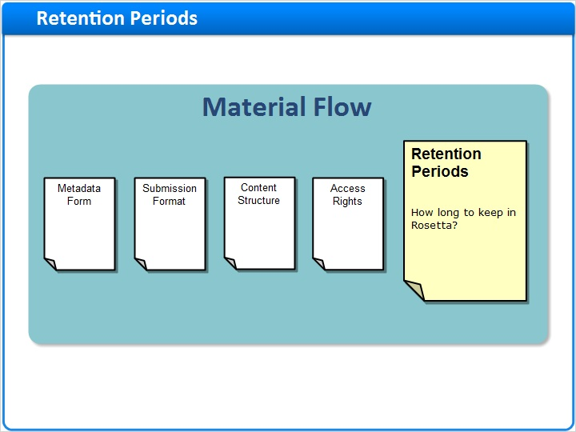
Notes:
The Optional Retention Period defines an end date after which the content will be purged from Rosetta.

1.12 Summary
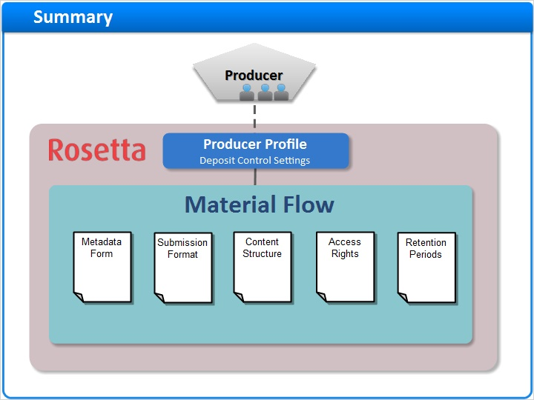
Notes:
So those were the components of the material flow: metadata form, submission format, content structure, access rights, and retention periods.

This concludes our brief introduction to the Rosetta Material flow, or ingest method, and its components

In our next Managing Material Flows sessions we’ll take a more in-depth look at these five components.

1.13 Additional Resources

Notes:
Thank you for joining us today!

You can find more Training Materials and documentation in the Ex Libris Knowledge Center: knowledge.exlibrisgroup.com

1.14 About this Training
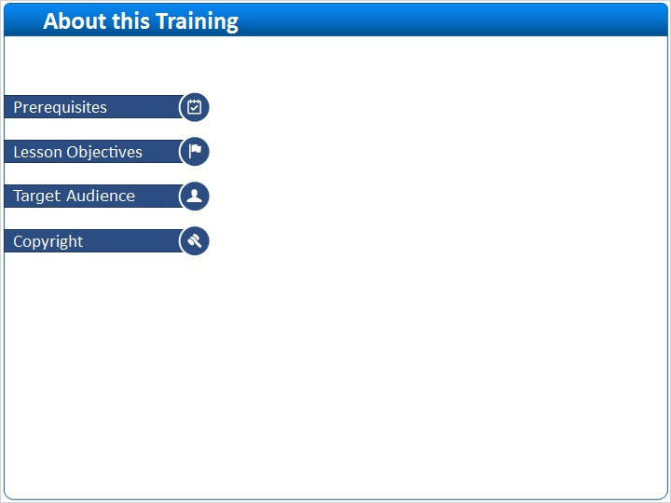
Notes:

1 (Slide Layer)
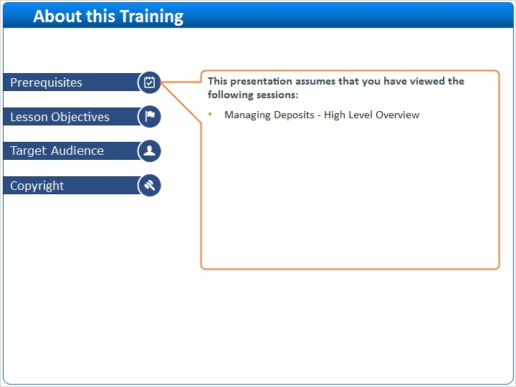

2 (Slide Layer)
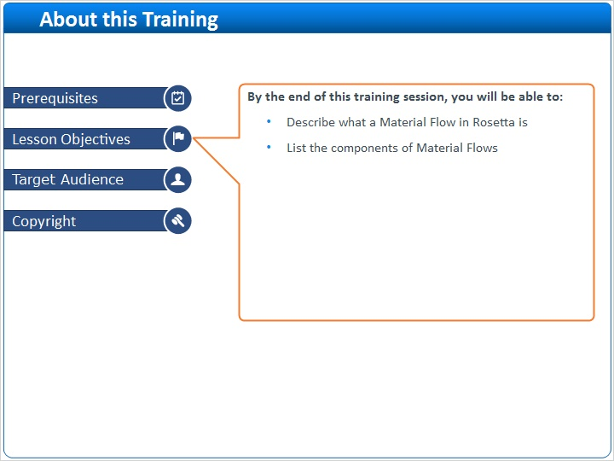

3 (Slide Layer)
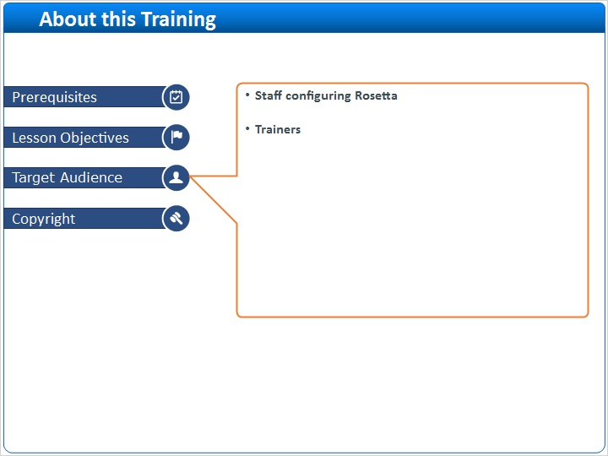

4 (Slide Layer)


