Material Flow - Submission Format

1. Managing Rosetta Material Flows - Metadata Form

1.1 Welcome
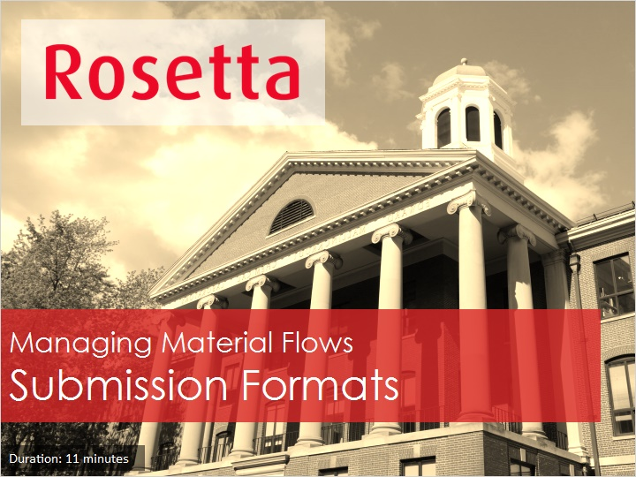
Notes:
Hello, and welcome to our session: Managing Rosetta Material Flows - Submission Format

1.2 Agenda
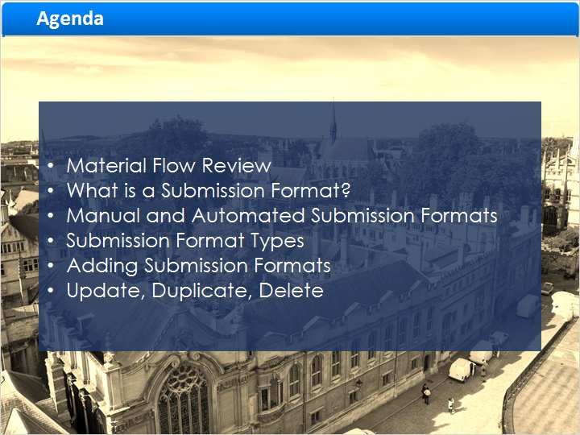
Notes:
In this session we continue to discuss the Rosetta Material flow and it’s components, focusing on Submission Formats, which define the limitations on deposited files.

We’ll learn about manual and automated submission formats.

And we’ll see how to create Submission Formats, and how to duplicate, update, or delete them.

1.3 Material Flow Review
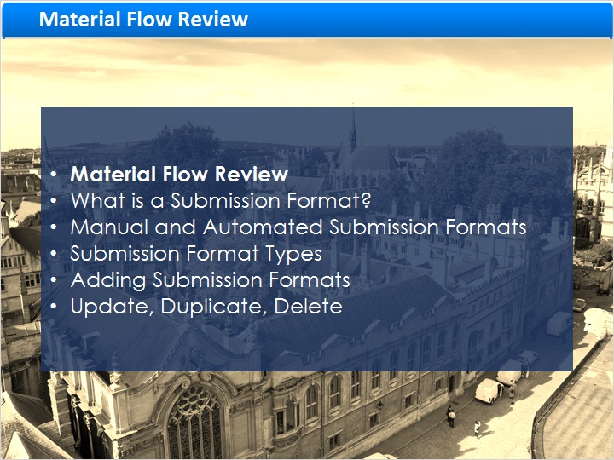
Notes:
First, a quick recap of Material Flows.

1.4 Material Flow Components
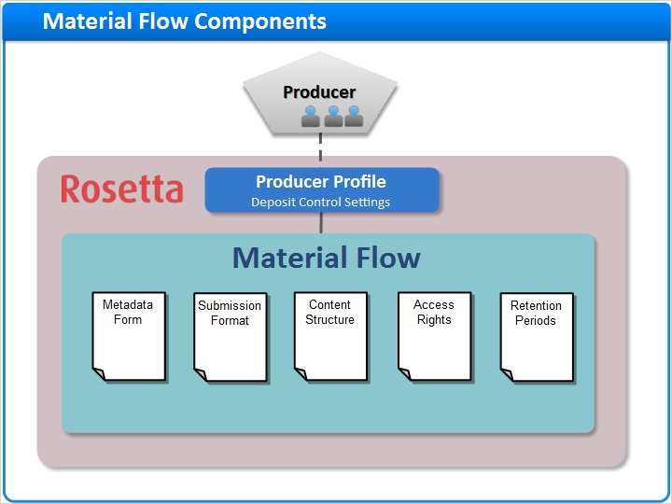
Notes:
In the Material Flows Introduction session we learned that the Rosetta Material flow defines what types of content Producer Agents can deposit and the means by which they perform deposits.

During deposit, the agent fills in a sequence of forms regarding the material.

These forms are configured in the five components of the Material flow.

Today we’ll focus on one of these components, the Submission Format.

1.5 What is a Submission Format?
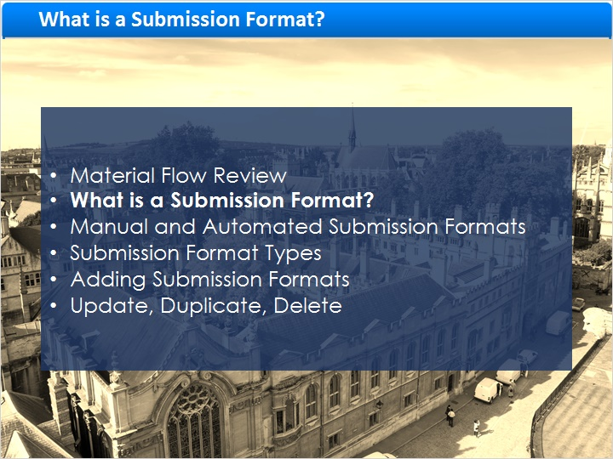
Notes:
What is a Submission Format?

1.6 Submission Formats
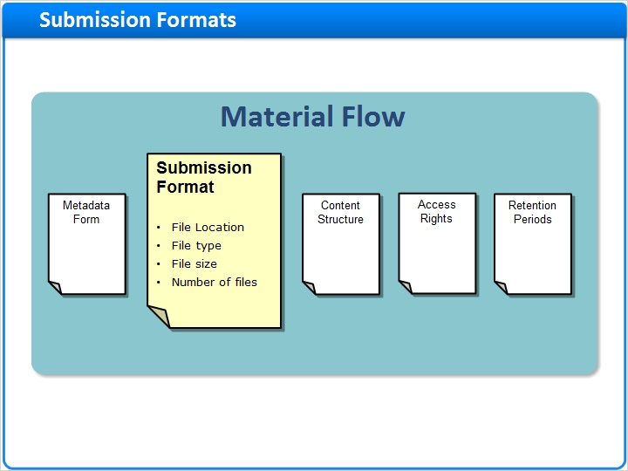
Notes:
As a component of the Material Flow, the Submission Format defines what files can be uploaded and from where.

It can impose limitations on uploaded files such as:

File type,
File size,
And Number of files to be uploaded.
Submission formats support both manual and automated file upload, and the same submission format can be linked to several material flows.

1.7 Manual and Automated Deposit
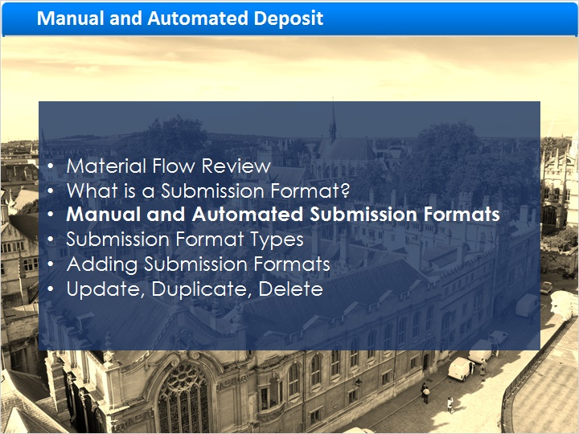
Notes:
Submission Formats can be Manual or Automated.

The main difference is in a manual submission format, the producer agent needs to manually enter the file location, and in the automatic one the files are uploaded from a predefined location.

lets see how manual and automatic submission formats both work within a Material Flow.

1.8 Manual Submission Format (in a Manual Deposit)
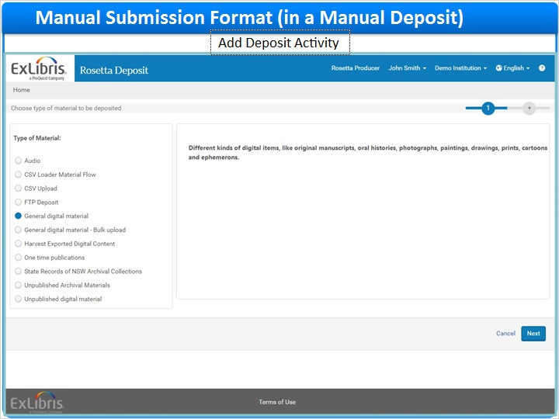
Notes:
We’ll start with a Manual Submission Format in a Manual Deposit.

During deposit with Rosetta’s web-based manual deposit wizard, producer agents enter the descriptive information manually.

1.9 Manual Submission Format – Upload Files Page
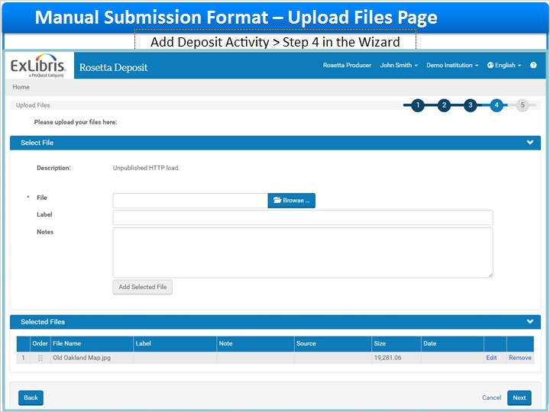
Notes:
Step 4 in the wizard, is the Upload Files page. Here you select the files for upload.

The options available in the Upload Files page are determined by the submission format associated with this material flow.

We will look at how to create submission formats that are used by this wizard later in this session.

1.10 Automated Submission Format (in a Manual Deposit)
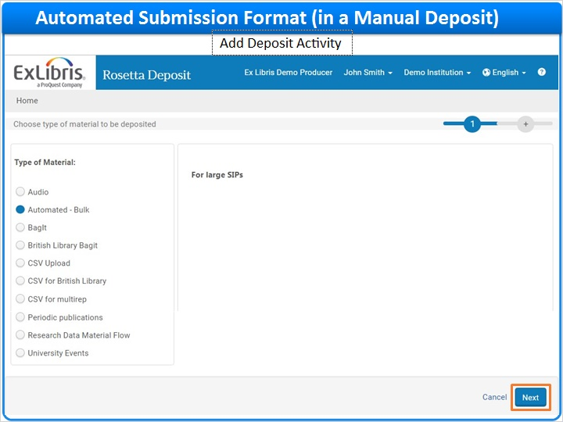
Notes:
Now let’s look at a manual deposit with an automated submission format.

Perhaps this is a slightly rare use-case but it may prove instructive in understanding Submission Formats.

Producer Agents can use this submission format for uploading large amounts of content.

When the automated submission format is used, the files are uploaded from a predefined location, typically a custom mount on the server.
Rosetta supports two protocols for automated deposit: File Transfer Protocol (or “FTP”), and Network File System (or “NFS”).
The FTP credentials or NFS directory location are defined in the submission format that is linked to the material flow.
We’ll see these locations when the user clicks Next to advance to step 2 in the wizard.

1.11 Automated Submission Format – Content Folders
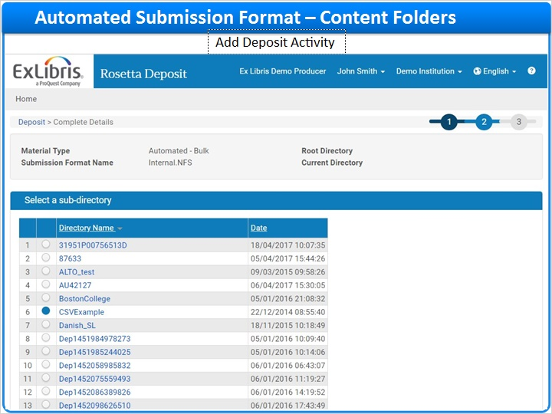
Notes:
Here in the second step, the producer agent selects the sub-directory containing the content for ingest, from a predefined location.

Since we are using our automated submission format in a manual deposit, note that only one folder may be selected.

1.12 Automated Submission Format – Summary
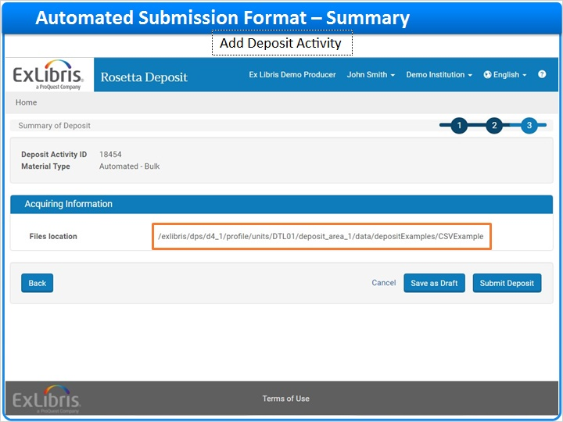
Notes:
Continuing to step 3 of our deposit wizard, the producer agent confirms the selected directory. Note that the files location is taken directly from the submission format.

1.13 Automated Submission Format in an Automated Ingest
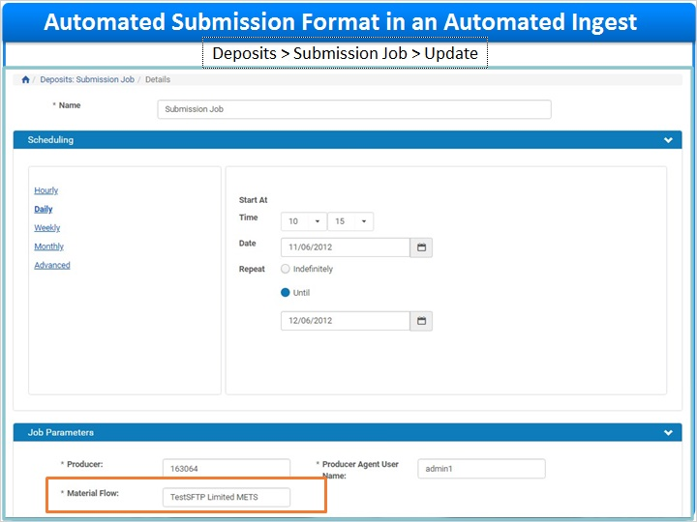
Notes:
In addition to Manual Deposit, Staff can perform bulk ingesting using a Submission Job in the Rosetta Management Module.

The Submission Job is an auto ingest mechanism that knows where to find the content thanks to the material flow’s submission format.

1.14 Submission Format Types
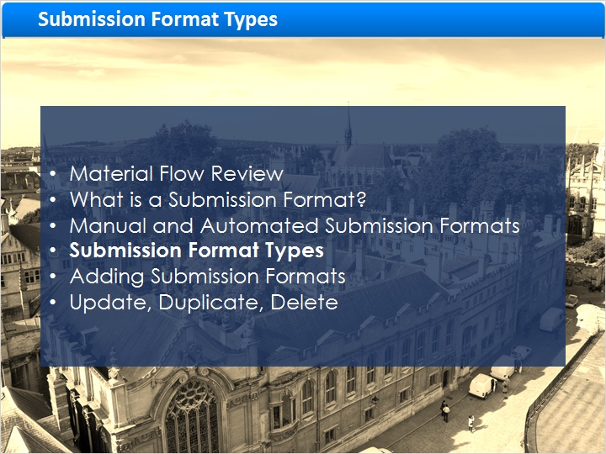
Notes:
Next we’ll discuss some commonly used submission format types, namely:

Detailed Submission Format, FTP Submission Format, and NFS Submission Format.

Note that different object’s file types warrant different submission formats. For example, MP3 files may have their own submission format and PDFs have theirs.

1.15 Detailed Submission Format
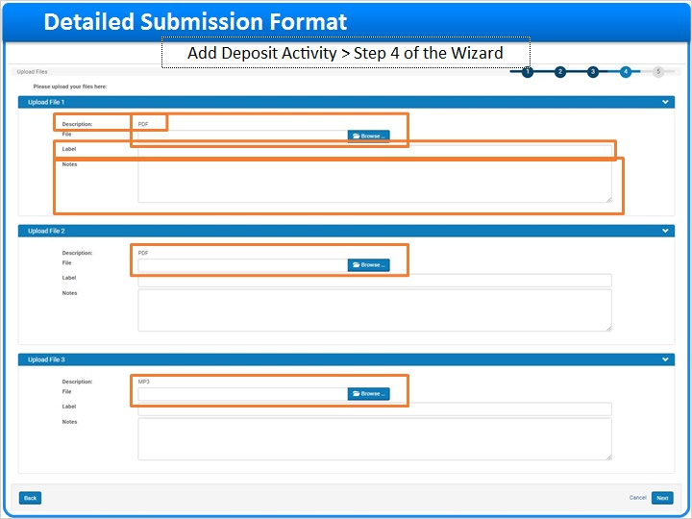
Notes:
Looking again at the web-based manual deposit wizard, we are now in step 4, The Upload Files page, where you select the files you want to upload.

In this example, the Detailed Submission Format is used; which specifies the exact number of each file type and maximum size of each file to be uploaded.

This particular Detailed submission format limits the deposit to 2 PDFs file that are no more than 2 MB each and 1 MP3 file.

Click on the Browse button to locate the file to upload from your local desktop or network.

Once the file is saved it’s name will display in the File field.

The Label will display to Staff in the Rosetta Management module and to end-users when the content is delivered.

Depositors can add Notes that will display to Staff in the Rosetta Management module, but not to end-users.
The Description field will refer to the file details once uploaded.

1.16 Detailed Submission Format – Configuration
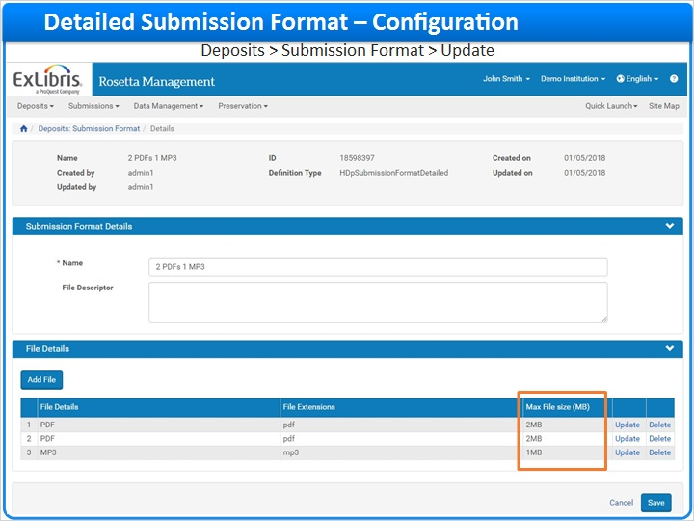
Notes:
Here is the same Detailed Submission Format as it looks to Staff configuring it in the Rosetta Management module.

You can see for example the limitations on file size we mentioned earlier; this is where they were defined.

1.17 FTP / SFTP Submission Format
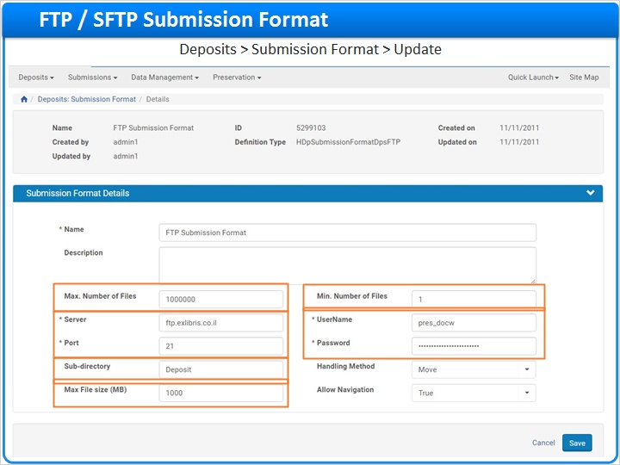
Notes:
In the previous example, we selected the files manually. But as mentioned earlier, Rosetta also allows content to be submitted via FTP or SFTP.

Let’s see how this is defined in the FTP / SFTP Submission Format.

The Server and Port refer to the server and port of the ftp or sftp server

Sub-directory refers to the directory on the ftp/sftp server where the files currently reside

UserName and Password are the authentication credentials for the ftp/sftp server.

Max File size (MB) allows you to limit the maximum file size that can be loaded with this submission format

Max. number of Files is the maximum number of files that can be uploaded with this submission format

Min. Number of Files specifies the minimum number of files that can be loaded; for example, a 1 file minimum.

1.18 NFS Submission Format
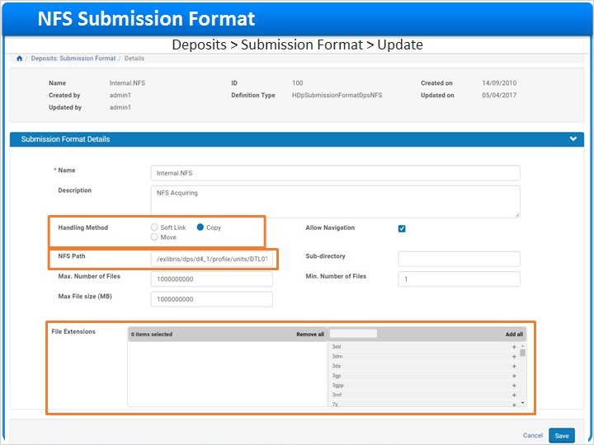
Notes:
Another option is for the automated submission format to upload files via NFS, or Network File System from your aforementioned mount directory,
Let’s review the more critical fields that comprise the NFS Submission format, as it is one of the more commonly used formats.
The Handling Method determines if the submission package is soft-linked, copied, or moved from the mount directory.
If the Move method is used, the submission package is deleted from the mount directory after ingest.
If the Copy method is used, a copy of the submission package is made for processing, and the original remains in the mount directory.
It is recommended to use the Copy method during load testing as you may need to re-run the same submission package several times.
Once the load testing is complete, and to save disk space, it is advisable to switch the handling method to ‘move’ so that the submission package is deleted once content is saved to the permanent repository.
NFS Path refers to the file path where the files to be ingested currently reside.
The Selected File Extensions parameter allows you to control what specific formats or file extensions can be loaded via this submission format.

1.19 Adding Submission Formats
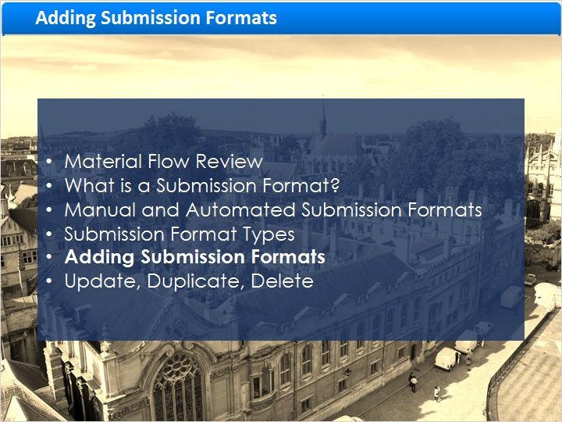
Notes:
Now let’s see how to create a Submission Format.

1.20 List of Submission Formats
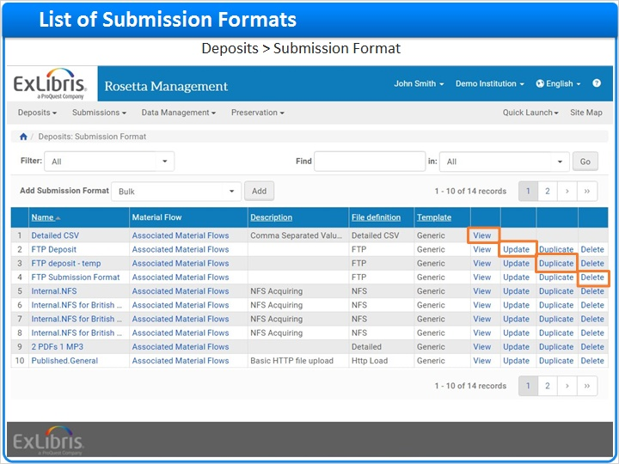
Notes:
To access the list of Submission Formats in the Rosetta Management module, go to Deposits > Submission Formats

This page enables Deposit Managers to view the existing Submission Formats or create new ones.

Click View to look at a Submission Format, without editing it.

Click Update to view and edit.

And you can also Duplicate and Delete Submission Formats.

1.21 Adding a Submission Format
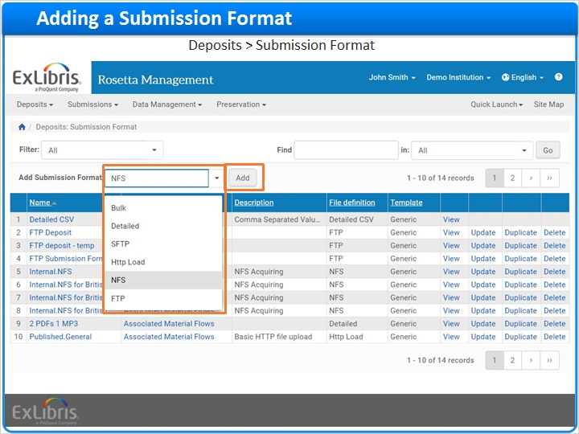
Notes:
For this exercise, let’s create an NFS Submission Format.

On the List of Submission Formats page, in the Add Submission Format drop-down list, select NFS.

Then, click Add.

1.22 Adding a Submission Format
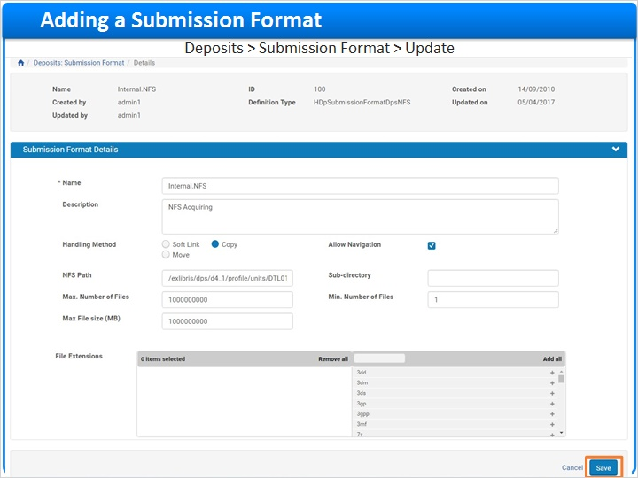
Notes:
The Submission Format Editor page opens.

Complete all mandatory fields as shown previously in the NFS Submission Format discussion of this session and click Save.
Clicking Save returns you to the List of Submission Formats with the new submission format added.

1.23 Link Submission Format to Material Flow
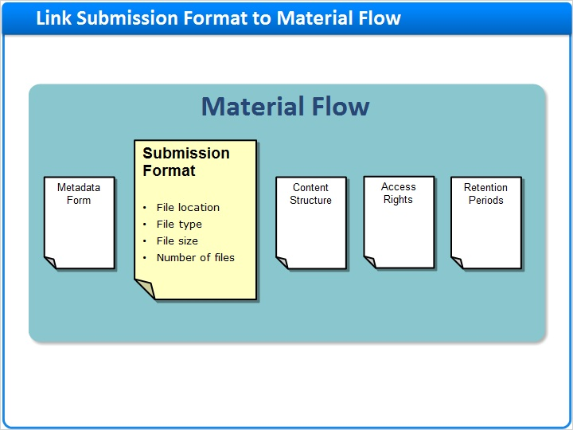
Notes:
To enable Producer Agents to use the submission format for deposit, Staff must link it with a Material Flow.
This topic will be covered in the Managing Material Flows - Combining Material Flow Components session.

1.24 Update, Duplicate, Delete
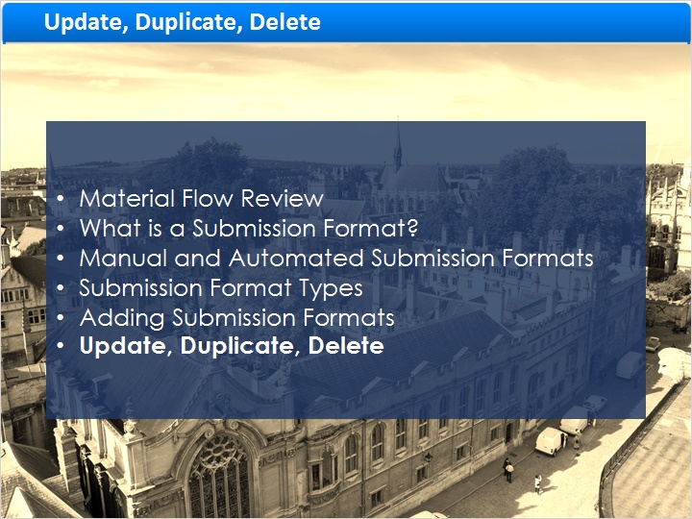
Notes:
Finally, let’s briefly look at the additional actions you can perform on a Submission Format.

1.25 Duplicate a Submission Format
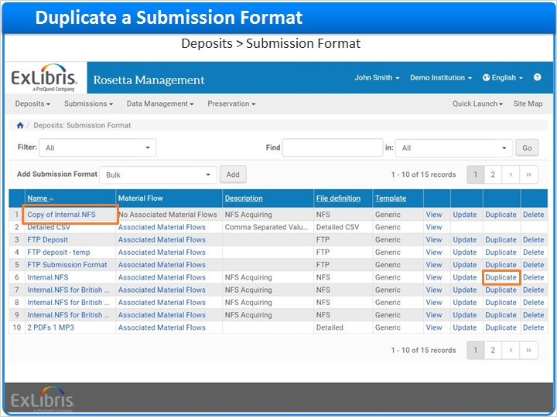
Notes:
Staff with the Deposit Manager role assigned can duplicate an existing Submission Format.
Duplicating can save you work and preserve consistency across Submission Formats.
To duplicate a Submission Format, on the List of Submission Formats page, locate the submission format you want to duplicate and click Duplicate.
A copy version of the submission format is opened for you to modify as needed.
When your updates are complete click Save and the new submission format is added to the list.
By default, the name of the new submission format is the same as the original one prepended with the word “Copy”.

1.26 Update a Submission Format
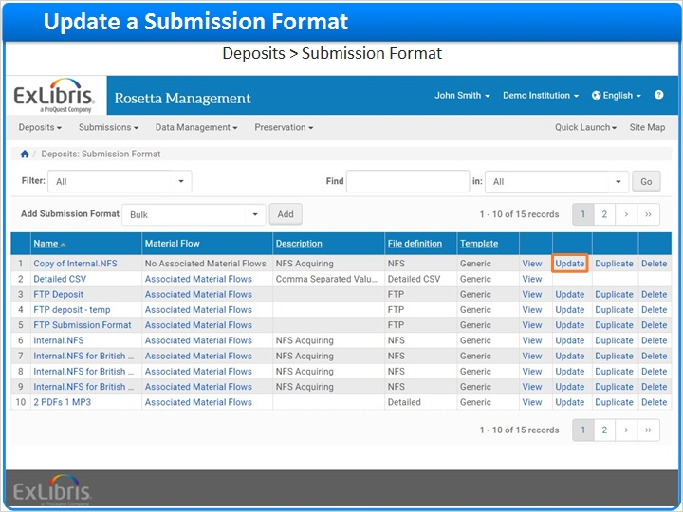
Notes:
Staff can update Submission Form details at any time.

To update, locate the Submission Form you want and click Update.

The Update Submission Form Details page opens for you to modify the fields as required, and save.

1.27 Delete a Submission Format
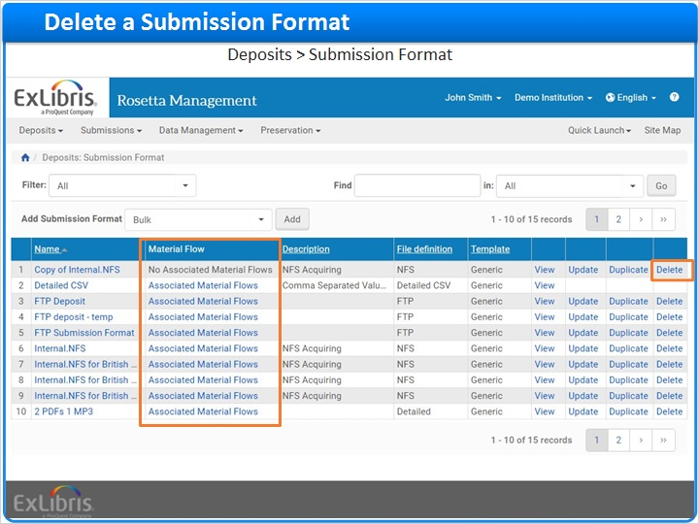
Notes:
If needed, users with the Deposit Manager role assigned can delete a Submission Format.

Note that if the Submission Format is currently associated to a Material Flow, it cannot be deleted.

To delete a Submission Format, find it in the list and click Delete.

This action is irreversible.

1.28 Session Summary
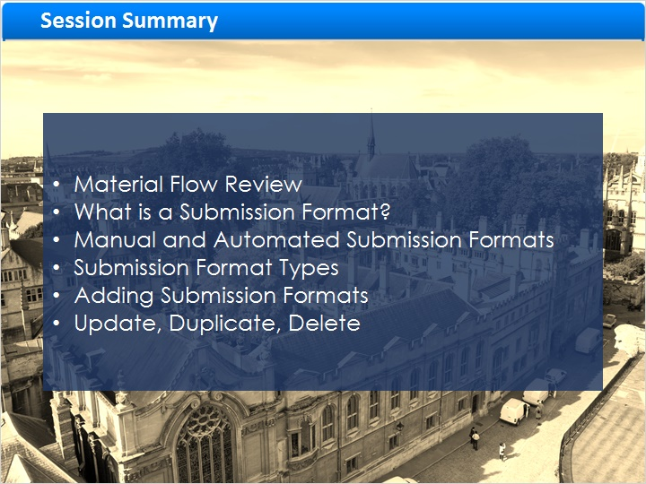
Notes:
In this session we continued to review the Material Flow components, focusing on the Submission Format.

We reviewed briefly the Manual and Automated deposit flows.

We also took a brief look at some of the more commonly used Submission Format Types.

Finally, we demonstrated how to Add a Submission Format as well as how to update, duplicate, and delete Submission Formats.

1.29 Additional Resources

Notes:
Thank you for joining us today!

We recommend that you continue to view the Managing Material Flows sessions to get acquainted with the other components of Material Flow.

These sessions and other documents and materials can be found in the Ex Libris Knowledge Center: knowledge.exlibrisgroup.com

1.30 About this Training
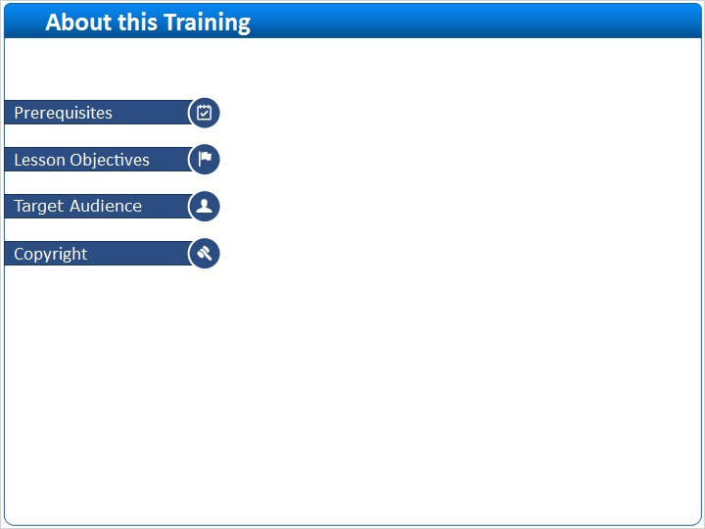
Notes:

1 (Slide Layer)
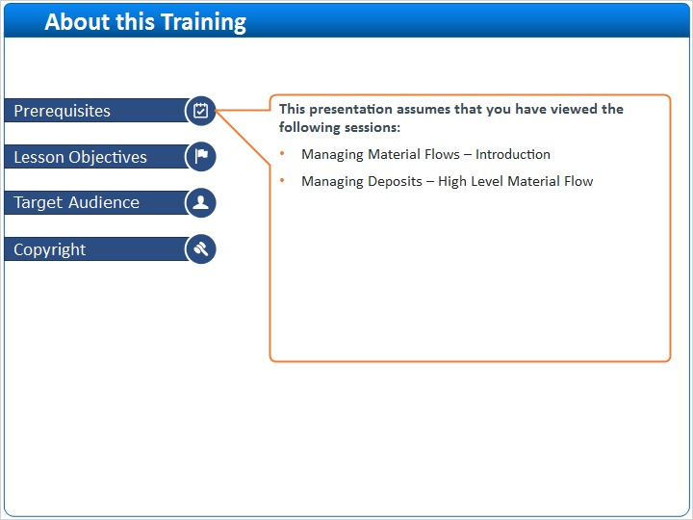

2 (Slide Layer)
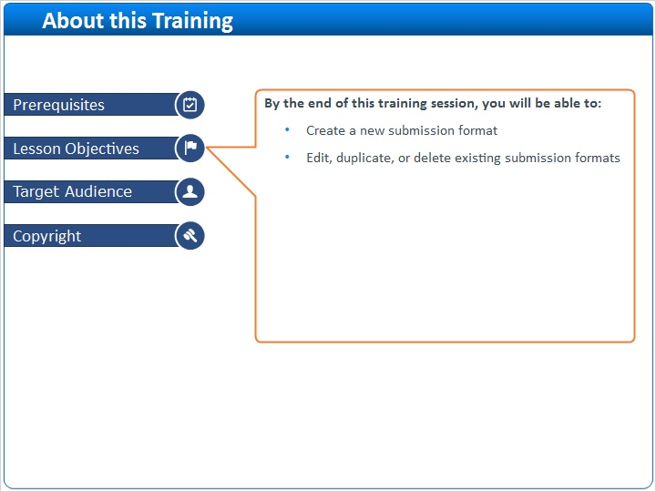

3 (Slide Layer)
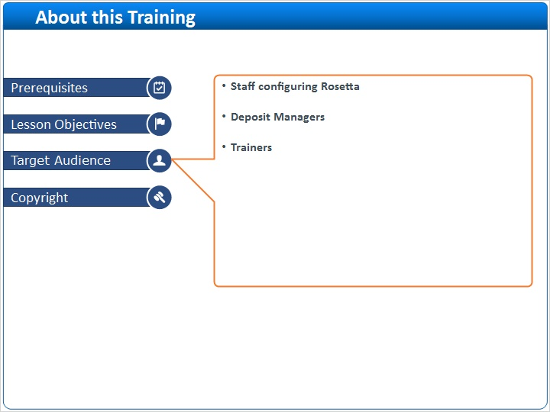

4 (Slide Layer)


