Material Flows - Content Structure

1. Managing Rosetta Material Flows

1.1 Welcome
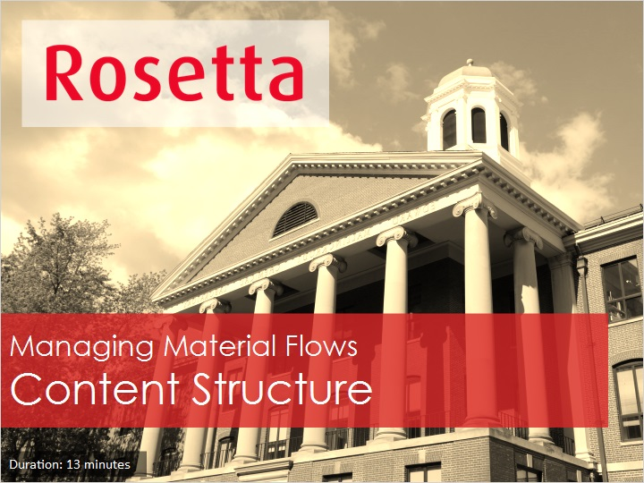
Notes:
Hello, and welcome to the Managing Rosetta Material Flows - Content Structure session

1.2 Agenda
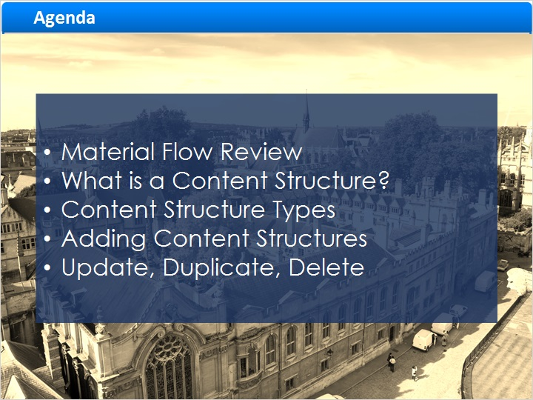
Notes:
Today we’ll start with a quick recap of material flows, then we’ll answer the question: what is a Content Structure?
- We’ll go over the different types of contents structures and how to add, update, duplicate and delete content structures.

1.3 Material Flow Review
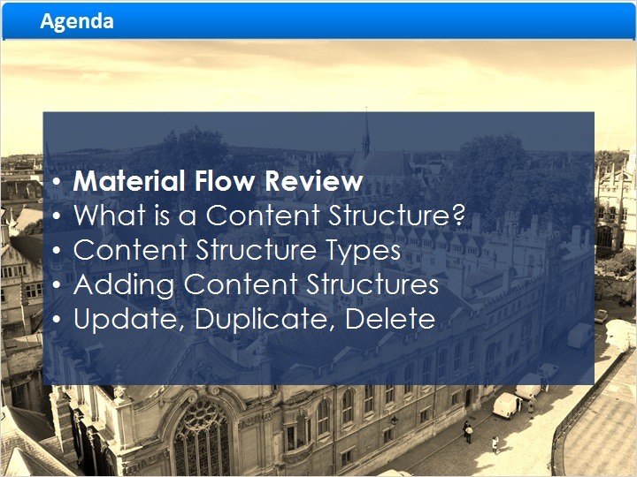
Notes:
Let’s start with a review of the Rosetta Material Flow

1.4 Material Flow Components
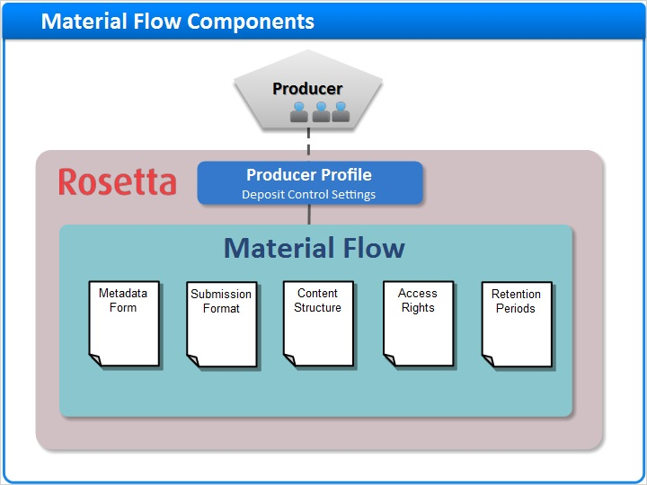
Notes:
In the “Material Flows Introduction” we learned that the Rosetta Material flow defines what types of content Producer Agents can deposit, and the means by which they perform deposits.

During deposit, the agent fills in a sequence of forms regarding the material.

These forms are configured in the five components of the Material flow.

Today we’ll focus on the third of these components, the Content Structure.

1.5 What is a Content Structure?
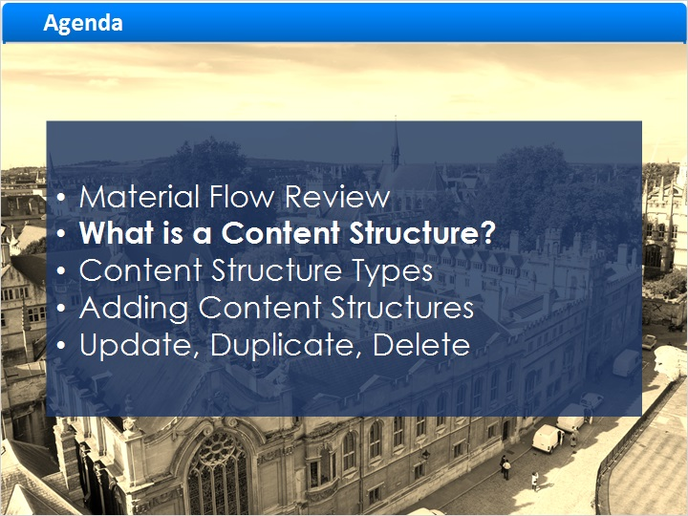
Notes:
So what is a Content Structure?

1.6 Content Structures in the Material Flow
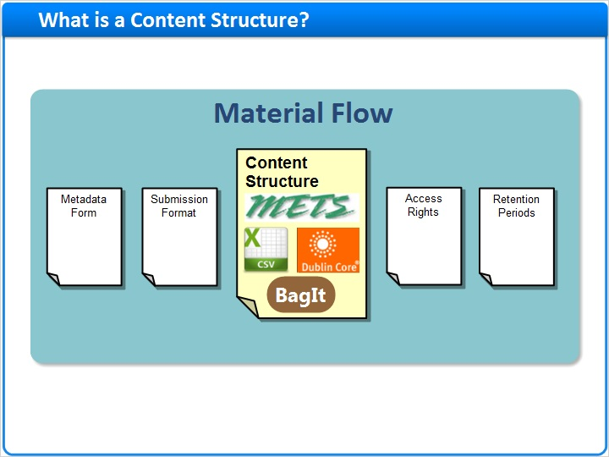
Notes:
As a component of the Material Flow, a Content Structure defines the structure of the submission package that will be ingested into Rosetta in order to convert it to the Rosetta-compatible METS format.

Staff with the Deposit Manager role can configure content structures.

1.7 Converting Input Formats
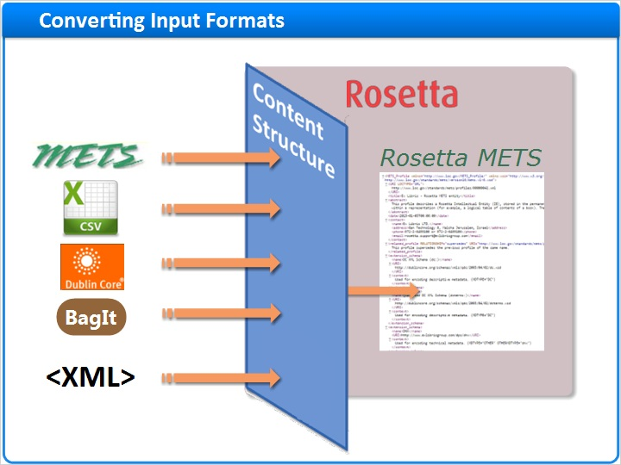
Notes:
Materials are deposited in one of four metadata structures: METS, CSV, Dublin Core, and BagIt.
The Content Structure converts them all to a unified structure: Rosetta METS.

Note that other XML structures may also be deposited, but they require conversion to one of the recognized formats via an XSL style-sheet, which must be configured ahead of time in the Content Structure.

1.8 Content Structure Types
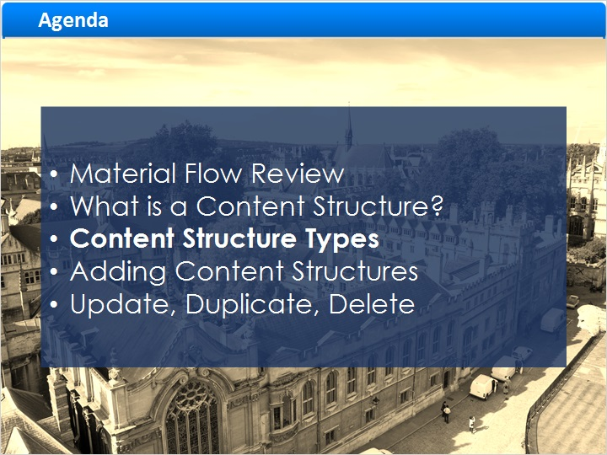
Notes:
There are several Content Structure types, reflecting the different types of input material.

As you implement Rosetta in your institution, Ex Libris Implementation staff will recommend appropriate content structures for your ingest needs.

Now let’s go over the different types of content structures.

1.9 METS Converter
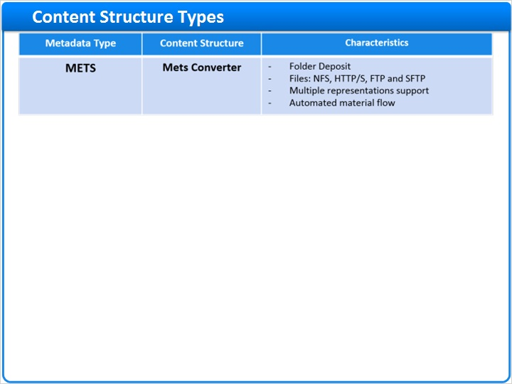
Notes:
The first type of content structure we’ll discuss is the METS converter, used to convert

METS metadata to Rosetta METS.
This content structure supports a folder deposit only and is recommended for automated workflows.
The SIP (submission information package) is comprised of a folder structure that includes the mets.xml file and stream files.
During the deposit, The folder is taken from a predefined location and files are pulled directly from original location via NFS, HTTP/S, FTP or SFTP.
METS files for ingest should comply with the Rosetta METS Profile which is registered at the American Library of Congress and includes attributes that are needed for Rosetta.

1.10 Comma Separated Converter
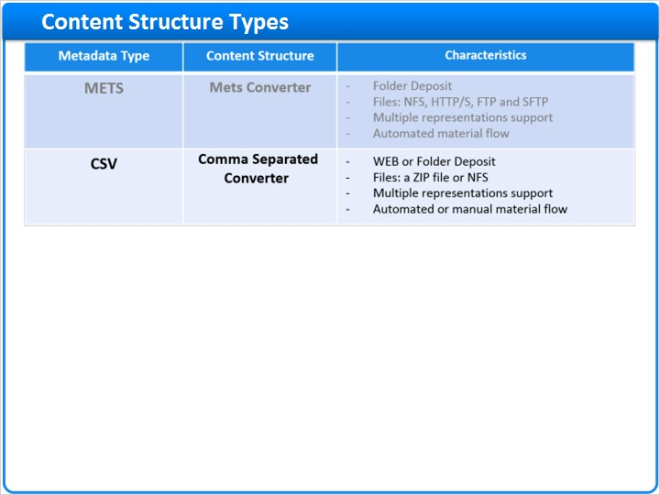
Notes:
CSV metadata is handled by the “Comma Separated Converter” also called “CSV Loader Converter”.
Rosetta provides a CSV template to ensure that ingested CSVs adhere to the Rosetta CSV structure.
The CSV loader can be used for Web deposit.
This loader allows you to ingest a CSV file containing Dublin Core descriptive metadata at the Collection, intellectual entity, representation, and file levels.
The material files may be deposited together in a ZIP file along with the CSV; or placed in a folder together with the CSV, for a SIP folder deposit.

1.11 XSL Converter
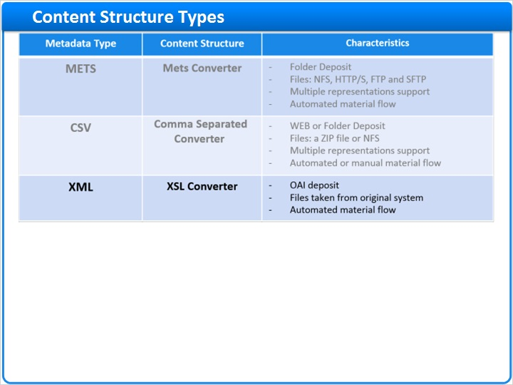
Notes:
XML metadata is handled by the “XSL Converter” which allows you to upload SIPs of any source format in an automated material flow.
Since Rosetta cannot recognize arbitrary XML formats, the XSL Converter relies on an XSL file to convert the XML to one of the recognized formats (namely, Dublin Core or METS). Rosetta offers four such XSL files Out-of-The-Box, but you may need to create your own stylesheet to fit your particular input format.
The “XSL Converter” can be used both to upload new files, and to enriching existing IEs with metadata, curtailing the need to create full, valid Rosetta METS.
This method is used for automated OAI deposit.

1.12 Dublin Core Converter
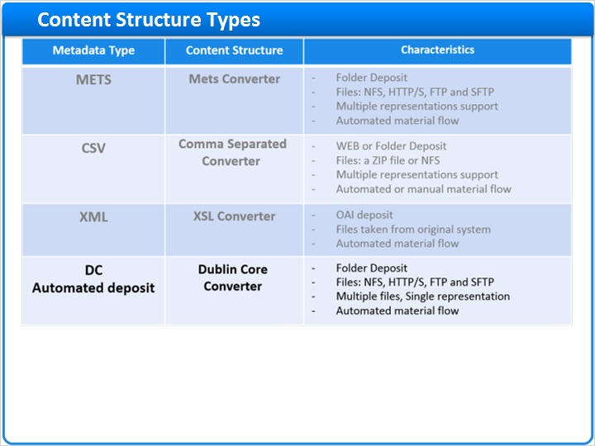
Notes:
Our next metadata type, Dublin Core Automated Deposit, is the loading of Dublin Core Descriptive metadata for single-representation deposits only (these are deposits where each IE has only one version of the material).

For such deposits, the “Dublin Core Converter” is used, allowing automatic ingest from one SIP folder of multiple stream files, each with its corresponding metadata.
These metadata are provided in one DC XML file, placed in the SIP folder together with the stream files.

1.13 Set of Files Converter
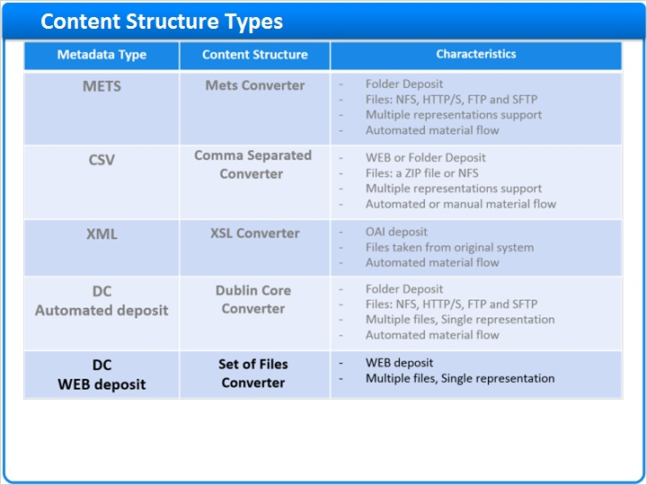
Notes:
For manual Dublin Core Web deposit the “Set of Files Converter” is used. It too supports only single representation.
This content structure can be configured for simple structure: 1 file per IE;
or complex structure: multiple files per IE.
In this method of deposit, The Dublin Core metadata is provided manually by the producer-agent in the Metadata Form.

1.14 BagIt Converter
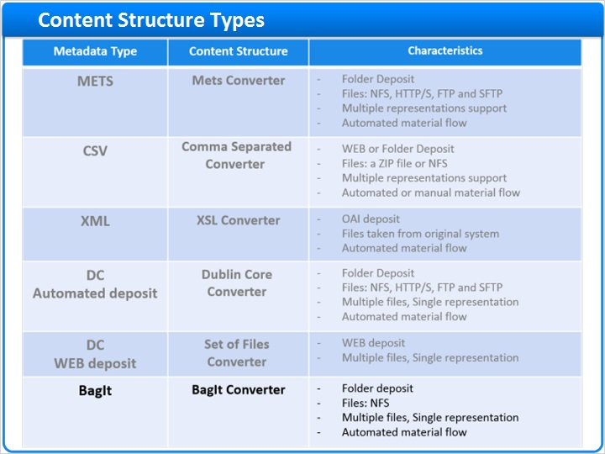
Notes:
Bagit metadata is handled by the Bagit Converter.

The BagIt format consists of the following sections:
Data - the digital files
Manifest - which contains a checksum that enables Rosetta to validate the files, and
txt file - which contains the MD tags of the BagIt data

1.15 List of Content Structures
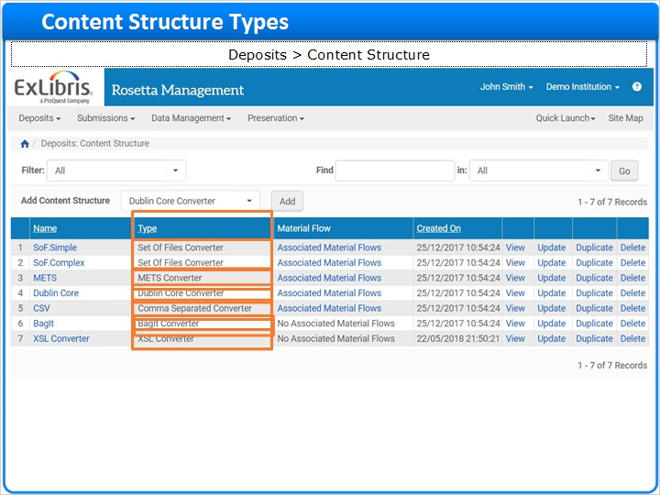
Notes:
This is what the list of Content Structures looks like in Rosetta.
To navigate to the list in the Rosetta Management module, go to Deposits > Content Structure.

In the second column we can see the type of each content structure. Let’s refresh our memory.

The “Set of Files Converter” is the simplest and quickest method to manually load content into Rosetta. In this example, we have two content structrures of this type in our system, a simple one and a complex.

The “Dublin Core Converter” is similar to the “Set of Files” Converter, but it is automatic, and supports multiple IEs with one metadata file.
The “XSL Converter” allows you to upload SIPs of any XML source format in an automated material flow. The XML is converted to a recognized format using an XSL style sheet.
The “METS Converter” is used when loading METS files in a structured SIP folder as part of an automated material flow.
The “Comma Separated Converter ” is used both for automated and manual deposit. The metadata is provided in a CSV file.
The BagIt Coverter is used when loading a BagIt package in a structured SIP folder as part of an automated material flow.

1.16 Add a Content Structure
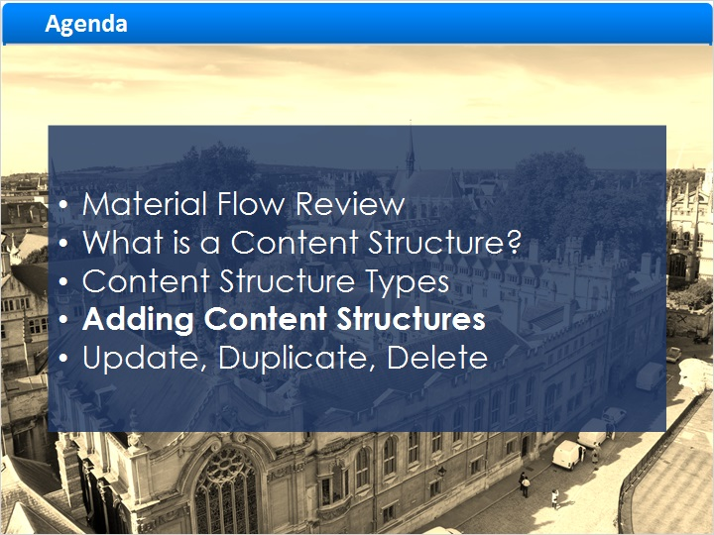
Notes:
Now let’s see how to create a new Content Structure.

Each type of Content Structure is created via a different form.

1.17 List of Content Structures
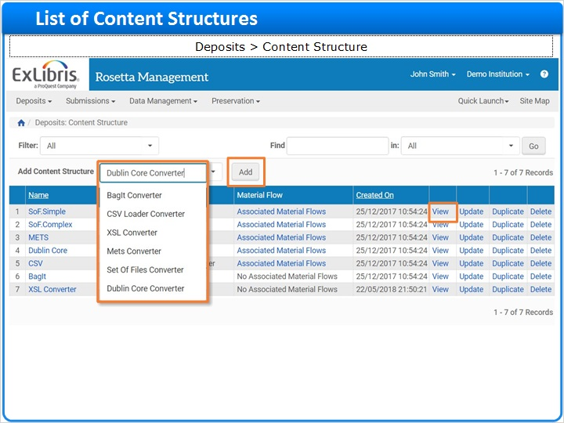
Notes:
Here we are again in the list of Content Structures.

In this page, Deposit Managers can view the existing Content Structures or create new ones.

[CLICK] Click on “View” to look at a Content Structure, without editing it.

[CLICK] To add a new Content Structure select the appropriate content structure type from the “Add Content Structure” drop-down list, and click “Add”.

1.18 Add Set of Files Converter
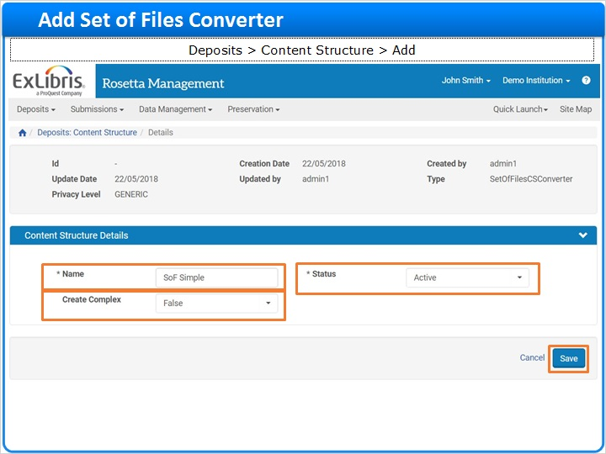
Notes:
The new Content Structure form opens, corresponding to your selection.

This example shows the “Set of Files Converter” form. This content structure is used for manual Web deposit, with the Dublin Core fields filled in via the metadata form.

Enter the content structure's unique name in the "Name" field.

"Status" should be set to active to allow use of this content structure.

If the “Create Complex" field is set to “true” Rosetta will create one IE with several files attached, or a “Complex Object”.
If the “Create Complex" field is set to “false” one IE is created for each file, a “simple object,” and all files will share the same descriptive metadata.
Click “Save” to save the content structure and return to the “List of Content Structures” page.

1.19 Add Dublin Core Converter
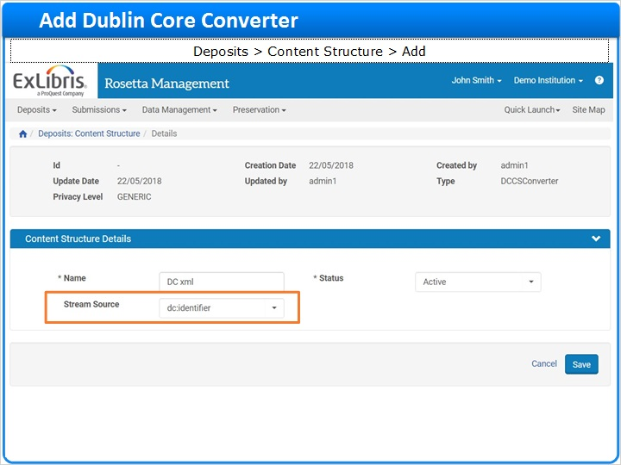
Notes:
This is the Dublin Core Converter form.

The Dublin Core Converter maintains a relationship between specific metadata and filestreams when creating multiple IEs with different metadata in one SIP. The dc.xml file that you ingest may contain multiple Dublin Core records.

You’re already familiar with most of these fields from the previous form.

"Stream Source" is the Dublin Core field in the dc.xml file, that tells Rosetta where to find the files being ingested.

The value of this field is a path relative to the streams subfolder in the SIPS folder. Altrenatively, it can be an absolute path or a URL; in any case, it must be a direct link to the file and not a virtual link.

1.20 Add CSV Loader Converter
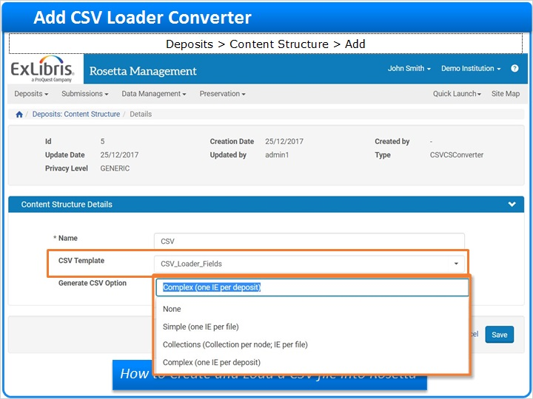
Notes:
Now let’s look at the CSV Loader Converter form.

The CSV Content Structure allows you to submit metadata in CSV format along with the associated file streams.

Rosetta creates Intellectual Entities with their Representations and files, based on the information in the CSV.

You can also include rows in the CSV to create collections during ingest and assign Intellectual Entities to them automatically.

When creating a CSV Content Structure you must specify a “CSV template”, which determines what metadata fields are included in the CSV.

The “Generate CSV Option” drop-down list, defines the CSV structure generated for the depositer during manual deposit.

The “Download CSV Template” becomes available after you’ve saved the content structure. This button allows you to auto-generate an example CSV file with the same structure as the one that will be used in the upload. Click on “Download CSV Template” to obtain the generated file.
For more information about creating a CSV template to be used by the CSV Content Structure, refer to the “How to create and load a CSV file into Rosetta” article in the Ex Libris Knowledge Center.
Also, during your Rosetta Implementation, Ex Libris project staff will work closely with you to configure this; so no worries!
Note that the CSV Content Structure can only be used in a material flow that is linked to either a “Detailed CSV” or “NFS” submission format.

1.21 Link Content Structure to Material Flow
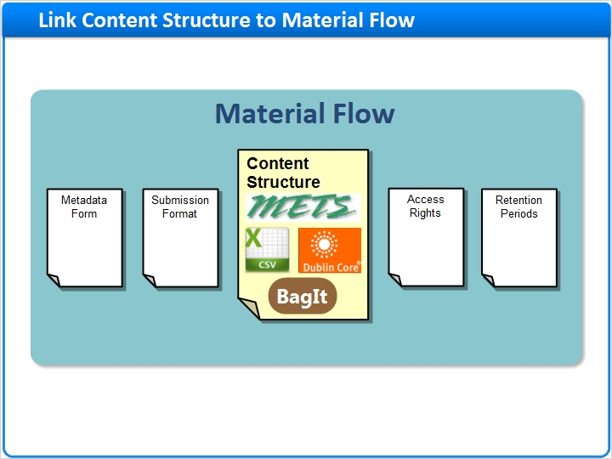
Notes:
Once you’ve finished creating the Content Structure, Staff must link it with a Material Flow, to make it available to the producer agents.
This topic will be covered in the “Managing Material Flows - Combining Material Flow components” session.

1.22 Update, Duplicate, Delete
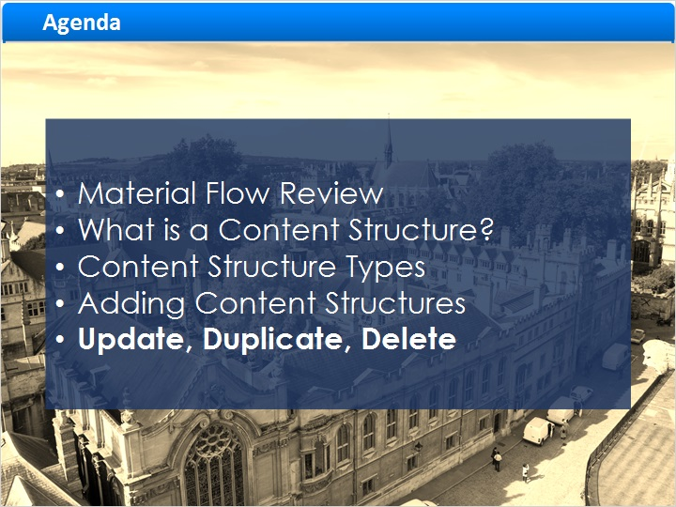
Notes:
Finally, let’s take a quick look at the other actions you can perform on content structures.

1.23 Update a Content Structure
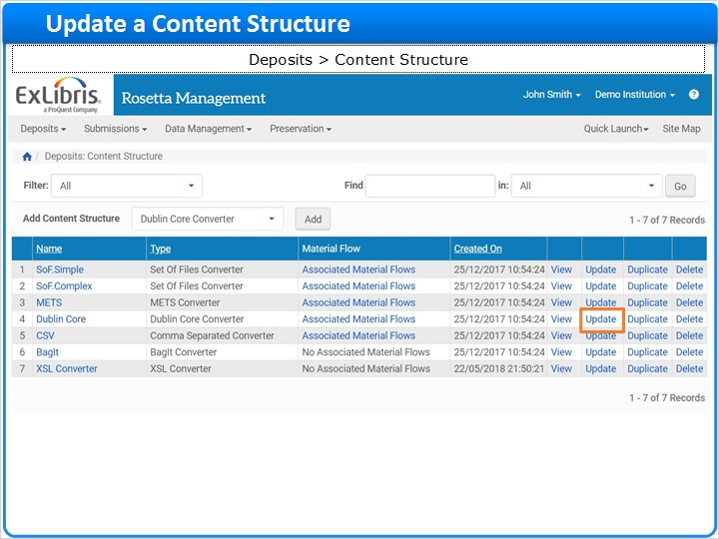
Notes:
Staff can update Content Structure details at any time.

To update a Content Structure click “Update”. The Content Structure Details page will open where you can modify the fields as required.

1.24 Duplicate a Content Structure
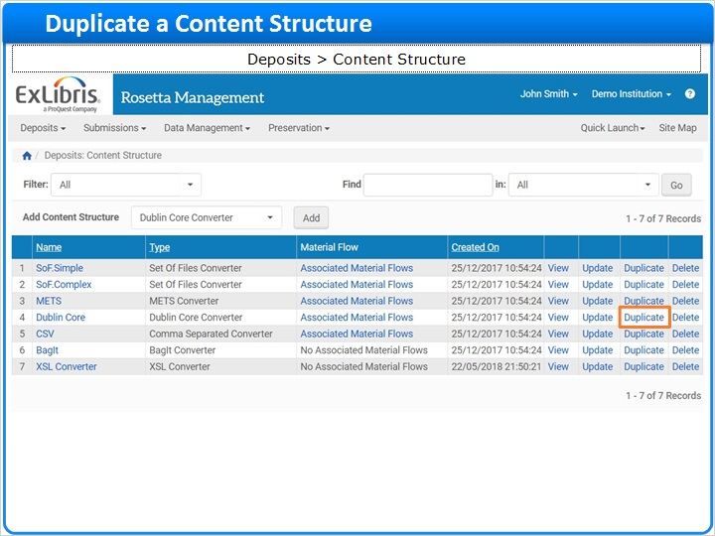
Notes:
Staff with the Deposit Manager role can duplicate an existing Content Structure.
Duplicating is often faster than creating a new one, and preserves consistency across Content Structures.
To duplicate a Content Structure, locate it in the list and click “Duplicate” [CLICK].
A copy version of the form is opened for you to modify as needed.
After saving, the copy of the Content Structure is added to the List.
By default, the new content structure will have the same name as the original with the word “Copy” prepended to it.

1.25 Delete a Content Structure
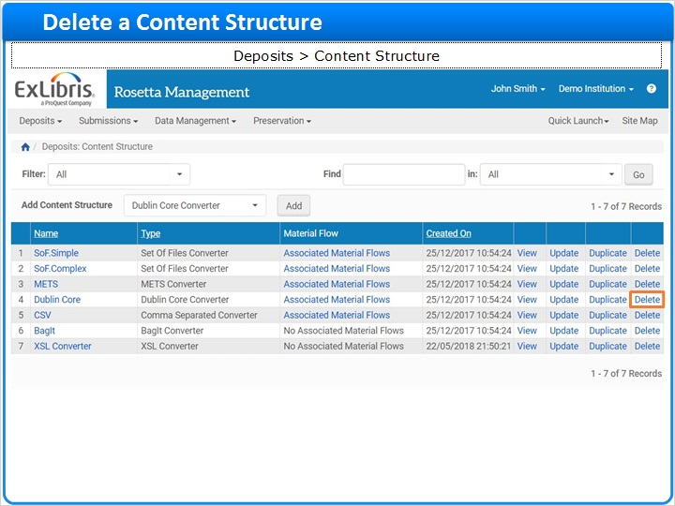
Notes:
And finally; Staff with the Deposit Manager role can delete a Content Structure, if needed.

A content structure cannot be deleted if it is associated with a Material Flow.

To delete the content structure, locate it in the list and click More -> Delete.

The content structure is removed from the list, and can no longer be used by producer agents.

This action is irreversible, so delete responsibly!

1.26 Summary
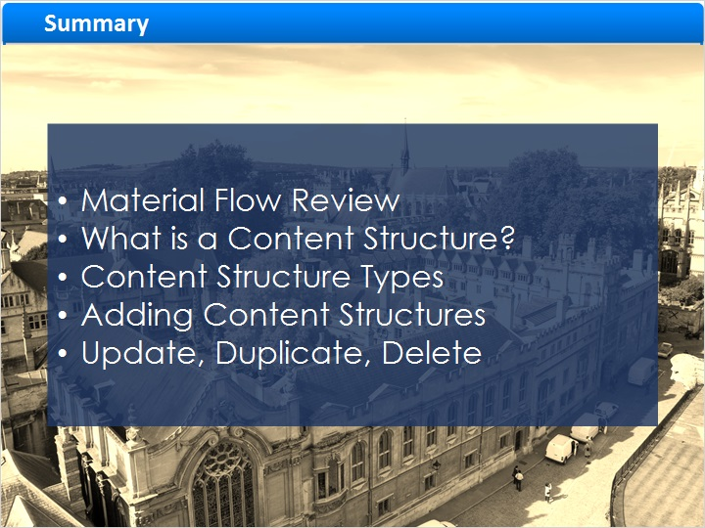
Notes:
In this session continued to review Material Flow components, focusing on Content Structures

We learned what a content structure is and went over the more commonly used Content Structure Types [CLICK]

Finally, we demonstrated how to Add a Content Structure as well as how to update, duplicate, and delete Content Structures

1.27 Additional Resources

Notes:
Thank you for joining us today!

We recommend that you continue to view the “Managing Material Flows” sessions to get acquainted with the other components of material flow.

These sessions and other documents and materials can be found in the Ex Libris Knowledge Center: knowledge.exlibrisgroup.com

1.28 About this Training
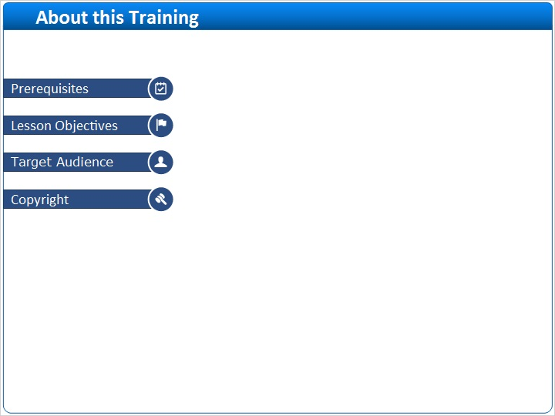
Notes:

1 (Slide Layer)
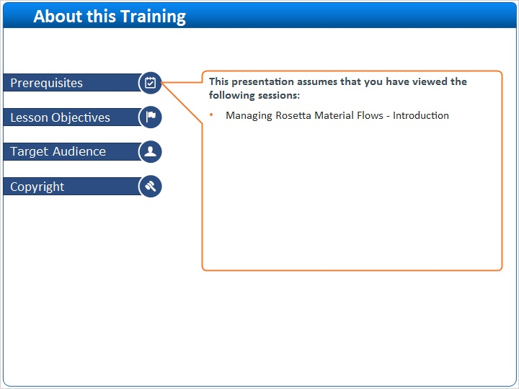

2 (Slide Layer)
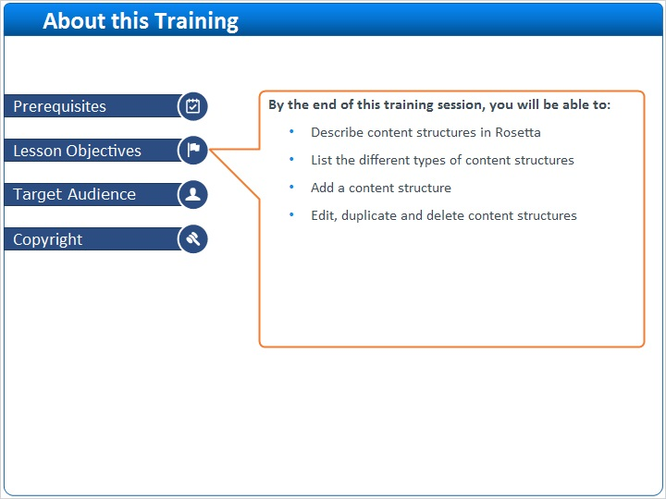

3 (Slide Layer)
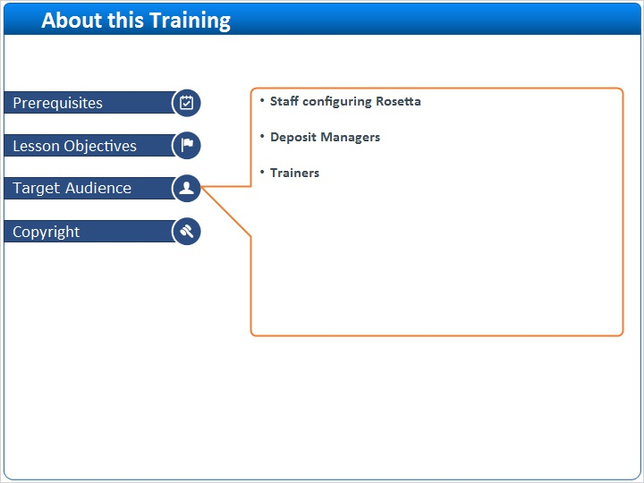

4 (Slide Layer)


