campusM Introduction

1.1 campusM Introduction
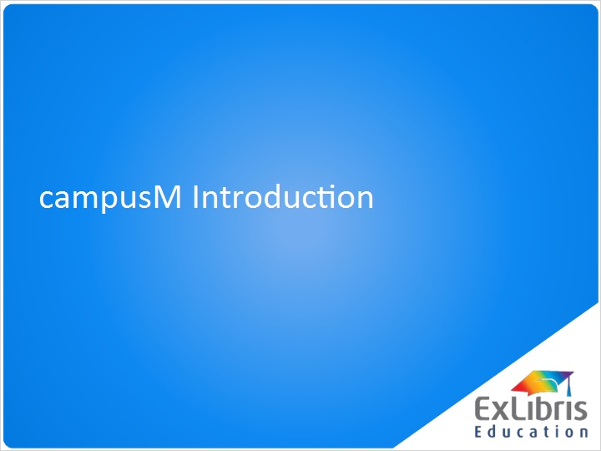
Notes:
Hello, and welcome to this session on Introduction to campusM.

1.2 Welcome
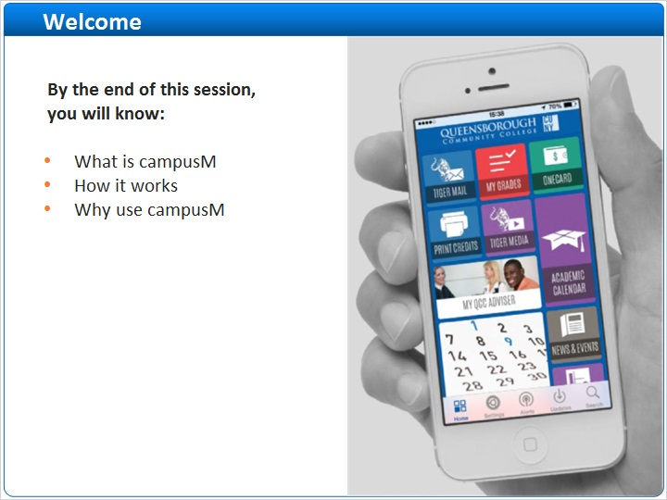
Notes:
In this session, we will introduce campusM -the app-first platform driving student engagement to unprecedented levels.
By the end of this session, you will know what campusM is, how it works and the benefits of using campusM in your university campus.

1.3 What is campusM?
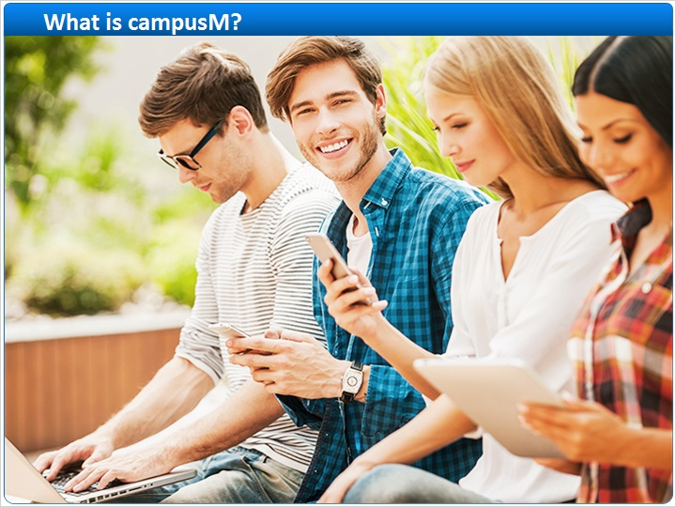
Notes:
There is overwhelming evidence that today’s students are Digital students.
They want and expect, to access services and information via apps on their mobile devices.

1.4 Why Use campusM?
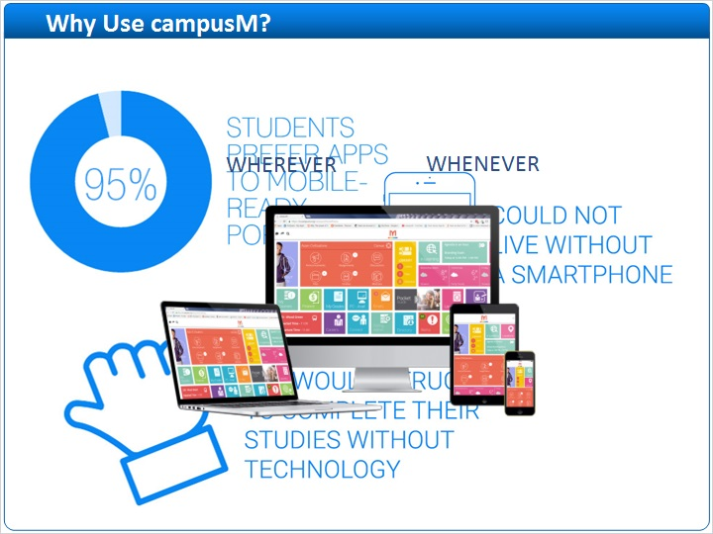
Notes:
We know that…
over 95% of students come to university with a smart device, many with more than one device.
88% of students would struggle to complete their studies without the use of technology.
74% of users who have a smartphone say they would be “unable to live without it”.
These students have the expectation that university information and services should be mobile-friendly, and available wherever and whenever they need them.

1.5 campusM: A Personalized Campus Service
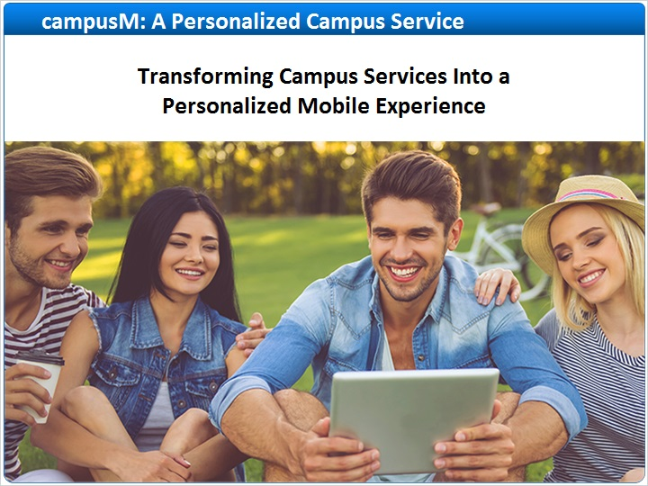
Notes:
campusM transforms your campus services into a personalized university experience by delivering consistent user experience across all devices and maximizing the value of university services for prospective students, students, staff, alumni and other users.

1.6 What campusM Offers You
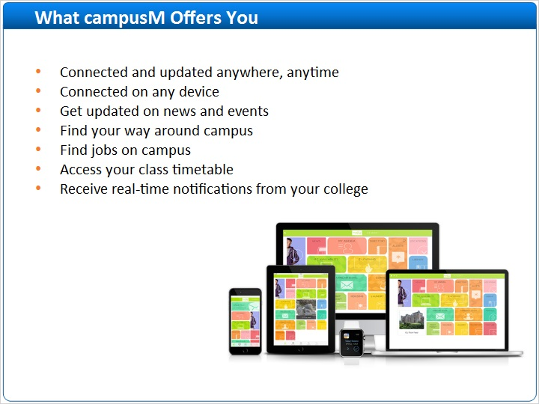
Notes:
With the campusM app installed, students and staff can be connected and updated anywhere, anytime and on any device!
Get updated on news and events, find your way around campus, find jobs on campus, access your class timetable and receive real-time notifications from your college.
These are just a few of the things campusM enables you to do.

1.7 The campusM Perspective
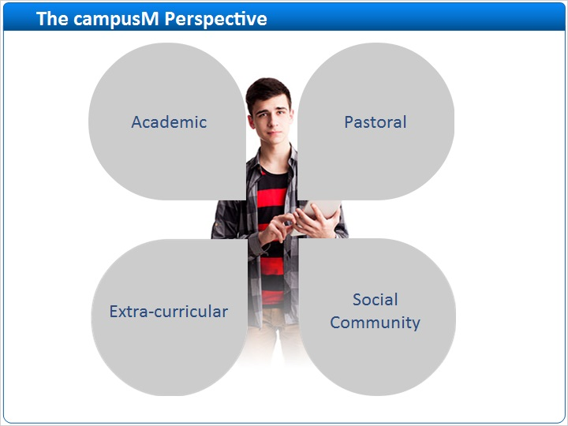
Notes:
campusM provides an intuitive platform with which to engage and participate across all key student areas:
- Academic progress and success
- Pastoral support and encouragement
- Extra-curricular activity to enhance students’ success and involve them in opportunities available outside of their study program
Participation and engagement with the wider university community, sports, clubs and so on.

1.8 Personalized Student Life-Cycle App
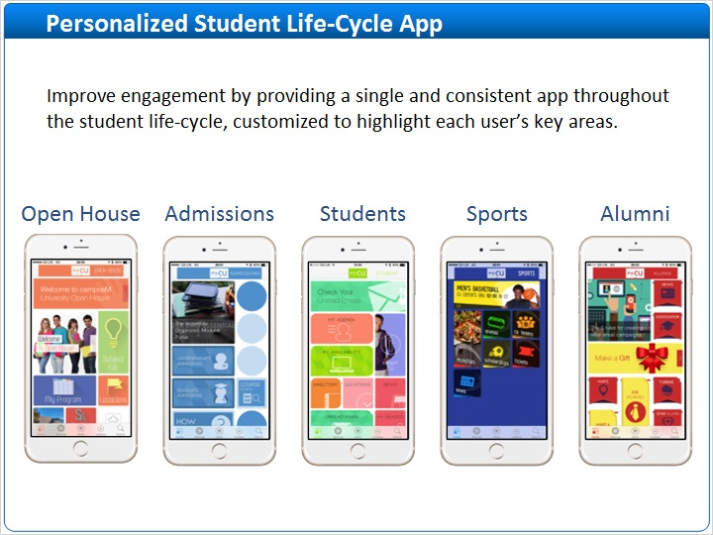
Notes:
campusM delivers value at all points of the student life-cycle, from pre-engagement of future students through to current students, graduates and alumni.
Each feature can have a different look and feel, tailored to the specific market.
You can manage all profiles through the same admin interface.

1.9 campusM Key Product Features
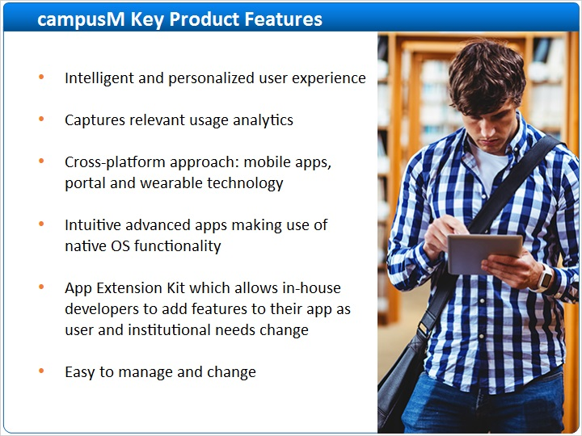
Notes:
Here are some of the key product features that are at the heart of the campusM experience.
· Intelligent and personalised user experience that increases student engagement
· Captures relevant usage analytics
· Cross-platform approach: mobile apps, portal and wearable technology
· Intuitive advanced apps making use of native OS functionality
· Easy to manage and change
With these key features, we can offer a platform that addresses the current challenges, whilst providing the tools to be ready for future opportunities.

1.10 campusM Digital Relationship on all Devices
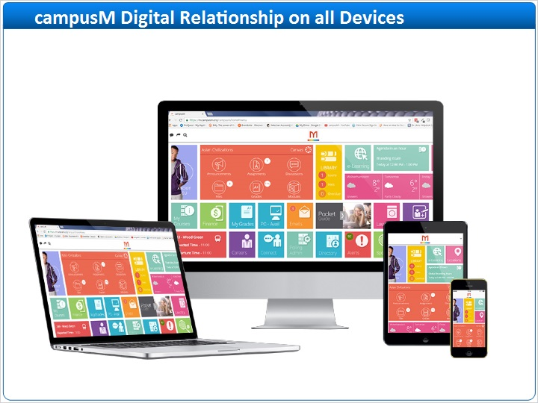
Notes:
campusM builds a digital relationship with its users by providing personalized content on their own devices, anytime and anywhere.

1.11 campusM Functionality Tailoring
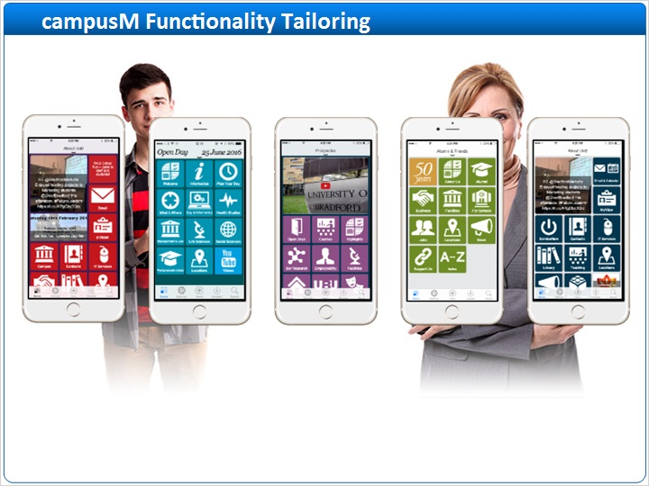
Notes:
campusM can be personalized to any role or profile. Different users will see relevant content and have functionality tailored to their needs. For example, what faculty members need in their app is different to what first year engineering students need.

1.12 The Magic of campusM

Notes:
So how does campusM do all of this? Let’s meet Joe.
With the campusM app, Joe receives exactly the information he needs.
Content can be targeted at a specific user. For example, notification from the library. The user lists can be synchronized with other university systems.
Joe and his class mates can access their course material, grades and assignments all through campusM.
Administrators use profiles, roles, and personalization settings to control access to all aspects of institutional deployments, including branding, content, screens and menu options.

1.13 The Magic of campusM
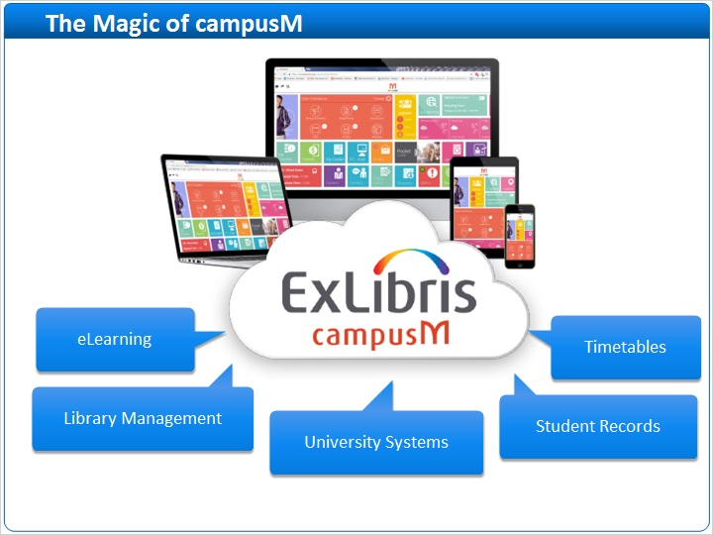
Notes:
campusM has a comprehensive middleware solution - campusM Cloud.
This provides a saleable and secure platform for integrating with university business systems.
It enables the intelligent personalisation of the university experience, delivering individuals data from the university systems to their personal devices.
This simplifies dealing with the logistics of being a student and provides that one-stop-shop for services and information for the student.

1.14 Platform Overview
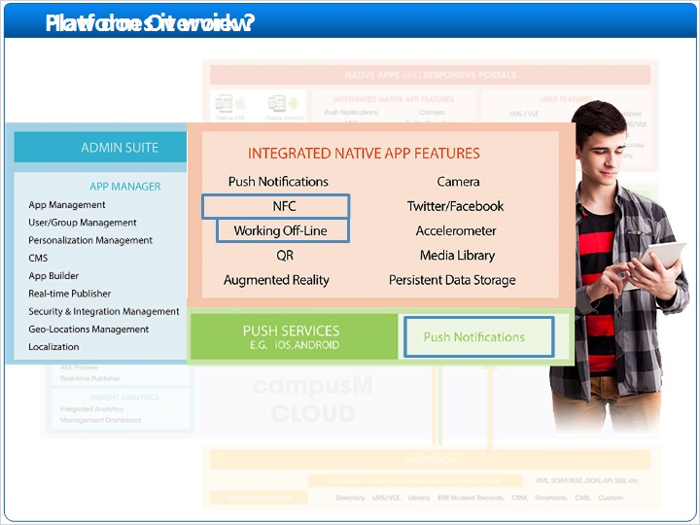
Notes:
So, how does this magic work?
The app is located on the campusM secure cloud. App services on the cloud connect to the institution and communicate with institution systems such as: directory, LMS, library, CRM and others, as well as with web services such as: XML, SOAP, REST and so on.
On the user side, for students and staff, app services on the could connect to native apps for iOS, Android and responsive leaning portal.
This dual-way connection makes university systems available for users anywhere, anytime, all in one accessible and intuitive place/platform.
Additionally, as an administrator, it is easy to manage, with the use of a full admin suite that includes the app manager, APP extension kit and insight analytics tools.
And in real life? Let’s take a look at Joe’s day.
It’s morning, Joe wakes up and checks his class timetable on his campusM app, his first class is at 10.
When he gets onto campus, he gets a push notification from campusM to tell him that there is a change in the room for his class.
He goes into his campusM app to read the alert and gets directions to the new room via the campus map.
As he walks into his lecture and campusM registers his attendance.
After class, he notices a banner in campusM advertising that his favorite campus coffee shop is giving away free doughnuts with every coffee purchased, so he goes and grabs a cup, using his phone to pay.
Next, he needs to go to the library, he received a campusM push notification telling him that the book he has requested is ready for him to pick up.
It’s time to go home, so he catches the next available bus, and during the ride home reviews the class notes from his lecture. He can do this without internet access because campusM apps store learning materials and other resources off-line. All connected, all in one place.

1.15 Summary
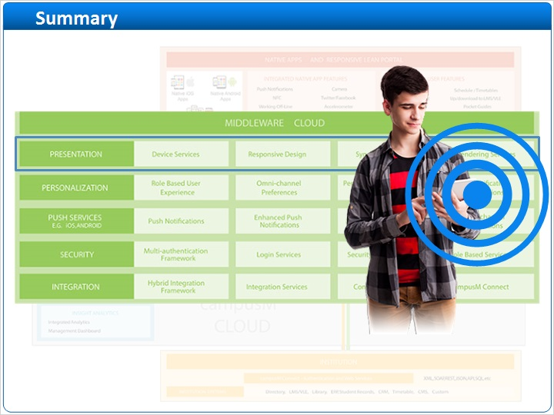
Notes:
This short example demonstrates only a very small part of what campusM has to offer.
You have seen the richness of presentation possibilities: A student can receive alerts and notifications, view static content through pocket guides and navigate campus using interactive maps.
Data and content hosted on university systems can be delivered directly to the student, and in addition external third party systems can be integrated directly into the app, for example, bus timetables or launderette availability.

1.16 Session Review
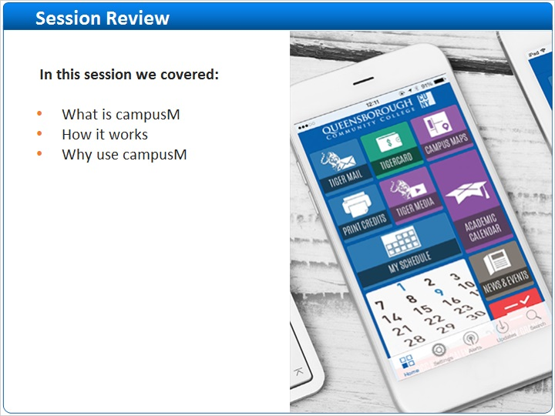
Notes:
That’s all for this session. In this session we discussed the wide variety of features and benefits of campusM app
We explored campusM structure and its working flow.

1.17 Thank you!

Notes:
Thank you for participating!

