TA Workbench

1. TA Workbench

1.1 Welcome
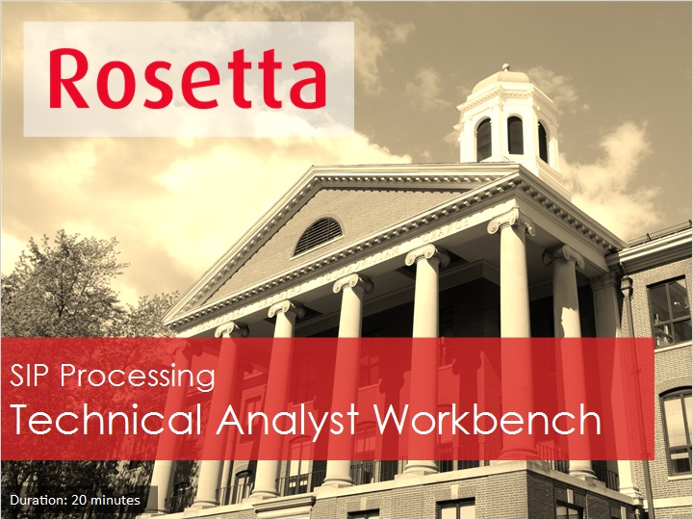
Notes:
Welcome to the Rosetta Technical Analyst Workbench session.

1.2 Agenda
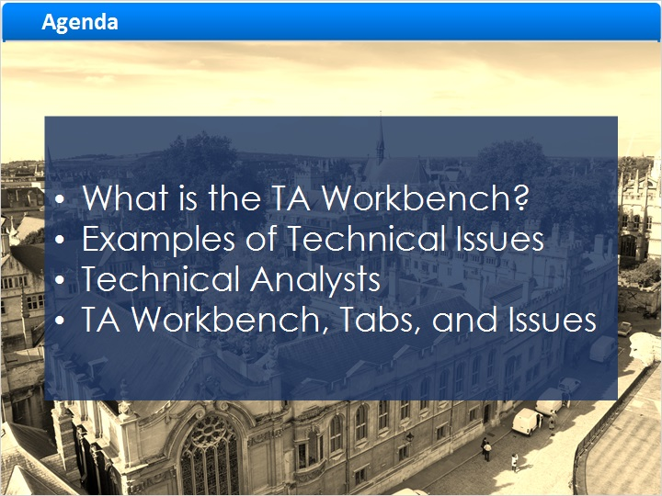
Notes:
In this session we will cover the following topics:
What is the TA Workbench?
Examples of Technical Issues that are addressed by using the TA Workbench.
Technical Analysts and their role.
And finally how each of the tabs in the TA Workbench allow for viewing and correcting issues.

1.3 What is the TA Workbench?
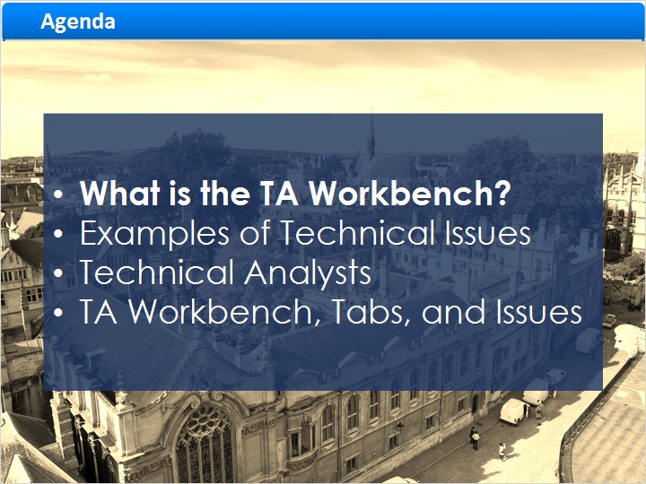
Notes:
What is the TA Workbench?

1.4 File Validation & Enrichment from SIP to AIP
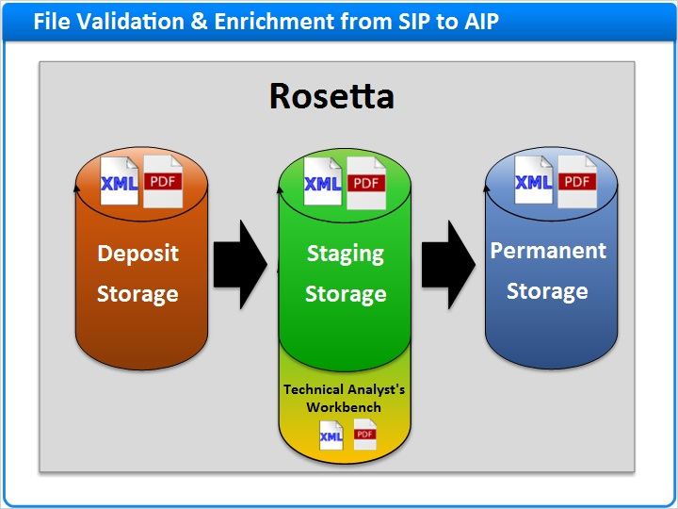
Notes:
The Technical Analyst's Workbench, or TA Workbench, is the area in Rosetta that allows Technical Analysts to work with content that was identified as problematic during the validation and enrichment processes.

To understand where the TA Workbench fits into the file loading process, let's refer back to the data model. SIPs are first deposited into the deposit area. The files are then copied to the staging area for processing where they will be transformed into an AIP, then copied to permanent storage.

Before moving the files to permanent storage, Rosetta performs a validation process on the files. Only valid files will continue to be processed and saved to the permanent repository. If there are issues validating the SIP's file, or the Enrichment processing is problematic, the SIP will get re-routed to the TA Workbench for further analysis.

1.5 From Submissions
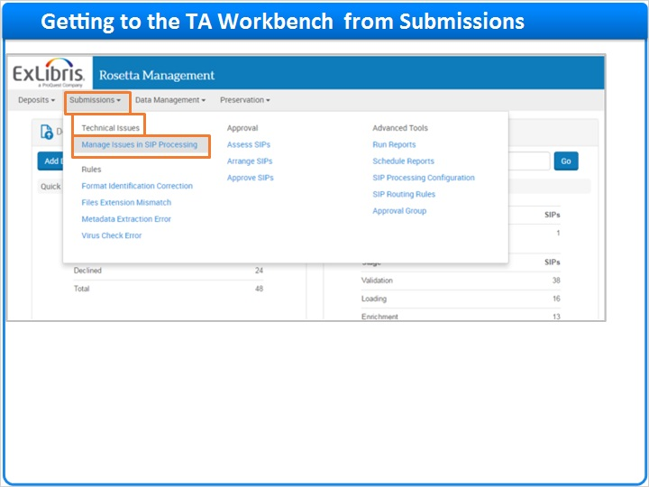
Notes:
To get to the TA workbench select Submissions > Technical Issues > Manage issues in SIP processing

1.6 From the Dashboard
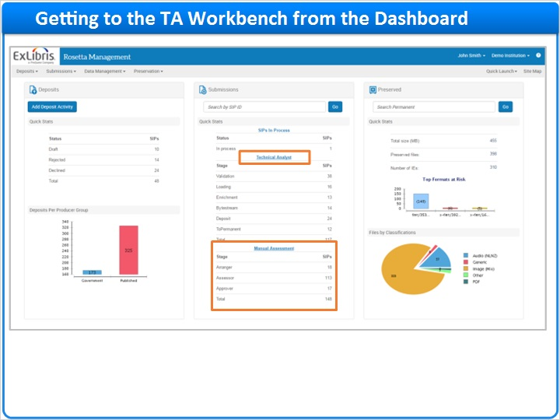
Notes:
Or from the Dashboard, you can click on Technical analyst. The Dashboard itself will display the number of SIPs which are currently in the TA Workbench

1.7 TA’s Workbench - Deposit
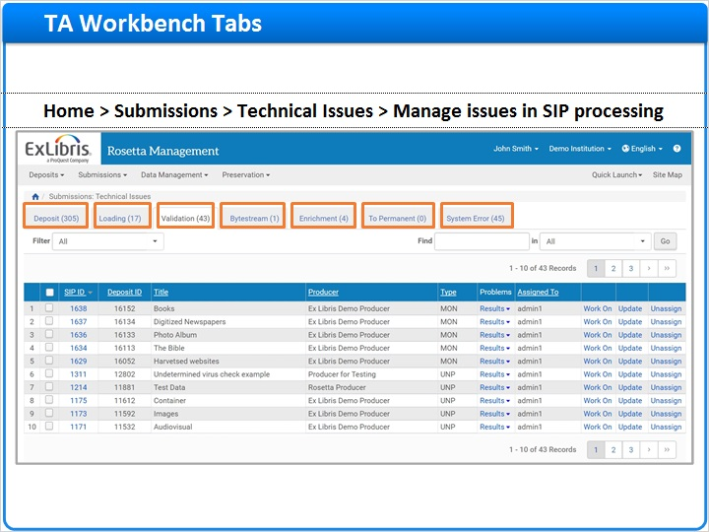
Notes:
The TA Workbench has 7 tabs:
The Deposit tab lists deposit activities that failed when they were uploaded to the Deposit Server.
The Loading tab contains SIPs that failed when they were moved from the Deposit Server to the Staging Server.
The Validation tab contains files that failed during the validation check.
The Bytestream tab displays SIPs with bytestreams that failed during the bitstream extraction stage.
The Enrichment tab contains files that failed when the Rosetta system was enriching the content.
The To Permanent tab contains files that failed when the Rosetta system was moving them from the Staging Server to the Permanent Repository.
And finally, the system error tab contains SIPs that failed to complete processing after several attempts.

Each tab contains the SIPs that failed in that tab, and different options to manage those SIPs.

1.8 Examples of Technical Issues
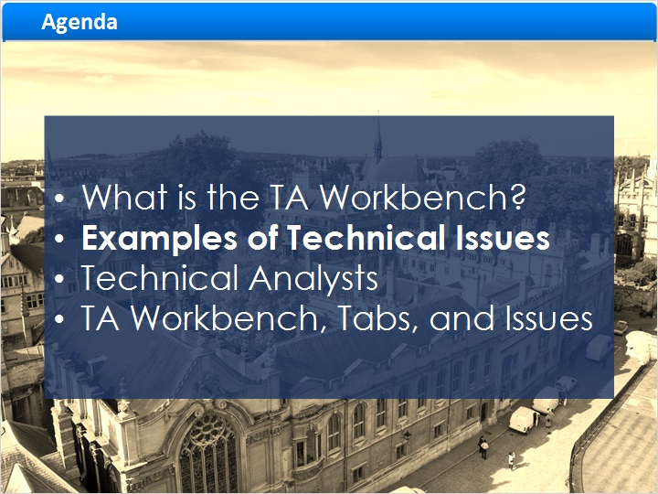
Notes:
Examples of technical issues

1.9 Virus Check Validation Fails
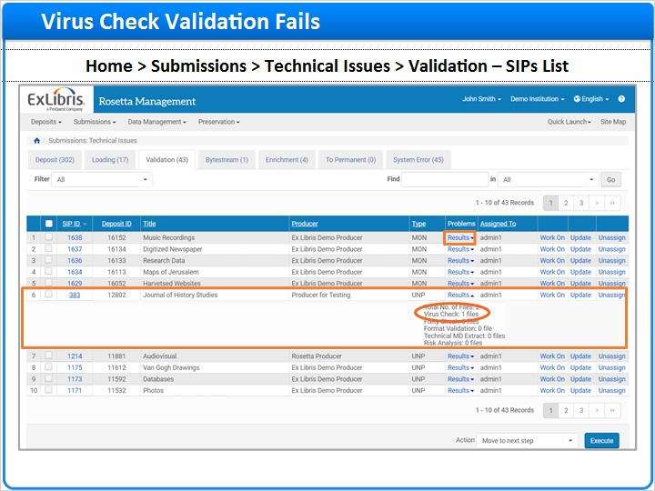
Notes:
Let's see some examples of technical issues that cause SIPs to show up in the TA Workbench.

When clicking on the results link we can see the stage where the file failed in the validation process. In our example SIP 383 failed during the virus check. Any time a file is loaded to a staging area or ingested into Rosetta, a virus check is run to confirm that all files are virus-free. If the file fails the virus check, the SIP will get re-routed to the TA Workbench for further analysis as we see here.

In order to perform the virus check, the task runs specialized software, like McAfee Virus Scan. This specialized software is added to the Rosetta server by the customer.

1.10 Technical Metadata Extraction Fails
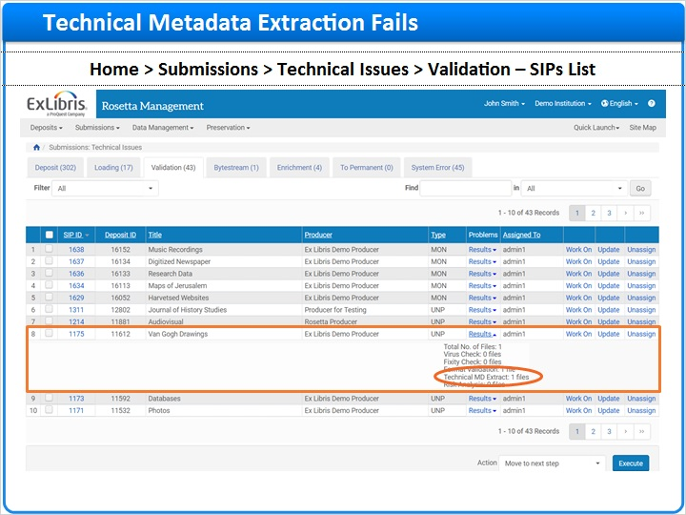
Notes:
Preservation information embedded in the file's properties must be extracted using Rosetta's bundled 3rd party technical metadata extraction tools.
3rd party utilities such as JHOVE or the NLNZ MD Extractor collect important preservation metadata about the file, such as the file's size, creation date, encoding, and compression.
Metadata extracted via the Technical Metadata Extraction task can then be used as input for both file format and risk identification.
However, in some cases the extractor is not able to read the file's properties which prevents the extraction of this information. When this happens, the SIP will get re-routed to the TA Workbench for further analysis.

1.11 File Format Identification Fails
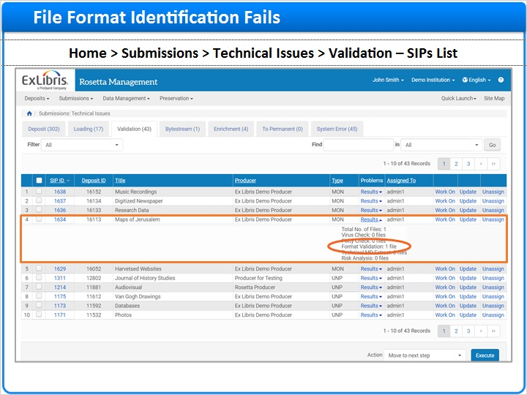
Notes:
In order to accurately preserve and render files, their File Format Identification must be known.
File Format Identification confirms that the file is recognized by the PRONOM registry maintained by the National Archives of the United Kingdom.
Once the file properties are extracted, this output is analyzed against Rosetta's Format Library in order to uniquely identify the file.
A correctly identified file will be assigned a known registry ID.
If it's not possible for Rosetta to identify a file, the SIP will get re-routed to the TA Workbench for further analysis.

1.12 Assign Collection / Derivative Copy Enrichment Fails
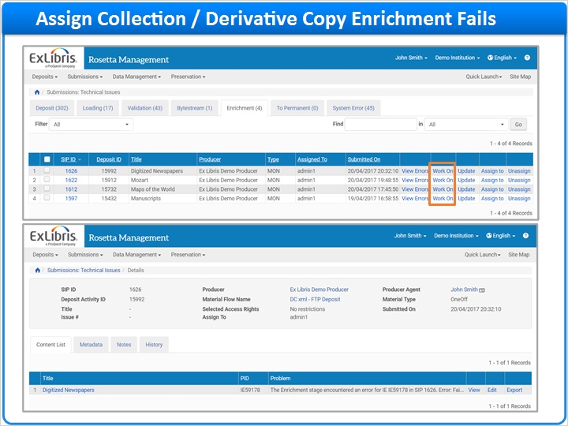
Notes:
SIPs can also fail during the enrichment stage.
The Create Derivative Copy Representation task creates a lower-resolution or lossy version of an existing preserved representation copy.
The create derivative copy process can be added as an enrichment task. If this process fails for any reason, the SIP will get re-routed to the TA Workbench for further analysis.
When clicking on the work we can learn what caused the failure, and handle the SIP.

1.13 Technical Analysts
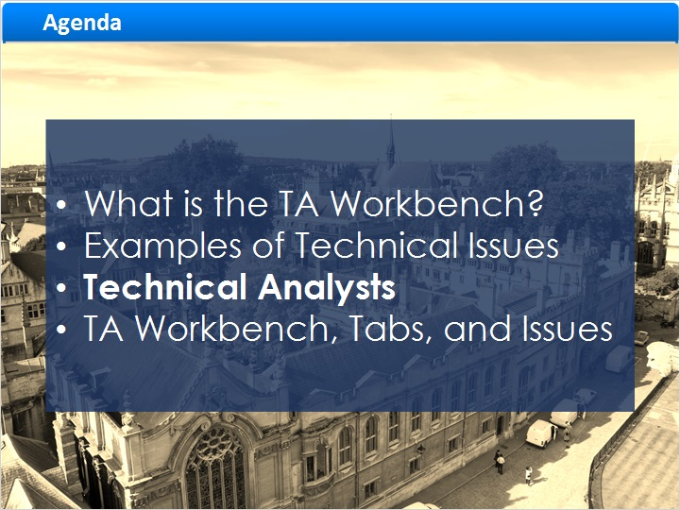
Notes:
Technical Analysts

1.14 Technical Analysts (TA)
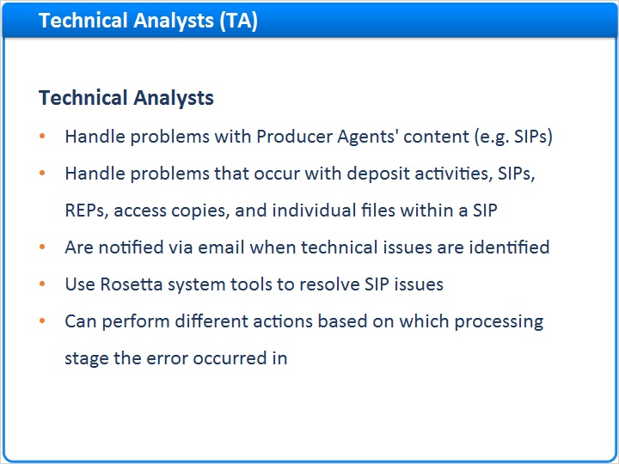
Notes:
Now that we have seen a few examples of validation and enrichment issues that may occur, let's review the Technical Analysts' roles.
Technical Analysts, or TAs,
Handle problems with Producer Agents' content (e.g. SIPs).
Handle problems that occur with deposit activities, SIPs, REPs, access copies, and individual files within a SIP.
Are notified via email when technical issues are identified.
Use Rosetta system tools to resolve SIP issues.
Can perform different actions based on which processing stage the error occurred in.

1.15 Technical Analysts (TA) Roles
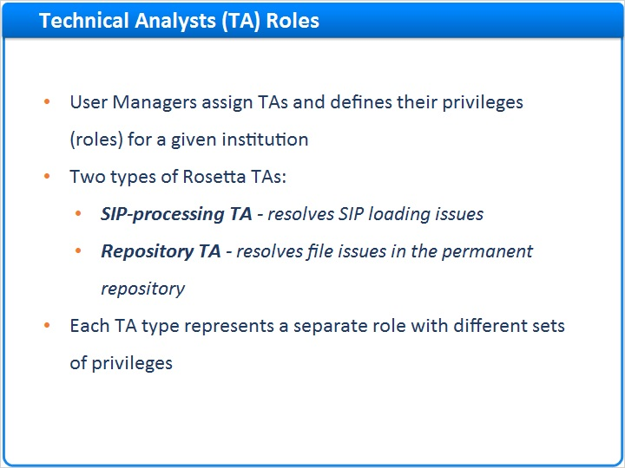
Notes:
User Managers assign TAs and define their privileges for a given institution.
There are two types of TAs in Rosetta:
A SIP processing TA resolves SIP loading issues.
While a Repository TA resolves file issues in the permanent repository.
SIP Processing and Repository TAs perform similar actions, but Repository TAs work with data that already exists in the repository, not with submission packages. Repository TAs also address technical issues related to adding or updating a representation.
Each TA type represents a separate role with different sets of privileges.

1.16 TA Workbench, Tabs, and Issues
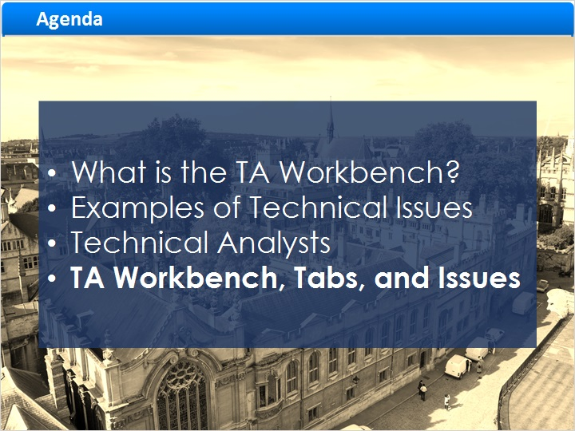
Notes:
The TA Workbench, Tabs, and Issues

1.17 Deposit Tab
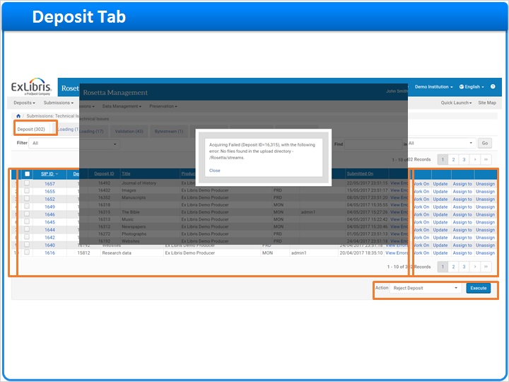
Notes:
Let's go to the TA Workbench now and review each of the problem tabs and columns on the SIPs list along with the actions that Technical Analysts, or TAs can perform in each tab.
If we select the Deposit tab we will get a list of problematic deposit activities that failed when they were uploaded to the Deposit Server.
Selecting the Checkboxes on the left enables "TAs to perform an action on multiple deposit activities.
The SIP ID column refers to the unique SIP ID assigned to the SIP. The Deposit ID column refers to the unique Deposit ID assigned to the deposit when it was created.
If SIP-level descriptive metadata was provided, the Title column will be populated with content from the dc:title field.
The Producer column lists the Producer who provided the content.
The Type column lists the Material Type from the Material Flow.
The Assigned To column lists the username for the TA who is assigned to work on the activity; other TAs can only view the activity.
The Submitted On column lists the deposit activity submission date.
Click on View Errors to open a pop-up that will provide a brief description of the problem.
To investigate the deposit issue further, click on Work On to display further info on the problem.
Once a user has selected the Work On option it will be assigned to them and their username will display in the Assigned To column.
Click Update to add an internal note on the SIP that can be viewed by other staff members. Click Assign to to assign the SIP to another TA.
Click Unassign to unassign it before re-assigning the SIP to another TA.
Additional actions can be selected from the drop-down list below the table; we will cover those later in this session.
As said, clicking on Work On will display further info on the problem.

1.18 Deposit Issues
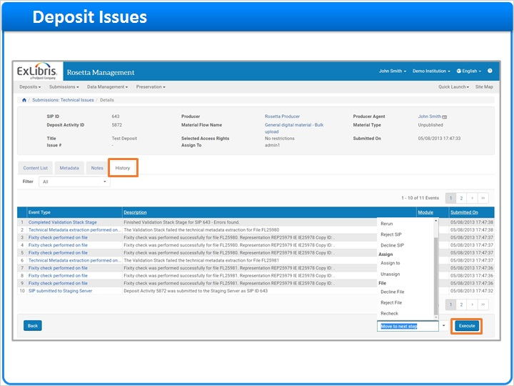
Notes:
Then we would be brought to this screen, where further info on the problem is displayed.
TAs can download one or more files and replace them from here.
Rosetta creates a *.zip file of all associated file streams that can be downloaded by clicking on the Download link.
To decline content, select Decline SIP in the ‘Action' drop-down list, then click Execute.
When SIPs are declined by a TA, they will display in the Producer Agent's Declined tab in the Deposit Interface and they will not be able to re-submit them.

In order to see more details about the SIP and where in the SIP processing it failed, click on the History tab.

1.19 Loading Tab
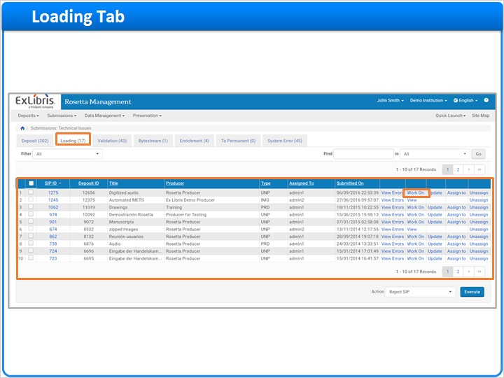
Notes:
The Loading tab lists SIPs that failed while moving from the Deposit Server to the Staging Server.
For each SIP, we can see:
The Checkbox column, where we can select the SIP,
The SIP ID,
The Deposit ID,
The Title,
The Producer,
The content type,
The Assigned To column,
The submission date- and the Actions that can be taken for each item.
To investigate this loading issue further, click on Work On.

1.20 Loading Issues
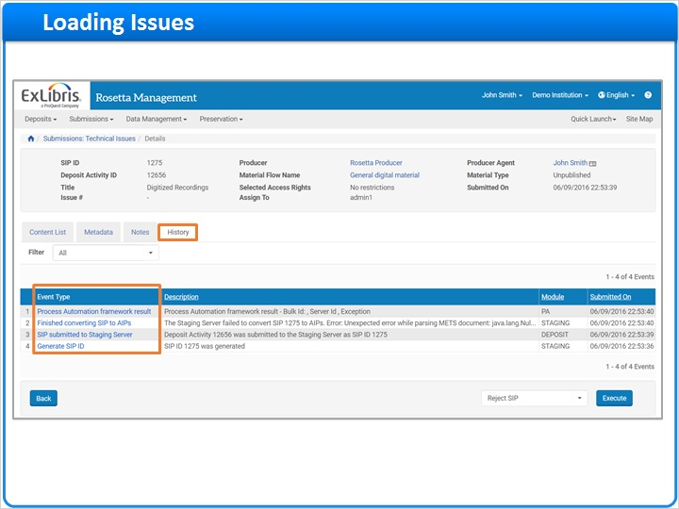
Notes:
Next, click on the History tab to see more details about the SIP and where in the SIP processing it failed.
To review the details of a particular event that failed, click on the Event Type link to see the details.

1.21 Loading Issues
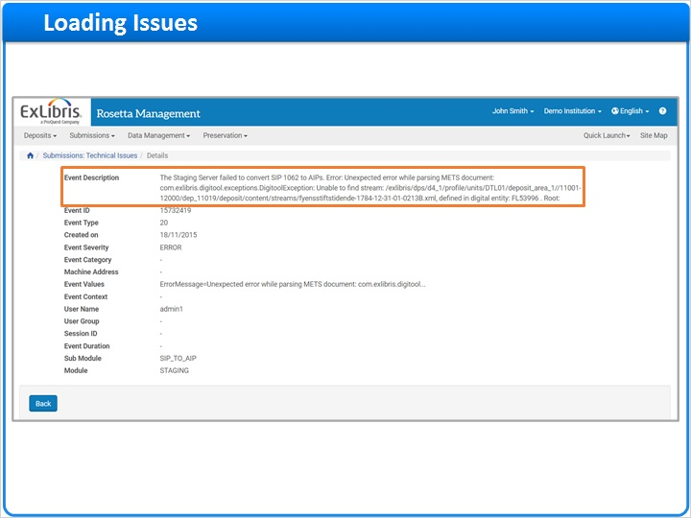
Notes:
Here in the description we can see why the SIP failed.
In this example - a problem in the METS structure prevented parsing of the METS.

1.22 Validation Tab
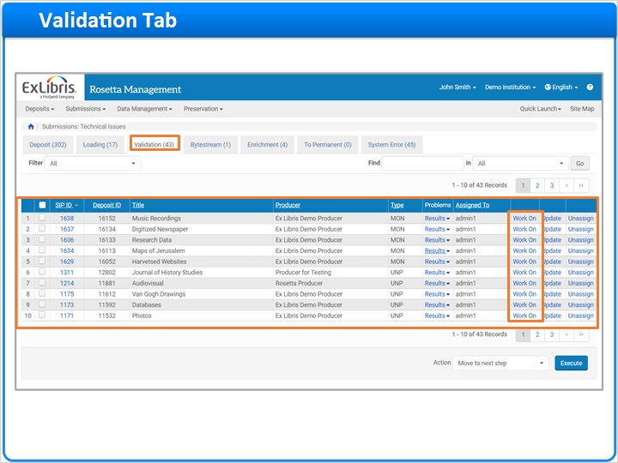
Notes:
The Validation tab includes problematic files that failed the Validation Stack routines.
In this screen, for each SIP, we can see:
Checkboxes to select each SIP,
The SIP ID,
The Deposit ID,
The Title,
The Producer,
The Type,
Problems associated with this SIP,
Who this SIP is Assigned To,
And the Actions that can be taken on this SIP

To investigate and resolve any validation issues, click Work On in the Actions Column.

1.23 Validation Issues
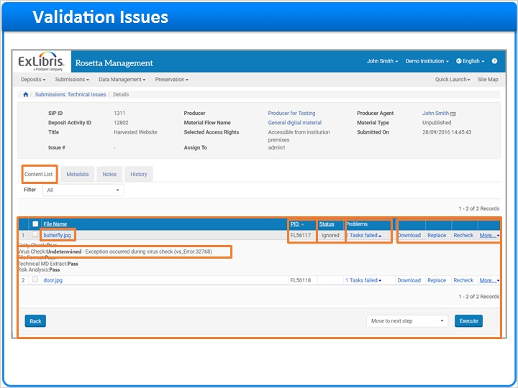
Notes:
This takes you to the Technical Analyst Workbench - Content List
The File Name column lists the problematic file name.
The PID column list the PID, or persistent ID, in this case a unique file ID number, for the IE.
The Status column which provides special status on the file level, if exists
The Problems column lists all of the validation errors associated with this file.
clicking the link opens a detailed validation status for that file - in this example, the file failed the virus check.
The Actions column lists what corrective actions are available for this file.
Click Download to download the files associated with this SIP for review.
Click Replace to replace one or more of the problematic files associated with this SIP with a better version.
Click Recheck to run the validation routine again.
After clicking the More link, the file related functions are available. The list of functions presented is based on the error that caused the validation failure.

1.24 Validation Issues
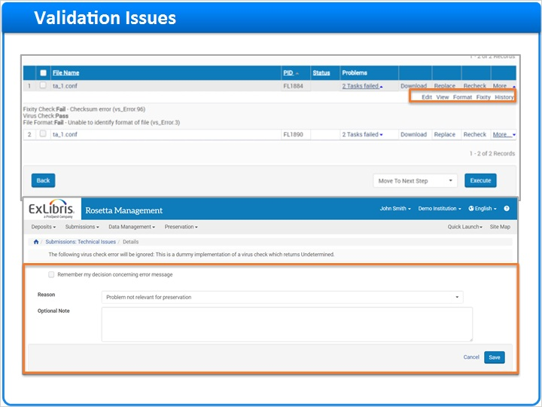
Notes:
Click Edit to update the file in the metadata editor.
Click View to display the file with the IE viewer.
Click History to get a report of all of the events associated with this file.
The options are dynamic based on the issues found during the validation phase.
For the virus issue The specific Virus error can be ignored..
If the issue was a fixity check, click Fixity to generate a new fixity value for the file.

If the file failed format validation - click Format to allow Rosetta to disregard the format error, then select which format the file will receive in Rosetta and note the exception.

1.25 Validation Issues
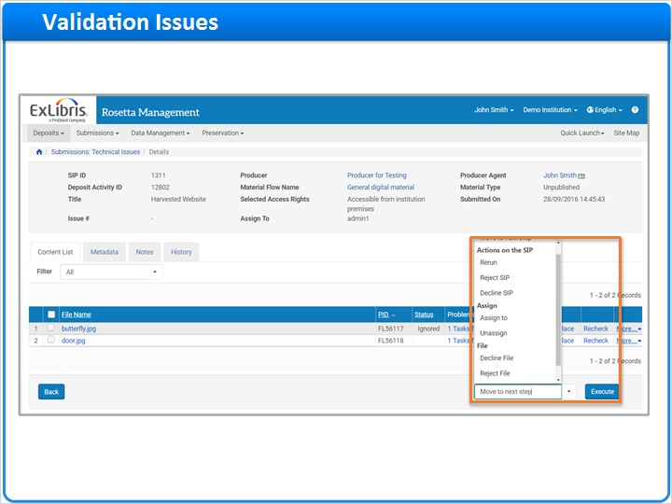
Notes:
Once the issues for the files have been resolved, select an action to proceed:
The Move to next step option - moves the SIP to the next processing stage as defined in the SIP routing rules.
Actions on the specific SIP can be : rerun, reject or decline the SIP.
To assign all specific validation issues to a specific staff user to handle, click Assign.
It is also possible to run actions on the file level in order to reject, decline or recheck the file. The action takes place once the execute button is selected.

1.26 Bytestream Tab
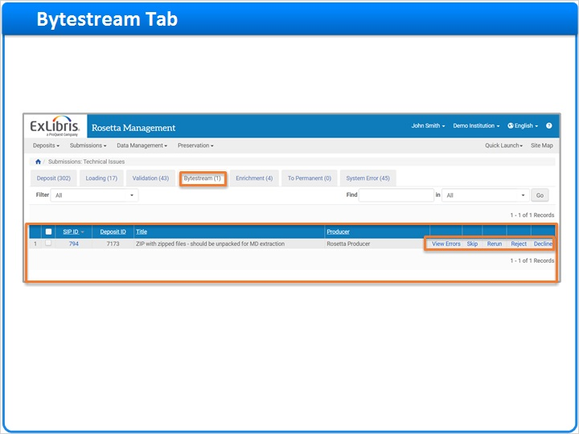
Notes:
The Bytestream tab displays SIPs with bytestreams (or containers) that failed during the bitstream extraction stage. For these SIPS, an error was encountered during the extraction itself, or when the validation stack was run on the bitstream.
For each SIP, we can see:
The Checkbox where we can select the SIP,
The SIP ID,
The Deposit ID,
The Title,
The Producer,
And the Actions available for these SIPs.
The options available for bytestream issues are: view errors, skip, rerun,reject and decline. Click on the view errors to get the results of the check.

1.27 Bytestream Issues
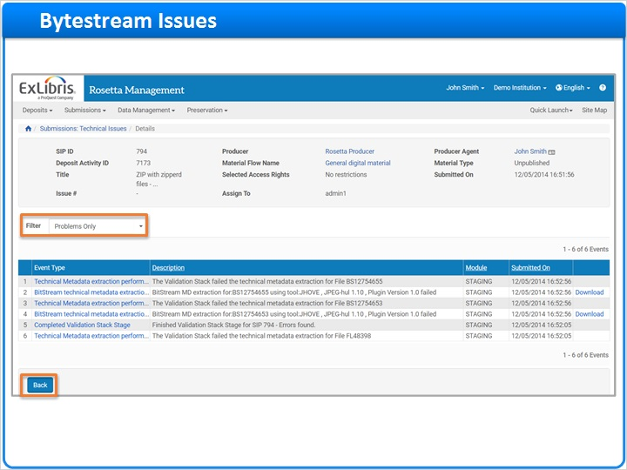
Notes:
The results can be filtered to show all results or just the files that had problems during the bytestream check.
Click Back to return to the list page.

1.28 Enrichment Tab
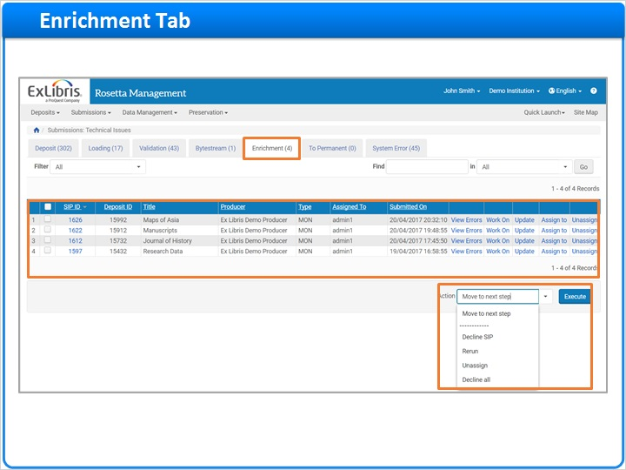
Notes:
The Enrichment tab lists files that failed during the Enrichment process.
For each SIP, we can see:
The Checkbox for selecting each SIP,
The SIP ID,
The Deposit ID,
The Title,
The Producer,
The Type,
The person Assigned To handle the SIP,
The submission date,
And the Actions they can take on the SIP.
Click Work On to see the problem that caused the enrichment failure.
The Actions drop-down presents several options - Move to Next Step, Decline the SIP, Rerun the Task, or Unassign.

1.29 To Permanent Tab
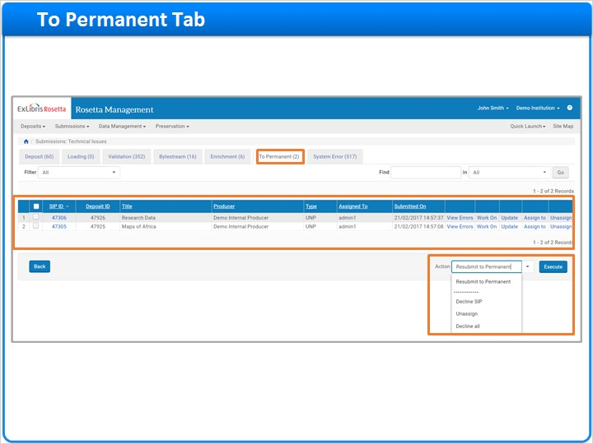
Notes:
The To Permanent tab contains files that failed when the Rosetta system was moving them from the Staging Server to the Permanent Repository.
For each SIP we have:
A Checkbox to select the SIP,
The SIP ID,
The Deposit ID,
The Title,
The Producer,
The Type,
The person who this SIP is Assigned To,
The submission date,
and the Actions they can take.

Click Work On to see the problem that caused the failure.
The Actions drop-down presents several options - Resubmit the SIP to the Permanent Repository, Decline the SIP, or Un-assign it.

1.30 System Error Tab
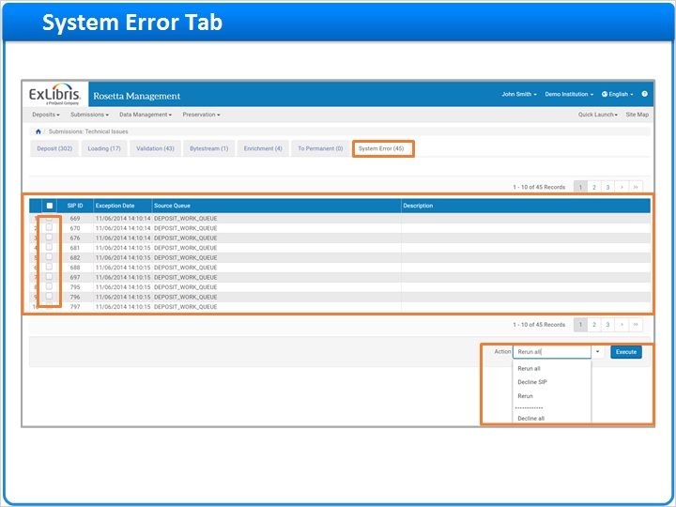
Notes:
When a SIP fails, Rosetta attempts to rerun the SIP processing up to five times.
The System Error tab lists SIPs that fail to complete the processing after repeated attempts.
Typically, these SIPs have failed processing due to environmental issues such as network, storage, or database issues.
Ideally these situations are temporary and readily addressed so that re-running these SIPs once the issues have been resolved will allow them to be processed successfully.
If this is not the case, please contact Ex Libris Support.
For each SIP, we have:
The Checkbox that selects the SIP,
The SIP ID,
The Exception Date, which shows the date the exception occurred,
The Source Queue, which shows which stage the SIP failed in,
And the Description, which may include a description of the problem.

Within the System Error tab, TAs can perform the following actions on the submissions listed :
After selecting one or more Activity IDs click Rerun to attempt to rerun the SIP processing again.
After selecting all Activity IDs click Rerun All to attempt to rerun the SIP processing again.
After selecting one or more Activity IDs click Decline SIP to return the SIPs to the Producer Agent.

1.31 Session Review
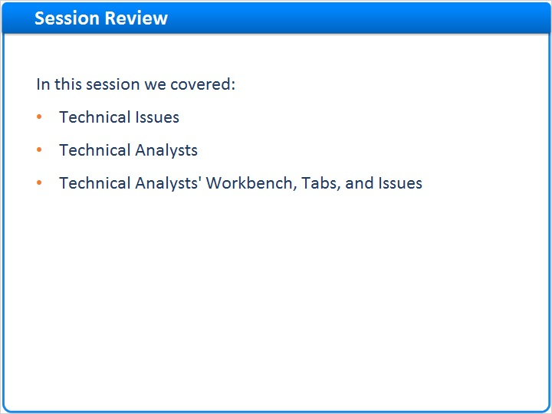
Notes:
In this session we learned about the different issues during the ingest process that can cause a SIP to go to the TA workbench, and how to handle them.

Please take this opportunity to review this information in your new Rosetta environment.

We hope that you've found this information helpful to your understanding of Rosetta.

1.32 Additional Resources

Notes:
Thank you for joining this session!

1.33 About this Training
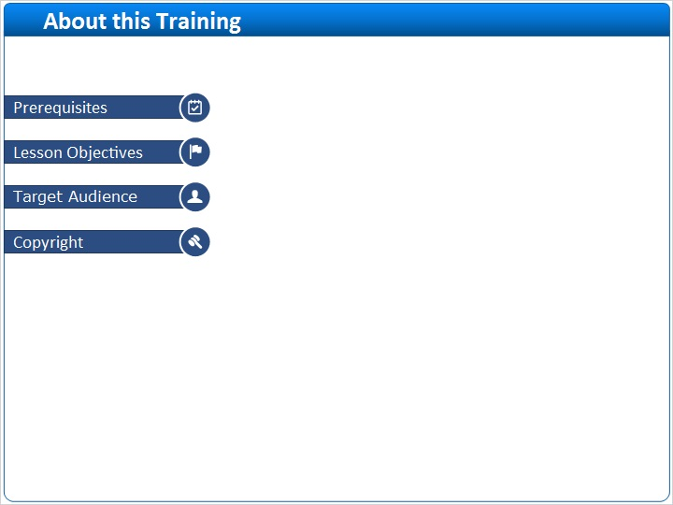
Notes:

1 (Slide Layer)
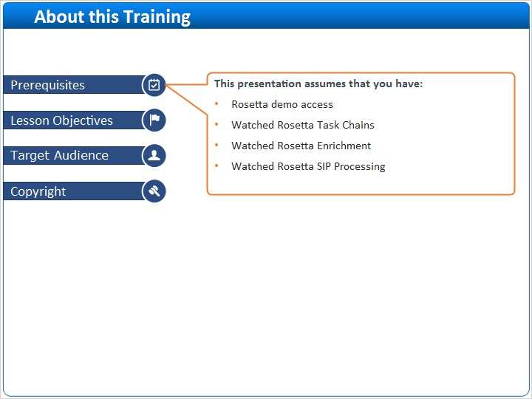

2 (Slide Layer)
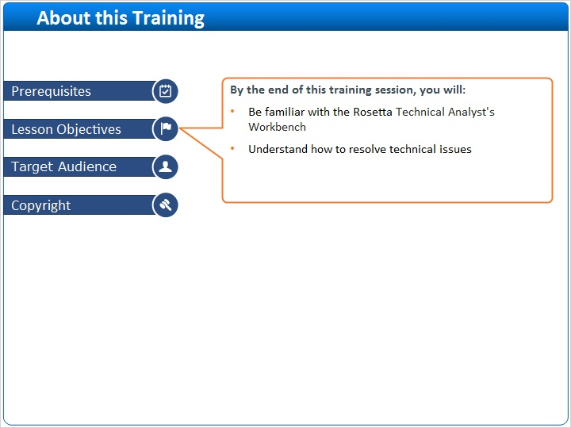

3 (Slide Layer)
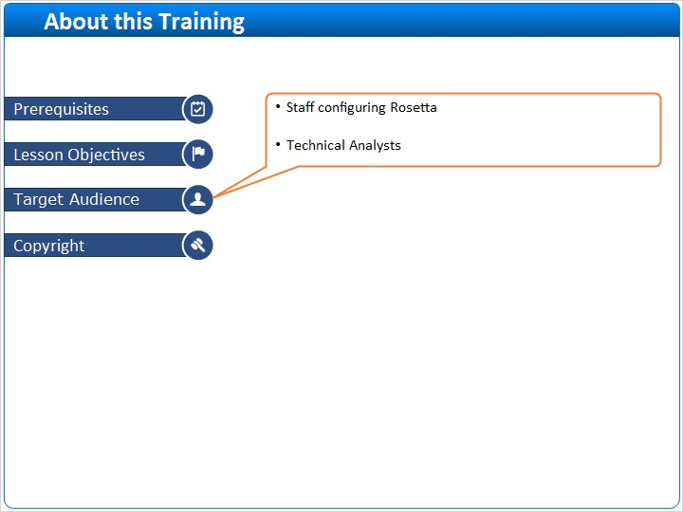

4 (Slide Layer)


