|  |  |
| --- | --- |
| **How to change the no results message to a specific message in an Analytics report** |  |
|  | |



**Yoel Kortick**

**Senior Librarian**

By default an Alma analytics report with no results will appear as follows (with the filter being the specific filter for the specific report)

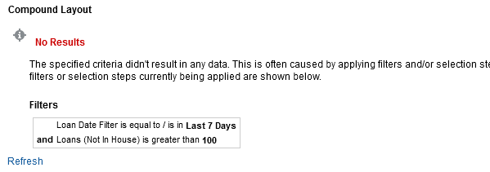

It is possible however to change this in the following manner.

**ONE**

From the criteria tab choose “Edit Analysis Properties”

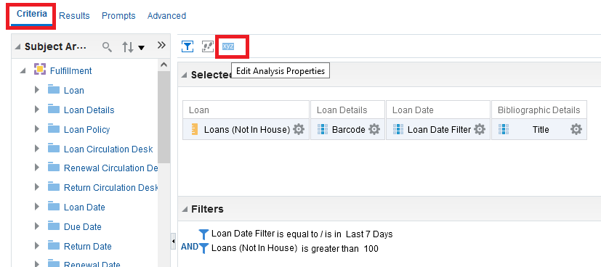

**TWO**

In the ‘Results Display’ tab choose ‘Display Custom Message’

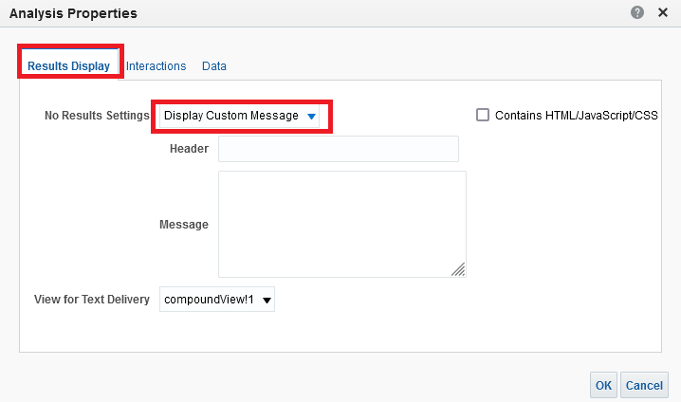

**THREE**

This is what will appear when the report has no results.

* The text entered in the “Header” field will by default be red bold.
* The text in the “Message” field will appear under the header. It is possible to use html tags in the message.

Below

Our header is “No results for query”

Our message is “There are no items with <b>more than 100</b> loans in the last 7 days”

Note that we have checked the box “Contains HTML/Java Scrcipt/CSS”

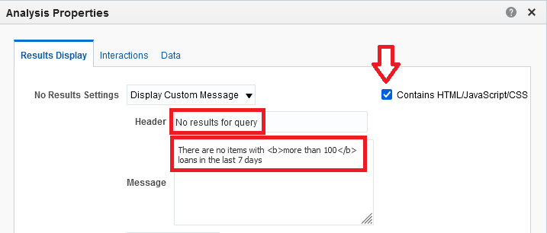

**FOUR**

See results

