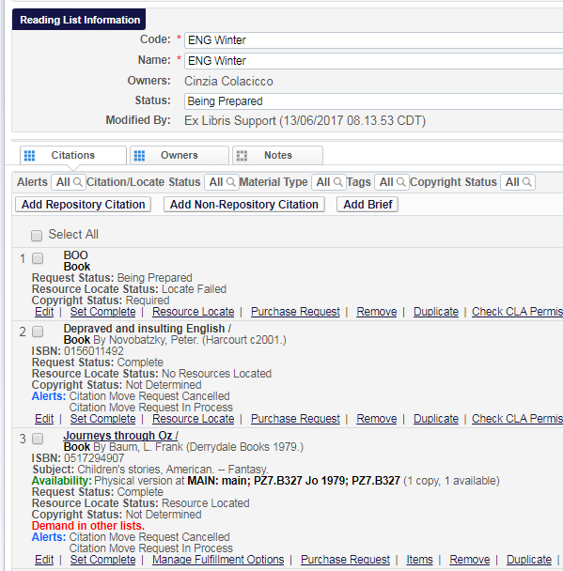
Example of a reading list where all citations are shown as „Book“

Example “Journeys through Oz” in the repository search result list shows “Music {Audio nonmusical – Physical}

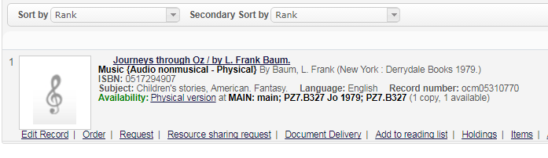

The resource types from a BIB record in resource management and the material types for citations in a reading list are unfortunately not related. The material type has to be assigned manually and if this is not done the default value "Book" is taken. Please see also the documentation https://knowledge.exlibrisgroup.com/Alma/Product_Documentation/Alma_Online_Help_(English)/Fulfillment/060Courses_and_Reading_Lists/040Managing_Citations#reading_list_citation.edit

In order to change the type of the citation you can edit the citation and select a value from the >Citation Parameters >Material type dropdown list.
