|  |  |
| --- | --- |
| **Acquisitions Units: Acquiring and receiving for specific libraries** |  |



**Yoel Kortick**

**Senior Librarian**

** **

Best viewed in mode ‘View > Navigation Pane’

# Introduction

It is possible to define that certain libraries will be able to

* Acquire for other libraries
* Receive inventory for other libraries

This is sometimes referred to as a “Library Unit”, an “Acquisitions Unit” or an “Acquisitions Service Unit”.

This document will briefly explain how this done.

In general these are the key elements:

1. The “Acquire for” library relations determine which POL Owner Library may acquire inventory for which other libraries
2. The “served libraries” of the acquisitions department for which the staff is a receiving operator determine which libraries’ inventory may be received while at that acquisitions department.

# Scope of the staff user role “Purchasing Operator”

The scope of the staff user role “Purchasing Operator” or “Purchasing Manager” determines which libraries can be chosen by the staff user as the POL Owner Library. For the remainder of this document we will show and discuss the “Purchasing Operator”, but it applies also for “Purchasing Manager”.

* If the scope of the role “Purchasing Operator” is the institution then any library may be chosen as the POL owner.
* If the scope of the role “Purchasing Operator” is a specific library then only that specific library may be chosen as the POL owner.
* One staff user may have multiple occurrences of the role “Purchasing Operator” and each time it may have a different scope.

The POL Owner library can only be a scope of the Purchasing Operator of the staff user.

For example:

User Sarah Khan has role Purchasing Operator for Main Library:



This is what she can choose as POL Owner (only libraries that match her Purchasing Operator scope):

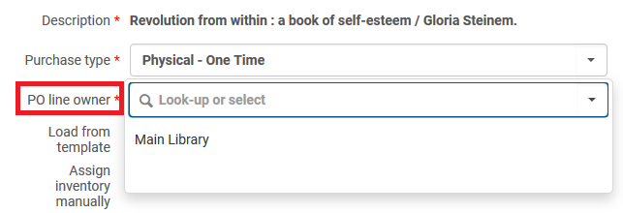

User Maya Ali has role Purchasing Operator for Law Library:



This is what she can choose as POL Owner (only libraries that match her Purchasing Operator scope):

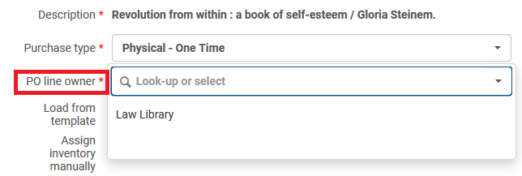

User Mary Ann Barlow has Purchasing Operator for both the Law Library and the Main Library

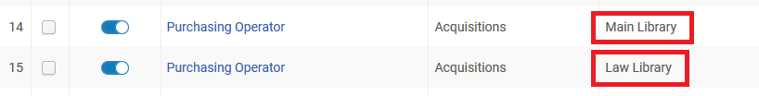

This is what she can choose as POL Owner (only libraries that match her Purchasing Operator scopes):

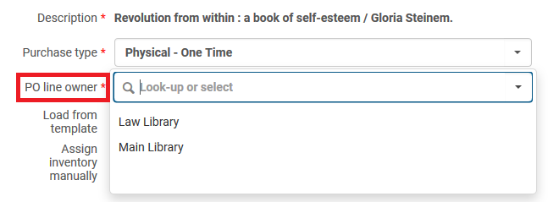

User Niki Karimi has Purchasing Operator for the entire institution “Alma University”



This is what she can choose as POL Owner (all libraries becaseu her Purchaing Operator scopew is the entire institution):

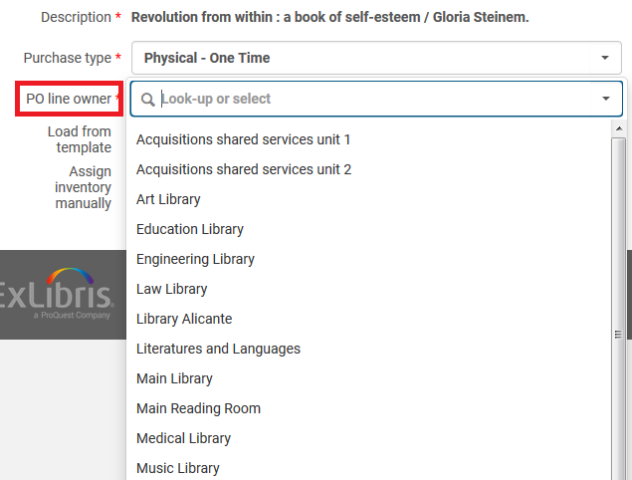

# Relationships of type “Acquiring For”

The definitions of which libraries can acquire for other libraries is defined in the library relations.

For example in the situation below the “Main library” is defined to be able to order for (acquire for) the following:

1. The Main Library (itself)
2. The Art Library
3. The Engineering Library
4. The Music Library

We have navigated as follows:

1. General Configuration Menu
2. Choose on top left ‘Configuring Main Library’
3. Relationships

See that it is defined that the Main Library may acquire for the Art Library, the Engineering Library and the Music Library.

 This means that **if the POL Owner is Main Library then inventory may be chosen in the POL for the Main Library, the Art Library, the Engineering Library or the Music Library**

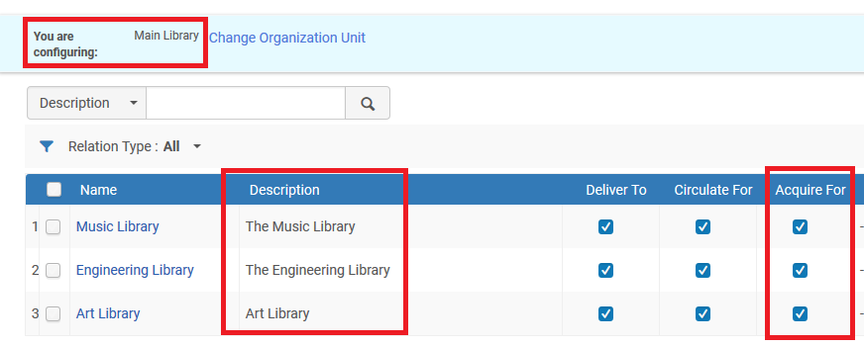

For example:

If the POL Owner is Main Library then Inventory may be added for the Main Library as well as those other libraries which are defined as an “Acquire For” relationship with the Main Library.

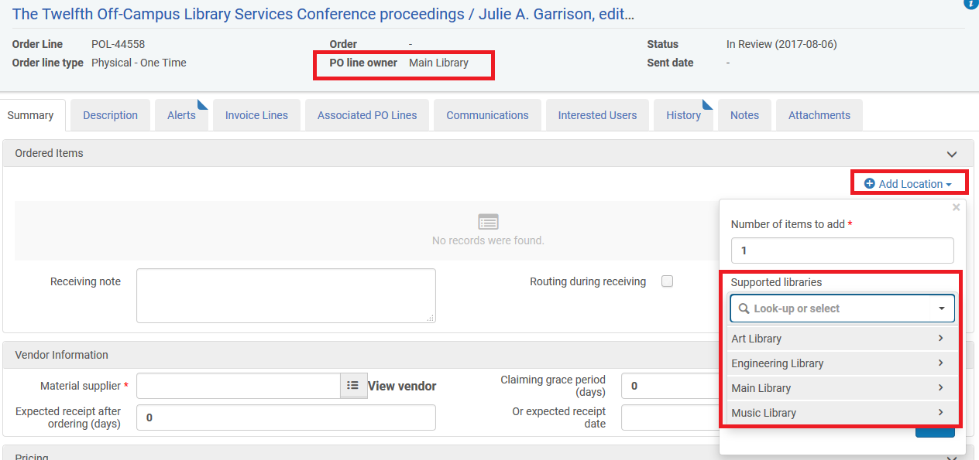

Additionally, the Law Library is defined to be able to order for (acquire for) only itself. We have navigated as follows:

1. General Configuration Menu
2. Choose on top left ‘Configuring Law Library’
3. Relationships

See that the Law Library has no “acquire for” relations set with any other libraries. This means that it can only “acquire for” itself.

 This means that **if the POL Owner is Law Library then inventory may be chosen only for the Law Library.**

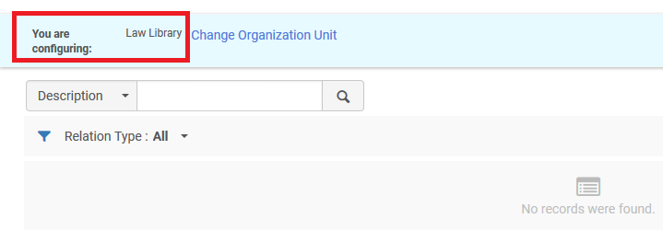

For example:

If the POL Owner is Law Library then Inventory may be added only for the Law Library.

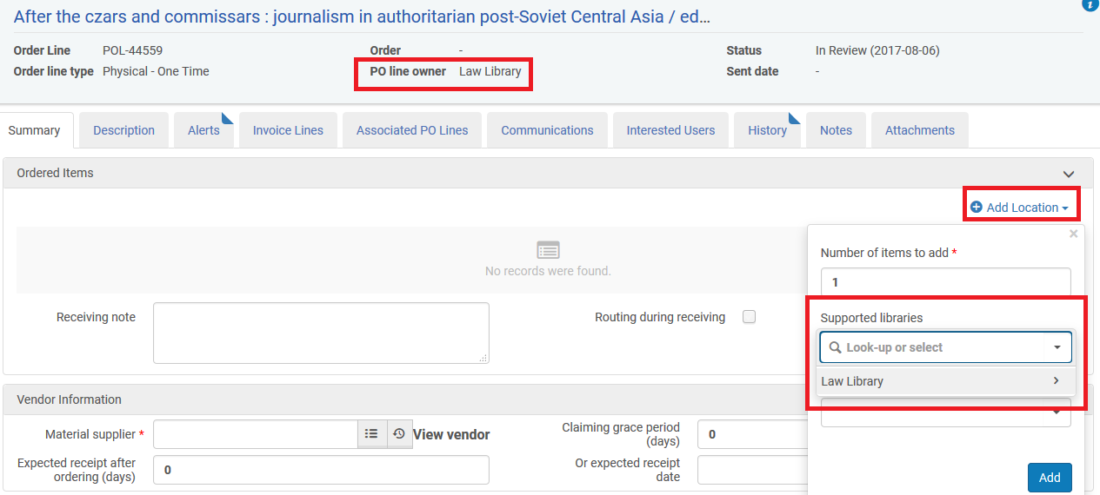

In summary:

* If the POL Owner is Main Library then inventory may be chosen in the POL for the Main Library, the Art Library, the Engineering Library or the Music Library
* If the POL Owner is Law Library then inventory may be chosen only for the Law Library

# Acquisitions Department Served Libraries and Operators

In order to receive the inventory which has been ordered the staff user must either be at

* An acquisitions department
* A circulation desk which supports an inquisitions work order

In both cases the logic is very similar, and in this document we will discuss being at an acquisitions department.

 The “served libraries” of the acquisitions department determine which library’s or libraries’ inventory may be received while at the department.

For example in the situation below the “Main library Acquisitions Department” is defined to be able to receive inventory belonging to the following libraries:

1. The Main Library
2. The Art Library
3. The Engineering Library
4. The Music Library

We have navigated as follows:

1. General Configuration Menu
2. Choose on top left ‘Configuring Main Library’
3. Work Order Departments
4. Acquisitions Department (Work order type AcqWorkOrder)

See that it is defined that the “Served Libraries” are the Main Library, the Art Library, the Engineering Library and the Music Library.

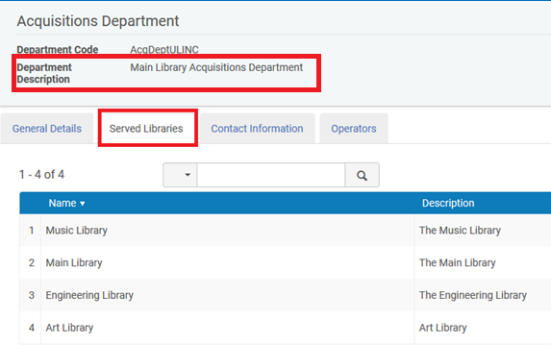

Sarah Khan is an operator in the Main Library Acquisitions Department

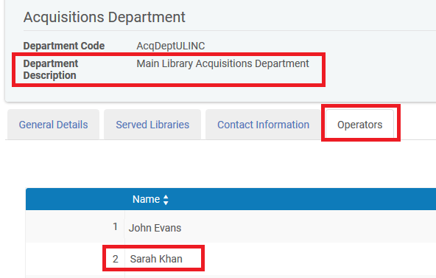

If a user is an operator in an acquisitions department then in the list of roles they will appear as

Role: Receiving Operator

Scope: The Library of the acquisitions department

Service Unit: Acquisitions Department



The above setup means that user Sarah Khan can be at the “Main Library - Acquisitions Department” and if she does “Acquisitions > Receiving and Invoicing > Receive” she will be able to receive inventory for any of the served library in the “Main Library - Acquisitions Department”:

1. The Main Library
2. The Art Library
3. The Engineering Library
4. The Music Library

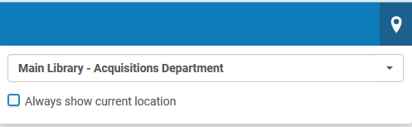

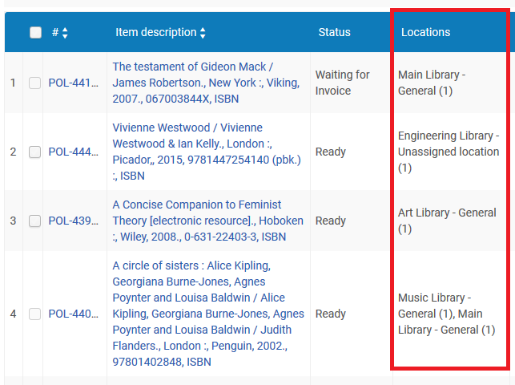

Another example is the situation below in which the “Law library Acquisitions Department” is defined to be able to receive inventory belonging to only the Law Library

We have navigated as follows:

1. General Configuration Menu
2. Choose on top left ‘Configuring Law Library’
3. Work Order Departments
4. Acquisitions Department (Work order type AcqWorkOrder)

See that it is defined that the “Served Libraries” are only the Law Library

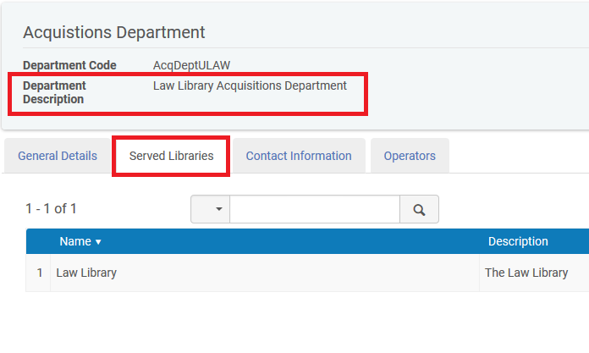

Maya Ali is an operator in the Main Library Acquisitions Department

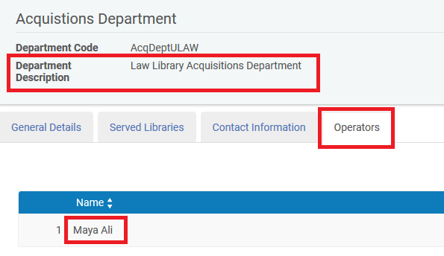

If a user is an operator in an acquisitions department then in the list of roles they will appear as

Role: Receiving Operator

Scope: The Library of the acquisitions department

Service Unit: Acquisitions Department



The above setup means that user Maya Ali can be at the “Law Library - Acquisitions Department” and if she does “Acquisitions > Receiving and Invoicing > Receive” she will be able to receive inventory only for the Law Library.

