|  |  |
| --- | --- |
| **How to resend an order to the vendor** |  |



**Yoel Kortick**

**Senior Librarian**

In addition to this document also see [here](https://knowledge.exlibrisgroup.com/Alma/Product_Documentation/Alma_Online_Help_(English)/Acquisitions/020Purchasing/060Approving_and_Sending_POs).

In order to resend an order to the vendor do as follows:

1. Identify the PO (Purchase Order) of the POL (Purchase Order Line) which you want to resend.
   1. It must be of acquisition type “purchase” and not have been canceled
   2. Here we have POL-44556 which was sent on Aug. 02, 2017
   3. The PO is PO-68316  
        
      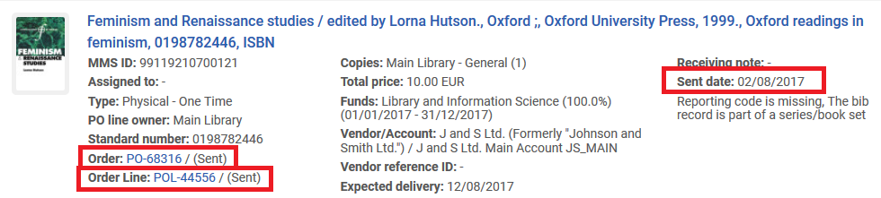
2. Navigate to the PO by cl8icking the link to the PO  
     
   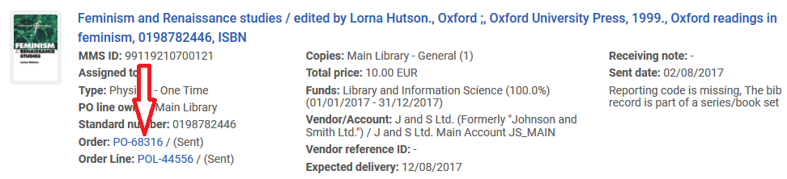
3. Scroll to the bottom of the “Summary Tab” and click “Resend Order”  
     
   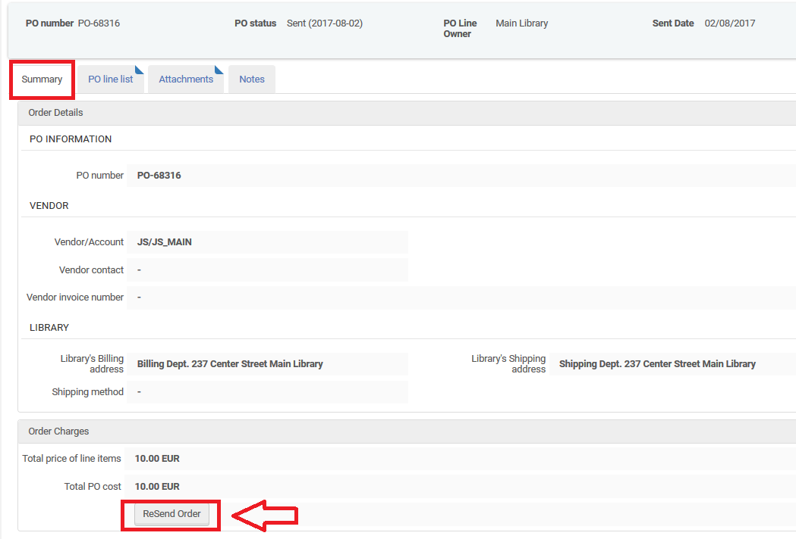
4. Confirm the message and receive confirmation  
     
   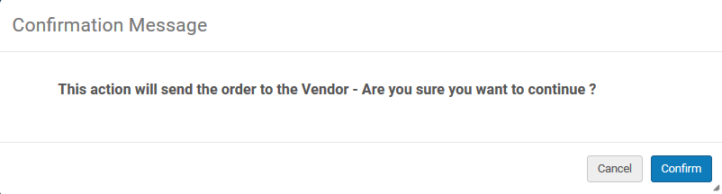  
     
   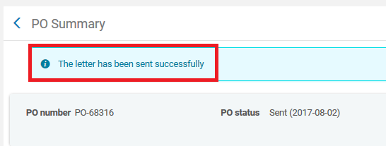
5. The letter has been resent  
     
   