|  |  |
| --- | --- |
| **How to make an Alma Analytics report of all bibliographic records which have no inventory** |  |



**Yoel Kortick**

**Senior Librarian**

Note that in addtion to the solution here it is also possible to perorm a search in the Alma user interface for all records which have no inventory. Here is an advanced search in the Alma user interface for index “Has Inventory” and value “No”

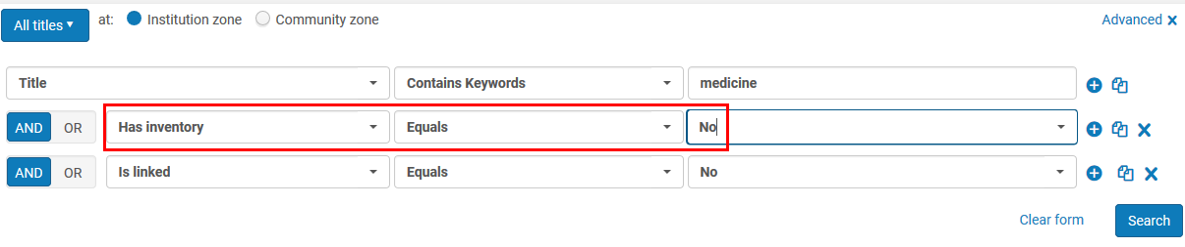

It also searches in this case for

Title keywords = medicine

Is linked = No (this will remove all records linked to the Community Zone).

All results have no inventory

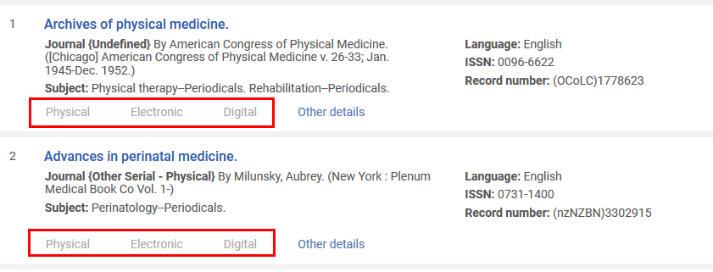

**To make an Alma Analytics report of all bibliographic records which have no inventory follow these steps:**

**ONE**

Create a new analysis in the “Titles” subject area

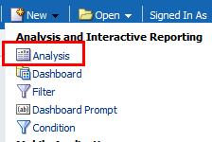 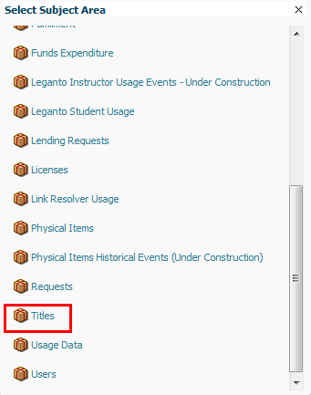

**TWO**

Under the “Title Measures” folder choose the following measures:

1. Num of Electronic Collections (Active)
2. Num of Physical Items (Active)
3. Num of Portfolios (Active)

Filter them all to be equal to 0

For example here is the filter on “Num of Physcial Items (Active)”

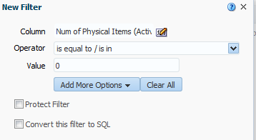

**THREE**

Filter by only bibliographic records which are not deleted. For this you can use “Lifecycle” field in the “Bibliographic Details” folder and filter by “In Repository”

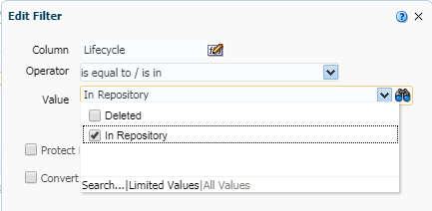

**FOUR**

You may want to make the report in ranges of time in which the bibliographic record was created. For that you can use the “Create Date” field in the “Bibliographic Details” folder.

Here we retrieve only records created between Jan. 1, 2017 and Dec. 31, 2017.

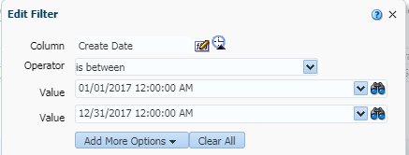

**FIVE**

Choose which fields you want to display. We will choose the MMSID and Title from the “Bibliographic Details” folder.

There is no need to display the fields we filtered on such as “Numr of Physical Items (active)”, “Numr of Electronic Collections (active)” and “Numr of Portfolios (active)” because they are always “0”. These fields should be left only in the filter.

Further, there is no need to display the “Lifecycle” from the “Bibliographic Details” because it is always “In Repository”. These fields should be left only in the filter.

Depending on the purpose of the report you may want to remove the “Create date” from the “Bibliographic details” folder.

**SIX**

Here is the criteria tab now. Note on the bottom right pane that all filters have operator AND between them.

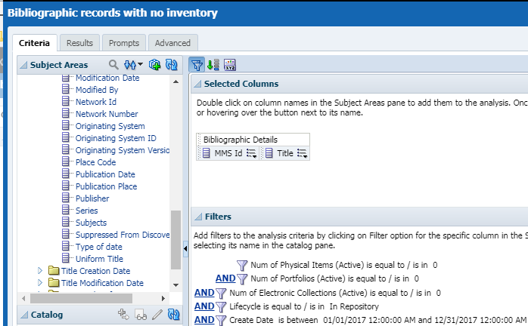

**SEVEN**

Here is a small sample of the results

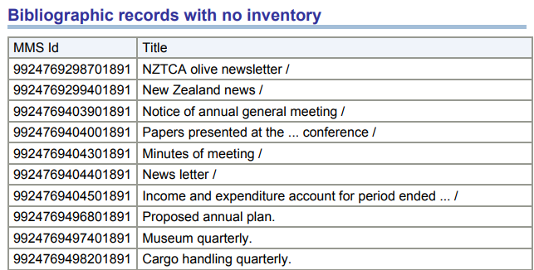

**EIGHT**

We can see in the Alma User Interface that these records exist with no inventory.

Here for example is the last example from the above screenshot “Cargo handling quarterly”

It has a holdings record but it has no items

