|  |  |
| --- | --- |
| **Normalization Process Add Hanzi to Pinyin Transliterations** |  |



**Yoel Kortick**

**Senior Librarian**

# Add Hanzi to Pinyin Transliterations

This process Converts Chinese content (Hanzi) to Pinyin.

This can be seen via the CNMARC profile.

1. Go to Resource management configuration menu > Cataloging > Metadata Configuration > CNMARC
2. Switch to “Normalization Processes” tab
3. Either add a new normalization process or view existing one
4. In the “Task List” tab see “Add Hanzi to Pinyin Transliterations”  
     
   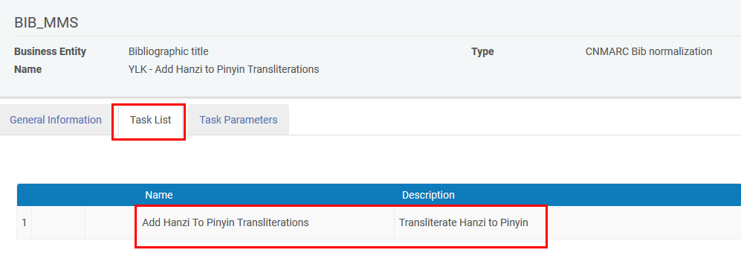
5. In the “Task Parameters” tab add the desired fields and subfields from the source fields as well as the desired fields and subfields of the target fields  
     
   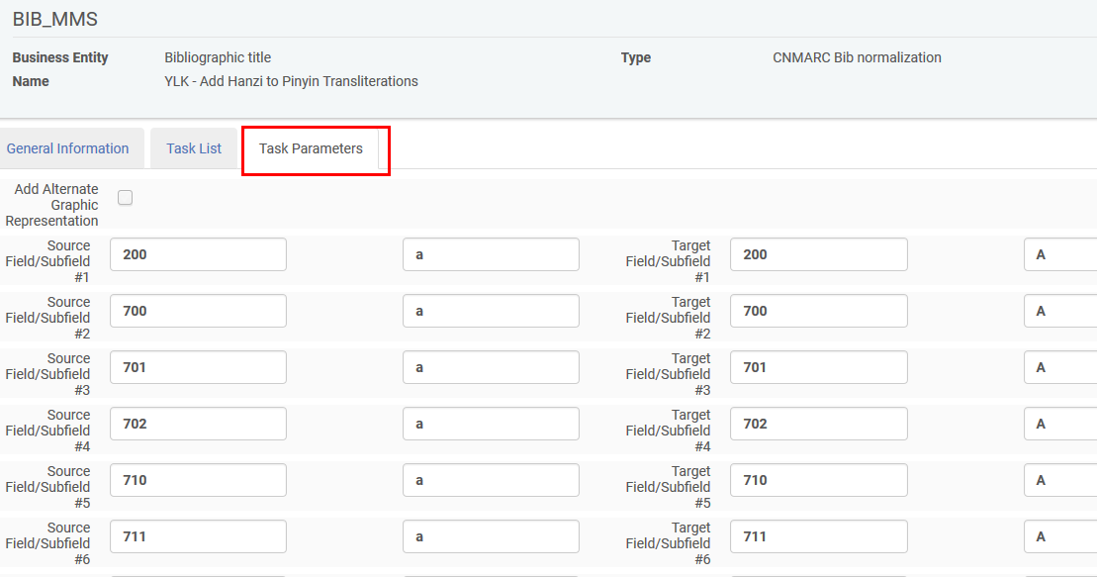
6. See it work as follows:
   1. Open a record which has the source fields above (so there will be something to translate to Pinyan)
   2. Choose Edit record > Enhance Record > Add Hanzi to Pinyin Transliterations  
        
      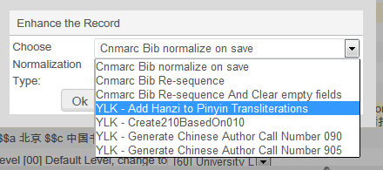
   3. See the new subfield A occurrences  
      Before  
        
      After  
      