|  |  |
| --- | --- |
| **Normalization Process Create 210 Based On 010** |  |



**Yoel Kortick**

**Senior Librarian**

# Create 210 Based On 010

This process task adds the MARC 210 $a to the record and places the Chinese publisher in the 210 based on the ISBN in the MARC 010 $a and a table managed within Alma.

1. Go to Resource management configuration menu > Cataloging > Metadata Configuration > CNMARC
2. Switch to “Normalization Processes” tab
3. Either add a new normalization process or view existing one
4. In the “Task List” tab see “Create210BasedOn010  
     
   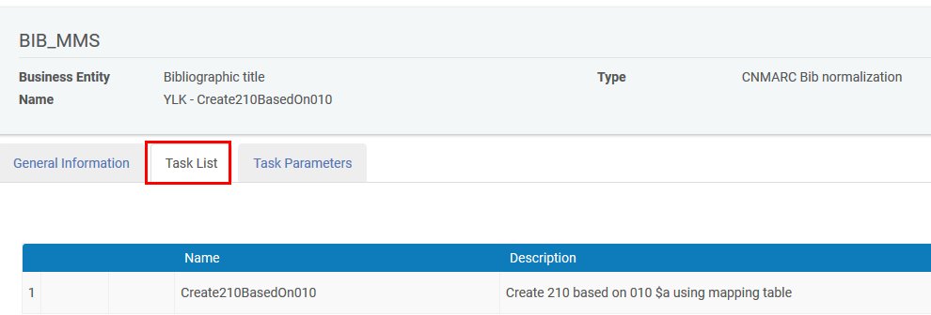
5. There are no “Task Parameters” for this process
6. See it work as follows:
   1. Open a record which has a 010 but does not (yet) have a 210.  
        
      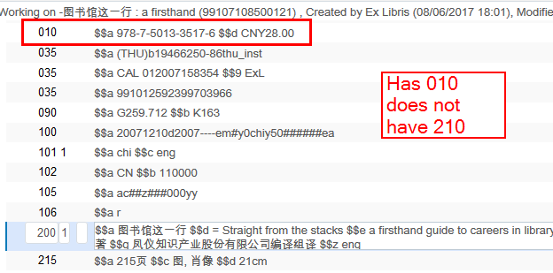
   2. Choose Edit record > Enhance Record > Create210BasedOn010  
        
      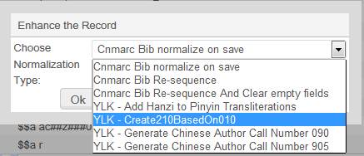
   3. See the 210 get created  
        
      