|  |  |
| --- | --- |
| **Normalization Process Generate Chinese Author Call Number (China)** |  |



**Yoel Kortick**

**Senior Librarian**

# Generate Chinese Author Call Number

This process task generates a Chinese author call number that is stored in the 090 or 905 (depending on what is chosen when creating the process).

1. Go to Resource management configuration menu > Cataloging > Metadata Configuration > CNMARC
2. Switch to “Normalization Processes” tab
3. Either add a new normalization process or view existing one
4. In the “Task List” tab see “Generate Chinese Author Call Number”  
     
   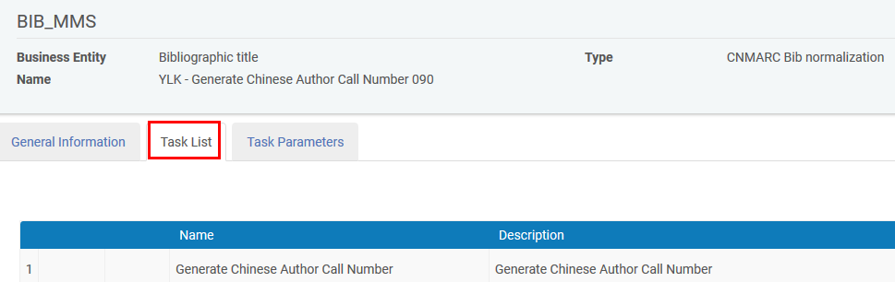  
   1. In the “Task Parameters” tab choose either “Chinese author number generation 090 1” or “Chinese author number generation 905 1”  
        
      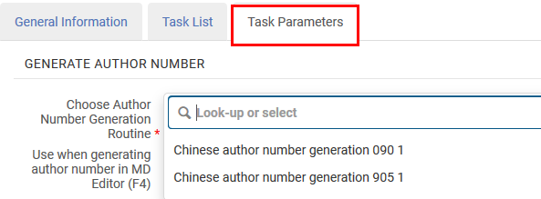
   2. We choose “090” and therefore also name the process with “090”  
        
      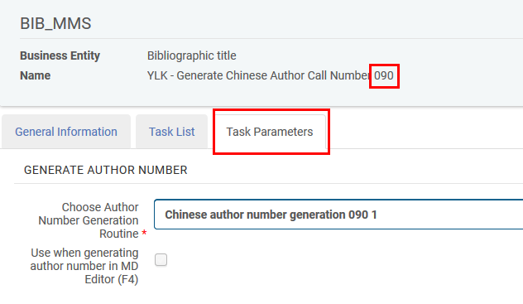
5. See it work as follows:
   1. “Generate Chinese Author Call Number 090” assumes that there are relevant fields and subfields dealt with in “Add Hanzi to Pinyin Transliterations”.
   2. In order for CNMARC Author number generation routine 090 to work pinyin transliterations of 200 and 7XX are required (in subfield A). If you do not already have them then “Add Hanzi to Pinyin Transliterations” should be run in order to create them. CNMARC Author number generation routine 090 also it copies the 690.a to 090.a
   3. Our record does not (yet) have a 090
   4. Here for example is MMSID 99107111200121 after running “Add Hanzi to Pinyin Transliterations”.   
        
      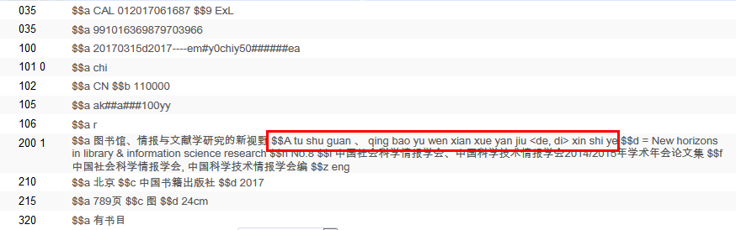
   5. Now we do ‘edit > enhance the record’ and choose “Generate Chinese Author Call Number 090”   
        
      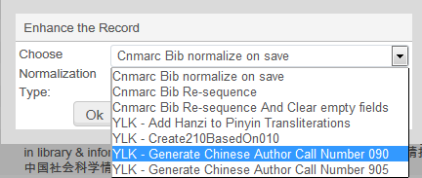
   6. See that you get a new 090.   
        
      