|  |  |
| --- | --- |
| **Creating multiple invoices with multiple invoice lines via an Excel file** |  |



# Introduction

This document will use Excel file [Excel File for Invoice Creation Sample YLK.xlsx](https://knowledge.exlibrisgroup.com/@api/deki/files/57400/Excel_File_for_Invoice_Creation_Sample_YLK.xlsx) as an example.

All references are to that Excel file.

When loading your own Excel file you should take the [Excel File for Invoice Creation Sample YLK.xlsx](https://knowledge.exlibrisgroup.com/@api/deki/files/57400/Excel_File_for_Invoice_Creation_Sample_YLK.xlsx) as an example and change accordingly.

You can also take the file which may be downloaded from within Alma at:

Acquisitions > Receiving and Invoicing > Create Invoice > From File > Next > Download Excel Example

In this document we will explain the structure of the Excel file and how it is filled in according to the invoice and invoice lines which it will create.

We will create two invoices via the file [Invoice Creation Sample YLK.xlsx](https://knowledge.exlibrisgroup.com/@api/deki/files/57400/Excel_File_for_Invoice_Creation_Sample_YLK.xlsx).

* The first invoice will have two invoice lines
  + Each invoice line will correspond to a POL
* The second invoice will have two invoice lines.
  + The first invoice line will correspond to a POL
  + The second invoice line will correspond to an added charge of type “overhead”

# About the Excel file

1. The Excel file must be in the same format as the example.
2. There must be one line beginning with HINV for each invoice in the file. This line
   1. Corresponds to the “Invoice Header” information.
   2. Contains column headers
3. There must be one line beginning with INV for each invoice in the file. This line
   1. Comes after the HINV line.
   2. Corresponds to the “Invoice Header” information.
   3. Contains the actual data
4. There must be one line beginning with HIL for each invoice in the file. This line
   1. Corresponds to the “Invoice Line Header” information.
   2. Contains column headers
5. There must be one line beginning with IL for each invoice line being created in the specific invoice under which it comes. These lines
   1. Must come after the HIL lines of the invoice to which they belong
   2. Correspond to specific “Invoice Line” information.
   3. May or may not be connected to a POL
      1. For example there may be a line for “Shipping” or “Overhead” and other lines which are connected to POLs.

# Description of first invoice in file

Invoice Number: YOEORA-001

Invoice Vendor Code: JS (chosen when uploading file)

Invoice Vendor Acct: JS_MAIN

Invoice Date: August, 14, 2017

Total Amount: 94.00 EUR

Payment Method: Cash

Note:

Use Pro Rata: True

Shipment Amount: 7

Overhead Amount: 2

Insurance Amount: 9

Discount Amount: 3

VAT Percentage:

VAT Amount:

Inclusive: False

Expended from fund: True

PrePaid: False

Payment Status: Paid

Voucher Number: (do not use if prepaid = false)

Voucher Date: August, 14, 2017

Voucher Amount: 94.00

Invoice Reference Number: 6499369

VAT In Invoice Line: False

Report Tax: False

## Description of first invoice line for first invoice in file

POL-43955

Line type: Regular

Title: A Concise Companion to Feminist Theory

Price: 34.00 EUR (became 40.46 after influence of Pro Rata)

Quantity: 1

Reporting Code: HIS

Fund: LIS

Start subs date:

End subs date:

Note:

VAT Amount:

VAT Percentage:

## Description of second invoice line for first invoice in file

POL-44401

Line type: Regular

Title: Acquisitions in Libraries

Price: 45.00 EUR (became 53.54 after influence of Pro Rata)

Quantity: 1

Reporting Code: HIS

Fund: LIS

Start subs date:

End subs date:

Note:

VAT Amount:

VAT Percentage:

# Description of second invoice in file

Invoice Number: YOEORA-002

Invoice Vendor Code: JS (chosen when uploading file)

Invoice Vendor Acct: JS_MAIN

Invoice Date: August, 14, 2017

Total Amount: 61.30 EUR

Payment Method: Cash

Note:

Use Pro Rata: False

Shipment Amount:

Overhead Amount:

Insurance Amount:

Discount Amount:

VAT Percentage:

VAT Amount:

Inclusive: True

Expended from fund: True

PrePaid: True

Payment Status: Paid

Voucher Number: 614

Voucher Date: August, 14, 2017

Voucher Amount: 61.30

Invoice Reference Number: 6499370

VAT In Invoice Line: False

Report Tax: False

## Description of first invoice line for second invoice in file

POL-44283

Line type: Regular

Title: Advancing women in leadership

Price: 51.30 EUR

Quantity: 1

Reporting Code: HIS

Fund: LIS

Start subs date:

End subs date:

Note:

VAT Amount:

VAT Percentage:

## Description of second invoice line for second invoice in file

Line type: OVERHEAD

Price: 10.00 EUR

Quantity: 1

Reporting Code: HIS

Fund: LIS

Start subs date:

End subs date:

Note:

VAT Amount:

VAT Percentage:

# Loading the file in Alma

From menu choose:

Acquisitions > Receiving and Invoicing > Create Invoice > From File > Next > Fill in Vendor > File Type Excel > Select file > click ‘Upload and Run Invoice Creation Job’

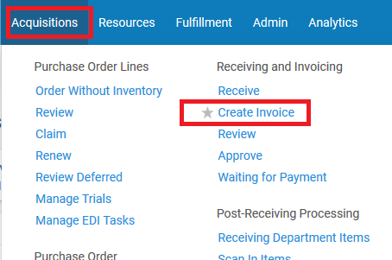 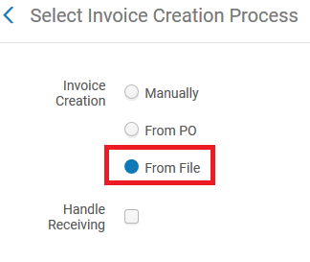

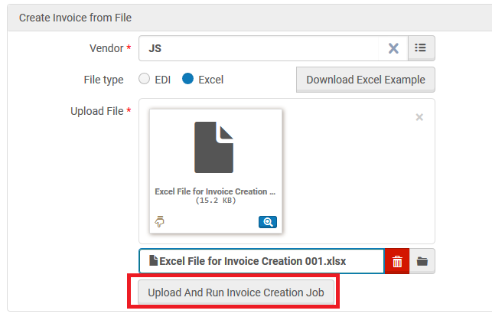 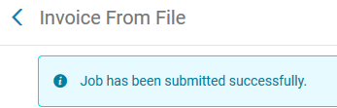

Here we can view the job from menu:

Admin > Manage Jobs and Sets > Monitor Jobs

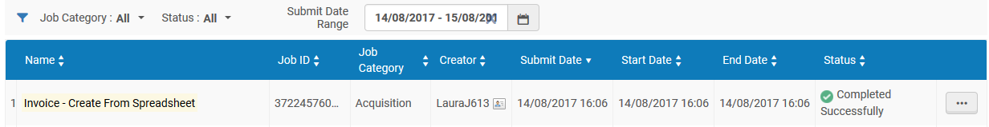

Here in the job report we can see details. It corresponds exactly to the Excel sheet.

Two invoices were created.

* The first invoice has 2 invoice lines and 2 POLs
* The second invoice as 2 invoice lines and 1 POL

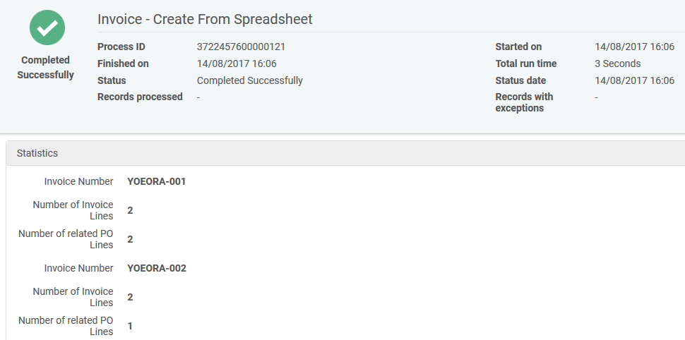

Here are the invoices

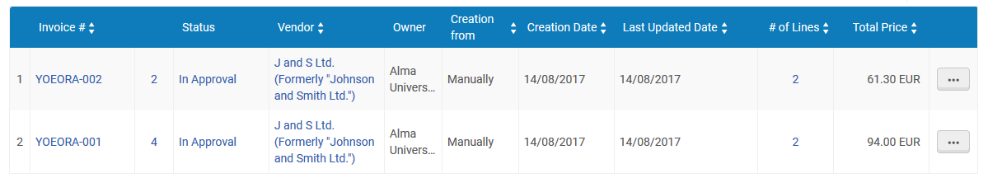

# Analyzing the first created invoice with the Excel sheet

Here in the Excel sheet we see that the first invoice is number YOEORA-001.

It has a total price of 94.00 EUR.

It has two invoice lines:

First Invoice Line for POL-43955 and costs 34.00 and has reporting code HIS (which is “History”)

Second Invoice Line for POL-44401 and costs 45.00 and has reporting code HIS (which is “History”)

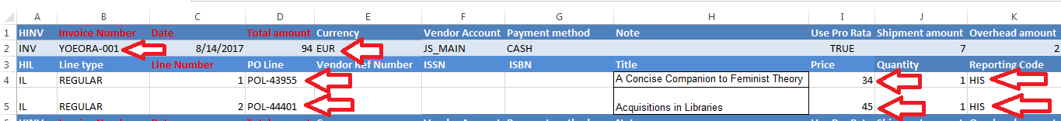

Here we see the same details in the invoice and invoice lines

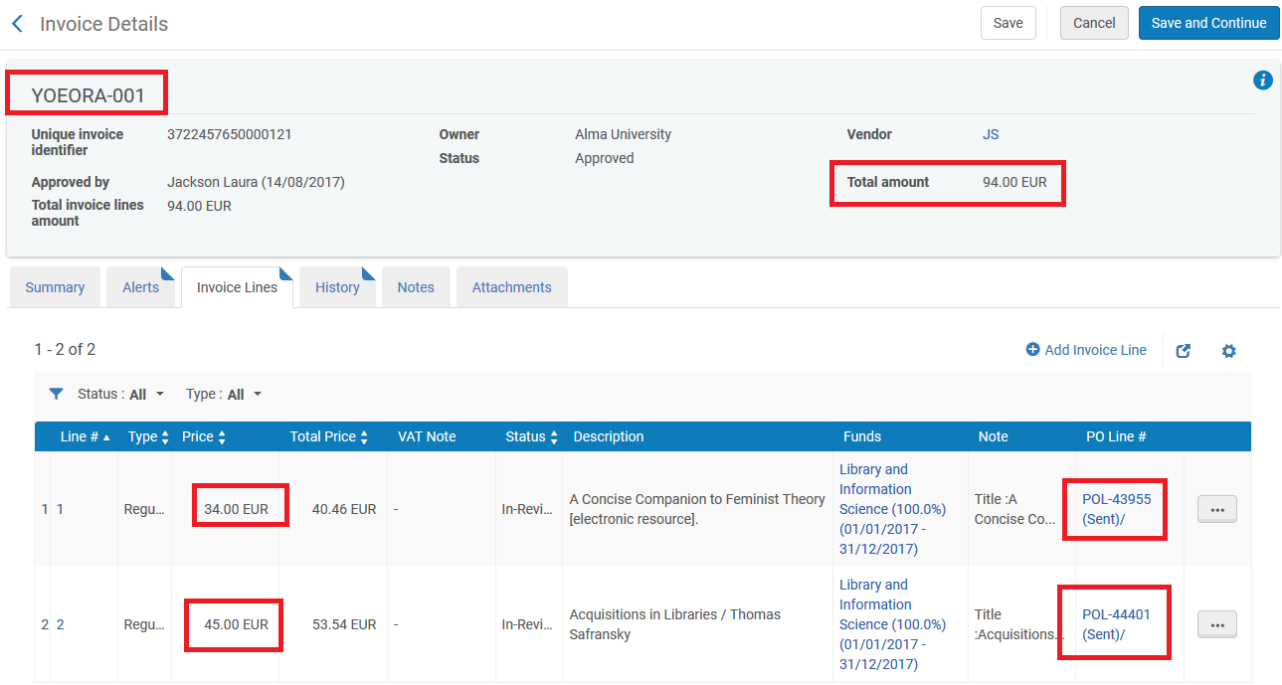

Note that above the “Total Price” column is more than the “Price” column because the invoice lines total is 79 (34 + 45), and the invoice total is 94. Thus a difference of 15 (94 – 79) was spread across the invoice lines.

6.46 was added to the first invoice line. (34 + 6.46 = 40.46)

8.54 was added to the second invoice line. (45 + 8.54 = 53.54)

The 15 difference was proportionally spread because the Excel file states “Use Pro Rata True”

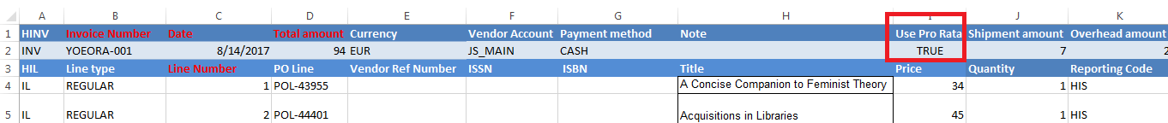

All additional charges (shipment, overhead, insurance and discount) in the summary tab of the invoice correspond to the Excel sheet, and as already pointed out the “Use Pro rata” is true

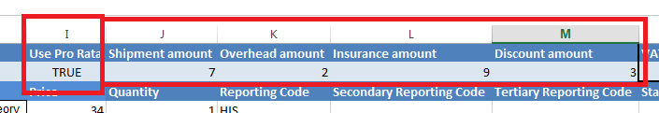

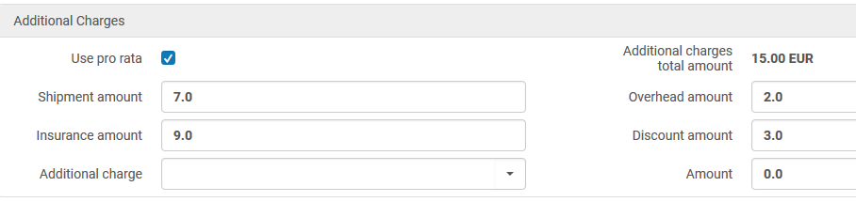

The reporting code from the Excel sheet appears in the invoice lines

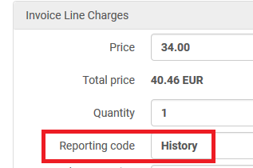

# Analyzing the second created invoice with the Excel sheet

Here in the Excel sheet we see that the second invoice is number YOEORA-002.

It has a total price of 61.30 EUR.

It has two invoice lines:

First Invoice Line for POL-44283 and costs 51.30 and has reporting code HIS (which is “History”)

Second Invoice Line in not for a POL. It is for “Overhead” and costs 10.00 and has reporting code SOC (which is “Social Sciences”)

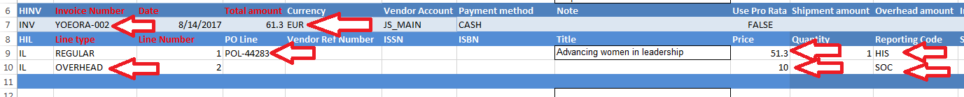

Here we see the same details in the invoice and invoice lines

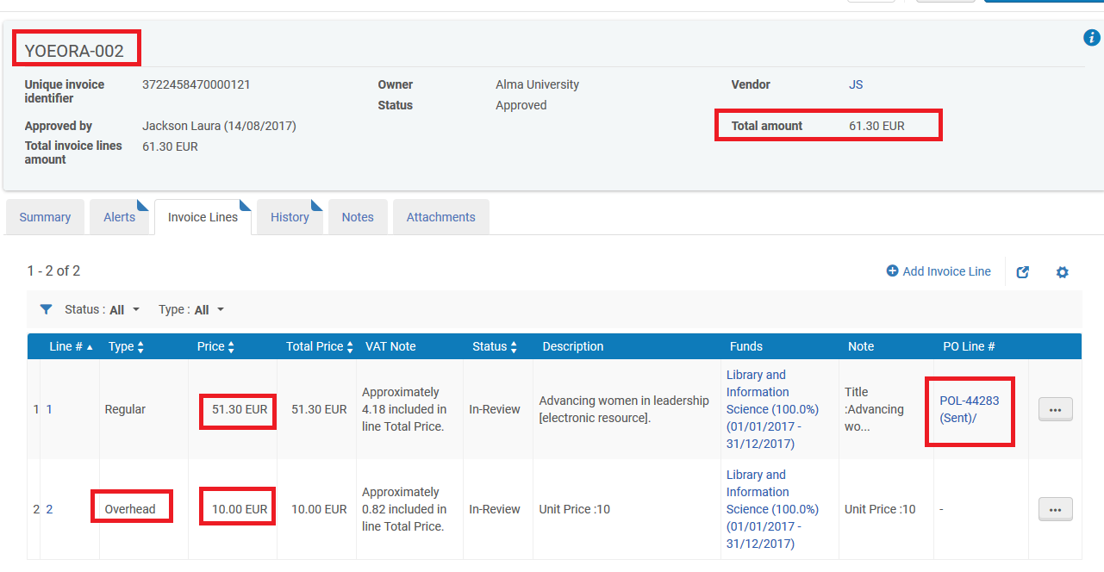

Note that above the “Total Price” column is the same as the “Price” column because the “Total Amount” in the Excel sheet is the same as the total of the invoice lines.

Note that the Excel sheet has VAT Amount 5, inclusive and expended from fund.

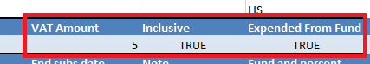

This is reflected in the summary tab of the invoice.

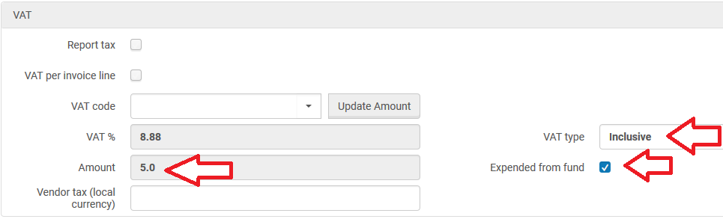

The reporting code from the Excel sheet appears in the invoice lines. Here for example is the invoice line for the ‘Overhead”

