App Builder and Branding

1. Essentials Kit - App Builder and Branding

1.1 App Builder and Branding
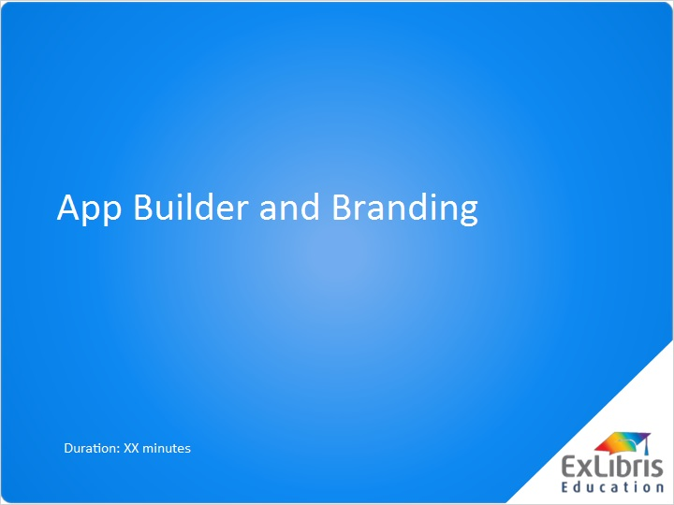
Notes:
Welcome to the Video Tutorial explaining the graphical interface App Builder and using it to brand your campusM app.

1.2 Agenda
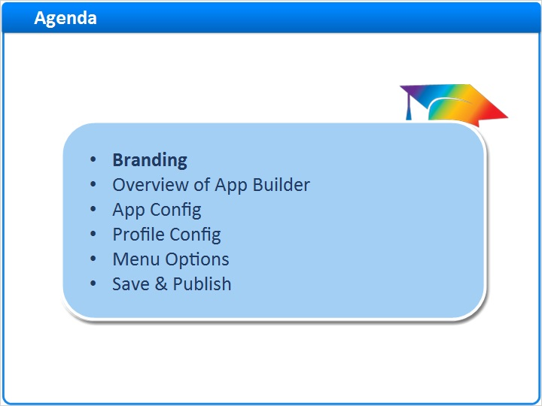
Notes:
During this session we will cover the following topics:

· Branding the app.
· An overview of the App Builder window, including the toolbar and configuration pane.
· App Config settings.
· Profile Config settings.
· The Menu Options section and
· … saving and publishing the changes to the live app.

We will start with branding.

1.3 Branding
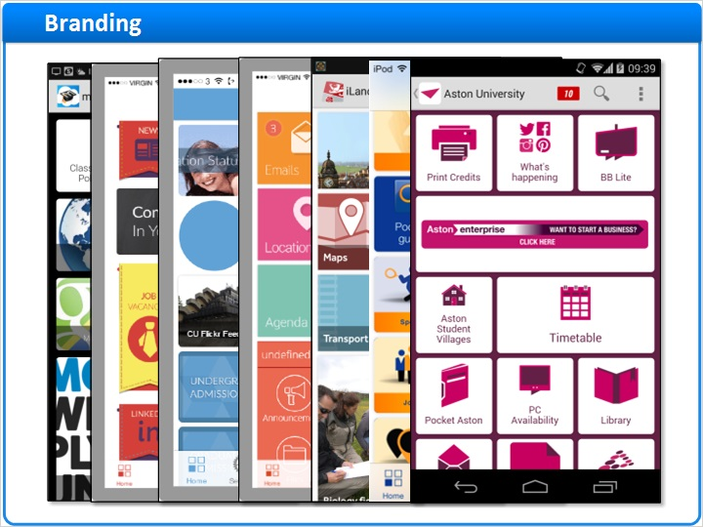
Notes:
Branding the campusM app covers all aspects including the published app name, the layout, coloring and placement of tiles and icons, images, and home page banners.

campusM provides a dedicated design team who use the customer’s own corporate branding guidelines to create an appropriate theme, design and set of icons as part of the initial implementation. The team continues to be available through campusM Professional Services to update and refresh the presentation.

1.4 Agenda
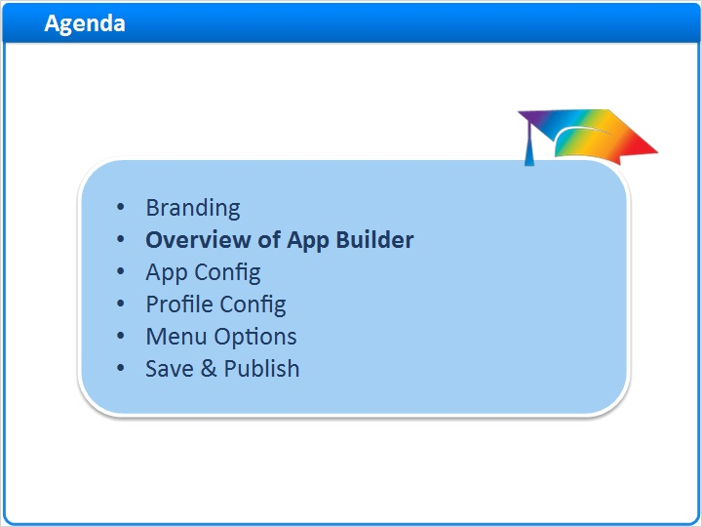
Notes:
The App Builder component enables the administrator to create new tiles, modify existing tiles and visualize what the end user sees in the app, depending on their device, their App Profile and their App Role.

New we’ll move on to an overview of App Builder and the functions available in the preview window.

1.5 App Builder
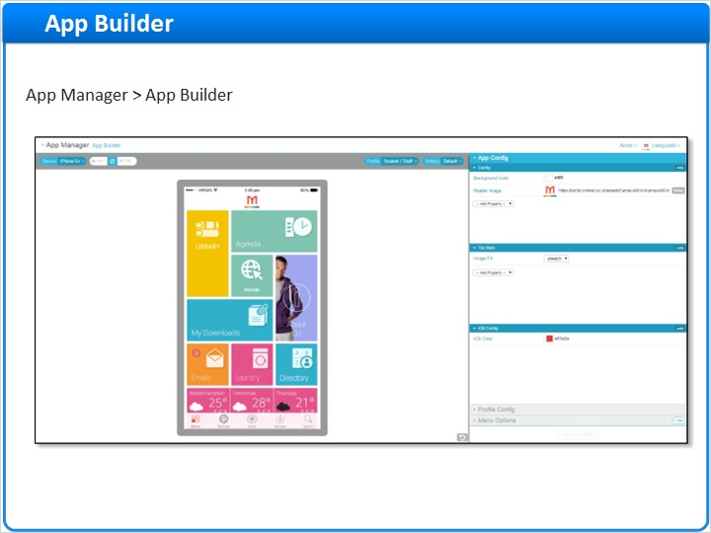
Notes:
App Builder uses an intuitive WYSIWYG interface so that the administrator can make changes, see how they are presented to the end user community and publish them immediately.

1.6 App Builder Toolbar: Device Settings
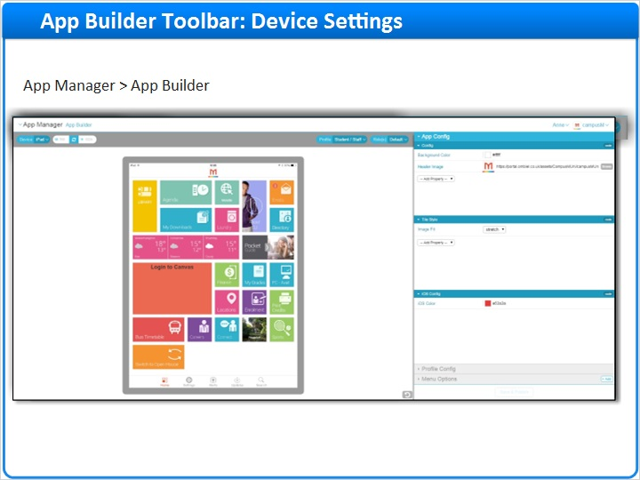
Notes:
The toolbar is always displayed in App Builder to select the options for the device to be configured.

The Device selection enables the administrator to select the display for the device they want to configure or amend, such as an Android device, an iOS device or a browser display. The device selection is reflected in the preview window. The current selection is for an iPad. The preview screen is designed to mimic the screen configuration and options that are available on that type of device.

For a tablet device display, the orientation can be switched from portrait to landscape, or vice versa, using the Width\Height refresh button. The tiles on the display are automatically rendered in the chosen orientation.

1.7 App Builder Toolbar: Profile/Roles
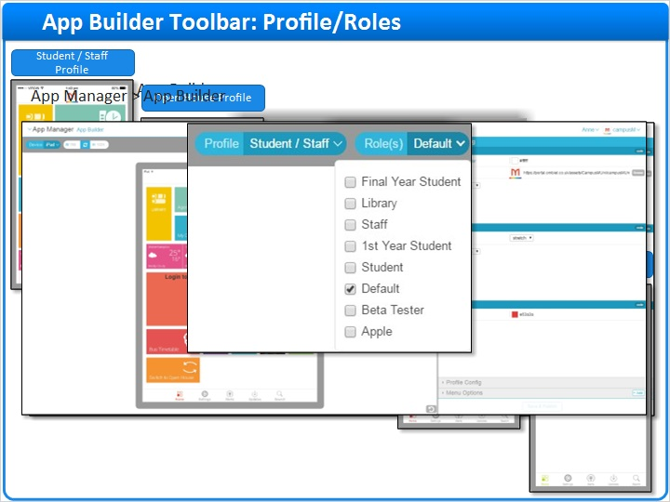
Notes:
App Profiles and App Roles allow you to tailor the experience of the app to different cohorts, and constituents of these cohorts respectively.

The Profile button allows the app to be branded entirely differently for each App Profile.

This is the same app with five different profiles configured.

Specific App Roles are selected against the App Profile to allow for extra refinements and granularity. For example, modifications may only be applied to a tester App Role at first, to ensure that the configuration is correct before finally publishing to the end user.

Only the App Roles applicable to that Profile are displayed.

It should be noted that branding configuration can only be set at the App Profile level. It cannot be changed for different App Roles within the same Profile.

Finally, it is important to ensure that the correct App Profile and App Roles have been selected before menu tiles are modified or created, to ensure that the end user sees only the appropriate content for their Profile.

1.8 App Builder Configuration Pane
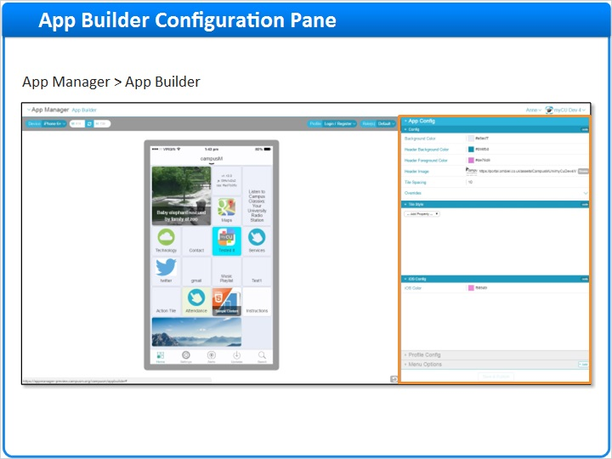
Notes:
The configuration panel down the right hand side of the window allows an administrator to control the branding for the app, perhaps modify the branding for a specific App Profile and create and configure each individual tile.

1.9 Agenda
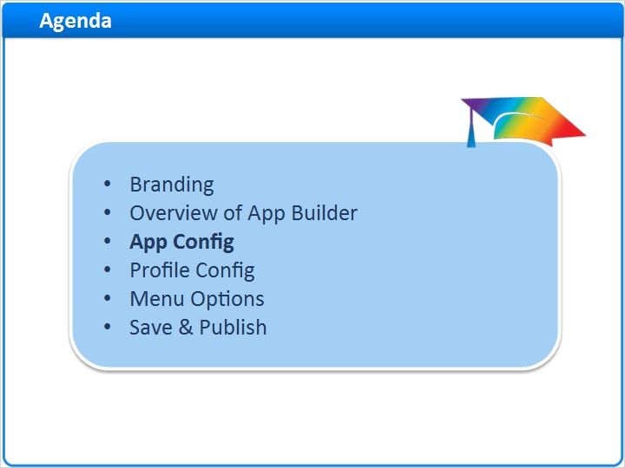
Notes:
To understand how the different elements are configured, it is necessary to explain the options in the configuration panel in more detail, starting with the App Config section.

1.10 App Config
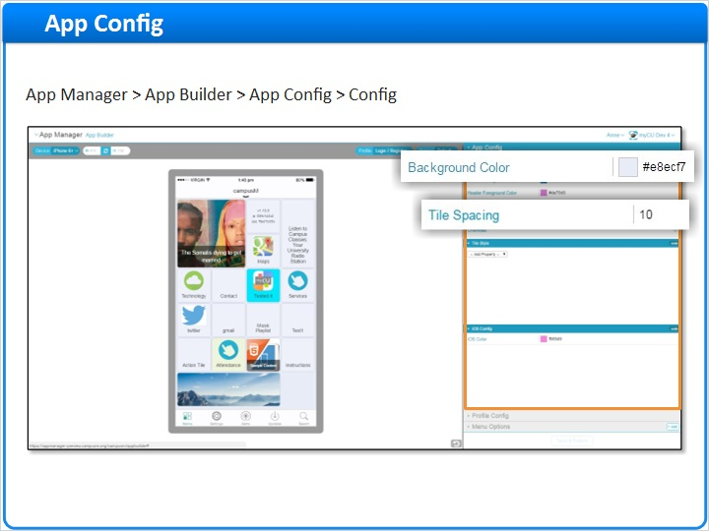
Notes:
The Config section of App Config covers the branding for all profiles in the app in terms of color, header images and spacing. Much of this section is specific to the web app, such as the header settings, apart from elements such as background color and tile spacing, which are more general and apply to all platforms.

1.11 App Config: Tile Style
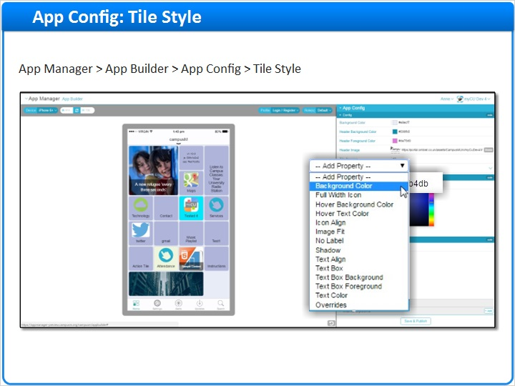
Notes:
The Tile Style section of App Config sets the default style for the tiles for the app.

For example, to set the background color of the tiles, click the square color icon to bring up the color palette. Click the small bar on the right hand side of the palette to select the approximate shading. If the full palette is not visible and cannot be accessed by using the scroll bar, click into the small bar on the right and press the Down Arrow key on the keyboard to display the full palette box.

Drag the small circle icon across the palette to select a color. The color icon and associated hex color code change as the circle is dragged. The preview of the device view is also updated so the administrator can see the effect.

A hex color code can also be entered directly into the field for precise color selection.

The administrator can continue to add as many properties as required to the App Config Tile Style.

1.12 App Config: iOS Config
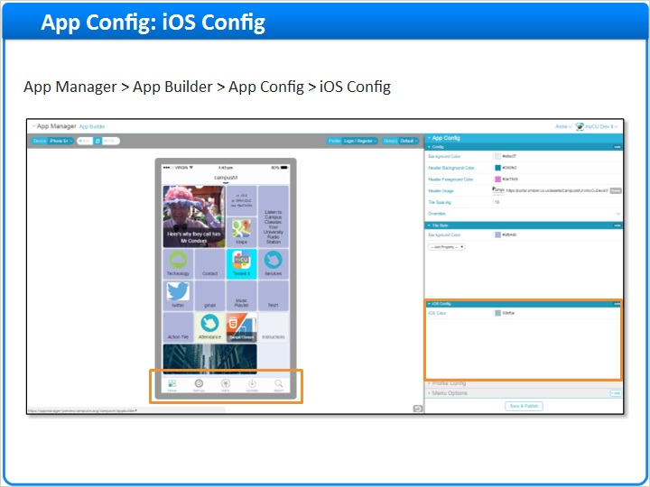
Notes:
The iOS Config section allows the administrator to set the color for the icons on the toolbar and the navigation buttons for an iPhone or an iPad that are not available on Android devices or the web app.

Don’t forget to Save & Publish any changes. We’ll look into this function in a bit more detail later.

1.13 Agenda
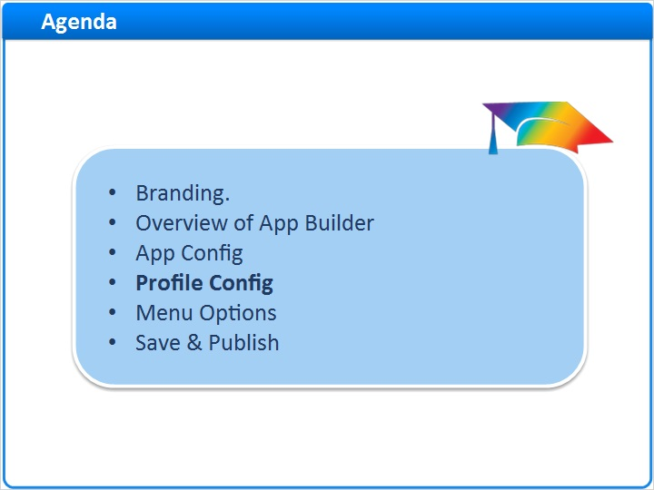
Notes:
We have just looked at the App Config section, which sets the defaults for the app. Now we’ll look at the Profile Config section which defines default settings for the App Profile.

1.14 Profile Config
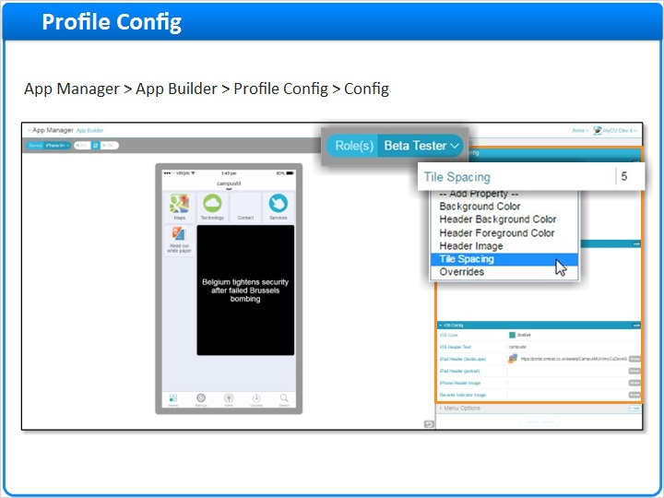
Notes:
The appropriate App Profile has been selected, and all the relevant App Roles. It’s recommended good practice to assign the Beta Tester App Role, so that the changes do not go to the end user until the configuration has been thoroughly tested.

If a property is set in the Profile Config section, it overwrites the setting in App Config. We looked at an example in the App Config section where the background color is set to light grey and the tile spacing is set to 10. We are not going to change the background color, so the color is inherited from the App Config settings. We are, however, going to reduce the Tile Spacing for this Profile.

If a property value in App Config is subsequently updated, it does not overwrite the same property in Profile Config, if it has already been set.

1.15 Profile Config: Tile Style
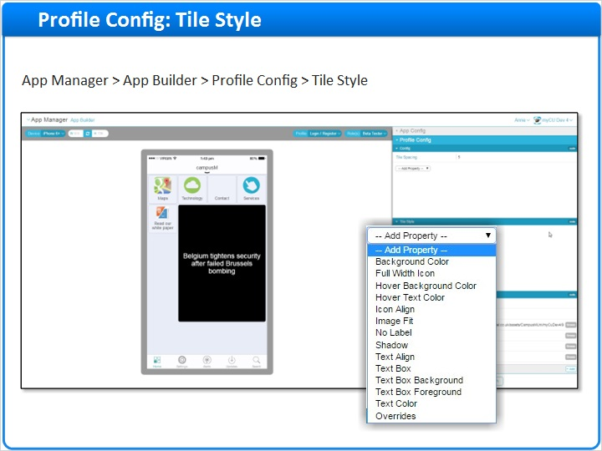
Notes:
The Tile Style section of Profile Config sets the default style for the tiles for the Profile. It is exactly the same list of properties as we saw for the App Config Tile Style section, but setting them only applies to this App Profile.

1.16 Profile Config: iOS Config
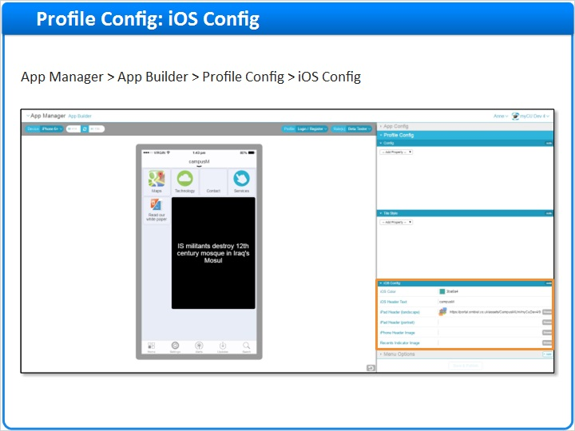
Notes:
The iOS Config section of Profile Config allows the administrator to define properties specific to an iPhone or an iPad for the selected App Profile where the feature is not available on Android devices or the web app.

If the option is not configured, the settings are inherited from the default App Profile. This also means that the configuration set in either the App Config or the Profile Config for the Header Text or Header Images are the default settings for Android devices and the web app.

Don’t forget to Save & Publish if you have made any changes.

1.17 Agenda
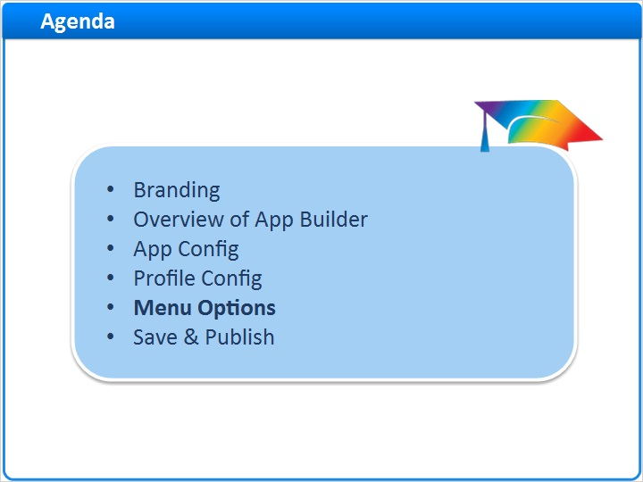
Notes:
We’ve set the defaults for the app in the App Config section, and we’ve configured settings for the App Profile in the Profile Config section. Now we are going to look at how the individual tiles are configured in the Menu Options section.

1.18 Menu Options
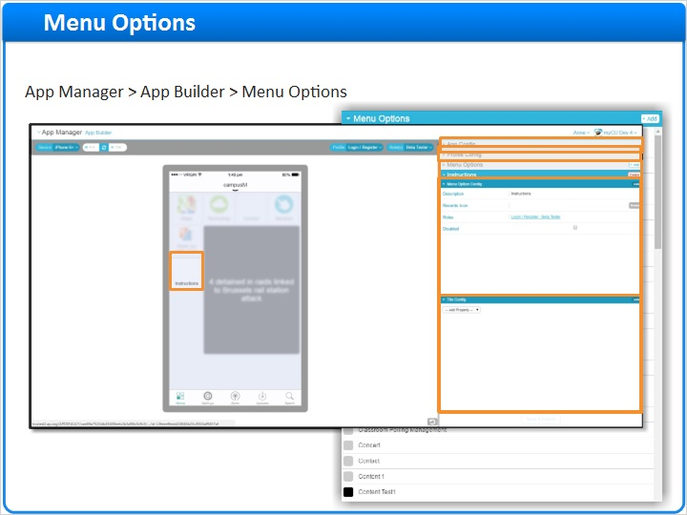
Notes:
The Menu Options section covers every menu option or tile that has been created for all App Profiles, including test tiles. The tiles are filed in alphabetical order of the Description.

You can either search for a tile by scrolling through the list, or highlight a specific tile on the preview screen to view the individual configuration settings. The tile settings have inherited any settings for the app defined in the App Config section, and any settings for the App Profile in the Profile Config section. Settings defined in the Menu Options section will override any specified in those sections for this tile.

The configuration is broken down into two sections: Menu Option Config for basic configuration options and Tile Config for more advanced configuration options.

1.19 Menu Option Config
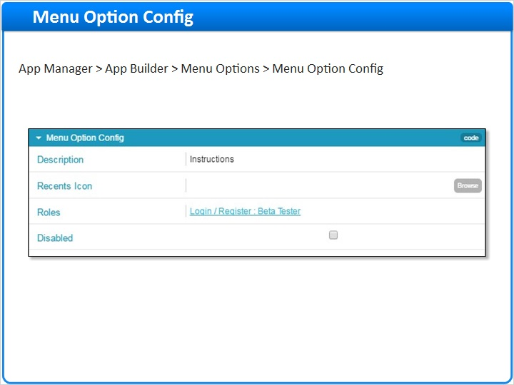
Notes:
Menu Option Config offers some basic configuration options for the menu tile and is the same for every Menu Option.

The Description is the name given to the menu tile when it is created and is used as the label for the menu tile in the app. It cannot be amended once the tile has been created.
The Recents Icon appears on both iOS and Android devices, if it is set, allowing users to quickly access recent menu options. The icon is the image that displays in the Recents menu for tiles that have been used most recently by the end user. The Recents Icon is selected from Asset Manager by clicking the Browse button.
Roles is how the menu tile is assigned to the appropriate App Roles for the App Profile selected. The App Roles must be updated and the menu tile saved and published before it is visible to the end user on the app.
If the Disabled checkbox is selected, the menu tile is not visible to the end user, regardless of the App Roles selected.

1.20 Tile Config
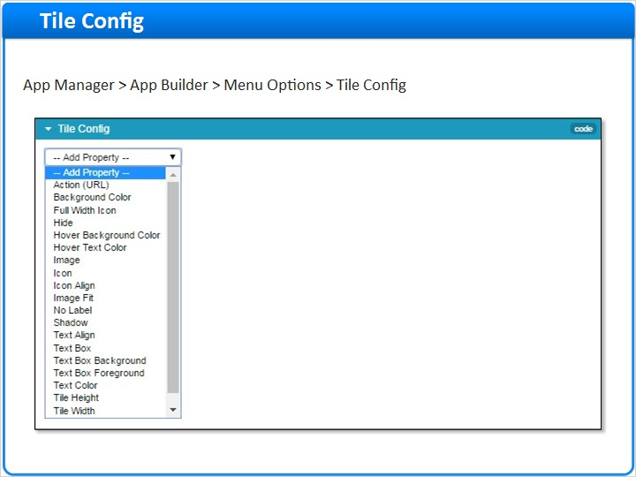
Notes:
The Tile Config section offers advanced configuration options for the menu tile and is the same for every menu tile configuration. Properties will have been inherited from the default App Config Tile Style configuration and also in the Profile Config Tile Style set up. Remember that the Profile configuration may also override the default configuration set up in App Config.

As many properties can be added as required although it is recommended that the configuration is not too complex as this would complicate ongoing administration.

1.21 Agenda
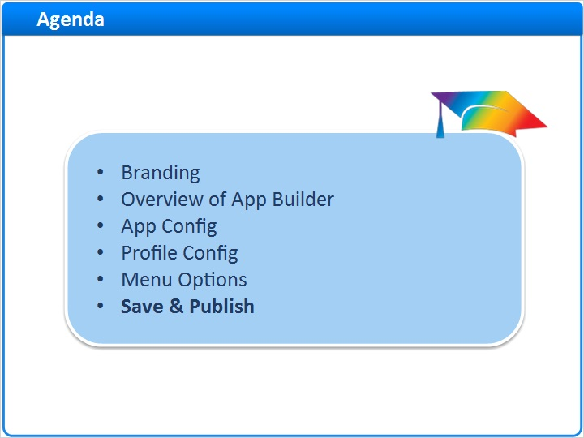
Notes:
It is recommended that you Save & Publish at each stage of the configuration to ensure that important changes are not lost. We’ll now look at this option in more detail.

1.22 Save & Publish
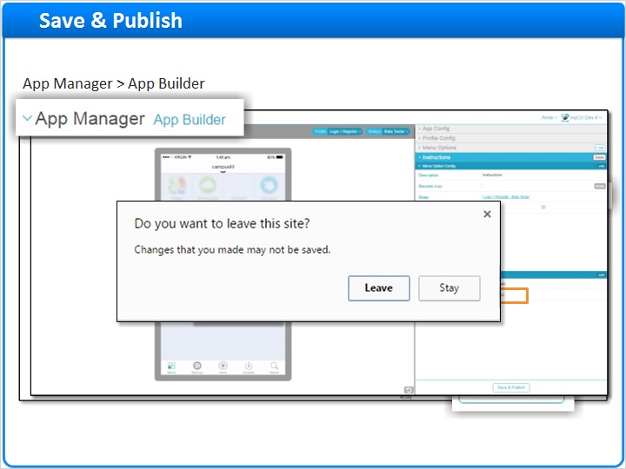
Notes:
Every change in App Builder that is to become part of the configuration must be saved and published. The App Roles should be updated to the intended end user audience if the configuration is now complete. The advantage in App Builder is that saving and publishing are all part of the same action.

Once a change has been made, the Save & Publish button at the bottom of the configuration panel is activated. Clicking the button returns a warning that changes are about to be saved and published to the app. The action can be cancelled at this point, or click the Save & Publish button to commit the changes. A confirmation window is displayed. Clicking the Show Details hyperlink displays a list of all changes made. Click the grey cross in the top right hand corner to remove the message and return to the App Builder preview window.

Once a change has been published, the change is pushed out when an end user next accesses their app. There is also a record in the app Updates menu option.

If changes have been made to a Profile but are not to be saved, click the App Builder option in the menu breadcrumb trail. A warning message is displayed that changes that have been made will be lost if the action is continued. Click Leave to confirm. The preview screen returns to the previous saved configuration.

1.23 Session Review
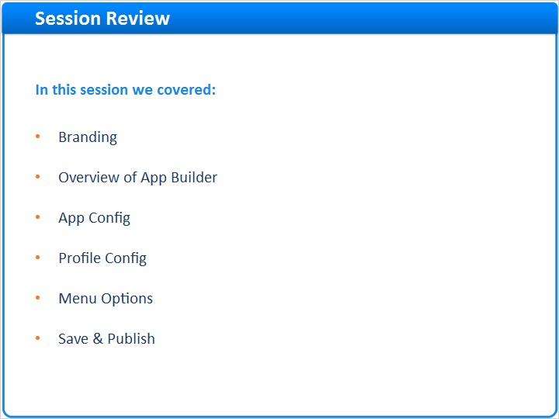
Notes:
This concludes the session on App Builder and branding. In this session, we covered branding the campusM app. We looked at how to configure the branding, starting with an overview of App Builder and then a consideration of the configuration options in more detail. We concluded the session by looking at how to Save & Publish the configuration changes.

1.24 Thank You!

Notes:
Further information about branding and the App Builder component can be found in the comprehensive online documentation in the Ex Libris Knowledge Center.

The Branding Guidelines document is also available from the campusM Professional Services team, on request.

Thank you.

