|  |  |
| --- | --- |
| **Integrating Purchase Orders with the ERP number for approval** |  |



**Yoel Kortick**

**Senior Librarian**

This document will show how it is possible to integrate Purchase Orders with the ERP number of the institution. In the setup below the PO cannot be sent to the vendor, or continue in the PO process, until the ERP approves the PO and the ERP number is supplied.

# Part One: Export Orders PO

In the ‘actions’ tab of the integration profile of type ‘finance’ a new checkbox (Nov. 2017) has been added to the ‘Export Orders (PO)’ section.

If ‘Integrate by ERP Number’ is checked and ‘Export Orders’ is set to Active at least for one finance integration profile then when the PO is sent the following check is done:

* If the PO has the field ‘ERP Number’ populated then the PO continues in regular workflow (for example it might be sent or go to approval task list)
* If the PO does not have the field ‘ERP Number’ populated then the PO is exported to the ERP and remains in review with alert ‘ERP number is missing’

If ‘Integrate by ERP Number’ is not checked then the behavior remains as it was: the PO gets sent to the ERP and continues in workflow

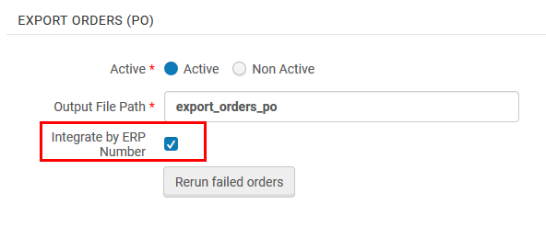

# Part Two: Example of PO sent to ERP

In this scenario the checkbox “Integrate by ERP Number” in the ‘actions’ tab of the integration profile of type ‘finance’ is checked.

In the order we click ‘Order now’ so the POL should get packaged and the PO should be sent.

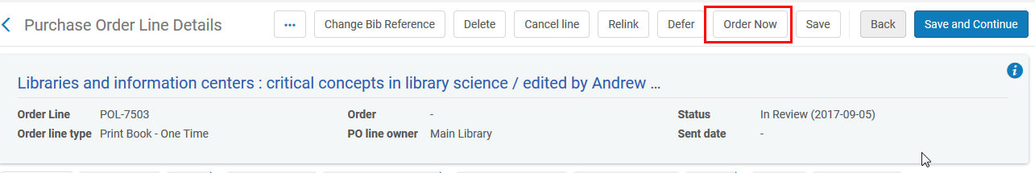

However, the PO goes to ‘In Review’

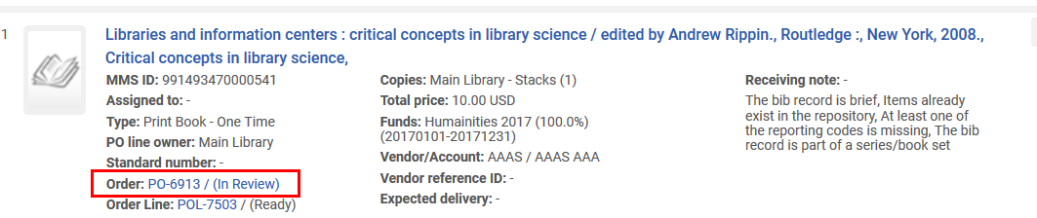

And the reason it is in review is because the ERP number is missing:

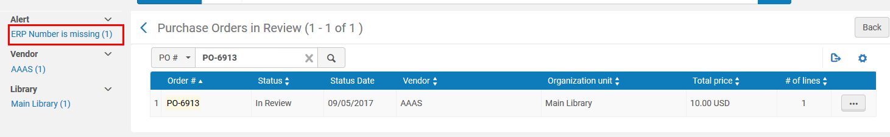

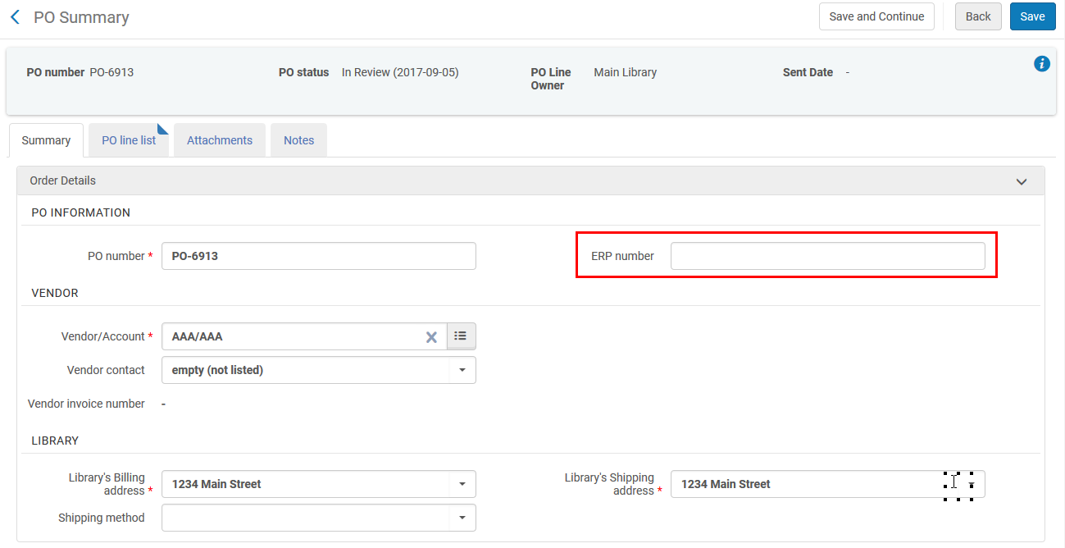

When we clicked ‘Order Now’ the PO was sent to the ERP. Here it is on the ftp server.

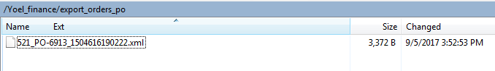

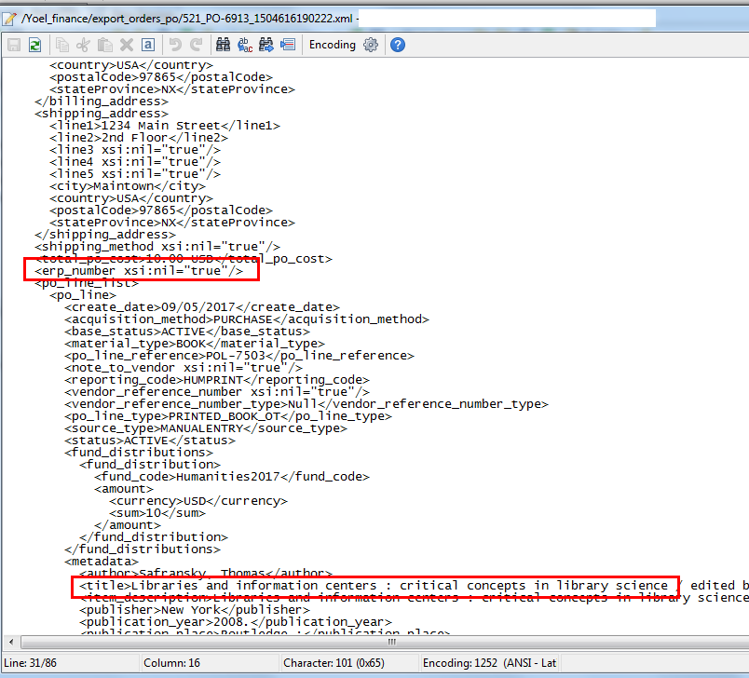

At the current time two POs have been sent to the ERP and are on the ftp server for the ERP to take and either approve or reject.

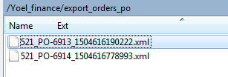

The POs are PO-6913 and PO-6914:

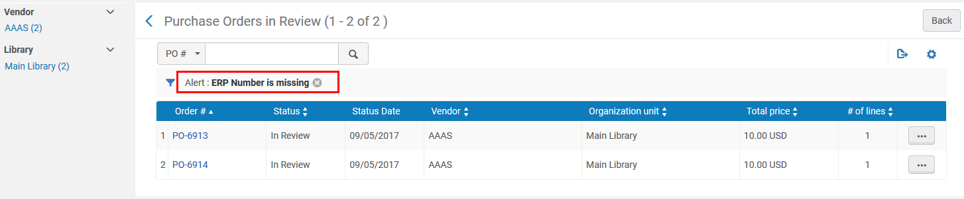

# Part Three: Import PO approvals

In the ‘actions’ tab of the integration profile of type ‘finance’ a new section (Nov. 2017) has been added called ‘Import PO Approvals’ with radio buttons “Active” and “Non Active”.

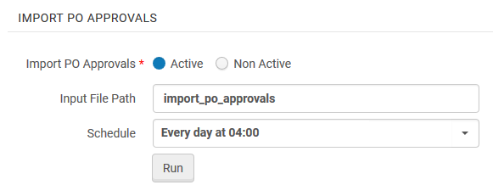

This job will take a file with the following fields:

1. The PO number
2. If it is approved or rejected
3. The ERP number
4. Rejection reason (when rejected)

When the job runs the POs which are approves get the ERP number automatically added and then they continue in the workflow.

The file is in the following format.

In this example

**PO-6913 is approved with ERP number 248.**

**PO-6914 is rejected with note ‘Not approved by Dept. head’**

|  |
| --- |
| <?xml version="1.0" encoding="utf-8"?>  <po_approval_data xmlns="http://com/exlibris/repository/acq/xmlbeans"  xmlns:xsi="http://www.w3.org/2001/XMLSchema-instance">  <po_list>  <po>  <po_number>**PO-6913**</po_number>  <erp_number>**248**</erp_number>  <approval_date>20170905</approval_date>  <approval_status>**APPROVED**</approval_status>  <reject_reason></reject_reason>  </po>  <po>  <po_number>**PO-6914**</po_number>  <erp_number></erp_number>  <approval_date>20170905</approval_date>  <approval_status>**REJECTED**</approval_status>  <reject_reason>**Not approved by Dept. head**</reject_reason>  </po>  </po_list>  </po_approval_data> |

Here it is on the ftp server.

It is also possible to have one file of approvals and one file of rejections.

The files can be divided however the institution wants, for example one file per order or one file per vendor.

It does not matter what the file names are called.

They must be in the above format and have suffix “.xml”.

Here is the file PO_approvals_20170905.xml

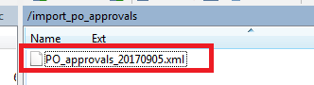

# Part Four: Results of job “Import PO approvals”

Now the job has run

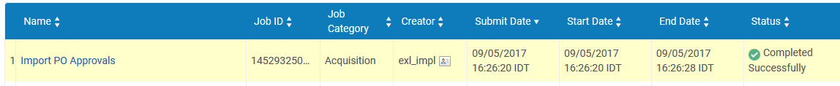

The one file on the ftp server processed both records in the file.

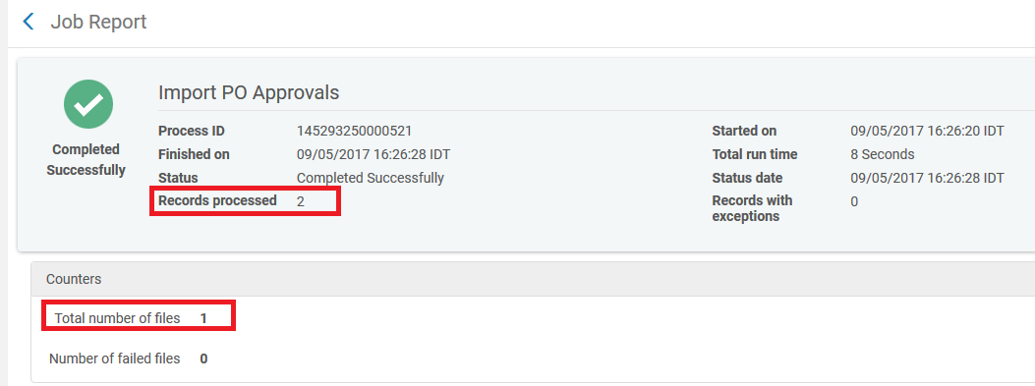

After the ‘Import PO approvals’ job runs the file gets renamed so that it will not be taken again next time the job runs:

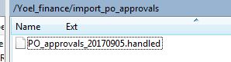

PO-6913 is now ‘In Approval”. This means it has continued in the workflow because previously it was ‘In Review”

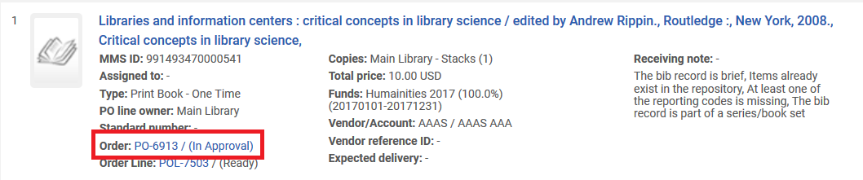

The ERP number has been added automatically to the approved PO.

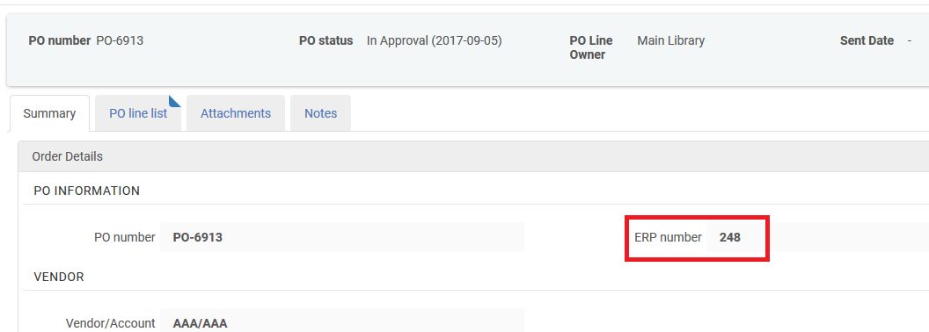

PO-6914 has been rejected. It is still in Review.

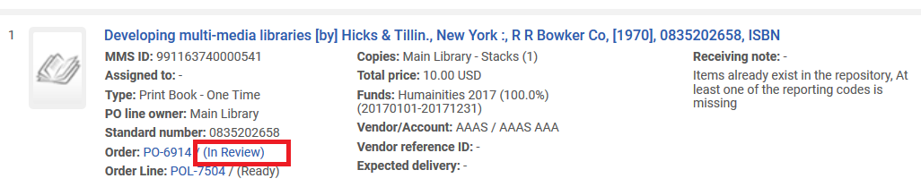

The reject reason from the xml is added to the rejected PO.

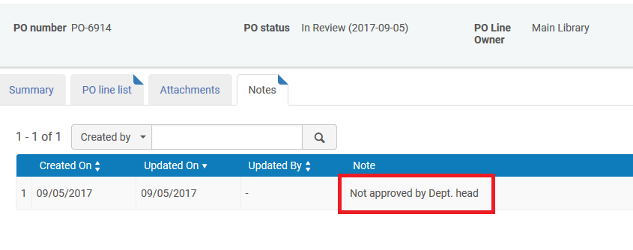

Note that when a PO is rejected it also gets an alert “Rejected by ERP system”. If a PO was previously rejected it can be changed to approved later if the decision was changed. This can be done by importing another approval file.

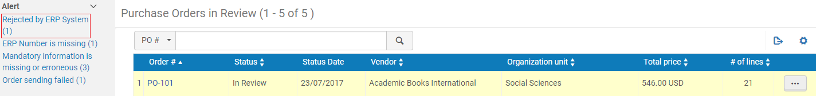

The ERP number for the sent PO can also be included in the letter to the vendor

