|  |  |
| --- | --- |
| **How to add a new local authority file vocabulary to Alma** |  |



**ONE**

In order to add a new local authority vocabulary do as follows:

“Configuration > Resources > Cataloging > Metadata Configuration > Add vocabulary”



**TWO**

For each desired vocabulary fill in the form.

For example here is local vocabulary UDC Technion Local:

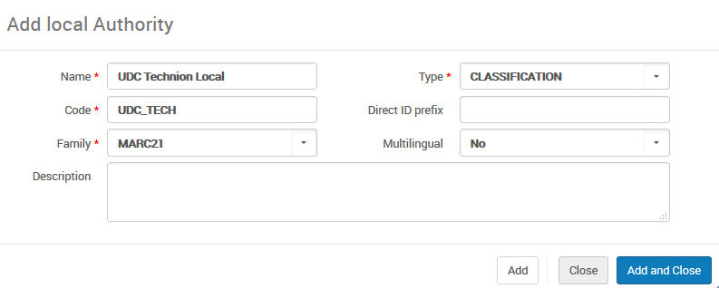

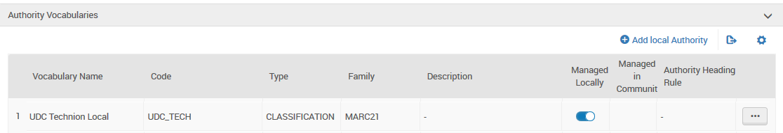

**THREE**

Take note that now you can add authority records manually for these files in the metadata editor

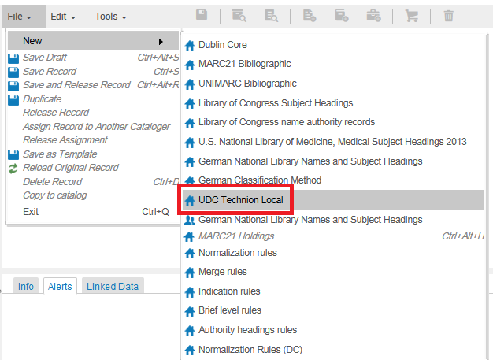

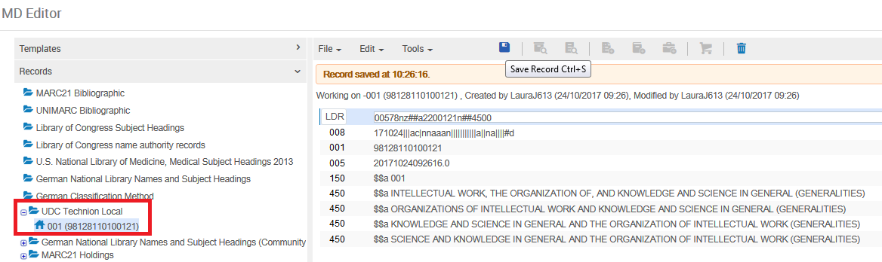

**FOUR**

The record exists in the repository

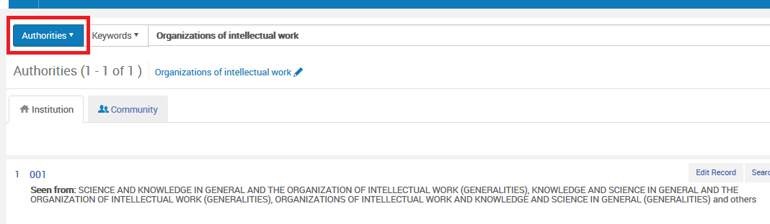

**FIVE**

Take note that now you can add authority records via an import profile for these records. We choose code “UDC_TECH” which is the code we gave for this type of authority record above.

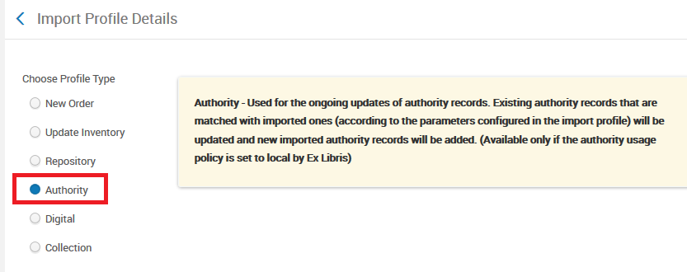

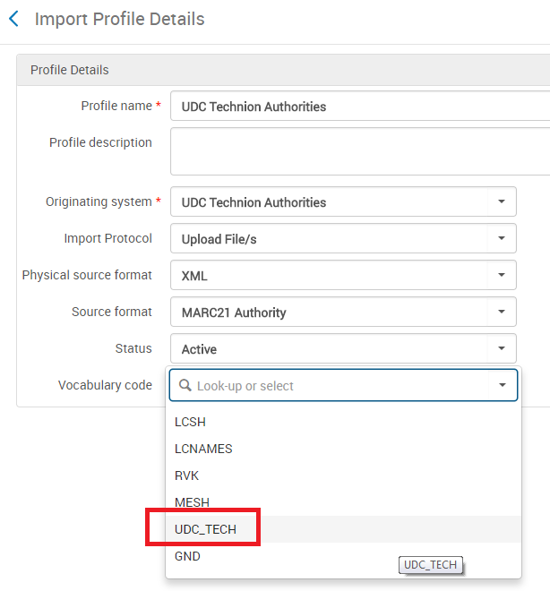

**SIX**

Here we have created an import profile for type “Authority” for UDC Technion Authorities

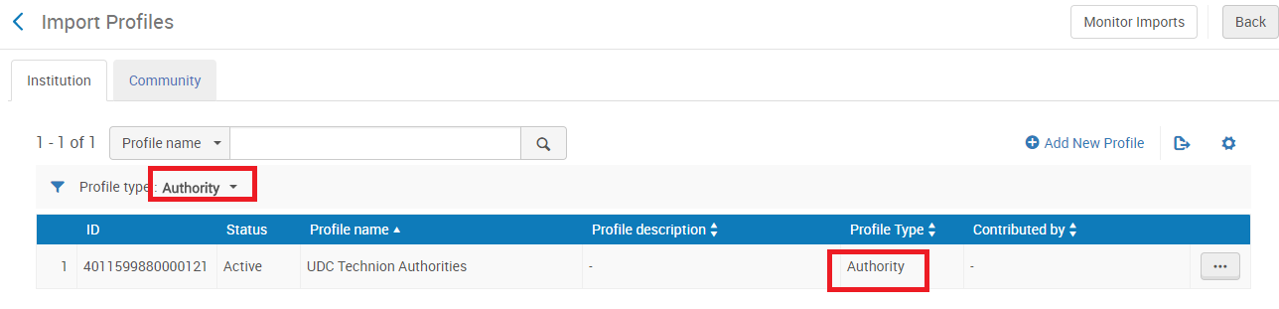

**SEVEN**

Now we import the file

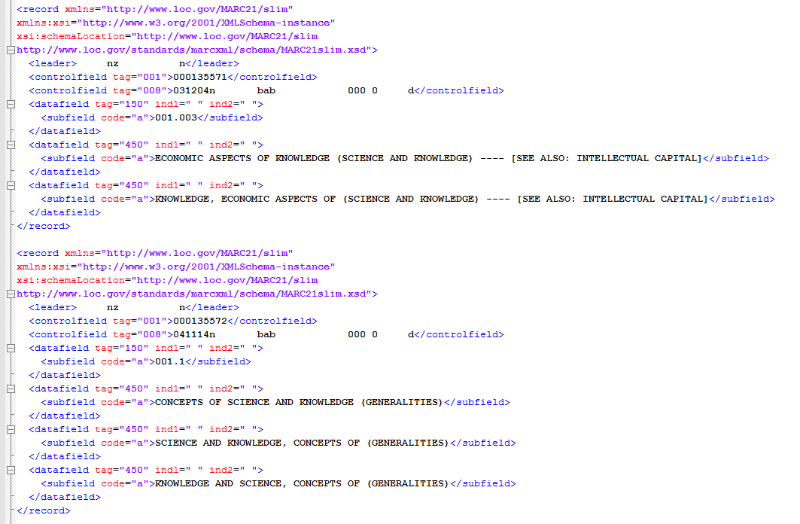

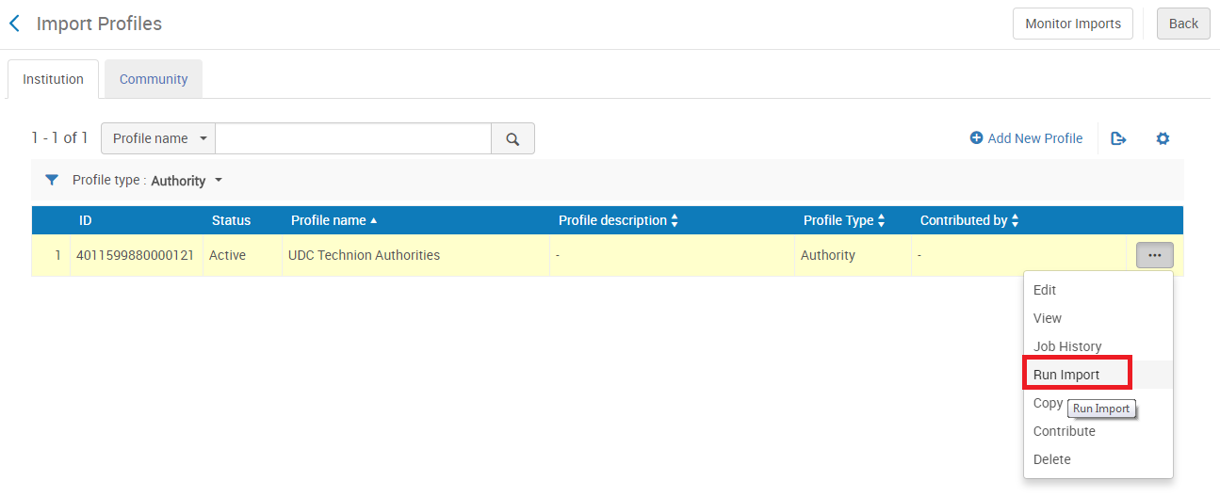

**EIGHT**

The job completed successfully

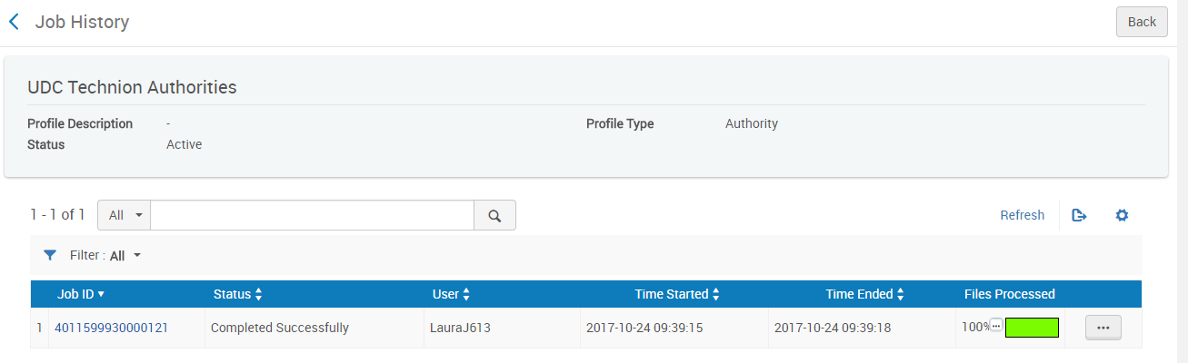

NINE

Three records were imported and we will preview them

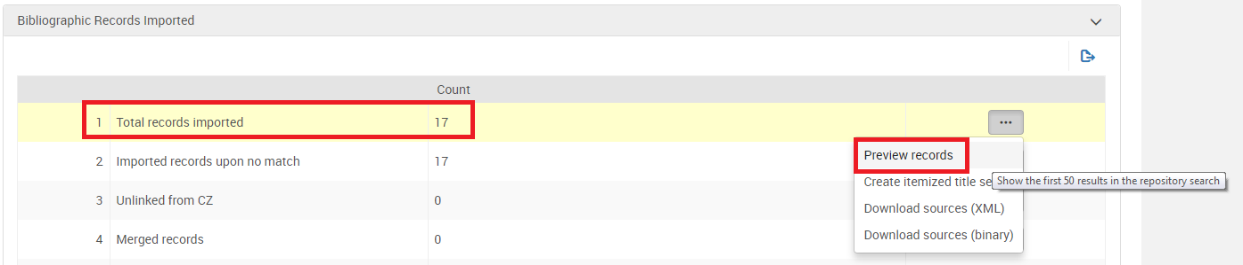

TEN

Here are the imported records:

