|  |  |
| --- | --- |
| **Saved searches alerts  (Selective Dissemination of Information SDI)** |  |



**Yoel Kortick**

**Senior Librarian**

Selective Dissemination of Information is a way for an end user to automatically receive updates when new records which answer specific queries are added to the repository.

This is possible via Primo using the “Saved Searches Alerts”.

For example if a user wants to receive an update every time records with keywords “feminist theory” are added to the repository then he can do as follows

1. Sign in to Primo
2. Search for “feminist theory”
3. Go to search history  
     
   
4. In right column click ‘keep this search’  
     
   
5. In the ‘Saved Searches’ tab click ‘Set an alert for this search’  
     
   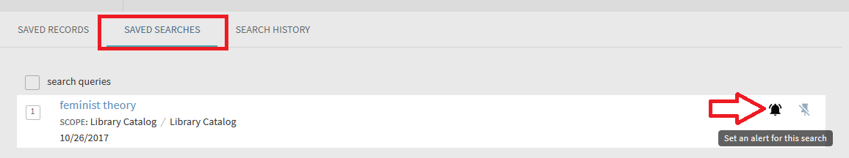
6. Get message that notifications will be sent to the email registered with the end user  
     
   
7. A new record is added to Alma which answers the end user’s query  
     
   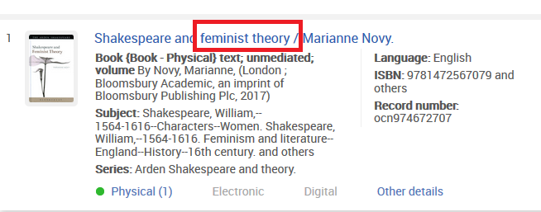
8. In Alma the job ‘Save Searches alert job’ will run  
     
   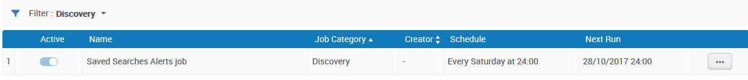
9. End user receives an email  
     
   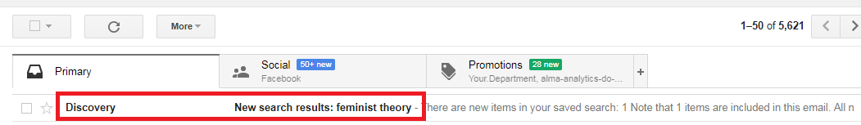
10. The email includes
    1. A link to the discovery interface with the search query already filled in
    2. The title(s) of the added record(s) with link(s) directly to them.  
         
       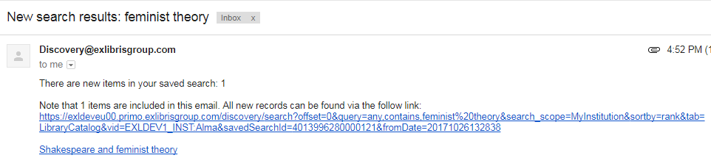
11. Clicking on the first link in email above opens discovery intercase with the search query already filled in:  
      
    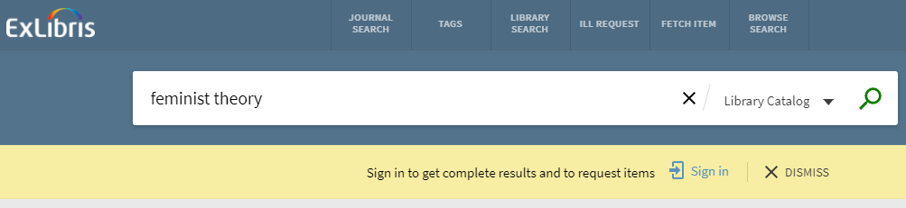
12. Clicking on the second link in email above opens discovery intercase with the specific title already retrieved:  
      
    