ILLiad Borrowing Request Workflow if you are using the default Resource Sharing Library
Alma Configuration Required:
--Set library hours for the Resource Sharing Library
--Configure TOU for Resource Sharing Library Fulfillment Unit
--Configure Resource Sharing Partner (ILLiad) parameters (Fulfillment>Resource Sharing>Partners)
Workflow:
- Requested Item received from lending library is scanned into ILLiad
  - This generates an Accept Item NCIP message from ILLiad to Alma.
  - In case of physical material a temporary item (and a brief suppressed bibliographic record) is created, request is automatically received in Alma and places a hold request for the requesting patron.
  - Location of the item is the Resource Sharing Library

Fulfillment>Resource Sharing>Borrowing Requests (to view request in Alma)
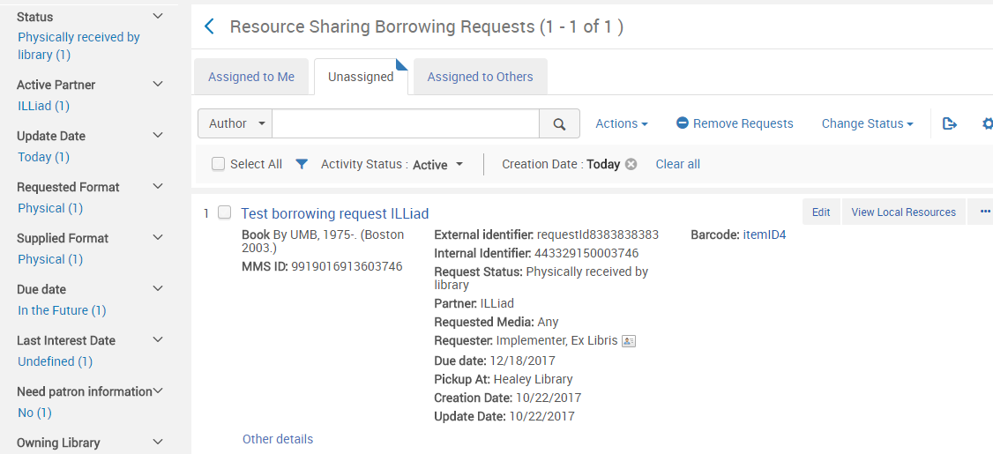

Fulfillment>Manage Patron Services (to see hold request for patron)
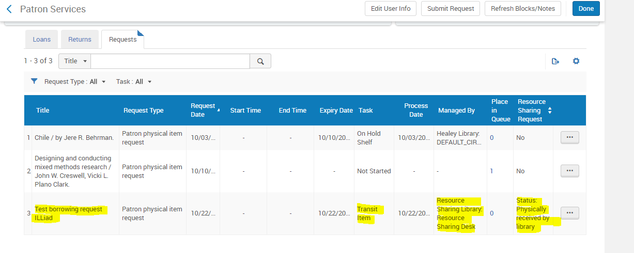
- Transit item to library for pick up by Patron (e.g. Healey Library – Default Circ Desk)
  - Change “Currently at” location to Healey Library – Default Circ Desk
  - Scan in barcode or request ID
Fulfillment>Resource Sharing>Scan in Items (to scan item barcode or request ID)
OR
Fulfillment>Checkout/Checkin>Return Items (to scan item barcode)
  - Transit message is generated

  - This also triggers an auto hold shelf message to the requesting patron:
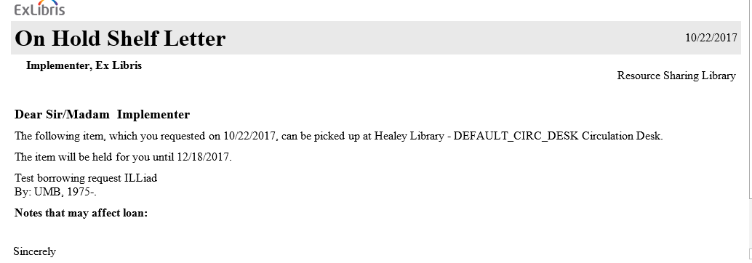
3. Patron arrives at the Healey Library – Default Circ Desk to pick up item.
4. Item is checked out to the patron.

NOTE: The Fulfillment Unit used in the transaction is the Resource Sharing Circulating Material:
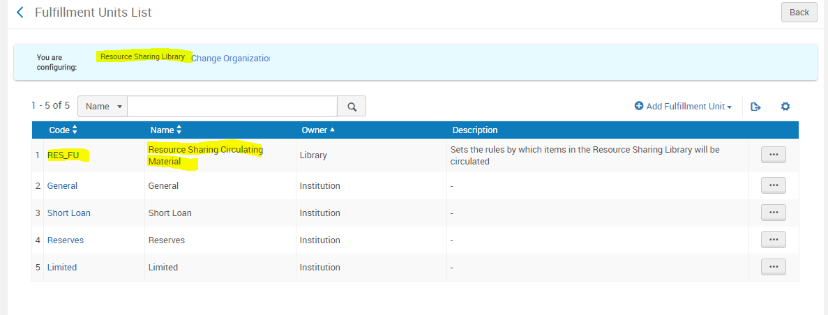

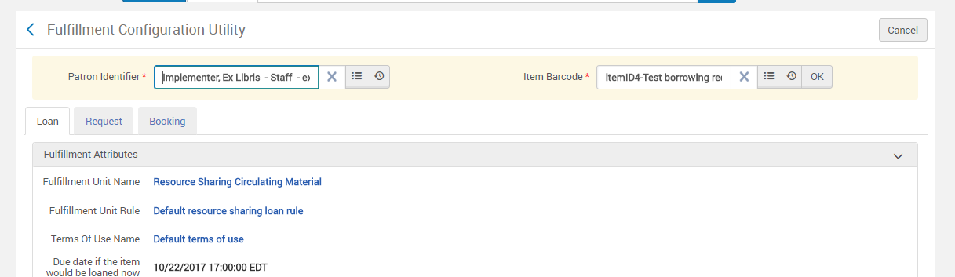

5. Patron returns item to circ desk
6. Item is scanned in a circ desk
Fulfillment>Resource Sharing>Borrowing Requests
You can see the status of the request is now Returned by patron.
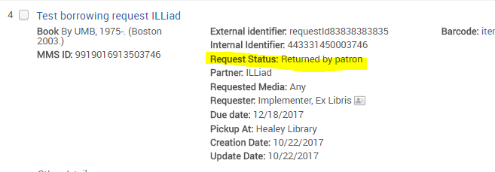

7. After scanning the item in at the circ desk, you get a message indicating the destination of the item is the Resource Sharing library:

8. Check in the item in ILLiad. (You do NOT have to scan in the item at the Resource Sharing library). If you do checkin the item in Alma, you still have to check it in in ILLiad.
9. A Checkin Item NCIP message is sent from ILLiad to Alma in order to mark the item as returned. Alma removes the temporary bibliographic record and the item and marks the borrowing request as complete.
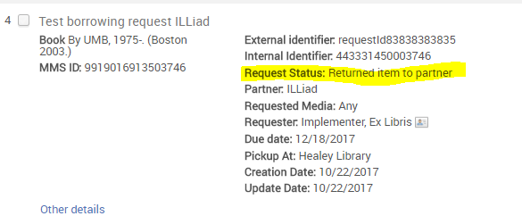

ILLiad Borrowing Request Workflow if you are using the Healey Library as the Resource Sharing Library
Alma Configuration Required:
--Configure Resource Sharing Partner (ILLiad) parameters (Fulfillment>Resource Sharing>Partners)
--Configure TOU for Fulfillment Unit in use with the location you designate for ILL items. (For testing, I used the existing Interlibrary Loan (ILL) location which is associated with the Limited Fulfillment Unit).
--Designate the Healey Library as a Resource Sharing Library. (Alma Configuration>Fulfillment>Library Management>Library Details>Summary tab>Resource Sharing Information.
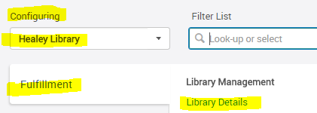

Workflow:
- Requested Item received from lending library is scanned into ILLiad
  - This generates an Accept Item NCIP message from ILLiad to Alma.
  - In case of physical material a temporary item (and a brief suppressed bibliographic record) is created, request is automatically received in Alma and places a hold request for the requesting patron.
  - Location of the item is the Healey Library
  - Patron is sent notification that item is on hold shelf. (See first workflow scenario for sample message).
  - Up to this point, all work has been done in ILLiad

Fulfillment>Resource Requests>Monitor Requests & Item Processes (to view request in Alma)
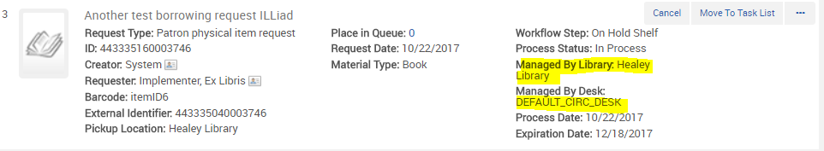

Fulfillment>Manage Patron Services (to see hold request for patron):

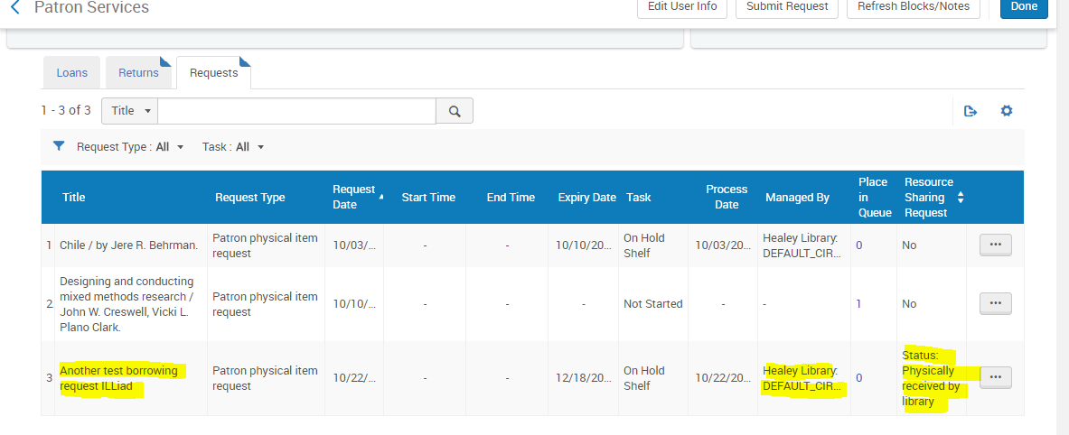

2. Patron arrives at the Healey Library – Default Circ Desk to pick up item.
3. Item is checked out to the patron
4. Patron returns item. Check in the item in ILLiad. (You do NOT have to scan in the item at the Healey Circ Desk). If you do checkin the item in Alma, you still have to check it in in ILLiad.
9. A Checkin Item NCIP message is sent from ILLiad to Alma in order to mark the item as returned. Alma removes the temporary bibliographic record and the item and the request is complete.

