|  |  |
| --- | --- |
| **How to make an Alma Analytics report of all items which transferred between two specific locations** |  |



**Yoel Kortick**

**Senior Librarian**

In this example we will make a report of all items which were transferred between the following two locations in the “Main Library”:

* Book Stacks
* Course Reserves_Main

The resulting report can later be further filtered as desired, and additional fields displayed

**ONE**

Create a new analysis in the “Physical Items Historical Events” subject area

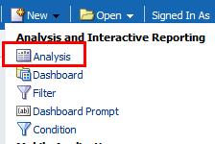 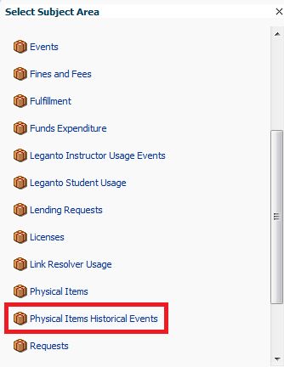

**TWO**

Add the following fields (you may later wish to remove or add others, but start with these)

1. "Barcode" from the "Item Event Details" folder
2. "Event type description" from the "Event Type" folder
3. "Event Start Date and Time" from the "Event Start Date" folder
4. "Event End Date and Time" from the "Event End Date" folder
5. "Item Location Name" from the "Item Permanent Location" folder
6. "Item Library Name" from the "Item Permanent Location" folder

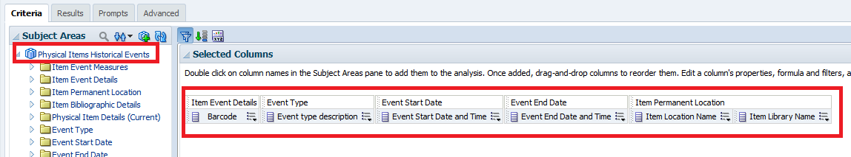

**THREE**

Filter by item library name. In our case the both locations are in the Main Library so we will filter by Main Library. Of course in your case use the library name in your institution.

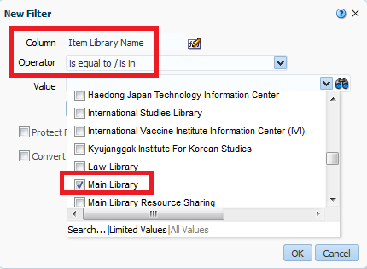

**FOUR**

In the bottom pane add a new filter for any field (for example “Barcode”) and then convert to SQL

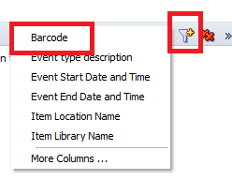 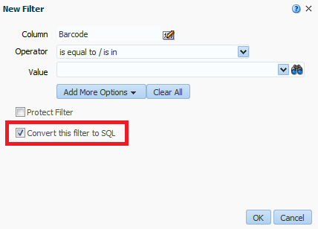

**FIVE**

Do the above twice, once for each of the two locations between which the items are transferred.

* In the first case use the example below for location name “Book Stacks”.
* In the second case use the example below for location name “Course Reserves_Main”.

Of course replace this location name with the actual location name in your library

**SUM(FILTER("Item Event Measures"."Num of events" USING ("Item Permanent Location"."Item Location Name" = 'Book Stacks')) by "Item Event Details"."Barcode") >= 1**

**SUM(FILTER("Item Event Measures"."Num of events" USING ("Item Permanent Location"."Item Location Name" = 'Course Reserves_Main')) by "Item Event Details"."Barcode") >= 1**

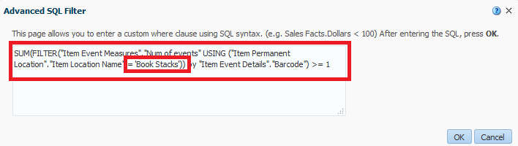

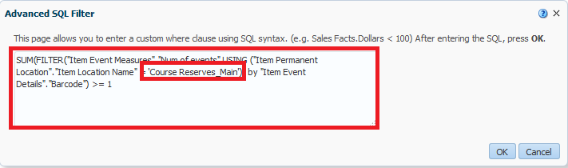

Here is how it looks now

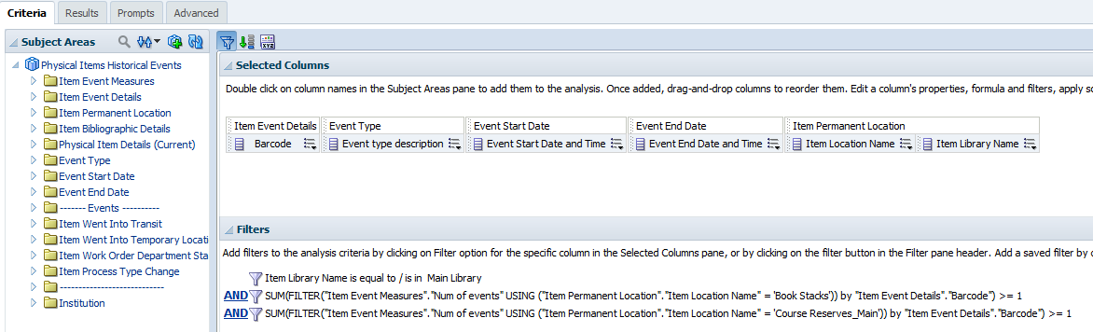

**SIX**

See results. Note that each barcode was at least one time in both the location “Book Stacks” and “Course Reserves_Main”

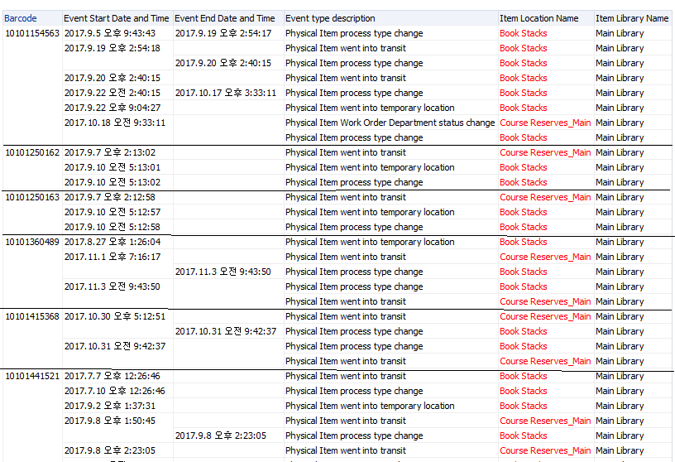

**SEVEN**

Do a spot check. Take the first barcode above, 10101154563, and check the history in the physcial item editor of Alma.

