|  |  |
| --- | --- |
| **How to filter a report by current and previous academic years** |  |
|  | |



**Introduction**

In this example we show an SQL filter to be used in an Analytics report for filtering a date by

* The current academic year
* One academic year ago
* Two academic years ago

Rather than making a hard coded date such as “is between 20170601 and 20180531” we will make the date be in an sql using relative dates, so that any time it is opened it will automatically retrieve the current academic year, or one of the previous academic years.

Thus if a report called “… in current academic year” is opened in 2017, 2018 or 2019 it will always give the current academic year with no need to edit it.

We cannot use here the standard

TIMESTAMPADD(SQL_TSI_YEAR,-1,CURRENT_DATE) because we are not getting one calandar year, but rather an academic year spanning two calandar years.

Our example below assumes that the calendar year spans from June 01 to May 31 of the following calendar year.

The SQL filters are below. You can just copy paste as in example at end. The samples use the loan date. The loan date can be substituted for any other date.

**ONE**

The SQL filter for **current** academic year (June 01 - May 31)

**YEAR(“Loan Date”.”Loan Date”)*10000 + MONTH(“Loan Date”.”Loan Date”)*100 + DAY(“Loan Date”.”Loan Date”)**

**between**

**(**

**case when MONTH(CURRENT_DATE) <= 5**

**then YEAR(TIMESTAMPADD(SQL_TSI_YEAR,-1,CURRENT_DATE))*10000 + 601**

**else YEAR(CURRENT_DATE)*10000 + 601**

**end**

**)**

**AND**

**(**

**case when MONTH(CURRENT_DATE) <= 5**

**then YEAR(CURRENT_DATE)*10000 + 531**

**else YEAR(TIMESTAMPADD(SQL_TSI_YEAR,1,CURRENT_DATE))*10000 + 531**

**end**

**)**

**TWO**

The SQL filter for **one academic year ago (June 01 - May 31)**

**YEAR(“Loan Date”.”Loan Date”)*10000 + MONTH(“Loan Date”.”Loan Date”)*100 + DAY(“Loan Date”.”Loan Date”)**

**between**

**(**

**case when MONTH(CURRENT_DATE) <= 5**

**then YEAR(TIMESTAMPADD(SQL_TSI_YEAR,-1,CURRENT_DATE))*10000 + 601 - 10000**

**else YEAR(CURRENT_DATE)*10000 + 601 - 10000**

**end**

**)**

**AND**

**(**

**case when MONTH(CURRENT_DATE) <= 5**

**then YEAR(CURRENT_DATE)*10000 + 531 - 10000**

**else YEAR(TIMESTAMPADD(SQL_TSI_YEAR,1,CURRENT_DATE))*10000 + 531 - 10000**

**end**

**)**

**THREE**

The SQL filter for **two academic years ago (June 01 - May 31)**

**YEAR(“Loan Date”.”Loan Date”)*10000 + MONTH(“Loan Date”.”Loan Date”)*100 + DAY(“Loan Date”.”Loan Date”)**

**between**

**(**

**case when MONTH(CURRENT_DATE) <= 5**

**then YEAR(TIMESTAMPADD(SQL_TSI_YEAR,-1,CURRENT_DATE))*10000 + 601 - 20000**

**else YEAR(CURRENT_DATE)*10000 + 601 - 20000**

**end**

**)**

**AND**

**(**

**case when MONTH(CURRENT_DATE) <= 5**

**then YEAR(CURRENT_DATE)*10000 + 531 - 20000**

**else YEAR(TIMESTAMPADD(SQL_TSI_YEAR,1,CURRENT_DATE))*10000 + 531 - 20000**

**end**

**)**

**FOUR**

For example a report “Number of loans per day one academic year ago (June 01 - May 31)” would have a filter like this:

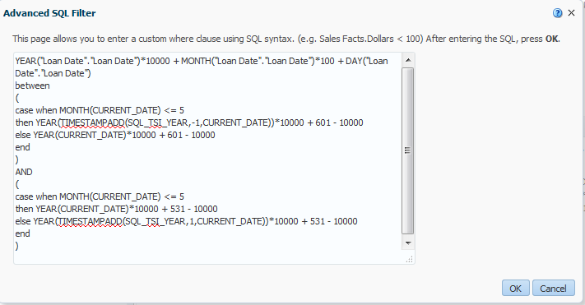

The report criteria tab would look like this:

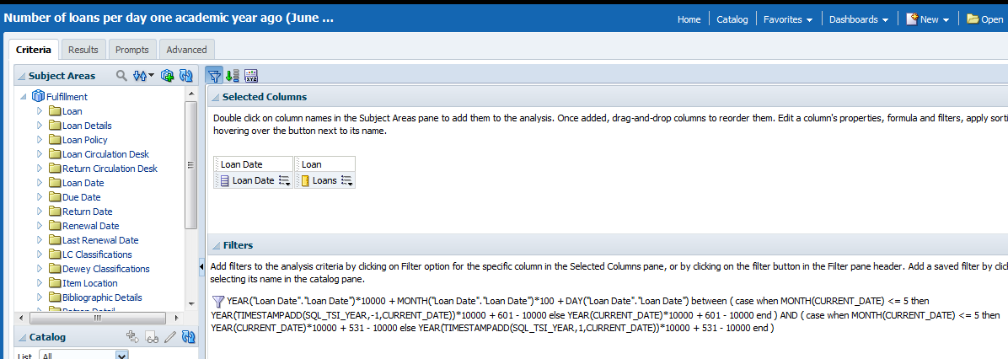

If it was run on Nov. 17, 2017 then the earliest possible day would be June 01, 2016 and the latest possible day would be May 31, 2017

