https://knowledge.exlibrisgroup.com/Alma/Product_Documentation/Alma_Online_Help_(English)/Administration/040Configuring_User_Management/040User_Details_Configuration#Configuring_Statistical_Categories_for_Analytics

Creating Statistical Category Types (Step 1)
You define statistical category types on the User Category Types code table (Configuration > User Management > User Details > Category Types).
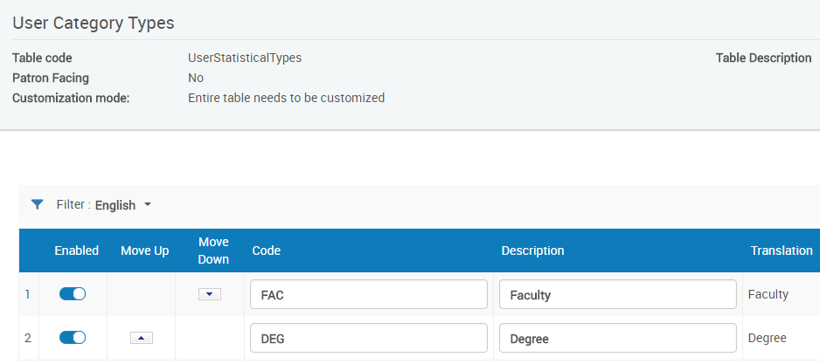

Creating Statistical Categories (Step 2)
You define statistical categories on the User Statistical Categories code table (Configuration > User Management > User Details > Statistical Categories). 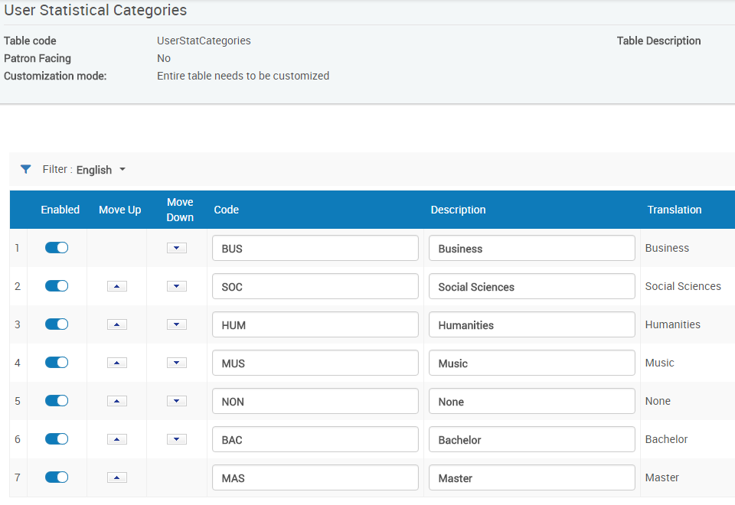

Mapping Statistical Categories to Types (Step 3)
You map statistical categories to types on the Statistical Categories/Types mapping table (Configuration > User Management > User Details > Statistical Categories/Types),

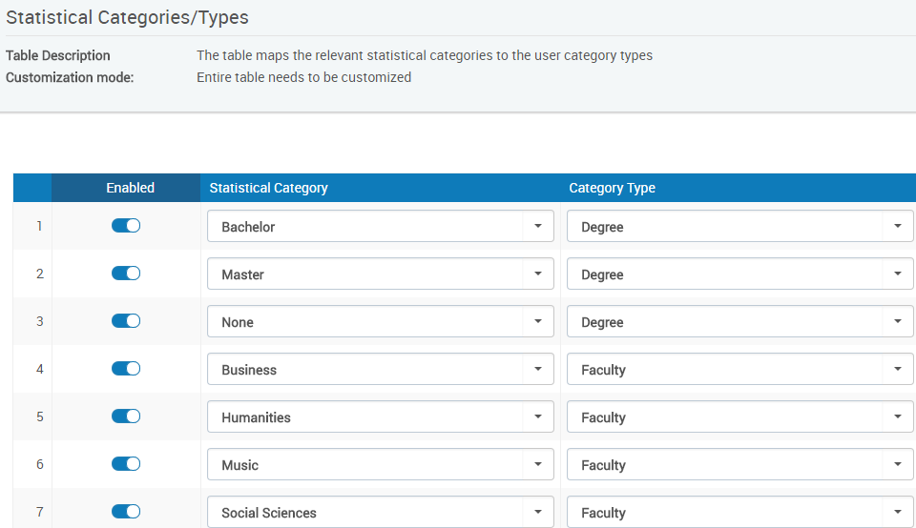

Selecting Statistical Category Types to Appear in Analytics (Step 4)
You select the (up to) five types of statistical category types that you want to make available in Analytics on the Analytics User Statistics code table (Analytics > Analytics Objects > Analytics User Statistics).

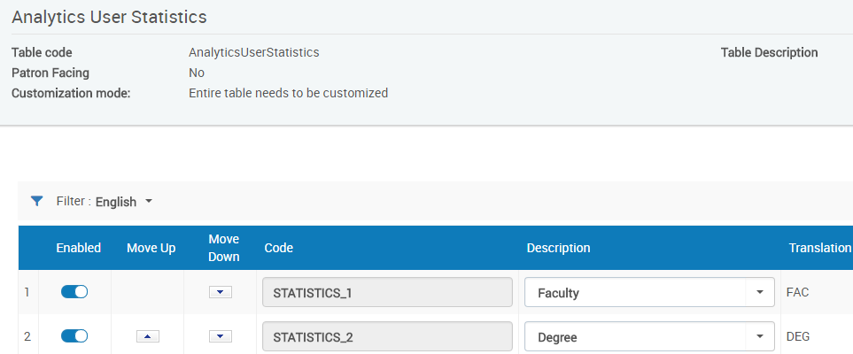

Sample User record with statistical categories
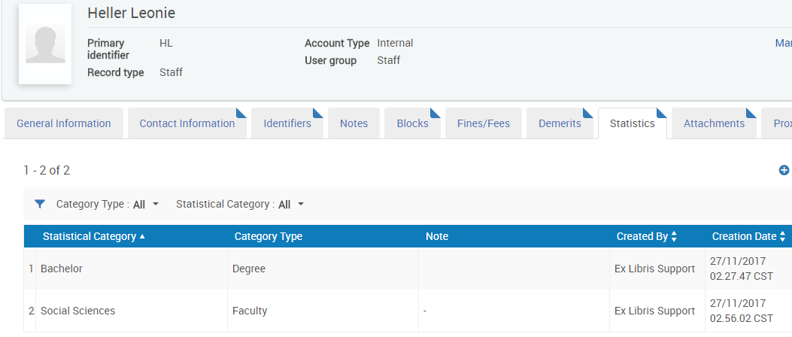

Outcome in Analytics
