|  |  |
| --- | --- |
| **How to retrieve duplicate barcodes via Alma Analytics** |  |
|  | |



**Yoel Kortick**

**Senior Librarian**

**Introduction**

While typically it is not possible to save items with duplicate barcodes, there may be extenuating circumstances in which duplicate barcodes do exist.

This document shows how to identify those duplicate barcodes.

The method used here for item barcodes could be used to find duplicate keys in other areas as well.

**ONE**

In the physical items subject Area create a report including the ‘Num of Items (in repository)’ and the ‘Barcode’ (both from the physical items subject area).

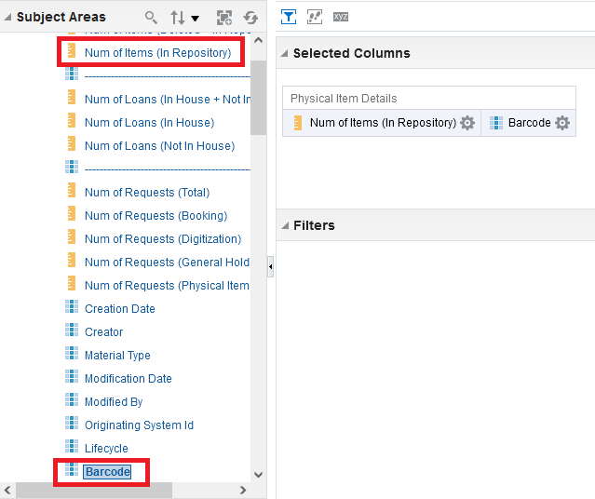

**TWO**

Filter by the ‘Num of Items (in repository)’ is greater than or equal to 2 (from the physical items subject area)

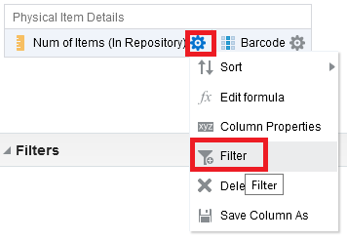

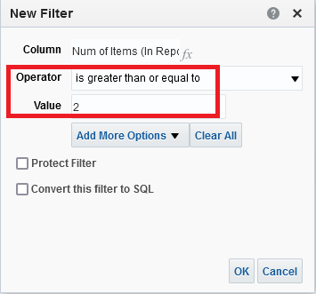

**THREE**

Filter by barcode is not NULL

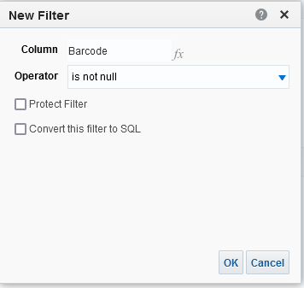

**FOUR**

The criteria tab of the report now looks like this:

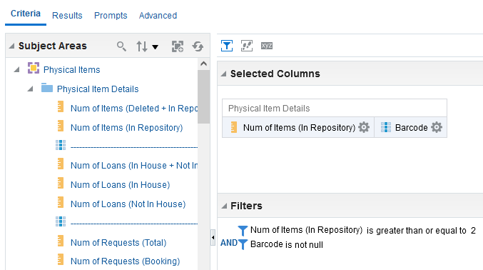

**FIVE**

See results, for example here the first result is barcode 32044096197355 which has two items

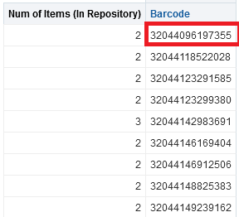

**SIX**

See in Alma that this really is a duplicate barcode

