|  |  |
| --- | --- |
| **How to make the "Use pro rata" always be unchecked for invoices created via EDI** |  |
|  | |



**Short answer**

* In order to make the “Use pro rata” in an invoice created by EDI to be by default checked (“yes”) go to the EDI tab of the vendor and uncheck the field “do not prorate”.
* In order to make the “Use pro rata” in an invoice created by EDI to be by default unchecked (“no”) go to the EDI tab of the vendor and check the field “do not prorate”.

**Full answer**

If the vendor EDI tab has field “Do not prorate” unchecked (as follows):

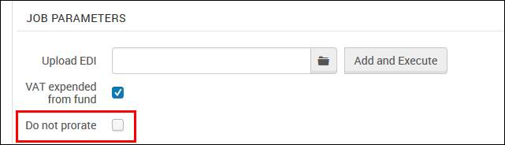

Then the invoice created via EDI will have prorate used (checked and yes)

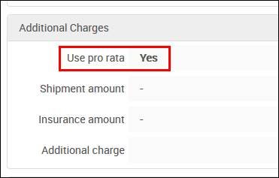

If the vendor EDI tab has field “Do not prorate” checked (as follows):

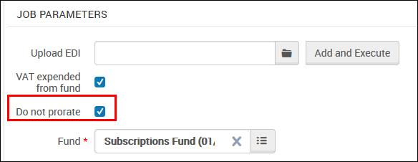

Then the invoice created via EDI will have not have prorate used (unchecked and no)

