|  |  |
| --- | --- |
| **How to add a vendor account in the invoice created from an EDI file** |  |
|  | |



**Short answer:**

1. If you want the vendor account to be part of the invoice created from EDI then you need to add the RFF+API line to the EDI file.
2. The vendor should add this before providing it to the institution.

If the vendor account code is **lmid** then add this line:

**RFF+API:lmid'**

If the vendor account code is **JC** then add this line:

**RFF+API:JC'**

**Full answer:**

If you want the vendor account to be in the invoice which is created from EDI, as follows ….

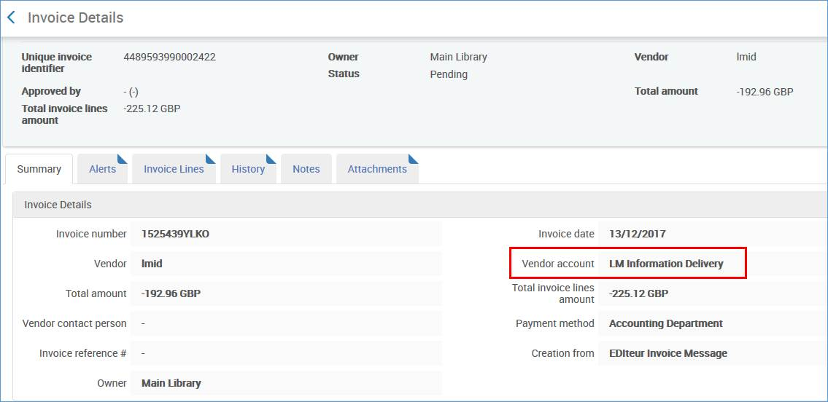

Then you need to add the vendor account to the EDI file.

In the above case the vendor account code is lmid (in lowercase letters):

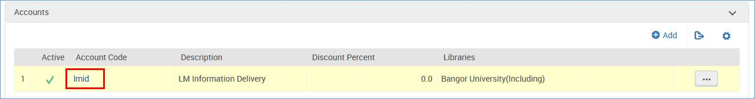

Therefore the vendor account should be added to the EDI file as follows.

The vendor should add this before providing it to the institution.

The RFF+API line should appear after the NAD lines as described here: <https://developers.exlibrisgroup.com/alma/integrations/edi/invoice>

