Leganto for Instructors: A Step-by-Step Guide to Presenting Leganto for Instructors

In order to prepare for your demo of Leganto for instructors, your Leganto Campus Engagement Team has created resources to assist you. This guide is part of these resources. Please reach out to your Campus Engagement Manager if you need further guidance or assistance. All of these materials will be located on the Leganto Knowledge Center under the Campus Engagement section, which may be accessed here: https://knowledge.exlibrisgroup.com/Leganto/Product_Materials/Campus_Engagement.

Before we get started on the presentation itself, first let’s take a look at what you will need to do to prepare prior to giving your presentation to instructors.

PRE-SESSION PREPARATION

Inviting Instructors
- Once you have selected the instructors you wish to participate, you will be sure to send them an email to invite them to your presentation. Be sure to provide them with relevant details such as the date, time, and location of the presentation. (A sample email to invite instructors may be found on the Knowledge Center.)

Room & Computer Preparations
- You will want to make sure that you have your room reserved and all technology in place.
  - Computer with Internet access
  - Presentation Capability – Projector or Television Monitor with Hookups
  - “Cite It!”
- Computer Necessities:
  - PowerPoint slides
  - Script
  - Search examples
  - PDF to use as a search example
  - Any and all IDs and Passwords that you may need.
- Take a sign-in sheet with you, and make sure that you get contact information from everyone so that you may send a follow-up email.
- Arrive at least 30 minutes prior to your presentation to make sure that the room and equipment are set up properly. Make sure that you get your PowerPoint ready, you get logged in, have Cite It! set up, and have any websites you want to use ready to go.

This outline is a model for you to follow as you introduce your instructors to Leganto. This is intended to be an introduction that will last 45 minutes-60 minutes.

First, you will go through some PowerPoint slides to set the stage, and then we will move onto a live Leganto demonstration before returning to our PowerPoint to close. Your Campus Engagement Manager can assist you with any questions regarding this outline.

SLIDE | INSTRUCTIONS | SAMPLE SCRIPT
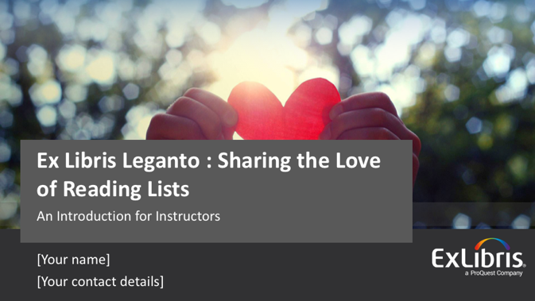 | Introduce yourself and set the stage for the presentation with enthusiasm. | Welcome. I am so pleased that you could join me today for an introduction to Leganto.  My name is ________________, and I am a librarian here on campus.  I hope that you’re as excited as I am to take a look at Leganto and to grow your love of reading lists. Let’s take a look at our agenda and get started.
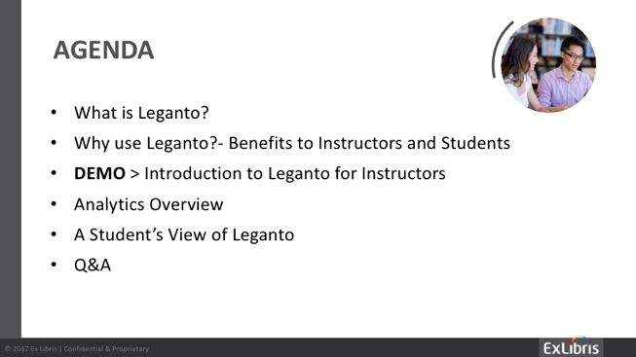 | You will use this slide to lay out your agenda and set expectations for your presentation.  Note: This is customizable based on your specific audience and your time allotted. It is recommended that you show at a minimum – one or two search examples using Leganto and a quick student’s view.  Read off the bullet points. | I would like to lay out our agenda for our time together today. First, I will briefly explain what Leganto is. Next, I will cover why we have chosen to use Leganto here on campus and will highlight its benefits to you as instructors and also for your students. We will then move into our live demonstration of Leganto so that you can see it for yourself and get a basic understanding of how to use Leganto. Next, we will take a quick look at some of the analytics and reports that can be pulled for you that illustrate the usage of your course materials. Finally, I will show you what your students will see when they go into your course resource lists, and then we will wrap up with Q&A.
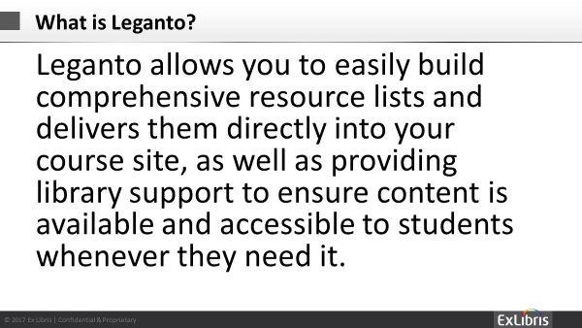 | Each campus will be slightly different with regard to why they chose Leganto, so you may modify this message based on your individual needs. For example, for some schools, copyright clearance is a major factor that should be referenced here; for others, the cost savings for students is a deciding factor and should be highlighted here. | Leganto allows you to easily build comprehensive resource lists and delivers them directly into your course site, as well as providing library support to ensure content is available and accessible to students whenever they need it.
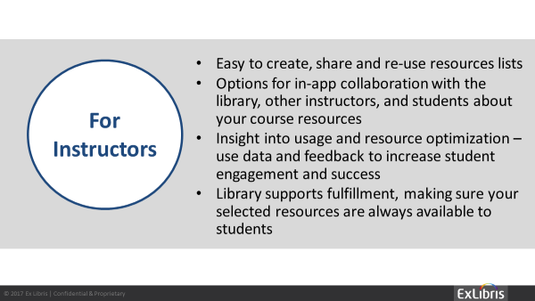 | Discuss the “why” behind it – why should instructors use Leganto for their course reading lists.  Please feel free to modify these bullet points as needed for your specific institution; you know your individual needs best. Your Campus Engagement Manager is available to assist if you have questions. | Very easy to use, re-use, and duplicate – Leganto is easy to use. It is simple to search for materials, share information with librarians and your students, and to duplicate readings and reading lists. Leganto has exclusive features that allow you to add materials from basically any resource – hard copy books, online journals, your own PDFs, and YouTube videos are just a few examples.  Easy collaboration with the library, other instructors, and students – Leganto allows you to easily search for and find materials to add to your reading lists – and with the simple click of a button, those materials that require processing assistance, such as copyright clearance or a physical hard copy reserve in the library, will be sent to the library for processing. Additionally, you can easily collaborate with other instructors and your students.  Insight into usage – Analytics and reports can be pulled easily to show the level of usage of your reading list materials and can also help with resource optimization – together, the library and instructors can make sure that the library has the resources available to give the most value possible to your students.  Automates copyright clearance – Importantly, Leganto will give immediate copyright clearance for many materials that you wish to use as part of your course. This will protect you and our institution from embarrassing, expensive, and illegal copyright violations.
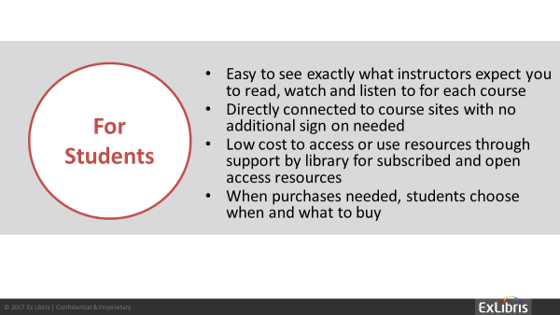 | Explain the benefits of the student experience in Leganto.  Please feel free to modify these bullet points as needed for your specific institution; you know your individual needs best.  Your Campus Engagement Manager is available to assist if you have questions. | Easy to use – This is often an undergraduate’s first experience with scholarly materials and a university library, and Leganto makes it easy for students to find and access what they need.  They get their reading lists directly through their courses – Leganto provides seamless integration with our LMS and is accessible via mobile devices – no additional log-in credentials needed. Most of the time, students won’t even realize that they are using a tool called Leganto because they will simply click a link to open the reading list directly embedded within the LMS frames.  Saves them money by maximizing library and open content – When you create your reading lists in Leganto, you will be able to utilize resources for which the library has an existing subscription and also incorporate open web content. This can result in a great cost savings to your students, and we all know how critical learning affordability is to our students.  Flexibility around what they purchase and when – When you use Leganto to create your readings lists, your students can purchase one reading at a time or all readings at the same time; Leganto is flexible and can assist them with their budgets.
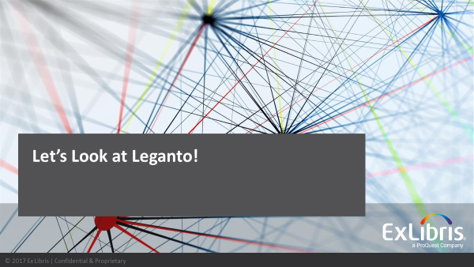 | You have now set the stage for what Leganto is, why it is of value for instructors and their students, and are ready to show Leganto live.  The demo script below will assist you with your live demonstration of Leganto for Instructors. | Now, let’s take a look at Leganto from the perspective of an instructor creating a course reading list. We will take a look at analytics and a student’s view of Leganto later.

Live Demo of Leganto for Instructors – Sample Script for Live Demo
Please note that what follows is a sample outline. You should always test your examples prior to each demonstration of Leganto.
Some items may be slightly different on your campus depending on your configurations. Example: Some institutions configure “Templates” that instructors may use when creating their course reading lists. These templates are optional and may vary by institution greatly. An * will indicate a configurable item that you must test due to these variances.
We recommend logging into a course in your LMS prior to beginning your live demo. Start your demo from the point where the instructor will need to click to enter Leganto. This may be named differently at each institution.
An introductory demonstration of Leganto should include showing:
- How to access leganto from the LMS
- A “tour” of the resource list page – you should set up a partial list already and give them an overview of what it will look like
- Showing how to add items via:
  - Searching
  - Collection/RefWorks or other integrations
  - Manually Add or upload
  - CiteIt!
- Discussing how to work with the library – Send to Library, some discussion of your policies around how you’ll receive and fulfil their requests and how to use the in-Leganto Send Note to Library function to communicate
- Publishing the Reading List so students can see it
- The Student Experience
- Brief overview of analytics
Our script below includes all of the above but you should practice and adjust it to fit your needs and the interests of your faculty.
WALKTHROUGH DETAILS
Action | Script | Search Examples
Entering your course through the LMS | Sometimes, you will be asked to name your course or associate your course to one listed in your LMS.  We will give our course a sample name. | Sample Course Name: Medicine in Ancient Times – Medicine from Ancient Egypt to Late Medieval Europe
Creating Sections for reading lists | Depending on your configuration, Leganto may have templates available for your reading lists; however, you can also utilize a blank template, create your own sections, and name them.  We will select “Blank Template” and name our own. | Select a Template if desired* or select “Blank Template”  Associate with Course if desired* or click “Not Now”  Example – Section One: Week 1; Section Two: Week 2

Action | Script | Search Examples
Adding citations to create course reading list | There are quite a few ways to add citations in Leganto; today, we will go through the most common ways.  In a nutshell, you may add citations by:  1. Searching in Leganto  2. Uploading Your Own Document  3. Cite It!  4. My Collection
Searching in Leganto | There are two search methods, Basic and Advanced.  I’m going to do a basic search and then and advanced search to add some readings to our list. | 1. Basic Search: Medicine in Ancient Society – Conduct this as a simple search in Leganto. Then, select a few of the results and click “Add” to add these to your course.  2. Optional: Advanced Search: Medicine in Ancient Greece – If time permits, conduct this using the advanced search template in the title section. Then, select a few of the results and click “Add” to add these to your course.

Action | Script | Example
Adding your own readings using Leganto | You can use Leganto to manually add your own readings and to upload documents. | Add Your Own Document:  1. Add a Sample Reading – Use the link to manually add/upload your own materials. Make sure you have a sample PDF available of a reading you wish to add to your course. Be sure to point out the check box option regarding copyright clearance.  2. Optional: Add a Syllabus or other Course Materials – If time permits, you may also explain that they can easily add additional materials such as a syllabus, lecture notes, lecture slides, and more. And since they “own” the materials, they can check the copyright compliance box.
Add Materials using CiteIt! | Use the CiteIt! button to add items from web sites or add the websites themselves (as URLs). CiteIt! is a fantastic tool that you can use to add articles, videos, and other materials that you discover in your day-to-day workflow. As you come across useful materials, you may simply click “Cite It!” to add this material to your reading lists. | 1. Show how to add CiteIt!  2. Have pulled up some sites to add (Tip: Find a resource your library already has a subscription to in order to best showcase this tool. Mention the concept of “My Collection” which will be covered next.) –  a. Link to Article – “occupational medicine in ancient Egypt”  b. Video – “Disease And Medical Treatment in the Middle Ages and Medieval Europe”
Action | Script | Example
Add materials using “My Colletction” | Instead of adding readings and materials directly to your course, you may add them to your “Collection” for use later.  You may also add materials of interest to “My Collection” when using “Cite It!” | 1. Click on “My Collection” to briefly show what it looks like.  2. Go back to your reading list and click “Open Collection” to show how to drag and drop items from your personal collection to your reading list.
Editing List Capabilities of List Citations | You may edit your citation list and reading details easily with Leganto. | 1. Click to see details of a reading  – Choose a reading and show the details and what is contained herein  2. You can edit each citation  – Pick a book and show how you can edit to add specific page numbers, for example.
Sending Citations to the Library for Processing | Once you have added some or all readings, you may choose to send the citations to the library for assistance with processing the citations. The librarians will check each citation and perform actions to fulfill them: set copies aside, subscribe to the required services, scan or digitize physical copies, clear copyright issues, and so forth. | Show them how to submit readings to the library for processing if needed.
Publishing Reading Lists for Students | When the reading list is ready, publish the list for access by your students, by anyone at the institution, or by the general public. Please note that your students will not see your reading lists until they have been published. | Show them how to publish reading lists.
A Student’s View of Leganto | Now, let’s take a look at a Student’s View of Leganto. Remember, these are just a few examples of how your lists done in Leganto will appear for your students. | Click on the link and show “Student’s View”

Now, let’s jump back to our PowerPoint to take a look at analytics and close out with Q&A.
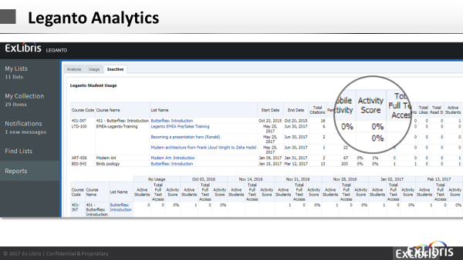 | You’ll use this slide to discuss and show analytics that may be pulled for instructors.  You will point out a few analytics that you think will be compelling – such as, number of participants and active students. Please note that the slide may not show heavy usage because this is merely a sample; this is meant to be illustrative only. | As an instructor, you can see how your reading list is being used, which articles people read and commented on, and engage with your students, but you may also want to adjust your reading list for next year based on this info.  Benefits of analytics include:  •Insight into usage for instructors and library  •Optimize collection development  •Highlight the value of the library collection
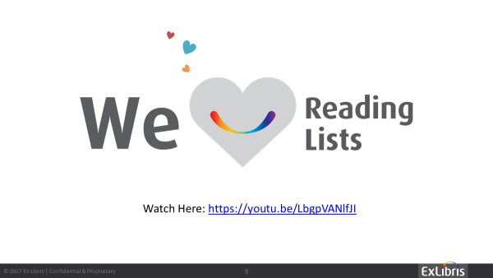 | You’ll use this slide for Q&A and any follow-up necessary based on your presentation. | I hope I’ve given you an excellent overview of Leganto and how and why you should use it in all of your courses going forward. Your library is here to help. Now, I would like to open the floor for any questions you may have. I would also welcome your initial feedback at this time – what did you think?  As a follow-up to today’s session, I will be emailing you a list of resources available to assist you with using Leganto. The resources are easily available on the Leganto Knowledge Center, and I will send you the link for that as well.  These materials include PDFs and short video tutorials. And, as always, the library is here to assist you as well.  We think you will find great value in using Leganto for your course reading lists and are excited to help you get started.  Thank you for your time and attention today.

