|  |  |
| --- | --- |
| **The POL “Interested User” and “Hold Item” functionality** |  |



This document will explain via an example how the POL “Interested User” and “Hold Item” options work. It will point out the difference in the workflow when the item is scanned in and the “Place directly on hold shelf” is or is not checked.

**ONE**

A POL is made for title “Cherchez la femme: women and values in the Francophone world”.

It is POL-44781

The interested user is “Alicia Chen”

When adding the interested user we choose

* Notify user upon receiving / activation
* Hold item

Then we click “Add and close”

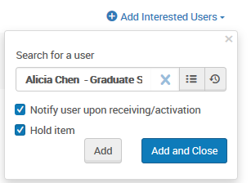

Here we see the interested user in the “Interested Users” tab of the POL.

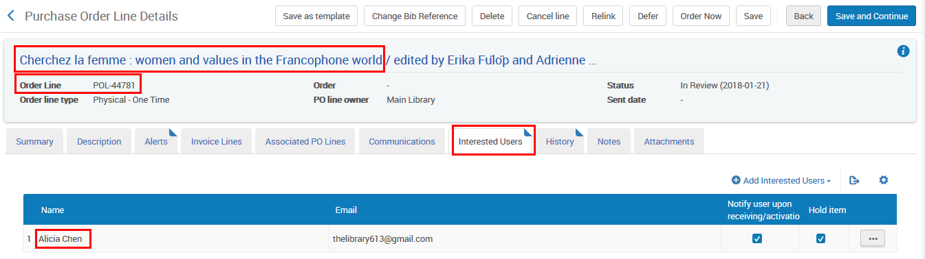

**TWO**

In the Receiving Workbench we can see that the POL has an interested user.

We will receive the item.

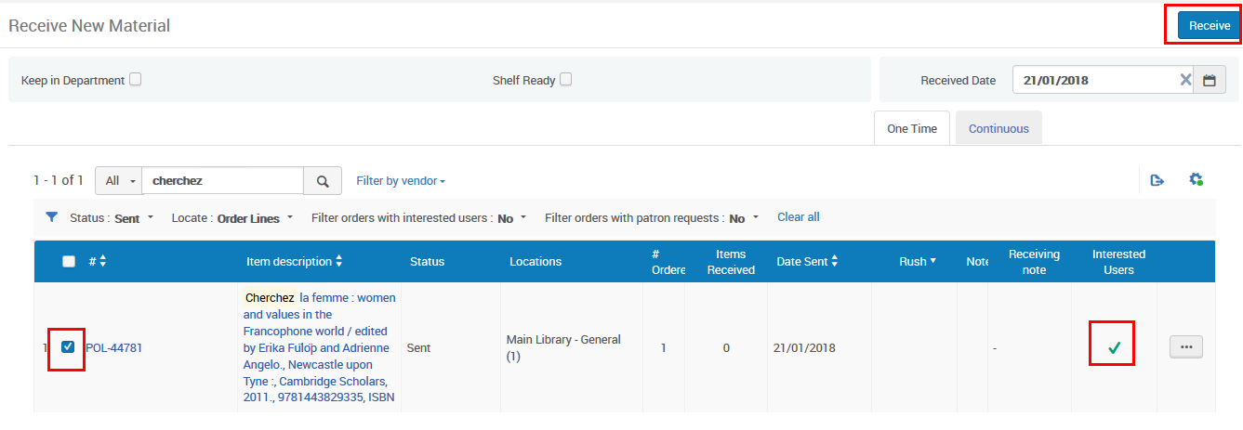

**THREE**

The item is transited to the circulation desk and scanned in.

Note that in this case we do not check “Place directly on hold shelf”.

We could check “Yes” for “Place directly on hold shelf” and that would depend on our desired results.

* If “Place directly on hold shelf” is checked then the item will go to the active hold shelf and also appear in the menu “Fulfillment > Resource Requests >active hold shelf”.
* If “Place directly on hold shelf” is not checked then the item will not go to the active hold shelf and would instead appear in the menu “Fulfillment > Resource Requests > Monitor Requests & Item Processes”. The purpose of this is that the library would still want to process the request and then later scan it in with “Place directly on hold shelf”.

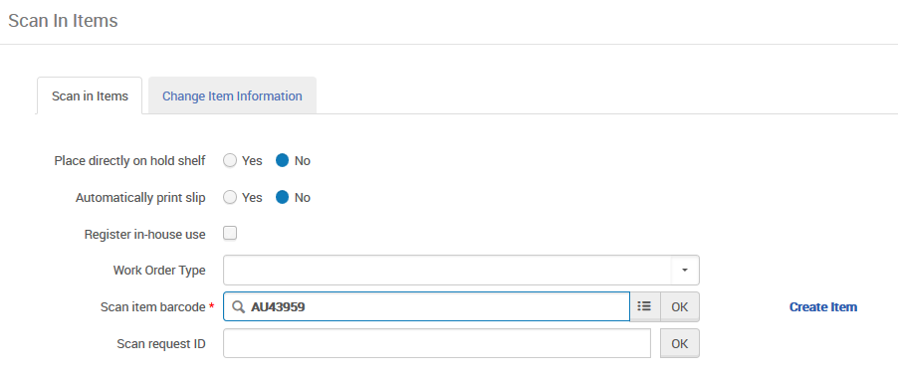

**FOUR**

The staff user who scanned it in is alerted that there is a hold request for Alicia Chen and the item should be processed and eventually put on the hold shelf

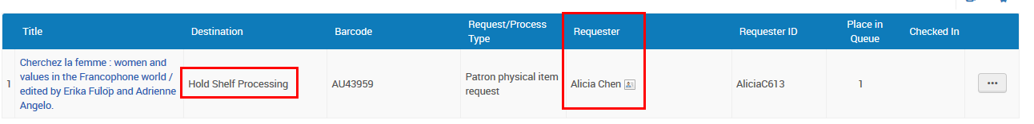

**FIVE**

The patron also receives a letter that the item was received

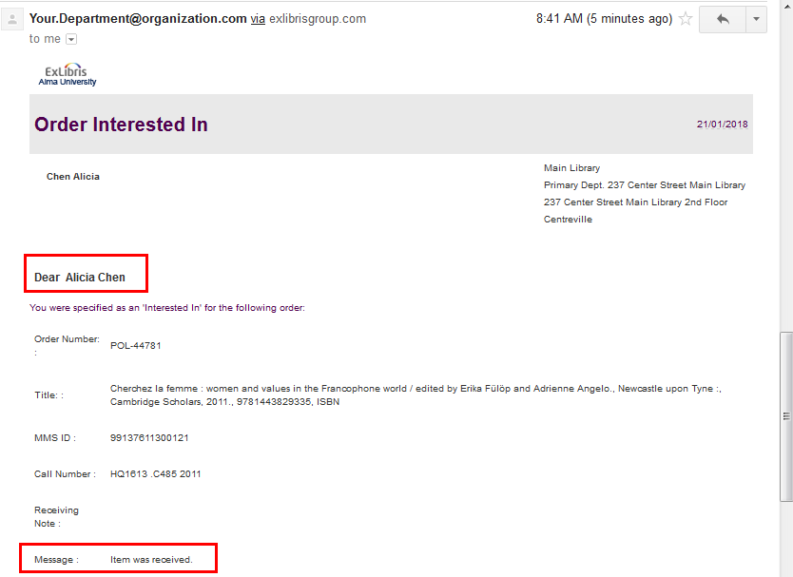

**SIX**

In Primo the item appears on the hold shelf

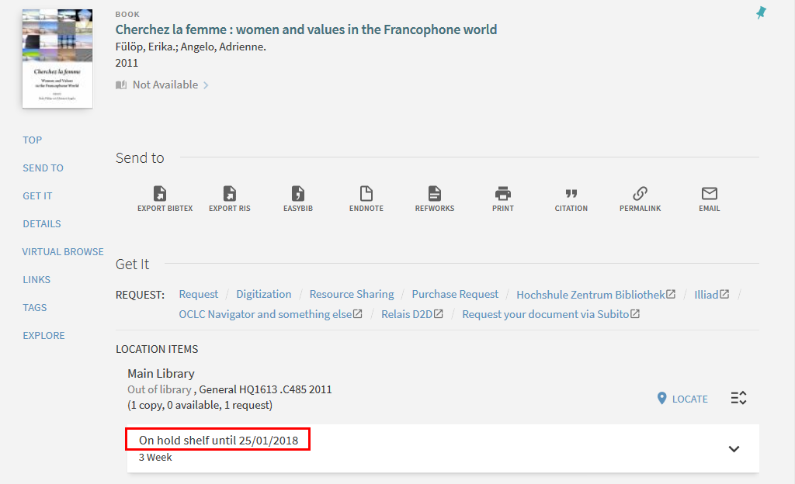

In Primo “Library Card” Alicia Chen sees that she has this item on hold and that it is on the hold shelf

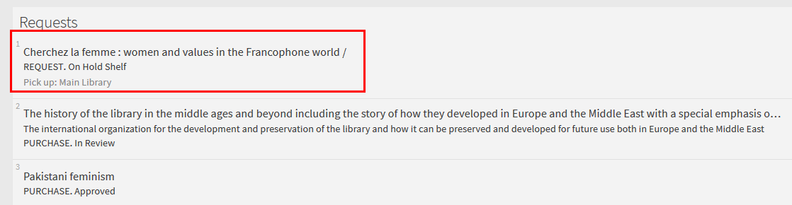

**SEVEN**

In Alma “Fulfillment > Resource Requests > Monitor Requests & Item Processes” the item still appears in workflow step “Hold Shelf Processing”

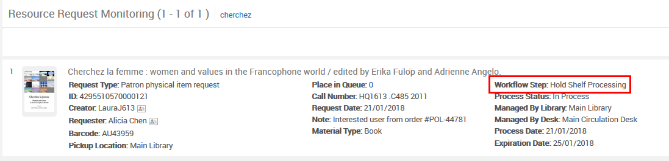

**EIGHT**

The item is scanned in again and this time the user chooses “Place directly on hold shelf”

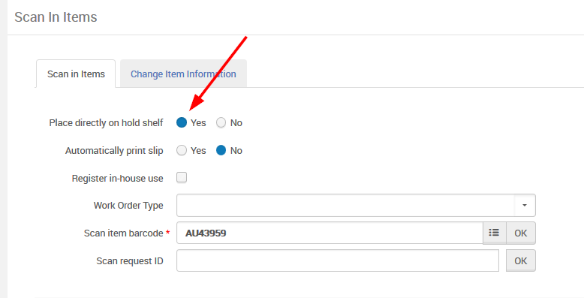

**NINE**

The item then has destination “On Hold Shelf”

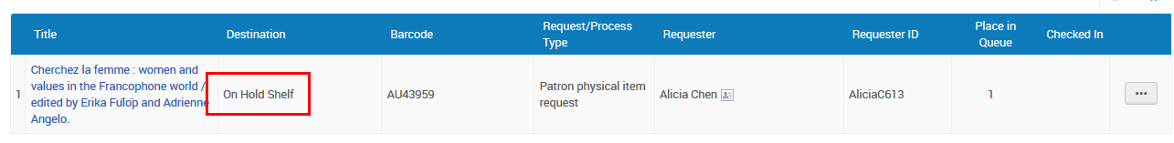

And it appears now on the active hold shelf accessible via “Fulfillment > Resource Requests > active hold shelf”.

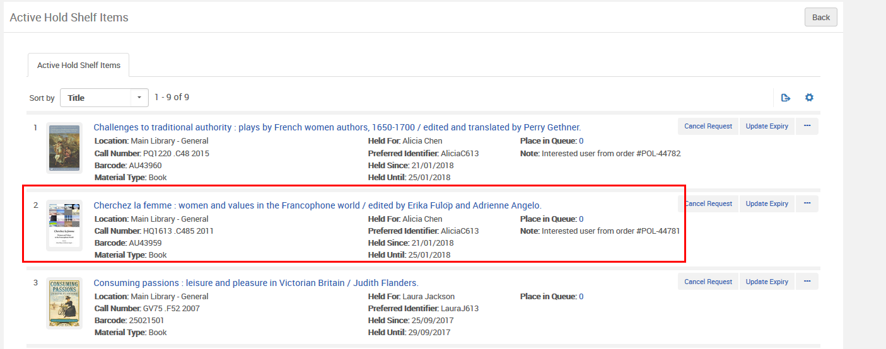

**TEN**

The patron gets an “On Hold Shelf letter”

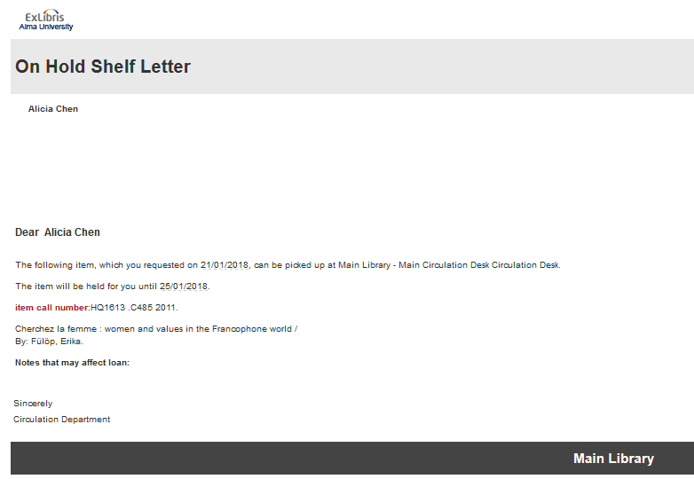

**ELEVEN**

Above we did two different scan in options:

1. Place directly on hold shelf “Yes”
2. Place directly on hold shelf “No”

When it was “No” it went to “Monitor Requests & Item Processes”

When it was “Yes” it went to “Active Hold Shelf”

Note that if you want this to always be “Yes” then in the circulation desk you can uncheck “has hold shelf processing”

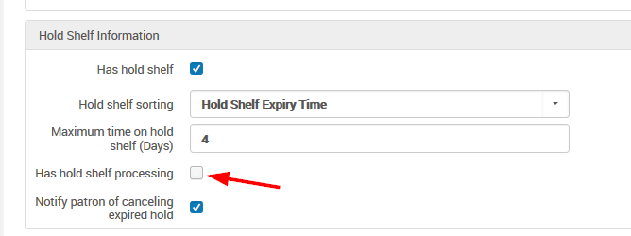

Now when we scan in we have no option “Place directly on hold shelf” and it will behave as if we checked “yes”.

