>Admin >Manage Sets >Add Set >Itemized
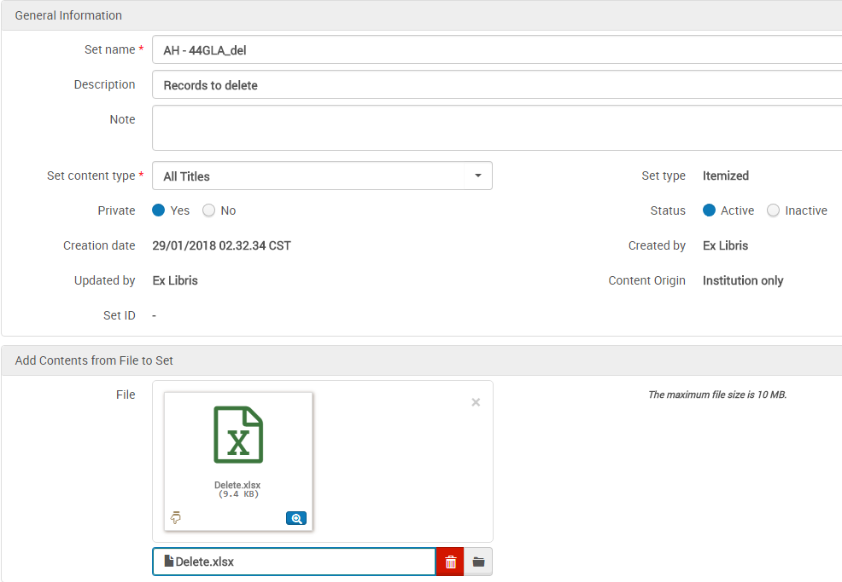
The input file should show the MMS ID in the first column

The set was created properly
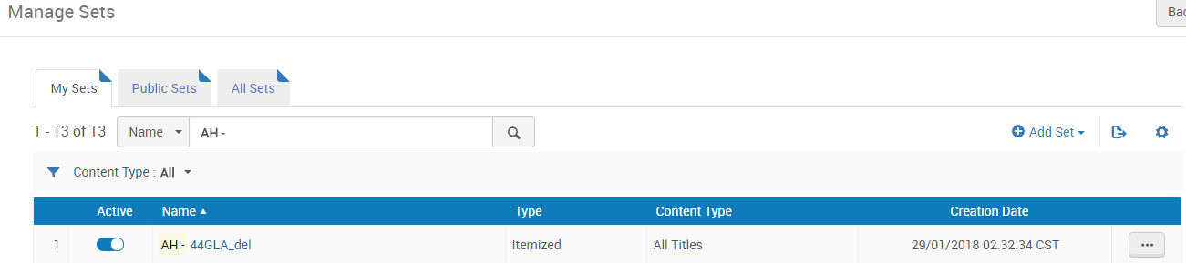

Looking at the “Members” of the set should show a list of the records for deletion

Now you can create the job >Admin >Manage jobs and sets >Run a job >Delete bibliographic records

Select the appropriate set
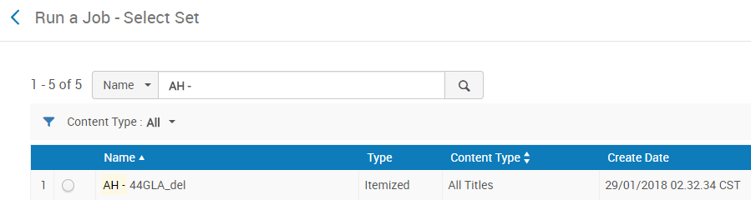

Select the relevant parameters
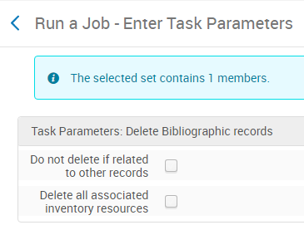

Click “Submit” and the job will run
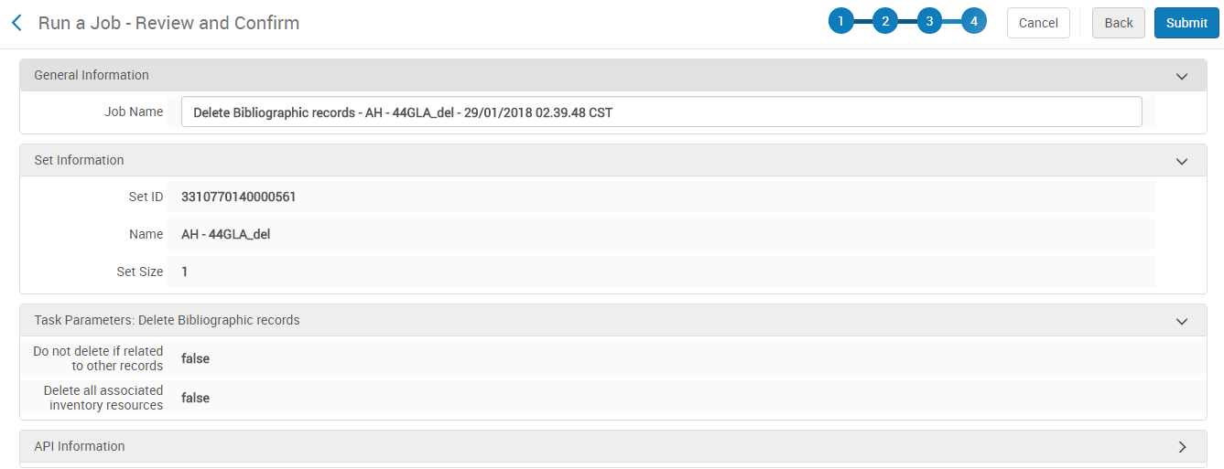

In the job’s history tab you can check afterwards if the job ran successfully
