|  |  |
| --- | --- |
| **How to customize an Alma letter by library and other values** |  |
|  | |



In this document we answer the question “How can I change the “change due date” letter to be different per library of the item being changed?” The library wants to have different text depending on the library of the item in which the change due date is occurring.

It is possible to customize the contents and format of Alma letters based on various data in the letter. For example the Letter to the vendor can be customized based on the library for whom the order is made or according to the vendor to whom it is sent. The customization is made by making a condition, for example if the library = [whatever library] or the vendor = [whatever vendor]

In this document we will change the xsl of the letter letter “Ful Item Change Due Date Letter”

We will focus on the change to the xsl.

Regarding how to access and change the xsl see [Letters - Letter Configuration in Alma.pptx](https://knowledge.exlibrisgroup.com/@api/deki/files/74499/Letters_-_Letter_Configuration_in_Alma.pptx)

**ONE**

In the xsl add the red bold condition below. You can see how the field name already is “called” in the letter and copy that and then add condition. Here we add this text which will be added only if the library_name = Main Library:

|  |
| --- |
| <xsl:for-each select="notification_data">  **<xsl:if test="/notification_data/item_loans/item_loan/library_name='Main Library'">**  <center>  <span style="font-family:Arial; font-weight:bold">  <FONT COLOR="#FF0000">  <B>Please check due date by logging into your library account</B>  </FONT>  </span>  </center>  </xsl:if>  </xsl:for-each> |

**TWO**

Test it by changing a due date of an item which **is** in the Main Library and also by changing the due date of an item which is **not** in the main library. See these two examples. The one with item in Main Library does have the text. The one with item in a different library does not have the added text. Therefore the condition worked.:

Here is letter for item in Main Library (correctly does have message)

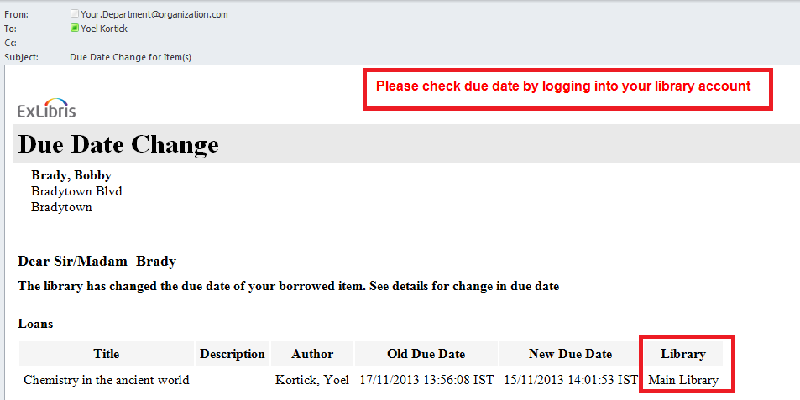

Here is letter for item not in main library (correctly does not have message)

