|  |  |
| --- | --- |
| **How to replace all or part of a string in an xsl letter** |  |



**Yoel Kortick**

**Senior Librarian**

This document will show how it is possible to add a function to the xsl of a letter to change all or part of a string text of values. For example in a certain letter we might want to change the text of a library or location, but leave the actual name as it already appears in Alma so that it will continue to appear the same way in other places.

Note: When copying and pasting xsl from this document be sure the dashes and quotes are not getting converted to different characters.

In this document we will change the xsl of the letter letter “Ful User Borrowing Activity Letter”

We will focus on the change to the xsl.

Regarding how to access and change the xsl see [Letters - Letter Configuration in Alma.pptx](https://knowledge.exlibrisgroup.com/@api/deki/files/74499/Letters_-_Letter_Configuration_in_Alma.pptx)

For example, in the following letter (FulUserBorrowingActivityLetter.xsl) we want to change “Main Library” to “Main (North Campus) Library”

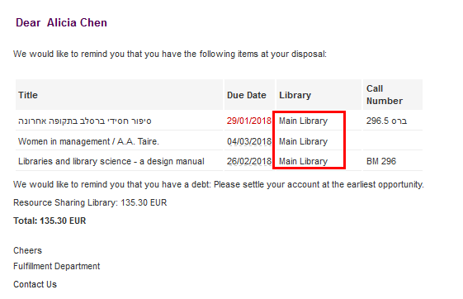

**Step One**

Identify the place in the letter where the text you want to change appears.

This is the place

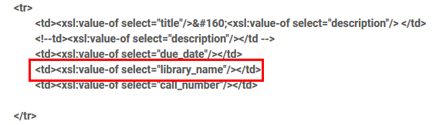

**Step Two**

Instead of:

|  |
| --- |
| <xsl:value-of select="library_name"/> |

Put

|  |
| --- |
| <xsl:call-template name="replace-string">  <xsl:with-param name="text" select="library_name"/>  <xsl:with-param name="replace" select="'Main'" />  <xsl:with-param name="with" select="'Main (North Campus)'"/>  </xsl:call-template> |

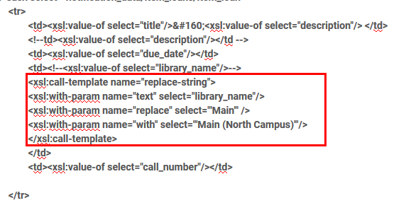

**Step Three**

At the end of the letter before the closing of the stylesheet add this:

|  |
| --- |
| <xsl:template name="replace-string">                  <xsl:param name="text"/>                  <xsl:param name="replace"/>                  <xsl:param name="with"/>                  <xsl:choose>                          <xsl:when test="contains($text,$replace)">                                  <xsl:value-of select="substring-before($text,$replace)"/>                                  <xsl:value-of select="$with"/>                                  <xsl:call-template name="replace-string">                                          <xsl:with-param name="text" select="substring-after($text,$replace)"/>                                          <xsl:with-param name="replace" select="$replace"/>                                          <xsl:with-param name="with" select="$with"/>                                  </xsl:call-template>                          </xsl:when>                          <xsl:otherwise>                                  <xsl:value-of select="$text"/>                          </xsl:otherwise>                  </xsl:choose>          </xsl:template> |

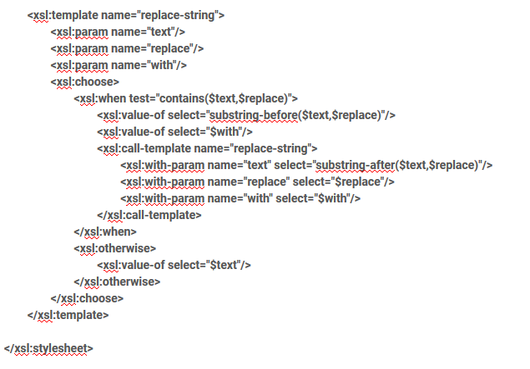

**Step Four**

See that now the value has changed in the letter

