|  |  |
| --- | --- |
| **How to configure a PO Line Cancellation Reason and report on it in Alma Analytics** |  |



**Yoel Kortick**

**Senior Librarian**

**Question**

How can we get statistics according to how many POLs were cancelled and why they were cancelled?

**Answer**

**ONE**

First define POL Cancellation reasons.

This is done at Configuration Menu > Acquisitions > Purchase Orders

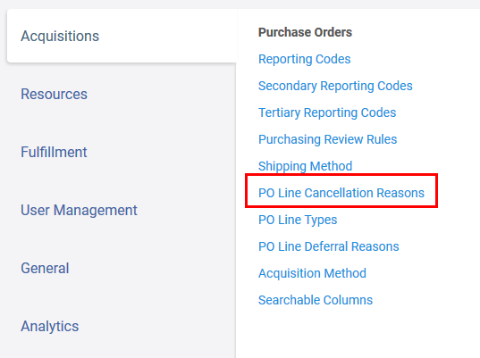

**TWO**

Add a code and name of the cancellation reasons which you will want to use.

Here we have defined

1. ENTRY-ERROR
2. ORDER_CLOSED
3. LIBRARY_CANCELLED
4. VENDOR_CANCELLED

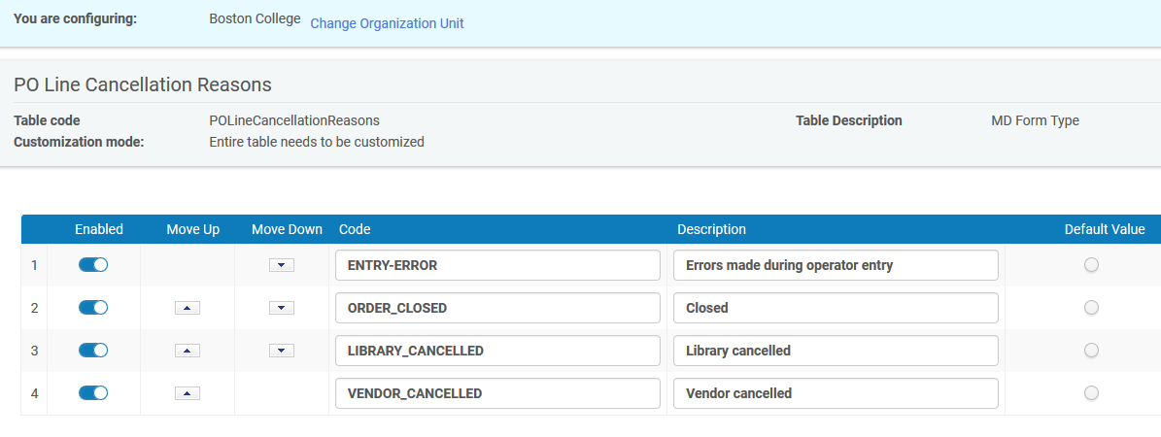

**THREE**

Now see these options when you cancel an order

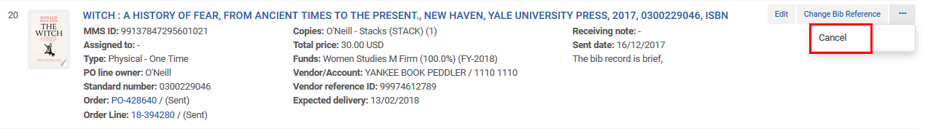

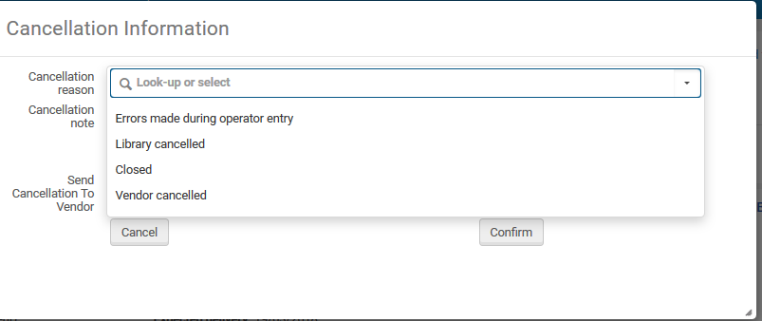

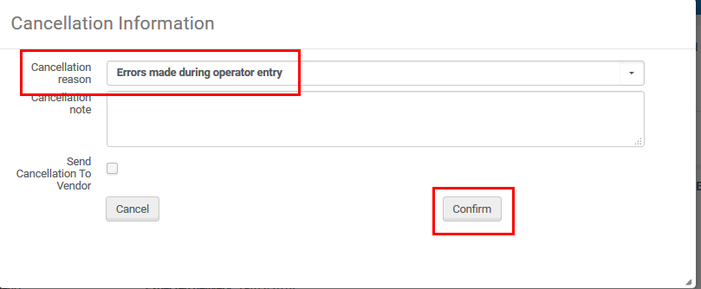

**FOUR**

Now in Analytics in the Funds Expenditure subject area we can display and filter by these reasons:

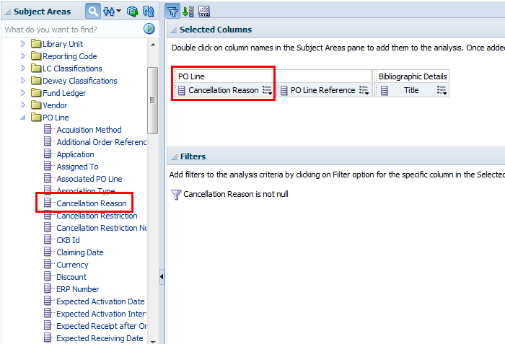

**FIVE**

See results:

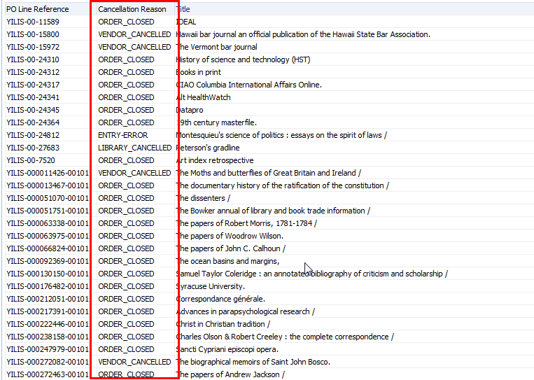

**SIX**

You can also get the number of POLs per cancellation reason

Do ‘edit formula’ on the ‘PO Line Reference’ and instead of this

**"PO Line"."PO Line Reference"**

Put this

**COUNT("PO Line"."PO Line Reference")**

Change the column heading from

**PO Line Reference**

To

**PO Line Reference Amount**

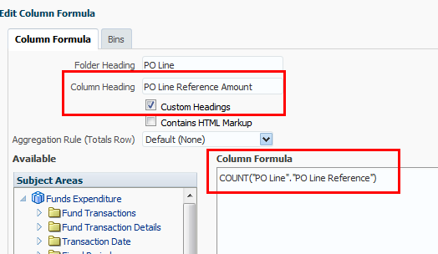

Display the reason and the PO Line Reference Amount

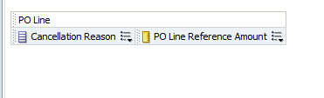

**SEVEN**

See results

