|  |  |
| --- | --- |
| **How to make a normalization rule which will move M and text after M in subfield h to subfield i in field 852** |  |
|  | |

Note: If you copy and paste make sure the quotation marks remain correctly

**Example one**

This will show how to make a normalization rule which will change

852 0  $$b UL $$c ul $$h PS3570.H56M7

To

852  0  $$b UL $$c ul $$h PS3570.H56 $$i M7

Or in other words:

Any time M (capital M) appears in 852 subfield h put it in subfield i together with whatever is after the M

**Note that in case above in the source record there is no space before the M**

rule "change M in subfield h to separator_M"

priority 3

when

not exists "852.i.*"

then

replaceContents "852.h.M" with "separator_M"

end

rule "splitSubField"

priority 2

when

not exists "852.i.*"

then

splitSubField "852.h.separator_"

end

rule "change duplicate subfield"

priority 1

when

not exists "852.i.*"

then

changeSubFieldExceptFirst "852.h" to "i"

end

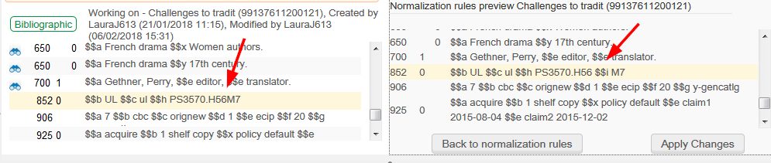

**Example two**

This will show how to make a normalization rule which will change

852 0  $$b UL $$c ul $$h PS3570.H56 M7

To

852  0  $$b UL $$c ul $$h PS3570.H56 $$i M7

Or in other words:

Any time space M (capital M) appears in 852 subfield h put it in subfield i together with whatever is after the M

**Note that in case above in the source record there is a space before the M**

rule "change M in subfield h to separator_M"

#

# Note that actions stipulated in the rule with the higher priority are performed first.

# For example, the action in the rule with priority 2 below is performed before the action in the rule with priority 1

#

# change 852 0 $$b UL $$c ul $$h PS3570.H56 M7

# To

# 852 0 $$b UL $$c ul $$h PS3570.H56 $$i M7

#

priority 3

when

not exists "852.i.*"

then

replaceContents "852.h. M" with "separator_M"

end

rule "splitSubField"

priority 2

when

not exists "852.i.*"

then

splitSubField "852.h.separator_"

end

rule "change duplicate subfield"

priority 1

when

not exists "852.i.*"

then

changeSubFieldExceptFirst "852.h" to "i"

end

