|  |  |
| --- | --- |
| **How to make a normalization rule which will move WIG and text after WIG in subfield a to subfield b in field 082** |  |
|  | |

Note: If you copy and paste make sure the quotation marks remain correctly

**Example one**

This will show how to make a normalization rule which will change

082 00 $$a 539.77 WIG

To

082 00 $$a 539.77 $$b WIG

Or in other words:

Any time space WIG appears in 082 subfield a put it in subfield b together with whatever is after the space WIG

**Note that in case above in the source record there is a space before the WIG**

rule "splitSubField"

priority 2

when

not exists "082.b.*"

then

splitSubField "082.a. "

end

rule "change duplicate subfield"

priority 1

when

not exists "085.b.*"

then

changeSubFieldExceptFirst "082.a" to "b"

end

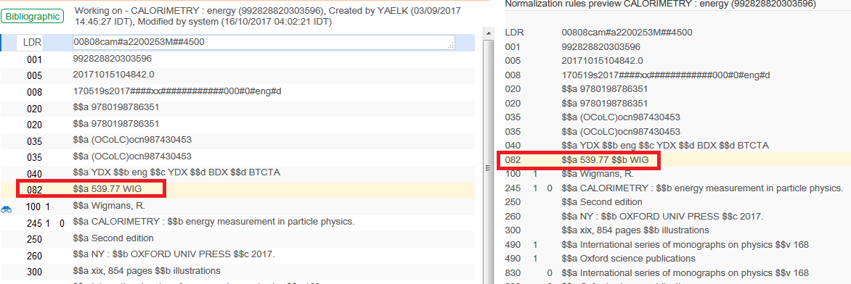

**Example two**

This will show how to make a normalization rule which will change

082 00 $$a 539.77WIG

To

082 00 $$a 539.77 $$b WIG

Or in other words:

Any time WIG (no space WIG) appears in 082 subfield a put it in subfield b together with whatever is after the WIG

**Note that in case above in the source record there is no space before the WIG**

rule "change WIG in subfield a to separator_WIG"

priority 3

when

not exists "082.b.*"

then

replaceContents "082.a.WIG" with "separator_WIG"

end

rule "splitSubField"

priority 2

when

not exists "082.b.*"

then

splitSubField "082.a.separator_"

end

rule "change duplicate subfield"

priority 1

when

not exists "082.b.*"

then

changeSubFieldExceptFirst "082.a" to "b"

end

