|  |  |
| --- | --- |
| **Peer Reviewed and Open Access in Alma** |  |



**Yoel Kortick**

**Senior Librarian**

See also: [Search Results Icons](https://knowledge.exlibrisgroup.com/Alma/Product_Documentation/010Alma_Online_Help_(English)/010Getting_Started/050Alma_User_Interface_%E2%80%93_General_Information/Searching_in_Alma#Search_Result_Icons).

# Peer Reviewed

As referenced in [Peer Reviewed - Search Field Descriptions - Additional Information for Advanced Search](https://knowledge.exlibrisgroup.com/Alma/Product_Documentation/010Alma_Online_Help_(English)/010Getting_Started/050Alma_User_Interface_%E2%80%93_General_Information/Searching_in_Alma#Peer_Reviewed_Advanced_Search) records with the text **Refereed/Peer-reviewed** in the 500 field subfield a will

* Have an indication in the repository search results that they are “Peer Reviewed”
* Be retrievable via advanced search “Peer Reviewed = Yes”

For example, see this search and the repository search results:

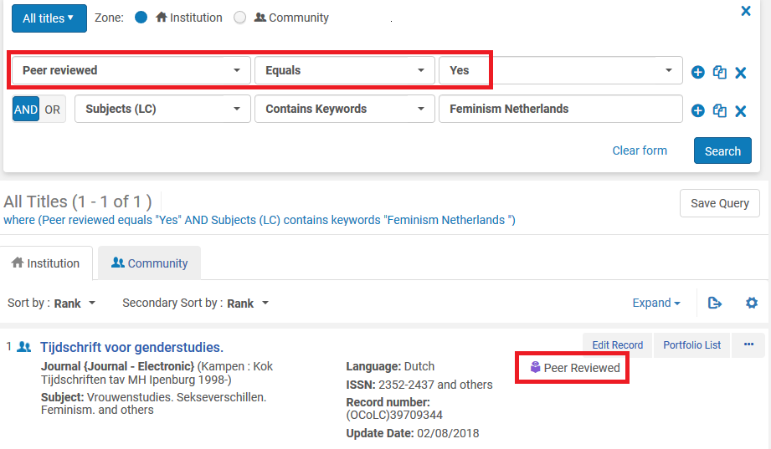

The reason the above occurs is because of this is in the record:

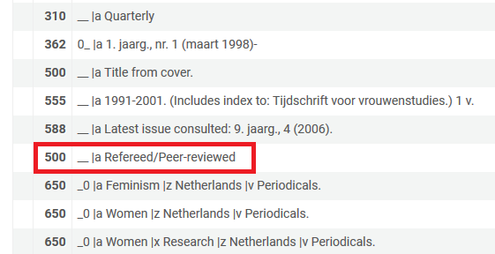

# Open Access

As referenced in [Open Access - Search Field Descriptions - Additional Information for Advanced Search](https://knowledge.exlibrisgroup.com/Alma/Product_Documentation/010Alma_Online_Help_(English)/010Getting_Started/050Alma_User_Interface_%E2%80%93_General_Information/Searching_in_Alma#Open_Access_Advanced_Search) records with the text **Unrestricted online access** in the 506 field with first indicator 0 subfield f and text **star** (star is **S**tandardized **t**erminology for **a**ccess **r**estriction) in 506 field with first indicator 0 subfield 2 will

* Have an indication in the repository search results that they are “Open Access”
* Be retrievable via advanced search “Open Access = Yes”

This uses the standard 506 subfield f definition as it appears here: <http://www.loc.gov/marc/bibliographic/bd506.html>

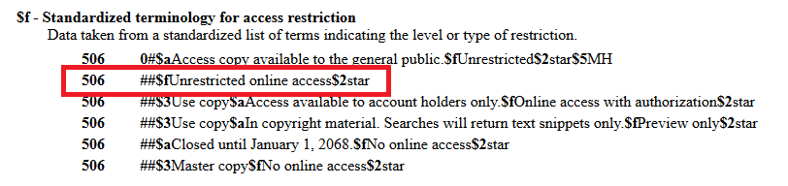

For example, see this search and the repository search results:

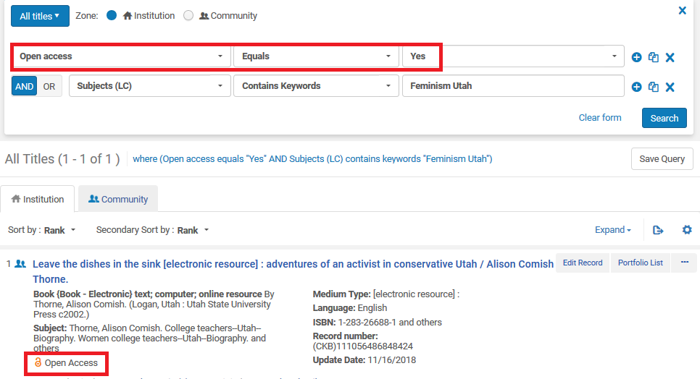

The reason the above occurs is because of this is in the record:

