|  |  |
| --- | --- |
| **How to convert a MARC file to Excel (or csv) format using MarcEdit** |  |
|  | |

**Yoel Kortick**

**Senior Librarian**

Question:

I need to get bibliographic records from Alma into Excel format and be able to choose exactly which fields and subfields I need in the Excel. How can I do this?

Answer:

Please follow steps below.

In addition to the explanation below you may also to see the video <https://www.youtube.com/watch?v=qkzJmNOvY00> from MarcEdit

**ONE**

Create a MARC file in Alma, for example by using the [General Publishing Profile](https://knowledge.exlibrisgroup.com/Alma/Product_Documentation/010Alma_Online_Help_(English)/090Integrations_with_External_Systems/030Resource_Management/080Publishing_and_Inventory_Enrichment) or the [Export Bibliographic Records](https://knowledge.exlibrisgroup.com/Alma/Product_Documentation/010Alma_Online_Help_(English)/050Administration/070Managing_Jobs/020Running_Manual_Jobs_on_Defined_Sets) job. We will run the “Export Bibliographic Records” job.

 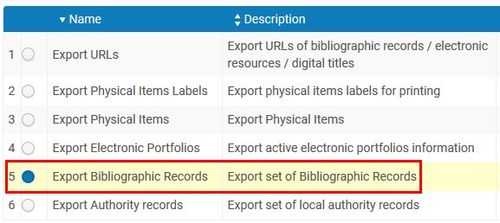

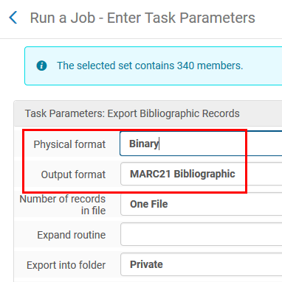 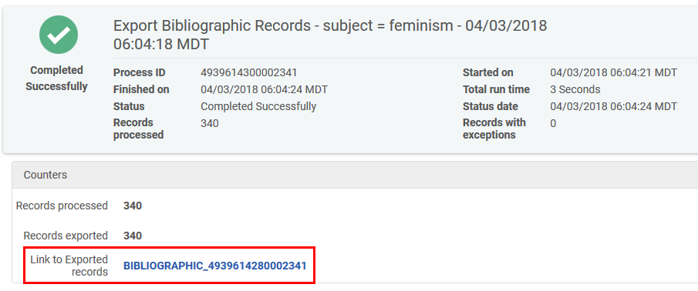

**TWO**

Identify location of MARC file

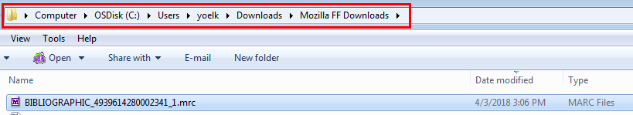

**THREE**

In MarcEdit do

1. Tools > Export > Export Tab Delimited Records.
2. Select Filed delimiter “Comma” (or of desired in different scenario choose “tab” or “pipe”). For repeatable fields note the “n field delimiter” semicolon
3. Click “Next”
4. Select fields and subfields to add
5. Note that the settings can be saved or loaded from a previous save
6. Click “Export”
7. Receive message that the file has been exported

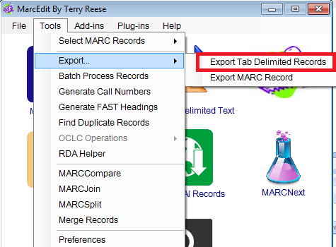 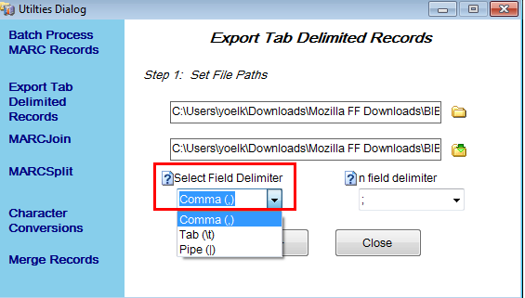

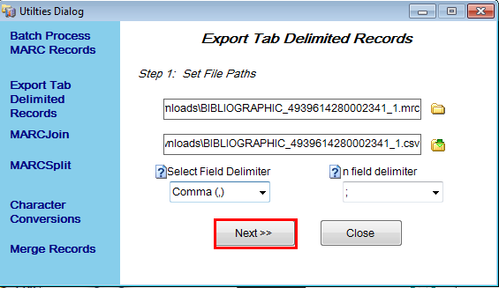 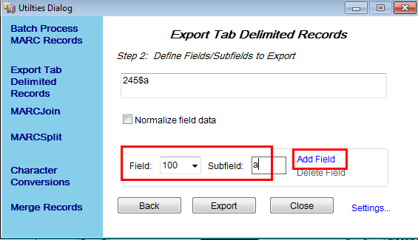

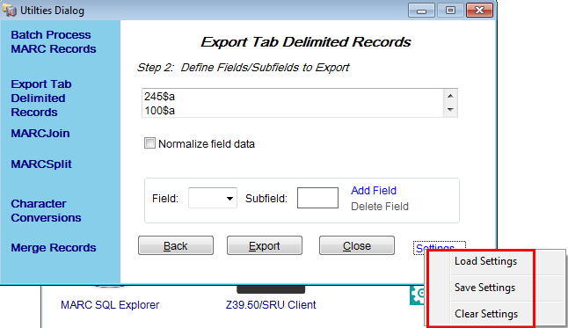 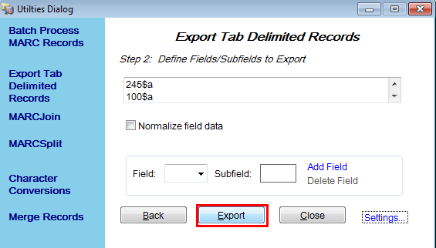

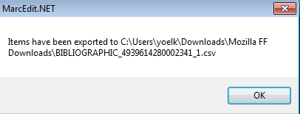

**FOUR**

Take a look at the file in Notepad or Notepad ++

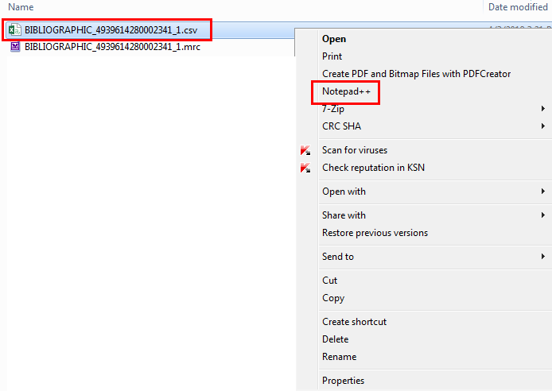

File looks great

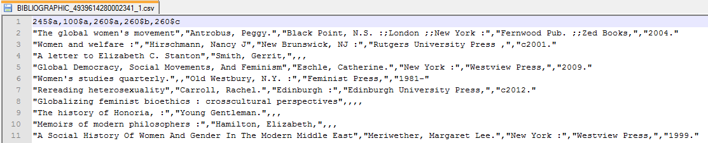

**FIVE**

Take a look at the file in Excel

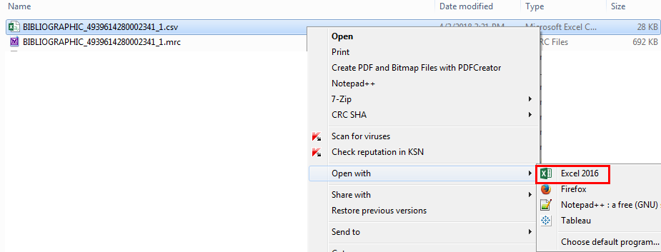

File looks great

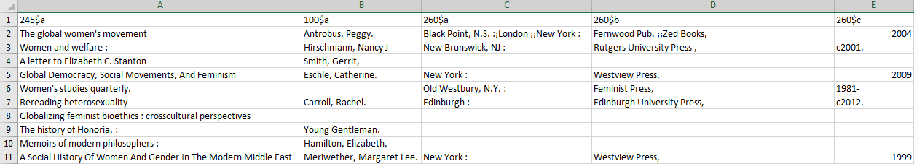

**SIX**

For repeatable fields note that happened becaseu we used “n field delimiter” semicolon.

Here we have three 260 $a and two 260 $b

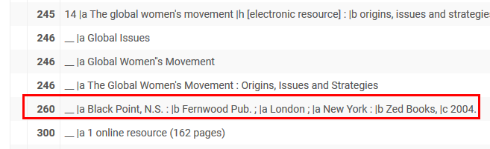

Each is semicolon separated within the comma-separated field.

