|  |  |
| --- | --- |
| **How to use Alma Analytics with Google Charts and APIs to display Analytics reports in web pages** |  |
|  | |

**Laura Guy. Colorado School of Mines**

**Yoel Kortick. Senior Librarian, Ex Libris**

**Introduction:**

We will present here instructions to make an Alma analytics report appear on a web page. This is often useful so that the library can present information from Alma Analytics to end users or other institution staff. In the examples here we will

1. Present in an html page an analytics report of link resolver access methods as a pie chart
2. Present in an html page an analytics report of active user groups as a pie chart
3. Present in an html page an analytics report of new titles in a web page as a table
4. Present in an html page all of the above (one table and two pies)

In all cases we will use Google Charts as described at <https://developers.google.com/chart/> .

It is assumed that users already know how to use an API key to retrieve an Alma analytics report. For more information about retrieving an Alma analytics report with an API key see “Creating and testing an API application to retrieve data via Alma analytics” at <https://developers.exlibrisgroup.com/blog/How-To-documents-for-various-aspects-of-the-Developers-Network>

The sample html files and the raw xml of the analytics reports used here can be obtained at <https://knowledge.exlibrisgroup.com/Alma/Training/Extended_Training/Presentations_and_Documents_-_Analytics> in the section “Analytics - Using Google charts with Alma Analytics Edit section”.

Therefore you can just download these html samples and change as needed. This, together with instructions at Google Charts should greatly aid in doing this on your own.

The sample html files include the edited code from Google charts. The Google chart code is not intended to “stand alone” but rather be inside an html page.

Here is a list of the files to be used together with a description:

|  |  |
| --- | --- |
| [Analytics - Google charts - Table Total Number of Titles.html](https://knowledge.exlibrisgroup.com/@api/deki/files/63635/Analytics_-_Google_charts_-_Table_Total_Number_of_Titles.html) | Html page showing report “Total number of volumes” as table |
| [Analytics - Google charts - Pie Chart Link Resolver usage by method of access for current year.html](https://knowledge.exlibrisgroup.com/@api/deki/files/63634/Analytics_-_Google_charts_-_Pie_Chart_Link_Resolver_usage_by_method_of_access_for_current_year.html) | Html page showing report “Link Resolver usage by method of access for current year” as pie chart |
| [Analytics - Google charts - Pie Chart Users.html](https://knowledge.exlibrisgroup.com/@api/deki/files/63632/Analytics_-_Google_charts_-_Pie_Chart_Users.html) | Html page showing report “Count of Unexpired Users by group” as pie chart |
| [Analytics - Google charts - One Table and Two Pies in one html page.html](https://knowledge.exlibrisgroup.com/@api/deki/files/63633/Analytics_-_Google_charts_-_One_Table_and_Two_Pies_in_one_html_page.html) | Html page showing all three of the above in one page |
| [Analytics - Google charts - Total Number of Volumes.xml](https://knowledge.exlibrisgroup.com/@api/deki/files/63636/Analytics_-_Google_charts_-_Total_Number_of_Volumes.xml) | Raw xml of analytics report “Total number of volumes” |
| [Analytics - Google charts - Count of Unexpired Users by group.xml](https://knowledge.exlibrisgroup.com/@api/deki/files/63630/Analytics_-_Google_charts_-_Count_of_Unexpired_Users_by_group.xml) | Raw xml of analytics report “Count of Unexpired Users by group” |
| [Analytics - Google charts - Link Resolver usage by method of access for current year.xml](https://knowledge.exlibrisgroup.com/@api/deki/files/63631/Analytics_-_Google_charts_-_Link_Resolver_usage_by_method_of_access_for_current_year.xml) | Raw xml of analytics report “Link Resolver usage by method of access for current year” |

**ONE**

Create Alma Analytics reports for what you want to display on the web pages and create corresponding URLs to retrieve the data in xml format via an API.

In our case we have these three reports:

1. Total number of volumes
2. Link Resolver usage by method of access for current year
3. Count of Unexpired Users by group

All are in directory “shared/Colorado School of Mines/Reports/Yoel/APIs/”.

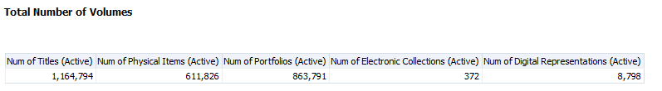

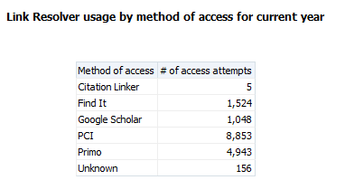

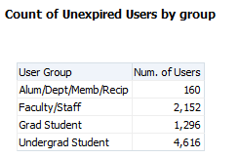

**TWO**

Here are the APIs to retrieve the reports

Total number of volumes

<https://api-na.hosted.exlibrisgroup.com/almaws/v1/analytics/reports?path=%2Fshared%2FColorado%20School%20of%20Mines%2FReports%2FYoel%2FAPIs%2FTotal%20Number%20of%20Volumes&limit=1000&col_names=true&apikey=l7xx7533d0d325c541d6a214d912f161c609>

Link Resolver usage by method of access for current year

<https://api-eu.hosted.exlibrisgroup.com/almaws/v1/analytics/reports?path=%2Fshared%2FColorado%20School%20of%20Mines%2FReports%2FYoel%2FAPIs%2FLink%20Resolver%20usage%20by%20method%20of%20access%20for%20current%20year&limit=1000&col_names=true&apikey=l7xx7533d0d325c541d6a214d912f161c609>

Count of Unexpired Users by group

<https://api-eu.hosted.exlibrisgroup.com/almaws/v1/analytics/reports?path=%2Fshared%2FColorado%20School%20of%20Mines%2FReports%2FYoel%2FAPIs%2FCount%20of%20Unexpired%20Users%20by%20group&limit=1000&col_names=true&apikey=l7xx7533d0d325c541d6a214d912f161c609>

**TWO**

Access the Google Charts pie chart at <https://developers.google.com/chart/interactive/docs/gallery/piechart> and look at the sample code.

Modify the sample code to take data from the above analytics report “Link Resolver usage by method of access for current year” and display it in a pie chart.

Use the html examples above with the links as guide. Simply download them to your PC and open in notepad to see the text and open in browser to see how they appear.

**THREE**

Here are how the four html files appear in a browser

Analytics - Google charts - Table Total Number of Titles.html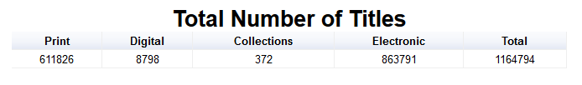

Analytics - Google charts - Pie Chart Link Resolver usage by method of access for current year.html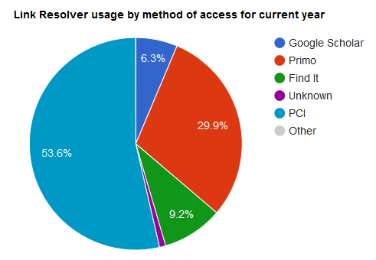

Analytics - Google charts - Pie Chart Users.html

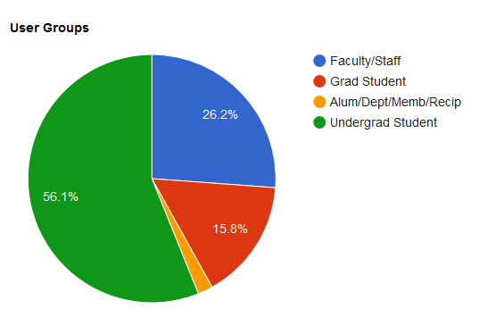

Analytics - Google charts - One Table and Two Pies in one html page.html

