|  |  |
| --- | --- |
| **How to use Alma Analytics with Google Charts and APIs to display a new book list** |  |
|  | |

**Laura Guy. Colorado School of Mines**

**Yoel Kortick. Senior Librarian, Ex Libris**

**Introduction:**

See also: [Analytics - Google charts - How to use Alma Analytics with Google Charts and APIs to display Analytics reports in web pages.docx](https://knowledge.exlibrisgroup.com/@api/deki/files/63639/Analytics_-_Google_charts_-_How_to_use_Alma_Analytics_with_Google_Charts_and_APIs_to_display_Analytics_reports_in_web_pages.docx)

We will present here instructions to make an Alma analytics report appear on a web page. This is often useful so that the library can present information from Alma Analytics to end users or other institution staff. In the example here we will present in an html page an analytics report of new records added to the institution repository.

We will use Google Charts as described at <https://developers.google.com/chart/> .

It is assumed that users already know how to use an API key to retrieve an Alma analytics report. For more information about retrieving an Alma analytics report with an API key see “Creating and testing an API application to retrieve data via Alma analytics” at <https://developers.exlibrisgroup.com/blog/How-To-documents-for-various-aspects-of-the-Developers-Network>

The sample html file and the raw xml of the analytics reports used here can be obtained at <https://knowledge.exlibrisgroup.com/Alma/Training/Extended_Training/Presentations_and_Documents_-_Analytics> in the section “Analytics - Using Google charts with Alma Analytics Edit section”.

Here is a list of the files to be used together with a description:

|  |  |
| --- | --- |
| [Analytics - Google charts new book list -Records created in the library in the last week as a table.html](https://knowledge.exlibrisgroup.com/@api/deki/files/63641/Analytics_-_Google_charts_new_book_list_-Records_created_in_the_library_in_the_last_week_as_a_table.html) | Html page showing report “records created in the library in the last week” as table |
| [Analytics - Google charts new book list -Records created in the library in the last week.xml](https://knowledge.exlibrisgroup.com/@api/deki/files/63642/Analytics_-_Google_charts_new_book_list_-Records_created_in_the_library_in_the_last_week.xml) | Raw xml of analytics report “records created in the library in the last week” as table” |

**ONE**

Create Alma Analytics reports for what you want to display on the web pages and create corresponding URLs to retrieve the data in xml format via an API.

In our case we have created this report:

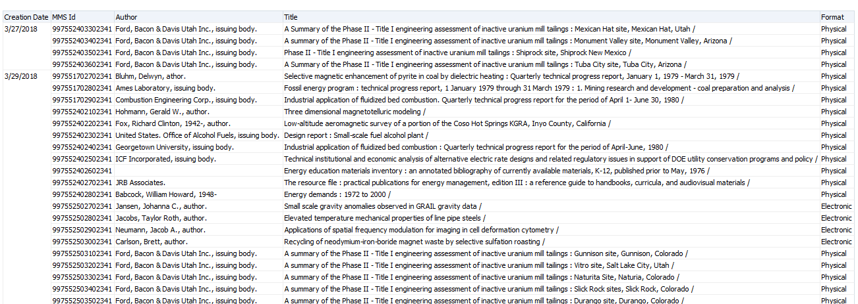

It is in directory “shared/Colorado School of Mines/Reports/Yoel/APIs/”.

**TWO**

Here is the API to retrieve the report

<https://api-na.hosted.exlibrisgroup.com/almaws/v1/analytics/reports?path=%2Fshared%2FColorado%20School%20of%20Mines%2FReports%2FYoel%2FAPIs%2FRecords%20created%20in%20the%20library%20in%20the%20last%20week&limit=1000&col_names=true&apikey=l7xx7533d0d325c541d6a214d912f161c609>

**THREE**

Access the Google Table Charts Gallery chart at <https://developers.google.com/chart/interactive/docs/gallery/table> and look at the sample code.

Modify the sample code to take data from the above analytics report “records created in the library in the last week” and display it in the table.

**FOUR**

Here is how the html appears. Note that the column for the author is defined differently than the other columns due to the fact that sometimes it may be empty

|  |
| --- |
| <html>  <head>  <script type="text/javascript" src="https://www.gstatic.com/charts/loader.js"></script>  <script type="text/javascript">  google.charts.load('current', {'packages':['table']});  google.charts.setOnLoadCallback(drawTable);  function drawTable() {  xmlhttp=new XMLHttpRequest();  xmlhttp.open("GET","https://api-na.hosted.exlibrisgroup.com/almaws/v1/analytics/reports?path=%2Fshared%2FColorado%20School%20of%20Mines%2FReports%2FYoel%2FAPIs%2FRecords%20created%20in%20the%20library%20in%20the%20last%20week&limit=1000&col_names=true&apikey=l7xx7533d0d325c541d6a214d912f161c609",false);  xmlhttp.send();  xmlDoc=xmlhttp.responseXML;  var rows = xmlDoc.getElementsByTagName("Row");  var data = new google.visualization.DataTable();  data.addColumn('string', 'Creation Date');  data.addColumn('string', 'MMS ID');  data.addColumn('string', 'Title');  data.addColumn('string', 'Author');  data.addColumn('string', 'Format');  for (var i = 0; i < rows.length; i++) {  data.addRow([  rows[i].getElementsByTagName("Column3")[0].childNodes[0].nodeValue,  rows[i].getElementsByTagName("Column1")[0].childNodes[0].nodeValue,  rows[i].getElementsByTagName("Column2")[0].childNodes[0].nodeValue,  rows[i].getElementsByTagName("Column5").length>0 ? rows[i].getElementsByTagName("Column5")[0].childNodes[0].nodeValue : "",  rows[i].getElementsByTagName("Column4")[0].childNodes[0].nodeValue    ]);  }  var table = new google.visualization.Table(document.getElementById('table_div'));  table.draw(data, {showRowNumber: true, width: '100%', height: '100%'});  }  </script>  </head>  <h3><center>Records created in the library in the last week</center></h3>  <body>  <div id="table_div"></div>  </body>  </html> |

**FIVE**

Here is how the html page appears in the web:

