|  |  |
| --- | --- |
| **How to include the values chosen in prompts as part of the header in the analytics report results** |  |
|  | |



**Yoel Kortick**

**Senior Librarian**

**Question**

I have a report called “Items created per year” by library.

It prompts by “Item Creation Year” and “Library Name (Active)”.

It displays the number of items.

I would like to know how to include the chosen parameters from the prompts in the report results.

Now the user chooses the prompts and then the results include the amount of items.

I want to have whatever the user chose in the prompts be included in the results.

Title of Report

[Name of Library selected from Prompt]

[Item Creation Year selected from Prompt]

I think I've seen this in examples, but I could not figure out how to do it.

Thank you for any help you can provide.

**Answer**

Note: This answer assumes the user already knows how to add prompts.

For more information on adding prompts see:

[Analytics - How to create a prompt in an Alma Analytics report.pptx](https://knowledge.exlibrisgroup.com/@api/deki/files/48622/Analytics_-_How_to_create_a_prompt_in_an_Alma_Analytics_report.pptx?revision=1)

**ONE**

When the column prompts are created:

1. Click the triangle next to the ‘Options’
2. In the “Set a variable” field choose “Presentation Variable”
3. In the field below “Presentation Variable” type the name of your variable
   1. It should have no spaces
   2. It should have a logical name, such as ‘Library_Name” for

Here is the Item Creation Year with a presentation variable item_creation_year

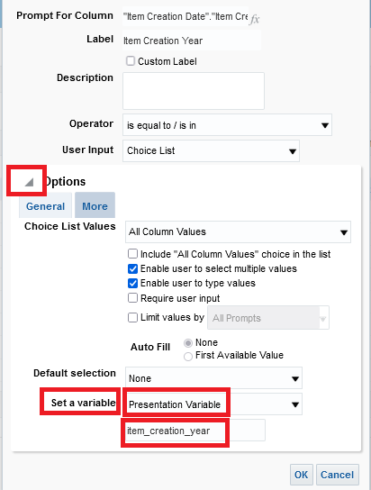

Here is the Library Name (Active) with a presentation variable library_name_active

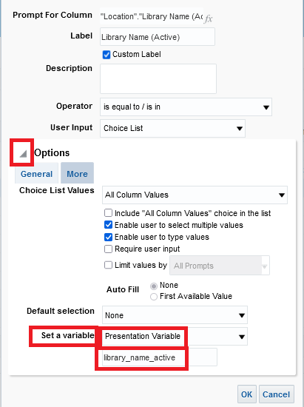

**TWO**

The prompt variable can be defined to appear

1. In the narrative
2. As a column
3. As part of the title

To make the prompt variable appear in the results it should be inside curly brackets and preceded by an @ sign.

For example the following two prompt variables:

item_creation_year

library_name_active

Should be as follows when making them appear in the results:

@{item_creation_year}

@{library_name_active}

**THREE**

We will add it to a narrative as follows:

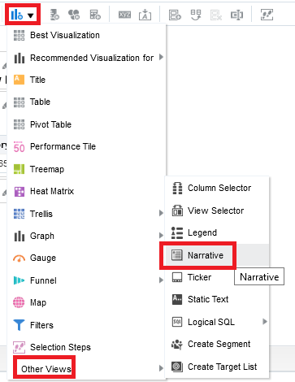

Here we have chosen “Contains HTML Markup” and put the fields as follows:

<div align = “left”>

<p>

Item Creation Year: @{item_creation_year}<br>

Library Name: @{library_name_active}<br>

</div>

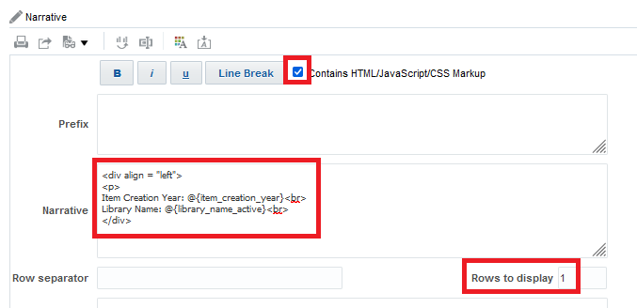

**FOUR**

After the narrative is added you will probably want to move it up near the title.

In the picture below there is no value for the two variables because it was run in the report switching from the criteria to results tab so they were no prompt inputs.

However, you can see it was moved under the title and before the report

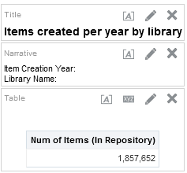

**FIVE**

Run the report. Here we choose item creation years 2020 and 2021.

We choose the G. Etzion library.

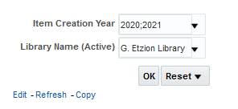

**SIX**

Here are the results

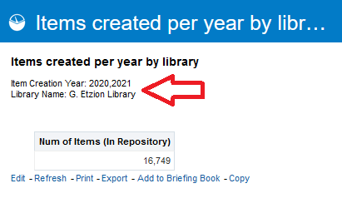

**SEVEN**

Similarly, we could make the title be:

Items created per year by library @{item_creation_year} @{library_name_active}



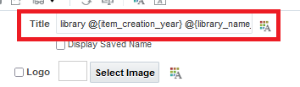

And the title will appear as follows:

