Do >Admin >Manage Sets >Add Set >Logical, add a Set name and select Set content type = User
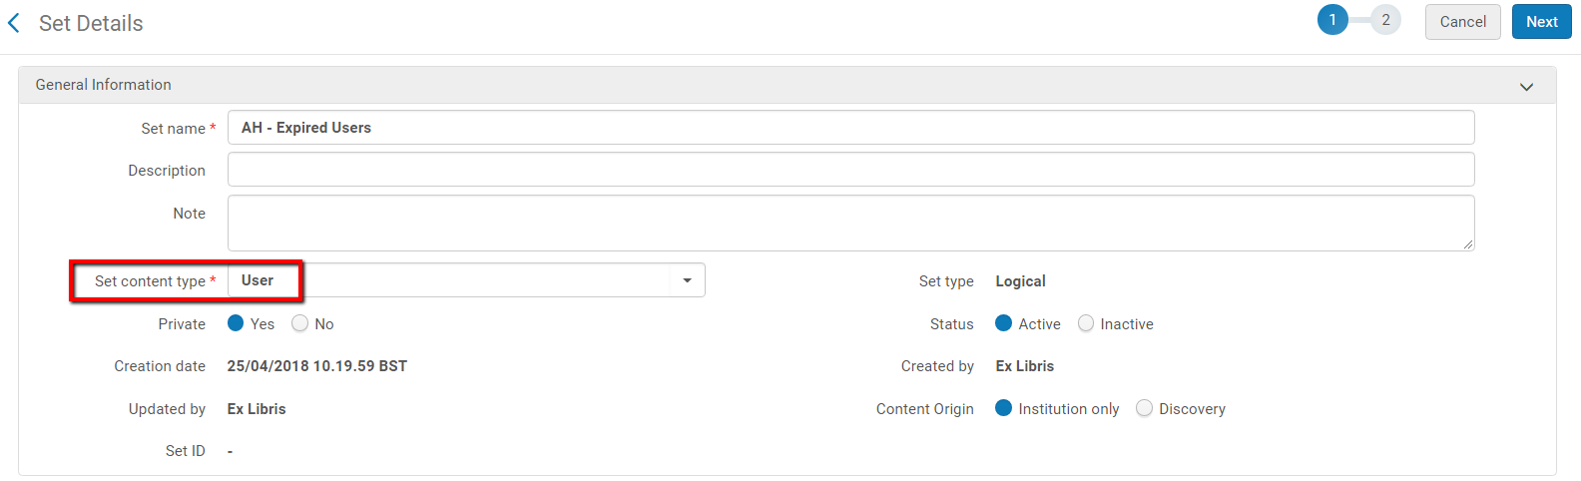

In the next step you see the user list and can set different filters
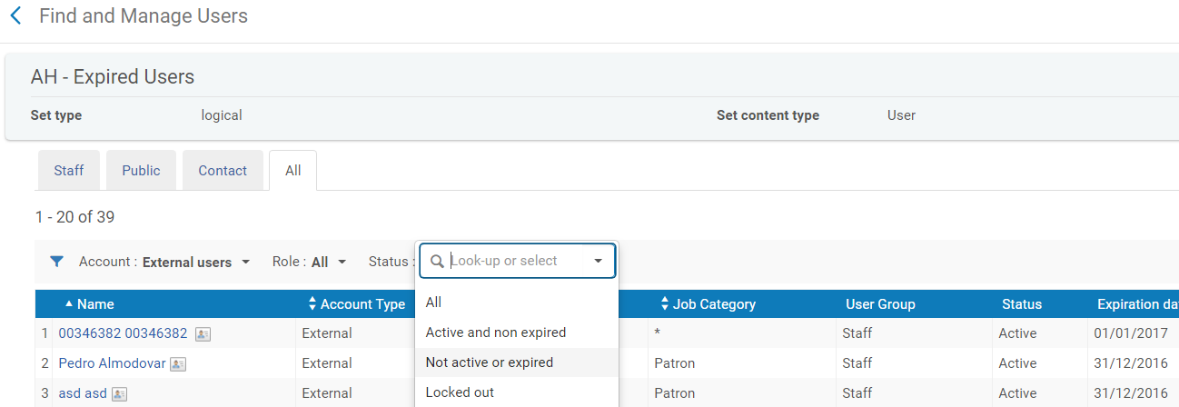

After “SAVE” the set is saved properly and can be used

