|  |  |
| --- | --- |
| **How to add the title to a bar graph and make the value appear on the top of each bar on an Alma Analytics graph** |  |
|  | |

**Yoel Kortick**

**Senior Librarian**

**Question:**

I have made a graph in my Alma Analytics report but I only see the actual amount in each bar if I roll my mouse over the bar. How can I put the actual value above each bar? I know it is possible because I have seen other libraries do it. I also want to change title which is now giving by default the name of field.

I create my graph by choosing the default bar graph

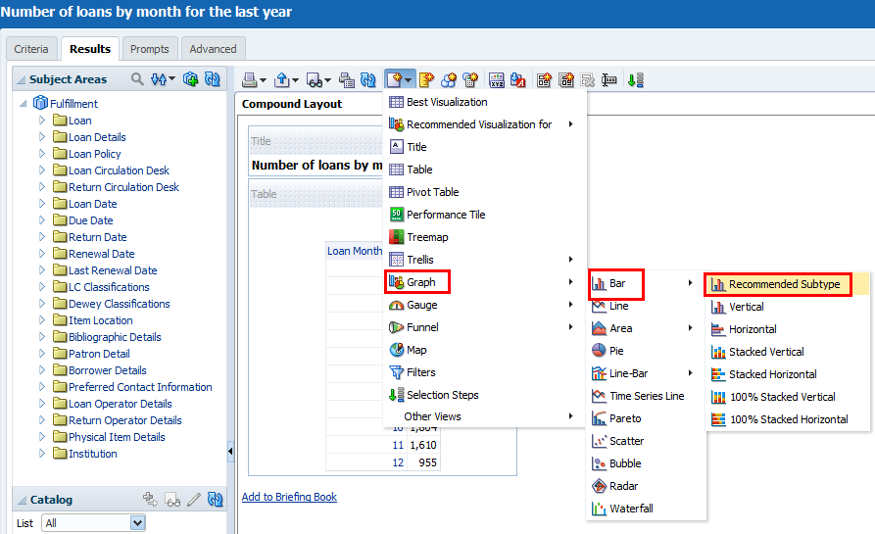

But I do not see the values above each bar

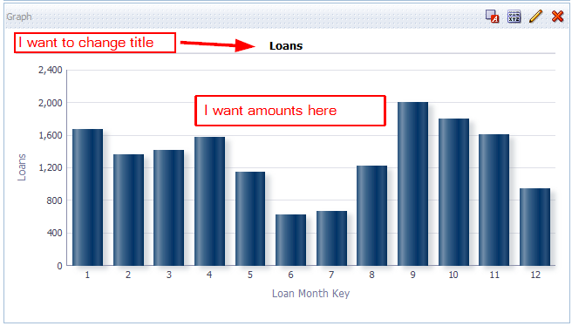

**Answer:**

**ONE**

When the graph is open in the “results” tab click the “View Properties”

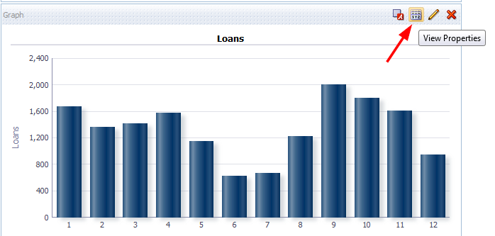

**TWO**

In the “Titles and Labels” tab uncheck “Use measure name as graph title”

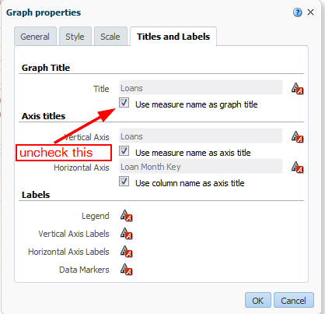

Put your desired title

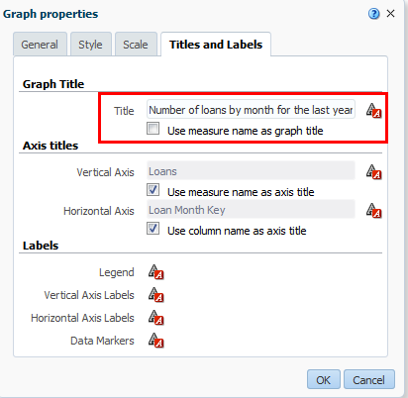

**THREE**

In the “Titles and Labels” tab click “Data Markers”

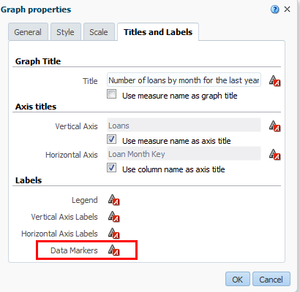

**FOUR**

In the “Display Options” tab choose “Always” instead of “Default (On rollover)”

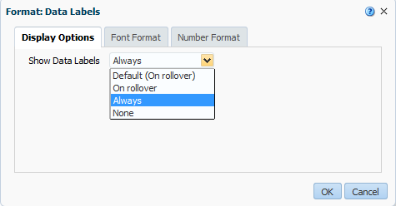

**FIVE**

Click “OK” for both changes, and now see desired title and results with values

