|  |  |
| --- | --- |
| **How to setup Alma holdings integration with Syndetics Unbound** |  |
|  | |

There are three steps in Alma to set up the holdings integration with Syndetics Unbound.

1. Define the FTP connection to Syndetics Unbound using your Syndetics Credentials
2. Define the set of all published records
3. Copy the predefined publishing profile for Syndetics Unbound from the community zone and attribute to it the set of all published records and FTP connection

After defining these three steps in Alma you will need to [enable Syndetics Unbound in Primo](https://knowledge.exlibrisgroup.com/Primo/Product_Documentation/010How_To_Documents_and_Presentations/Setting_Up_Syndetics_Unbound_in_Primo).

1. **Define the FTP connection to Syndetics Unbound using your Syndetics Identification**
2. Configuration Menu > General > External Systems > S/FTP Definitions > Add S/FTP connection
3. Fill in as follows:

|  |  |
| --- | --- |
| Name: | Syndetics Unbound FTP |
| Description: | Syndetics Unbound FTP |
| Server: | unbound-ftp.syndetics.com |
| Port: | 21 |
| FTP Passive Mode: | Checked |
| Username and Password: | Use your Syndetics Unbound Admin login information |

1. Save profile and then click “Test FTP” on top right of profile.
   1. If it connects then continue
   2. If it does not connect then contact Syndetics Unbound at: [techsupport@bowker.com](mailto:techsupport@bowker.com)

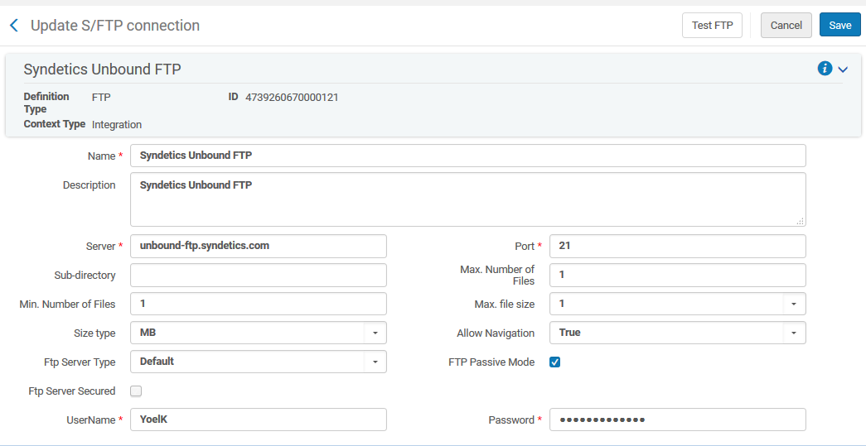

**2. Define set of all published records**

1. In Alma do an ‘all titles’ ‘advanced search’ for all records which have been published
   1. MMSID > 1
   2. Tag Suppressed (Title) equals No
2. Perform the search then click “Save Query” to save the results as a set
3. Call the set “Syndetics Unbound”

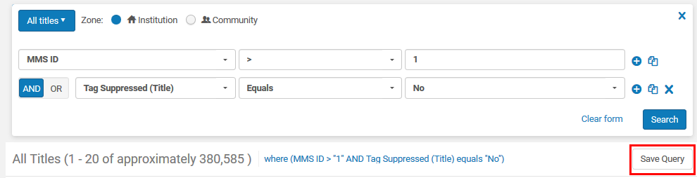

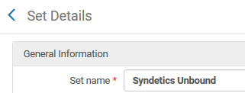

1. **Copy predefined publishing profile for Syndetics Unbound from community zone  
   and add the set of all published records and FTP connection**
2. Resources > Publishing > Publishing Profiles > Community tab > Copy profile “Syndetics Unbound”
3. Edit the profile and add set made above and your ftp configuration made above

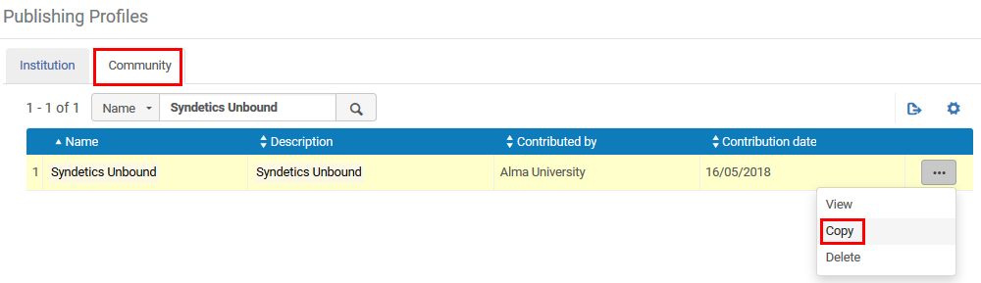

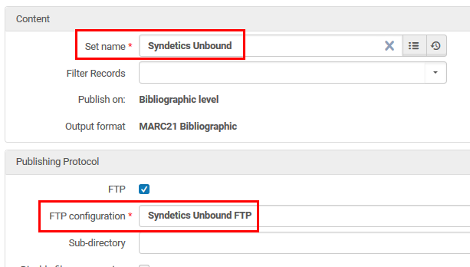

1. Activate the profile:



The publishing profile will run every Saturday at 04:00 AM in your local timezone.