|  |  |
| --- | --- |
| **How to setup and use the "No information provided" option for the Call Number Type browse list** |  |
|  | |

It is possible to browse by several types of holdings record call numbers in the “Browse Shelf Listings”.

Among those types is “No information provided”. This is type of call number is used when the first indicator of the 852 in the holdings record is empty (blank or a space).

This document will discuss related issues to defining and using the “No information provided” call number type.

**Short description:**

There are three steps to define and use the call number type “no information proved”:

1. Define **use_space_as_call_number_type** as ‘false’ so that the default call number type will be used (this is the default do you can just “leave it as is).
   1. The default call number type will come from either
      1. resources > other settings
      2. physical location ‘call number type’
2. Define where you want space to be used as default call number type
   1. If you want to define it on the institutional level then define in resources > other settings
   2. If you want to define for a specific location define in physical location ‘call number type’
3. In **call_number_mapping** define which bibliographic field and subfields you want to be copied to the holdings record

**Full description:**

**ONE**

A parameter exists in "Configuration > Resources > General > Other settings" called **use_space_as_call_number_type**



* If **use_space_as_call_number_type** = false and the 852 first indicator is space then it will be saved as whatever is defined as the default for that location (or for the institution if there is no location default). This is the default.
* If **use_space_as_call_number_type** = true and the 852 first indicator is space then it will be saved as an actual space regardless of what is defined as the default call number type for the institution or specific location

In other words:

* false means to take the default from resource management “other settings” or location call number type
* true means make space be space no matter what is defined elsewhere

For example if **use_space_as_call_number_type** = false and my default call number type is 0 then if I have this in the holdings record

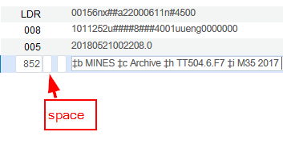

Then after I save I will have this:

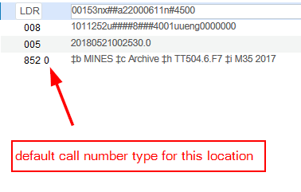

**TWO**

See also [Configuring Physical Locations](https://knowledge.exlibrisgroup.com/Alma/Product_Documentation/010Alma_Online_Help_(English)/030Fulfillment/080Configuring_Fulfillment/030Configuring_Physical_Locations) and [Configuring Other Settings (Resource Management)](https://knowledge.exlibrisgroup.com/Alma/Product_Documentation/010Alma_Online_Help_(English)/040Resource_Management/080Configuring_Resource_Management/060Configuring_Other_Settings).

The default call number type may be defined on the level of the institution or on the level of a specific location of a specific library.

If there is no definition for the location of a specific library then the definition will be taken from the institution level.

On the **institution** level the call number type is defined in "Configuration > Resources > General > Other settings":

Here it is defined as 0 which means Library of Congress



Here it is defined with hash sign which means "No information provided"



On the **location** level the call number type is defined in "Configuration > General > Select library >

Locations > Physical Locations > Select Location > Choose from Pull Down Box for "Call Number Type":

Here for location code "ColoradoRm" (location name "Colorado Room") the Call Number Type is defined as "No information provided”

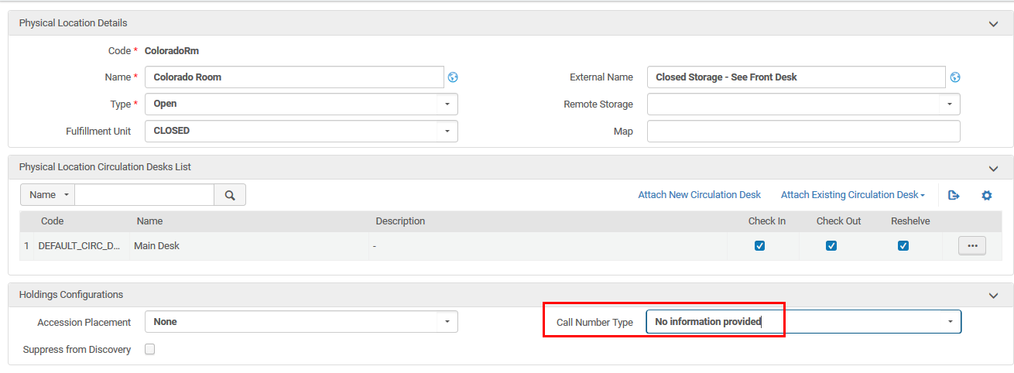

If the staff user puts a hash sign in the first indicator of the 852 and the default call number type is defined as "No information provided" then the hash sign will disappear and there will be space. The same is true if the use puts a blank or nothing in the first indicator.

Before save:

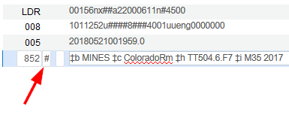

After save

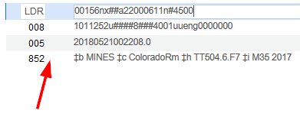

**THREE**

See also [Call Number Mapping](https://knowledge.exlibrisgroup.com/Alma/Product_Documentation/010Alma_Online_Help_(English)/040Resource_Management/080Configuring_Resource_Management/195Mapping_Call_Numbers_to_Holdings).

Now we want to define that when the holdings record has a blank, a space, or a hash sign in the first indicator of the 852 then a specific field of the bibliographic record will be copied to the holdings record.

We can define this in "Configuration > Resources > General > Call Number Mapping". To specify a blank, a space, or a hash sign in the first indicator of the 852 a hash sign should be used.

Here we are stating that if the first indicator of 852 is blank, a space, or a hash sign then copy the 093 subfield a to 852 h and copy the 093 subfield b to 852 subfield i.



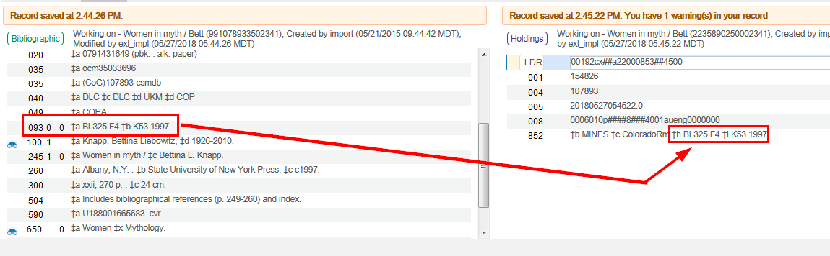

**FOUR**

Now we will browse the shelf listing

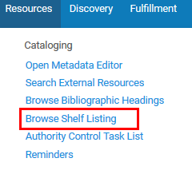

And we will choose call number type “no information provided”. These resulting call numbers are all coming from holdings records with a blank in the first indicator of 852.

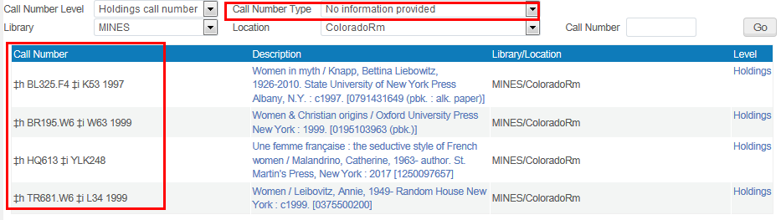

For example we will click the holdings link to the first example here “Women in myth” with call number  
BL325.F4 K53 1997



We see that the 852 1st indicator is blank, meaning “No information provided”.

