Assign a new item policy



Add Fulfillment Unit rules to the according Fulfillment Unit

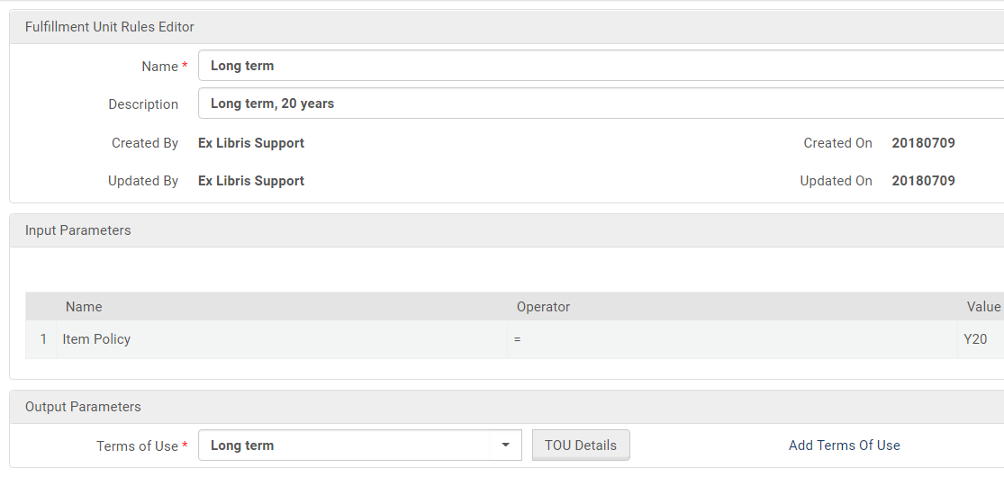

Add Terms of Use

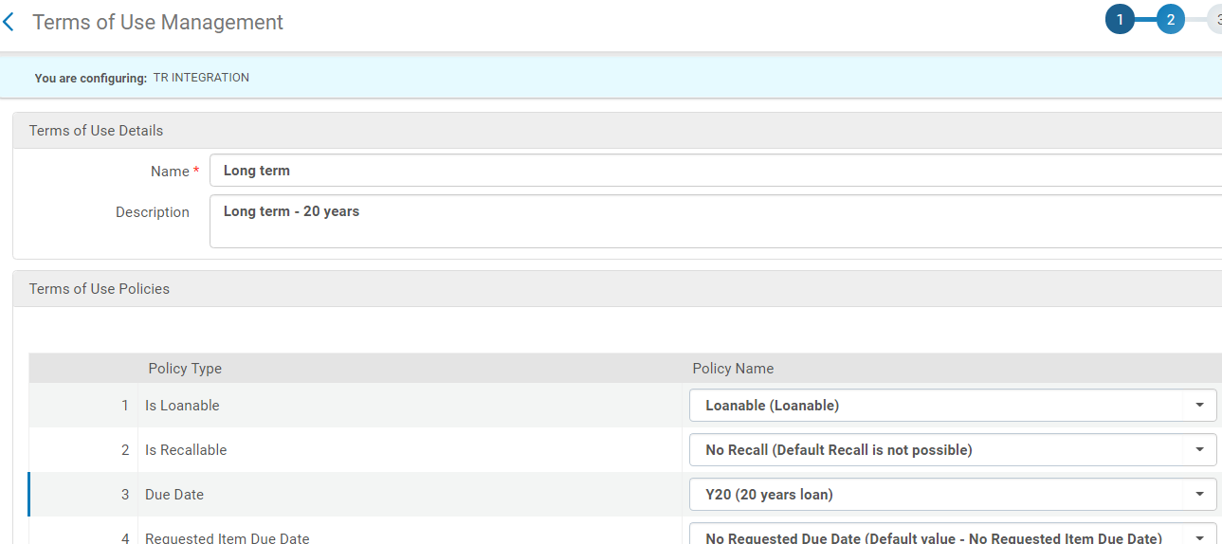

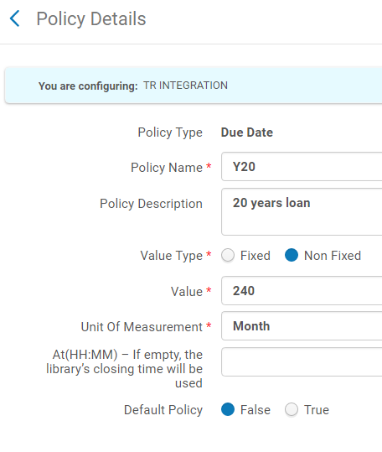

Define the due date value here