Leganto enables you to easily create, maintain, evaluate, and share course resource lists.

With Leganto, you can assemble materials of all types—physical books, online or digitized book chapters, scholarly articles, videos, newspaper articles, websites, and any other type of material—to create a structured, comprehensive resource list. You can build a resource list by yourself or collaborate with others, such as colleagues or librarians. Leganto connects to your course site and makes it simple for students to access all of the materials you’ve selected.

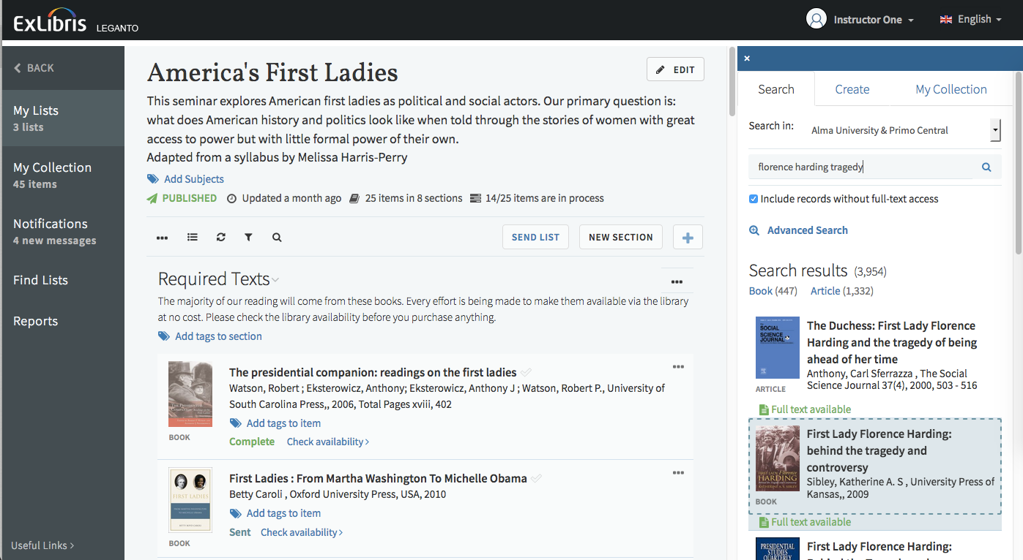

Why use Leganto? Our Top 5 Reasons

All Materials in One Stop | Easy to Create & Modify Lists | Connect with Students | Library Support & Collaboration | Next Term? Ready to Go!
Include all kinds of material types from all sources in one list – easy for students to find right from your course site! | Search the library collection, add from web content and upload our own files.  Organize your list for structure & context. | See where students are engaging with your choices and, if you like, enable discussions & let them suggest additional content. | We help you make sure the materials are available to students at no or low cost with no access restrictions or broken links. | Create your list now, then easily duplicate it next term making adjustments as you go.

Building Your List
Start in your course site and locate the Leganto reading list tool. Clicking on the tool launches Leganto and connects you to a blank course listing where you’ll begin building your list.

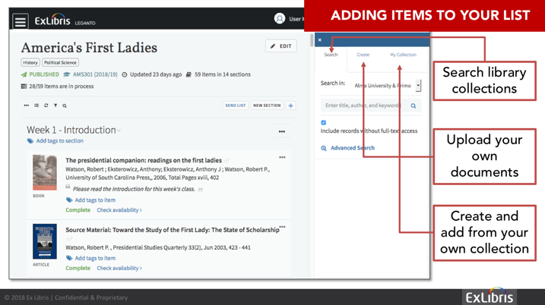
Using the Leganto search feature, you can find any physical or electronic item that your library offers. You can add items directly to a resource list or, after creating a personal collection, drag items from it to your list. You can upload files, type in citation information, import lists of citations, and select references from your RefWorks, Zotero and/or Mendeley folders.

You can also click the Leganto CiteIt! button in your browser to incorporate items from external resources into a resource list—resources such as scholarly databases, publishers’ websites, online bookstores, and YouTube. If your library has an item that you discovered elsewhere, a note to that effect appears with the item’s details.
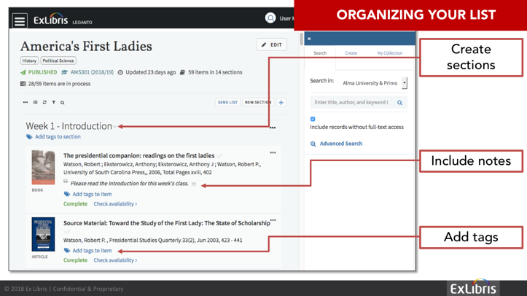
When you start a new list, you can choose a predefined template with the kind of structure you want to use – week by week or core materials and additional resources, etc. At any stage, you can add, remove, edit, or reorder the sections, and you can drag items from one section to another. Leganto makes it easy for you to label items—mandatory or optional, for example—as well as to add notes to items, sections, and citations.

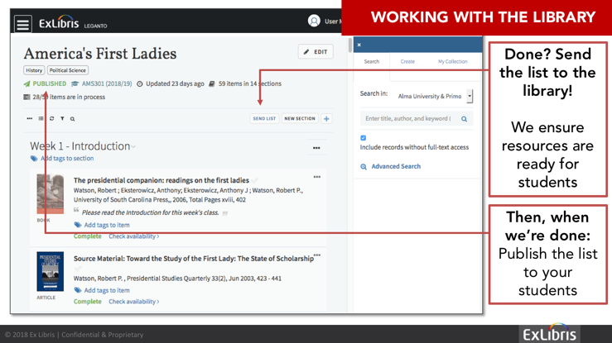
Leganto makes it easy to communicate with your library to discuss the fine points of making items available. For instance, you may want to request that the library digitize a book chapter and make it available online or put certain items on reserves.

Once your list is ready, the library makes all the items available to your students and takes care of digitization, copyright clearance, short-term loans, and any other action that is required. You determine who is permitted to view the list: course enrollees only, anyone at your institution, or the general public. Regardless of who may view the list, access to the actual materials still complies with the library’s subscription terms and copyright regulations. And, of course, you can modify your list at any time, even after the list has been published.
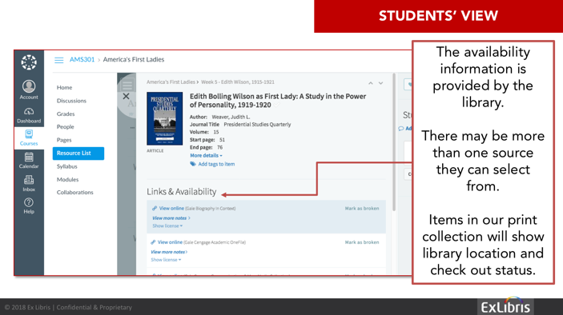

When the term begins, your students have easy access all their course materials. You can see the number of student views for each item as well as student feedback. Your students can add a “like” to an item or communicate with you through an item-specific comment thread. They can mark items that they have read, build their own collection of citations, and suggest additional materials for the list. It’s everything they need to be successful in your course, all in one place.

