Preservation Overview

1. Preservation Overview

1.1 Preservation Overview
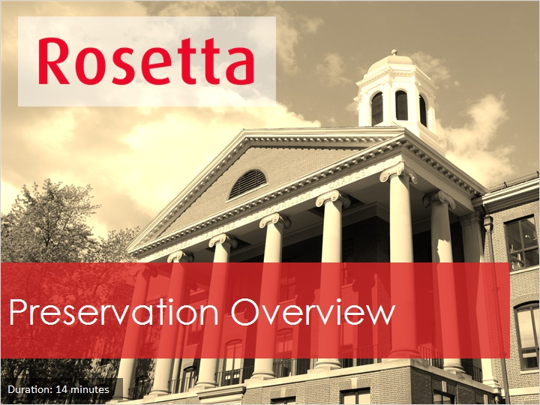
Notes:
Hello, and welcome to this Overview of Rosetta Preservation.

1.2 Preservation Module Overview
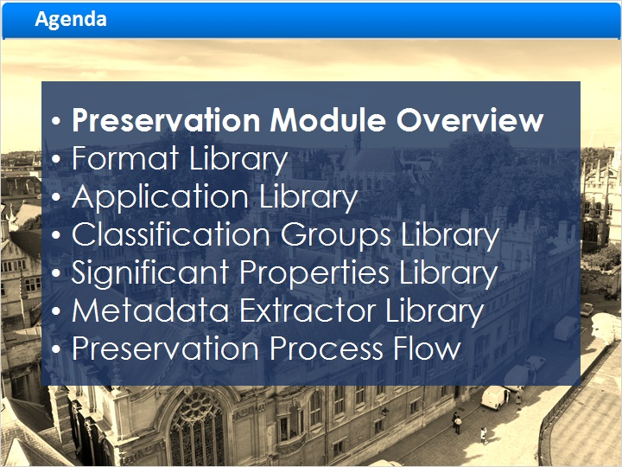
Notes:
In this session we’ll see how you can preserve your digital materials with Rosetta,
beginning with an overview of the Rosetta Preservation Module.
Then we’ll look at the different knowledgebases or libraries or maintained in this module, such as a library of all file formats.
Finally, we’ll look at the workflow of the preservation process.

1.3 Rosetta Preservation Module
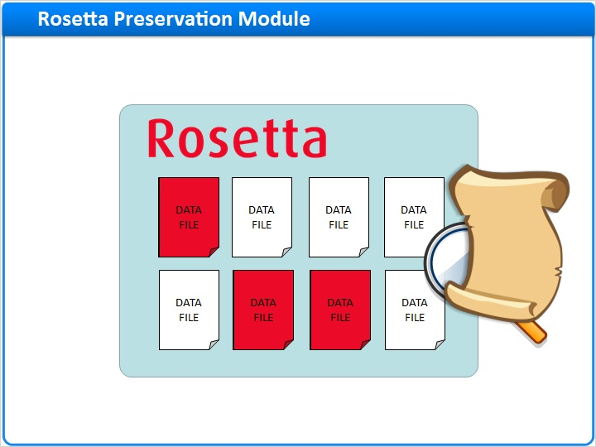
Notes:
Rosetta’s Preservation module provides an environment in which digital data can be managed and preserved.
Rosetta’s Preservation module:
Provides the tools to identify and describe file-level risks
Locates the at-risk file population
Creates Preservation Plans to eliminate or otherwise address these risks
Executes these Preservation Plans for the files at risk

1.4 Preservation Terminology: Preservation Plan / Alternative
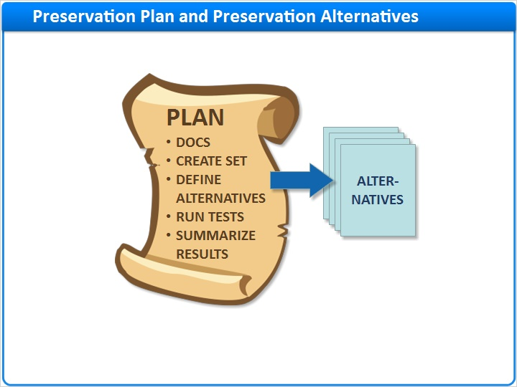
Notes:
A Preservation Plan is a structured workflow used by the Preservation Analyst or “PA” to pro-actively manage objects that are at risk and develop best practices for their preservation.
The workflow takes the PA through the stages of gathering documentation and general information, creating the preservation set, defining the preservation plan’s alternatives, running tests, and summarizing the results.
A Preservation Plan Alternative is a potential course of action for addressing at-risk objects.
Preservation Plan Alternatives are linked to Preservation Plans and tested with sample objects in order to determine the best preservation approach.
A single Preservation Plan may have one or more Alternatives in order to ensure success.
For example, the same Preservation Plan may have two migration utilities that convert the at-risk file from the source format to the target format.
Each one of these is saved as an Alternative, and the workflow allows the Preservation Analyst to evaluate each utility and add relevant information to the Preservation Plan for the utility being evaluated.

1.5 Rosetta Preservation Sub-Modules
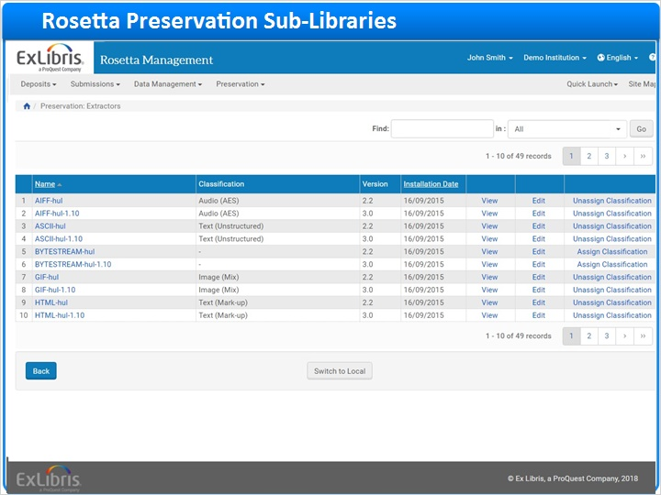
Notes:
Rosetta’s Preservation module includes these sub-libraries:

The Format Library is an authoritative knowledgebase of file-formats, derived from the PRONOM Registry.
The Application Library lists all known software applications and which file-formats they can render.
The Classification Groups Library groups file formats into types that share properties, such as Audio, Video, Image, or Text.
The Significant Properties Library includes all discrete file-level properties that can be extracted from files with a metadata extractor such as JHOVE.
And the Metadata Extractor Library manages the metadata extractor tools and maps their output to Rosetta’s DNX fields.

1.6 Risk Analysis
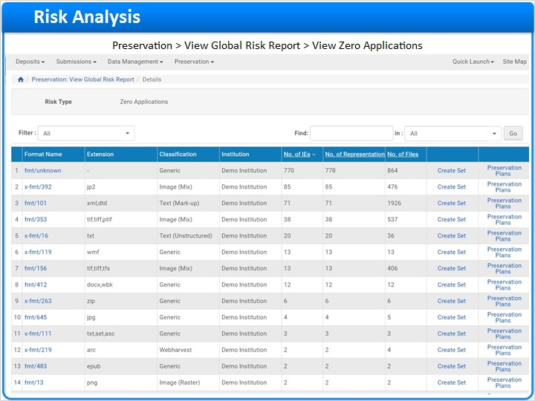
Notes:
Preservation risks are defined in Rosetta as files that cannot be rendered or processed by software or hardware.
The Risk Analysis submodule manages the automated and manual processes that measure the risk status of the repository.
Based on the results of these processes, the Preservation Analyst creates sets of objects to be analyzed and processed by the Preservation Planning submodule.
Risk Analysis is run on ingested files, as part of the the SIP processing.
It can then run on an ongoing basis, once the content is in Rosetta’s permanent repository.
Using Risk Analysis, Preservation Analysts can assess current and future format risks for objects in the repository, including format obsolescence, application incompatibility, or an attribute that puts one or more formats at risk.
Analyzing the current repository holdings from this perspective provides long-term protection and preservation of files.

1.7 Risk Types
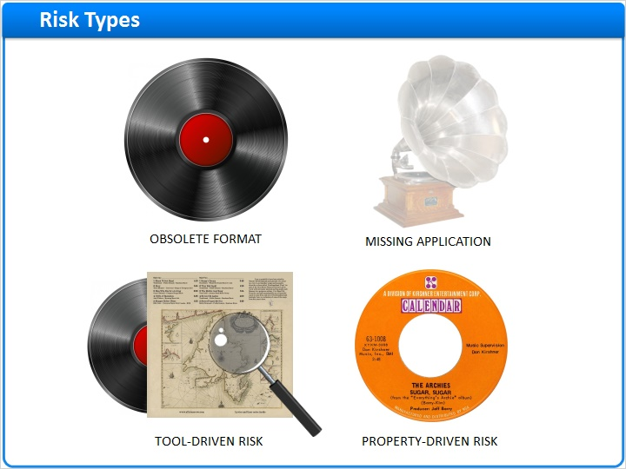
Notes:
There are four format‐related Risk Types:

Obsolete Formats are file formats deemed obsolete by the global preservation community.
Missing Applications are formats for which an institution no longer has the required software or hardware to render.
Property‐Driven Risks occur in formats with file properties values that prevent them from being properly rendered.
For example, the TIFF format may have a certain color encoding which puts certain TIFF files at risk.
Tool‐Driven Risks refer to format properties that cannot be extracted by the available metadata extractors, for example, JHOVE.
Rosetta identifies Tool-Driven Risks via plug‐in tools; and the extracted file properties are stored in Rosetta.

1.8 Format Library
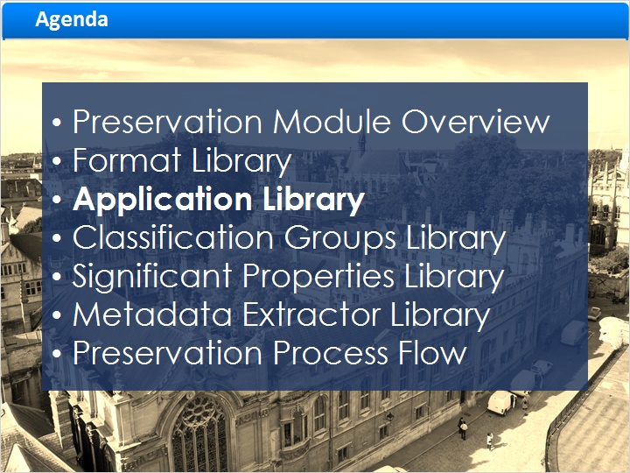
Notes:
Now let’s take a look at Rosetta’s Format Library.

1.9 Formats
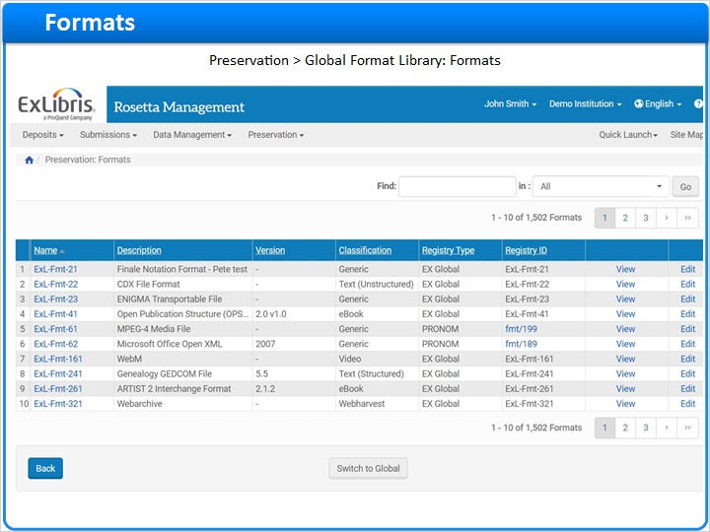
Notes:
Rosetta’s Format Library is as an authoritative knowledgebase of file formats derived from the PRONOM Registry.
The Format Library is maintained by the Rosetta Format Library Working Group which includes the Rosetta Product Manager and members of the Rosetta customer community.
This Working Group is managed by Rosetta customers, not Ex Libris.
The Rosetta Format Library Working Group meets quarterly to discuss general format changes, tools updates and adjustments to Rosetta's Format Library management.
Using the Format Library, Project Administrators and Managers can easily identify risks and utilize metadata extraction tools to plan and execute preservation‐related activities.
The Format Library includes format-related information, such as Name, Description, related applications, related risks, and sustainability factors.
The Format Library is linked to the following libraries: Application, Significant Properties, Classification Groups, and Metadata Extractor.
We will soon cover these related libraries in more detail.

1.10 Format Library Updates
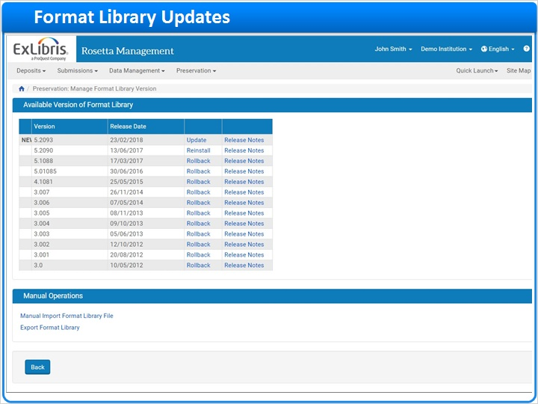
Notes:
The format library is updated from time to time by the Format Library Working Group.
You can manage the format library versions in Rosetta.
Note that the Format Library versions are independent of the Rosetta version.
However, Format Library major releases are coupled with a specific Rosetta release.

A scheduled Format Library Updates job runs to determine if a new Format Library version is available for download.
By default, the job is scheduled to run Every Sunday at 2am and includes the option to automatically install the Format Library when available.
Whether the Format Library Updates job is set to download or auto‐install,
It can send an email notification to a recipient of your choice indicating a new version is either available for manual installation, or has been installed.

1.11 Application Library
Notes:
Let’s review the Application Library next.

1.12 Applications
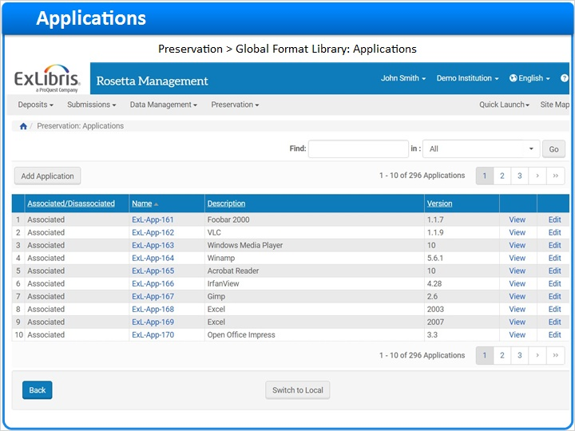
Notes:
Rosetta’s Application Library is a knowledgebase of all known software applications designed to render files.
A Disassociated application is an obsolete application such as WordPerfect Office.
An Associated application can still render files, such as the Windows Media Player.
File formats with Disassociated applications may or may not be at risk.
For example, WordPerfect Office files may be at risk because there are no currently available applications to render them.
On the other hand, even if there are no applications to render jp2, wav, and xml files according to the Application Library, the Preservation Analyst may still not consider them at-risk since they can be rendered in a Web browser.

1.13 Classification Groups Library
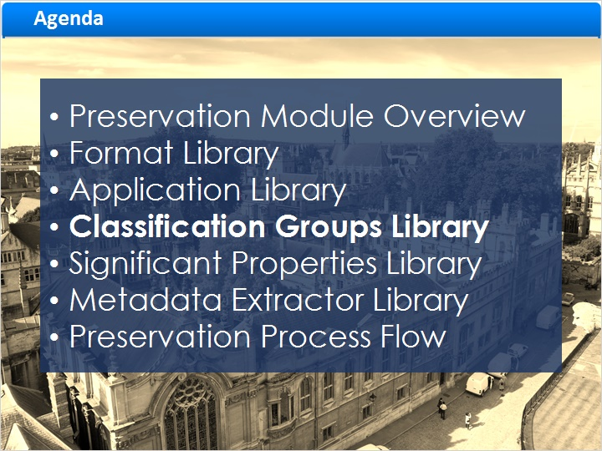
Notes:
Now let’s learn more about Classification Groups.

1.14 Classification Groups
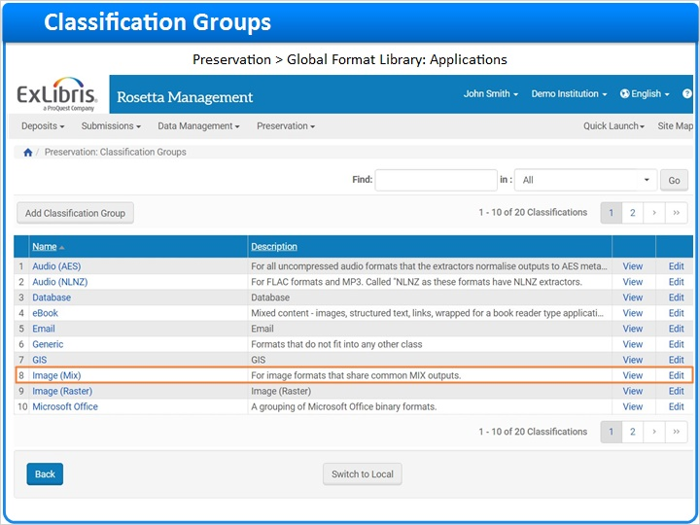
Notes:
Rosetta’s Classification Groups collate similar preservation file types, such as Audio, eBook, Email, Image, PDF, Text, Video, and Web harvests that share properties.
For example the Image (Mix) grouping has a number of associated file formats, such as JPEG 2000 and the Tagged Image File Format, and a set of file properties, such as image.colours and image.compressionType that these file formats share.
Referring to the Classification Groups during file preservation analysis can help Preservation Analysts and Managers to plan and execute preservation‐related activities.
Classification Groups work closely with Significant Properties, which includes all of the discrete properties, such as the image colours and compressionType mentioned above.

1.15 Significant Properties Library
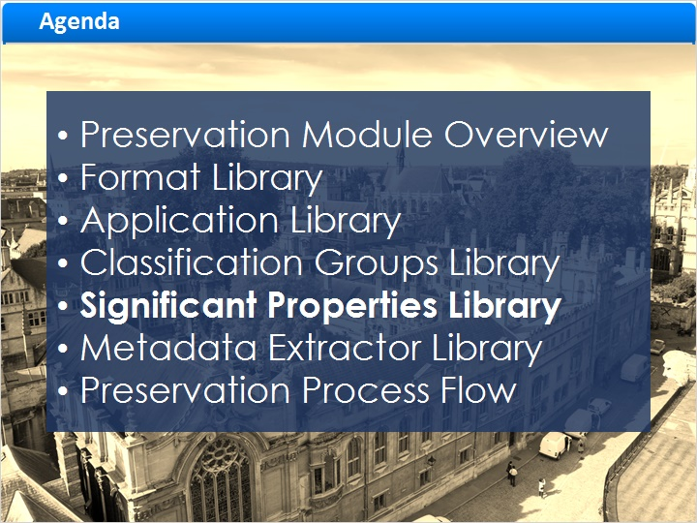
Notes:
So let’s take a look at the Significant Properties.

1.16 Significant Properties
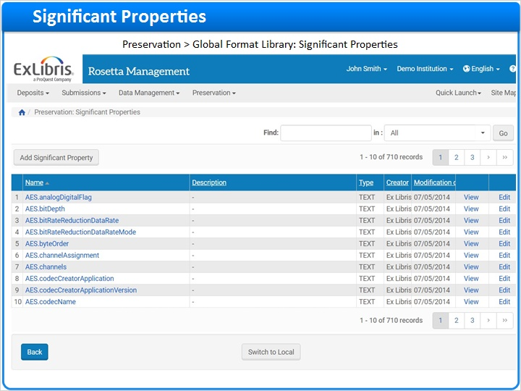
Notes:
Rosetta’s Significant Properties Library includes all discrete file level properties that can be extracted from files.
If the Classification Groups library collates similar file types (such as image files), that share some properties, the Significant Properties library is where those properties are listed.

1.17 Metadata Extractor Library
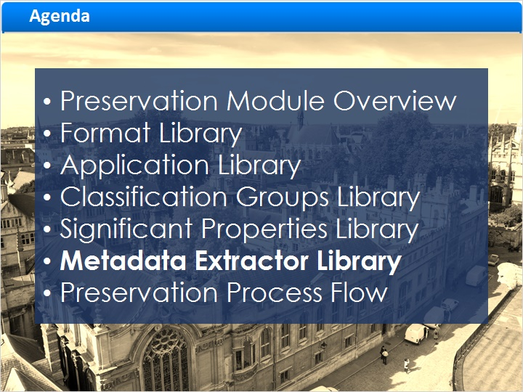
Notes:
The Metadata Extractor Library is the final component of the overall Format Library.

1.18 Extractors
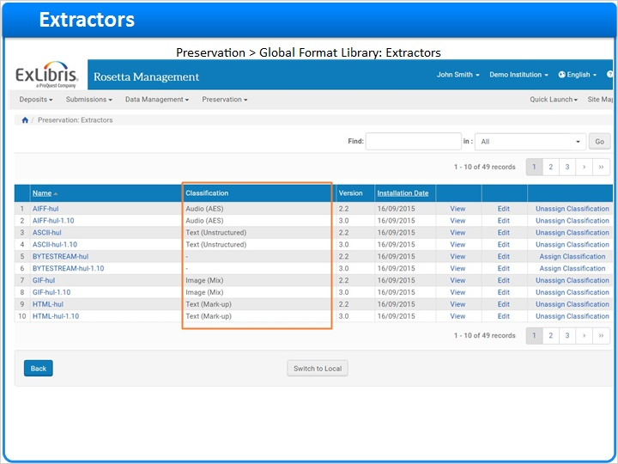
Notes:
Rosetta’s Metadata Extractor library manages the metadata extractor tools and maps their output to Rosetta’s DNX fields.
The Metadata Extractor library includes the metadata extractors for format classifications such as: Audio, Image (Mix), Microsoft Office, PDF, Text, Video, and Web harvest.
Institutions who wish may develop and use their own custom Metadata Extractors if the Rosetta-provided extractors don’t extract a particular file format.
These customized extractors are treated as plugins by Rosetta.

1.19 Preservation Process Flow
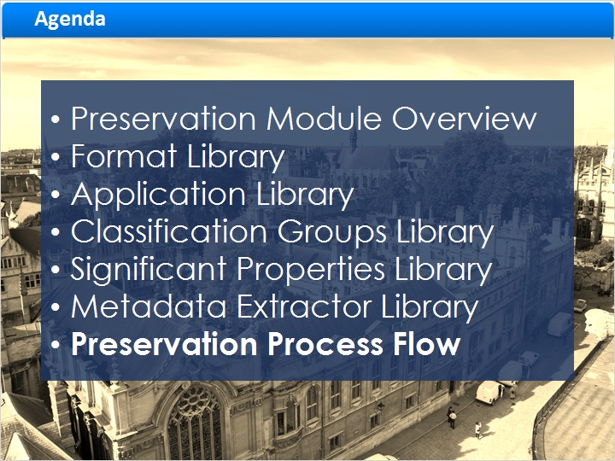
Notes:
Let’s conclude this session with a high-level overview of the Rosetta Preservation workflow.

1.20 Rosetta Preservation Process Flow
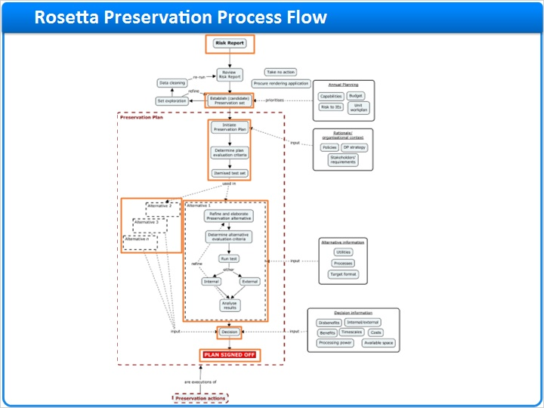
Notes:
Preservation of files begins when the files are ingested into Rosetta's permanent repository.
During ingest files are analyzed to confirm their format, for example that a file with a .pdf extension is indeed a PDF file.
Next the technical metadata, or file properties, are extracted from the files, as covered in our discussion of Significant Properties.
These properties are analyzed by Rosetta and if they are identified as risks, they will be flagged in the Risk Report.
In this preservation workflow diagram, the preservation planning process begins with running the Risk Report.
From the Risk Report, PAs can establish a Preservation Set, which is sample set of at-risk files that can be used to test Preservation Plan Alternatives.
Next the PA will Initiate a Preservation Plan, adding evaluation criteria and linking the Preservation Set for testing.
Once the basic Preservation Plan is established, the PA will next add one or more Preservation Plan Alternatives that will need to be tested and their results evaluated.
Once all Preservation Plan Alternatives have been evaluated, one Preservation Plan Alternative must be chosen, after which the Preservation Plan is officially signed-off Preservation Manager, or “PM”.
When the Preservation Plan is executed, Rosetta will apply the signed-off Preservation Plan Alternative on all eligible records.
Now when new at-risk files are ingested into Rosetta, the Preservation Plan will manage them.

1.21 Summary
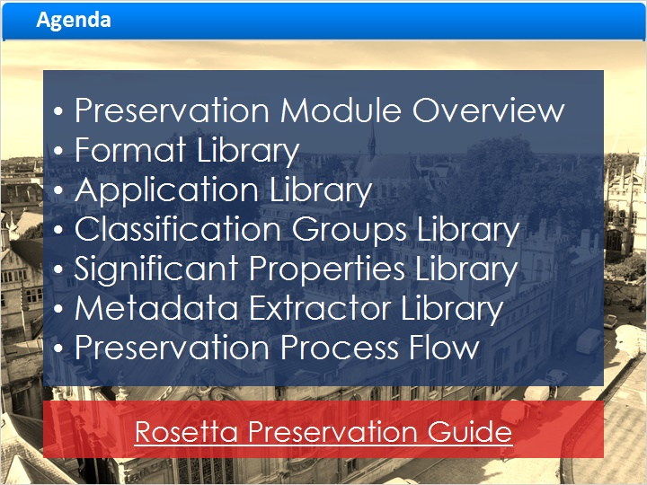
Notes:
In this session we were introduced to the Preservation module in Rosetta.

The module hosts the following libraries related to preservation:
The Format Library, which lists the recognized file formats, such as TIF or PDF.
The Application Library, which lists the applications that can open the files in each format, such as Adobe Reader.
The Classification Groups library, which lists groups of file types that share common properties like audio files, or image files.
The Significant Properties library, which lists the aforementioned shared properties, an example for image files being the colors or compression type.
And finally the Metadata Extractor Library, which lists the different plugins that can extract metadata from the different media files.

These libraries help Preservation Analysts and Preservation Managers come up with Preservation Plans.

Finally we saw the flow of the Rosetta Preservation Process.

You can learn more about everything we discussed in this session in the Rosetta Preservation guide, linked here:
https://knowledge.exlibrisgroup.com/@api/deki/files/63960/Rosetta_Preservation_Guide.pdf?revision=1

1.22 Thanks

Notes:
Thanks for joining!

1.23 About this Training
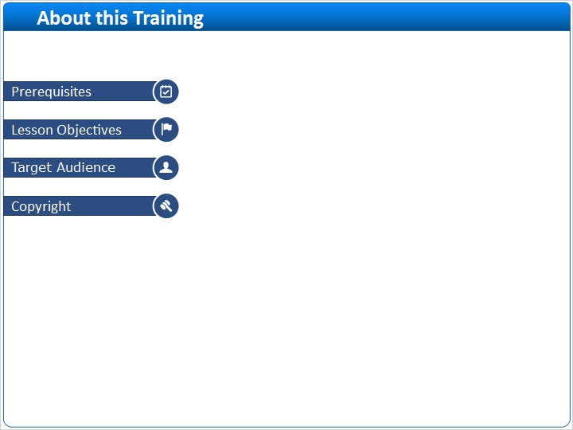
Notes:

1 (Slide Layer)
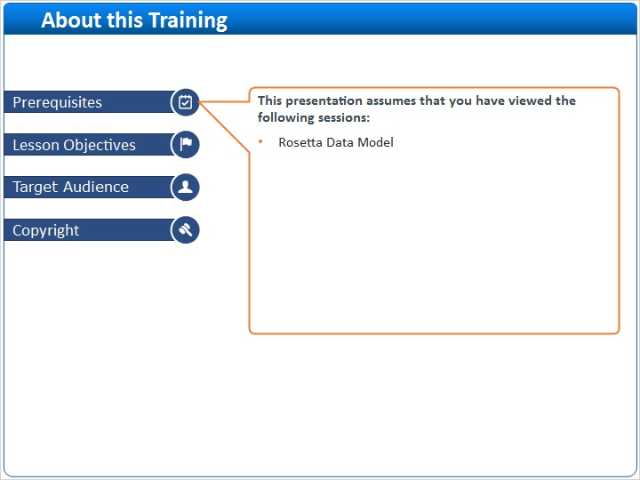

2 (Slide Layer)
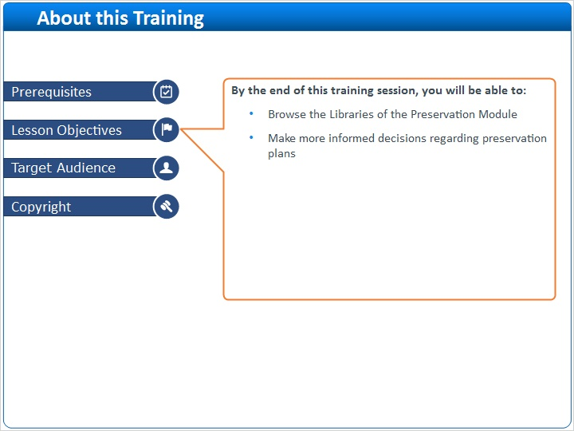

3 (Slide Layer)
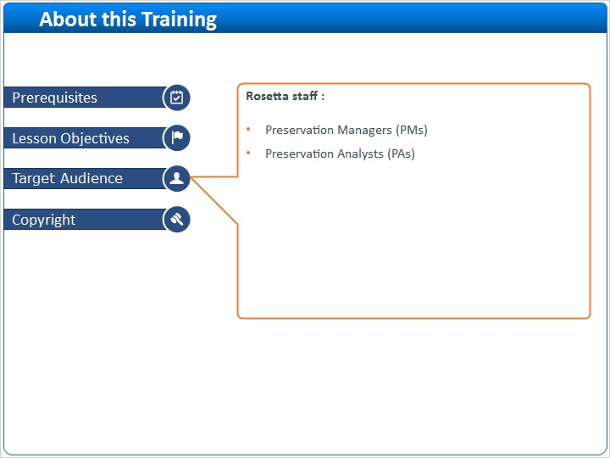

4 (Slide Layer)


